ASSIGNMENT-1
FSDL
Write-up:
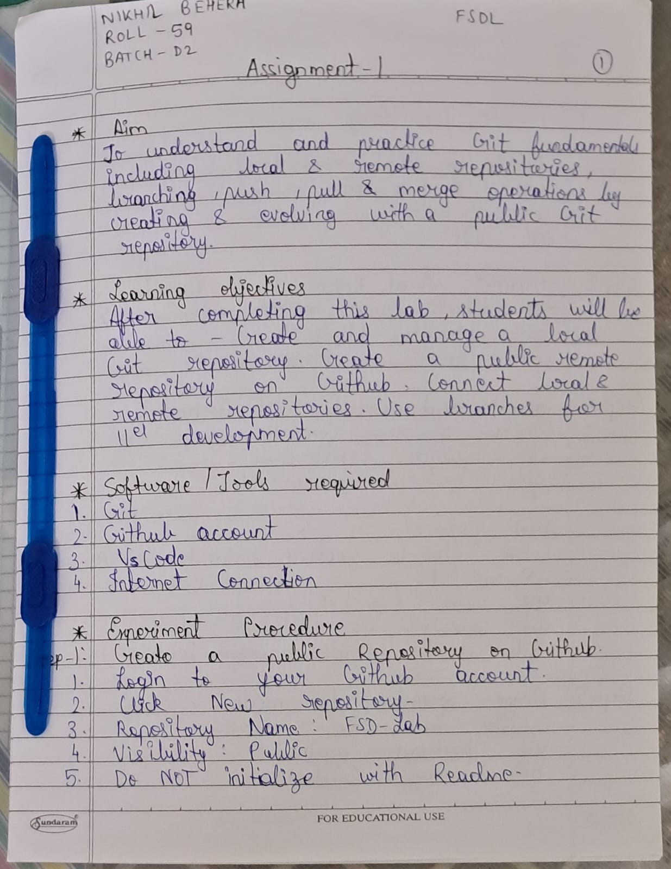


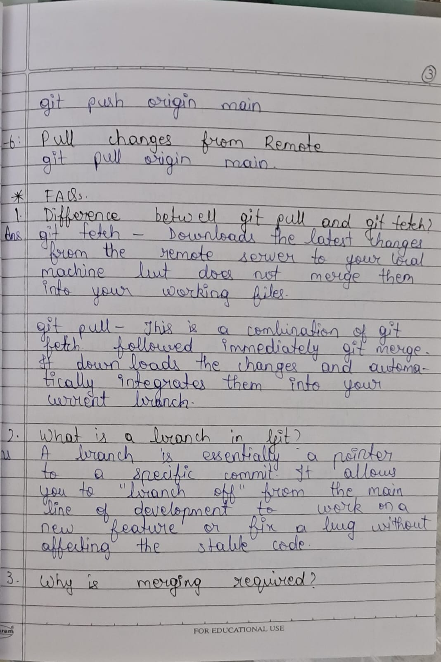

GitHub Repository link -:
https://github.com/Nikhil-Behera/Fsd_Lab

Name – Nikhil Behera
Roll No – 59
Batch – D2
PRN - 1032233446

