**APPENDIX A**

**SNAPSHOTS**

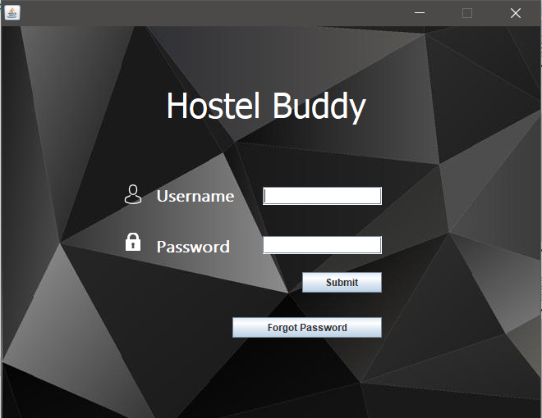

**Snapshot 1: Login Page of the project**

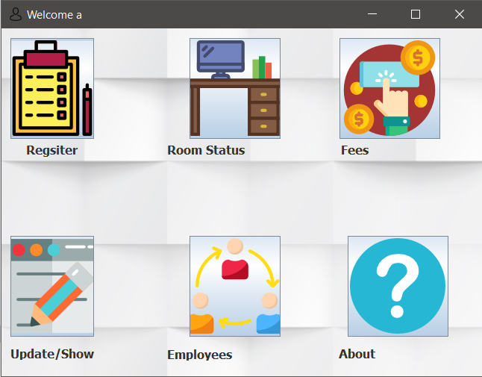

**Snapshot 2: Features page of the project**

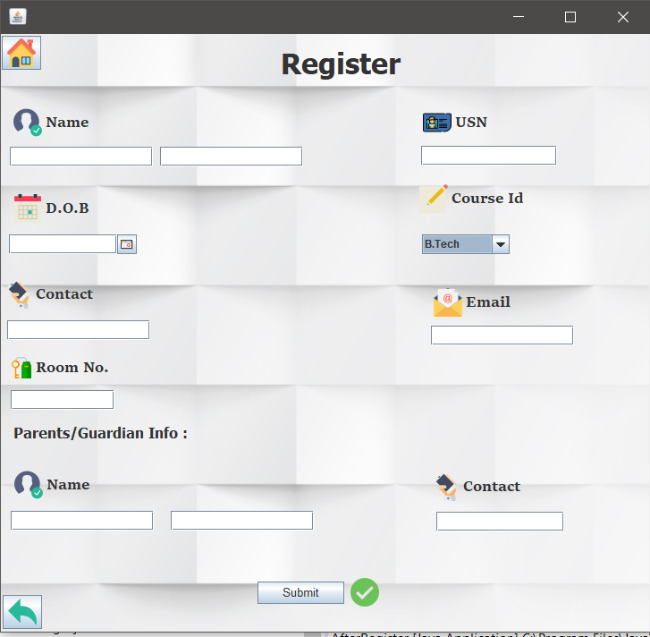

**Snapshot 3: Registration page for new Students**

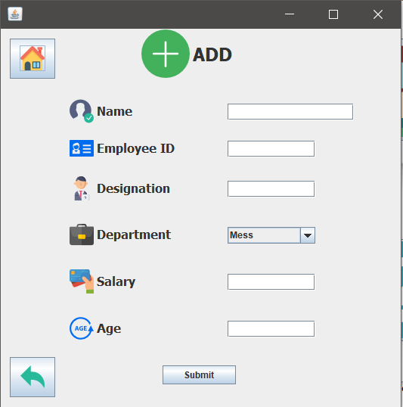

**Snapshot 4: Employee registration page**

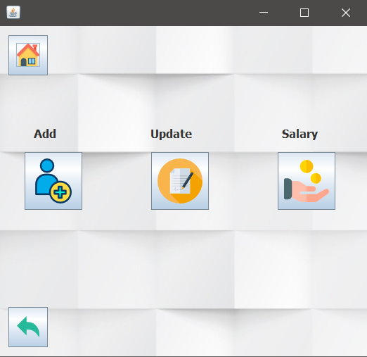

**Snapshot 5: Options for employee management**

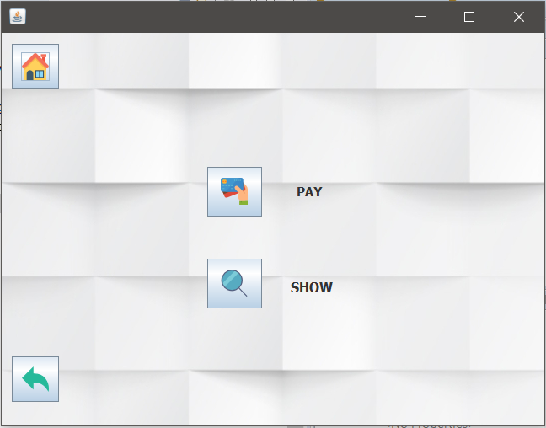

**Snapshot 6: Fee update and fetch page**

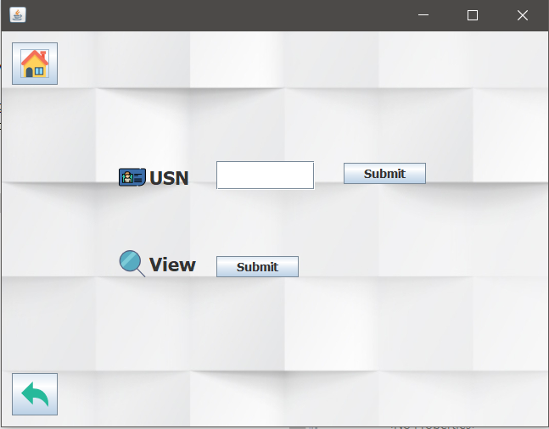

**Snapshot 7: Fetch fee details of individual students**

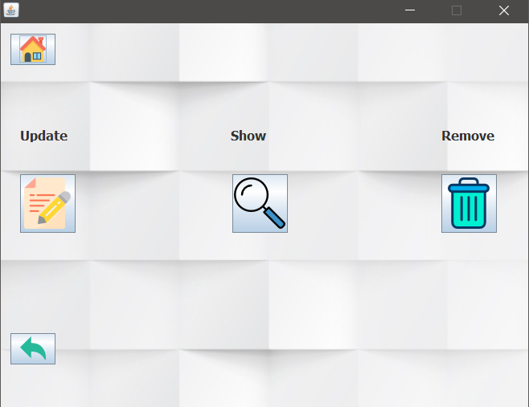

**Snapshot 8: Maintain student records of the system.**

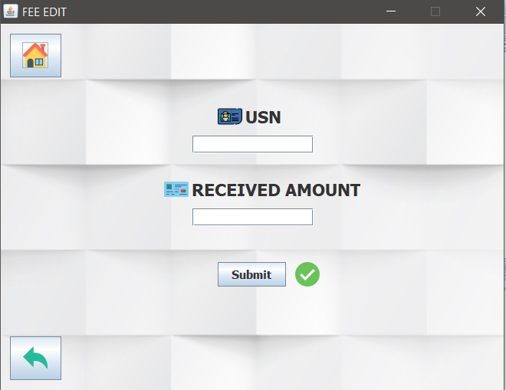

**Snapshot 9: Update fee details of specific student.**