**Capstone Project Report**

**Introduction and Business Problem**

• A customer, Nikhil, wants to open a new gym in Mumbai, India.

• Due to Mumbai’s high population density and very large size, he asked me for help in order to find the best spot to place the gym.

• Mumbai has 35 large neighbourhoods and we aim to find the best one.

• We need to choose a Neighbourhood that has good amount of customers and low amount of competition.

**Data**

• To help Nikhil in his search we will need to access following data:

• The Neighbourhoods of Mumbai, India from Wikipedia: <https://en.wikipedia.org/wiki/List_of_neighbourhoods_in_Mumbai>

• The coordinates (latitude, longitude) ot these Neighbourhoods of Mumbai from Open Street Map APIs.

• From Foursquare we will need the following venues data:

• the gym venues of the Neighbourhoods.

• the offices venues of the Neighbourhoods.

• the high schools venues of the Neighbourhoods.

• the universities venues of the Neighbourhoods.

• We will then leverage the data in order to determine which neighbourhood is the most appropriate in order to locate the gym.

**Methodology**

• For each neighbourhood, all offices, schools, universities and gyms venues data have been collected from Foursquare.

• Then for each locality, the sums of the offices, schools, universities and gyms were computed.

• For each of these 4 categories, a weight (or penalty) has been defined according to what Nikhil considers the most important.

• Gyms have been weighted with -1, since we want to avoid concurrence.

• Schools have been weighted with 1, since student are good customers.

• Universities have been weighted with 1.5, since adult students are better customers.

• Offices have been weighted with 2, since employees are even better customers.

• Note that the weights can be modified according to the importance of each category.

• Lastly, a score was computed for each locality as the weighted sum of the number of venues in each of the 4 categories (school, university, office, gym).

Neighbourhoods of Mumbai, India.

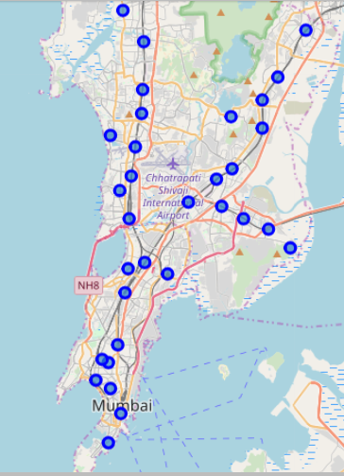

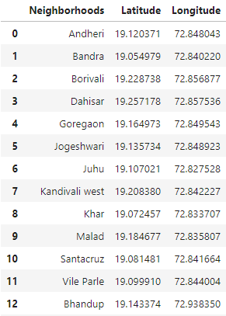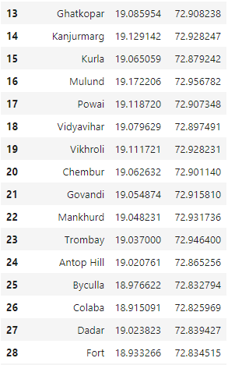

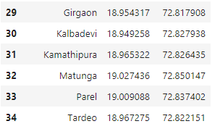

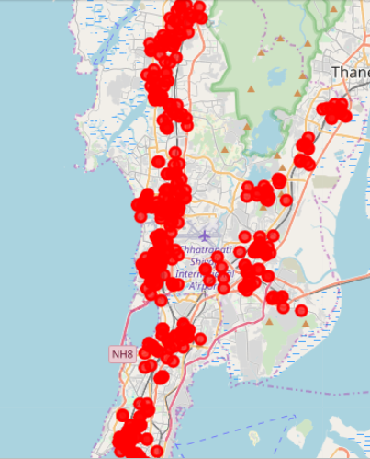Gyms in Mumbai

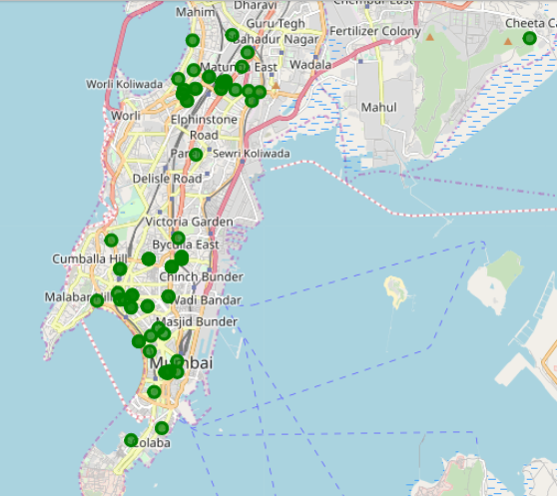

High Schools in Mumbai

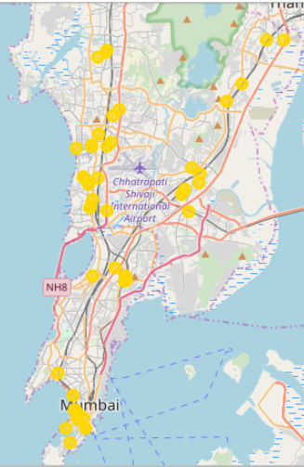

Universities in Mumbai

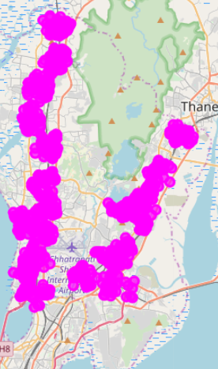

Offices in Mumbai

**Results**

• The Neighbourhood with the best score is “Fort” with 103.0, being the best option.

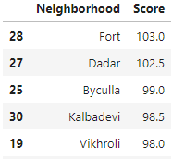

• Followed closely by “Dadar” with 102.5. These options maximize the number of potential customers from offices and universities and at the same time have little competition from other gyms.

**Best Place for nikhil’s gym in Mumbai is “Fort”**

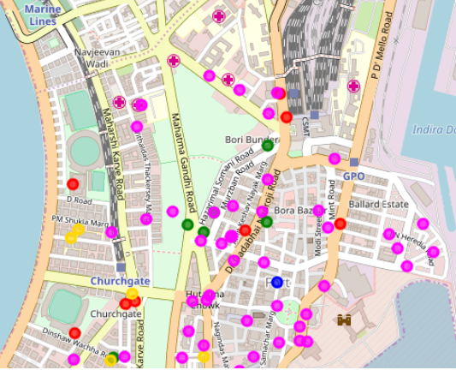

**Recommendation**

The following analysis can be improved with following extensions:

• Consider more categories. For example like "Sports Complexes" which is also a good source for customers. But also like "Martial arts", which even if not gyms may be some concurrence if too many.

• In the Neighbourhood itself, it can also be computed the distance between all the venues in order to find a place with the most number of potential customers.

• Using smaller geographical areas like Streets could improve the accuracy for the scores.