A Seminar Report

on

Edge AI: Intelligence at the Edge of Devices

Submitted in the fulfilment of the requirement for the degree of
Bachelor of Technology
in
Information Technology
Nikhil Dubey - 2023071047

Department of Information Technology & Computer Applications
MADAN MOHAN MALVIYA UNIVERSITY OF TECHNOLOGY
GORAKHPUR (273010)

ACKNOWLEDGEMENT
We are pleased to acknowledge our sincere thanks to the Department of Information
Technology & Computer Application, MMMUT for their kind encouragement in this Seminar
and for completing it successfully. We are grateful to them.
We convey our Thanks to Head of ITCA Department Dr. Daya Shankar Singh for providing
us necessary support and details at the right time during the progressive work.
We would withal relish conveying our gratitude to all the faculty members and staff of the
Department of ITCA for their wholehearted cooperation to make this work turns into
authenticity.

Sign: Date:
Student Name: Nikhil Dubey Place:
Roll No.: 2023071047

Abstract
Artificial Intelligence (AI) has traditionally depended on cloud-based infrastructure for processing complex computations. However, the increasing demand for real-time decision-making, reduced latency, enhanced data privacy, and the proliferation of Internet of Things (IoT) devices have necessitated a paradigm shift towards Edge AI. Edge AI refers to the deployment and execution of AI algorithms directly on edge devices such as smartphones, embedded systems, IoT sensors, and autonomous vehicles, enabling local data processing without continuous reliance on cloud connectivity.
This seminar report presents a comprehensive study on Edge AI, exploring its architecture, working principles, advantages, challenges, and real-world applications across diverse industries including healthcare, smart homes, autonomous vehicles, and industrial IoT. The report also examines the comparison between cloud-based AI and Edge AI, highlighting the trade-offs and complementary nature of both approaches. Technologies enabling Edge AI, such as TensorFlow Lite, NVIDIA Jetson, and neuromorphic computing, are discussed in detail.
The findings indicate that Edge AI significantly reduces latency, enhances privacy, enables offline operation, and reduces bandwidth consumption. Despite challenges related to limited computational resources and model optimization, the rapid advancement in AI-specific hardware and 5G connectivity positions Edge AI as a transformative technology for the future of intelligent computing.

Table of Contents
Abstract ............................................................. i
Candidate Declaration ............................................... ii
Approval Sheet ..................................................... iii
Table of Contents ................................................... iv
List of Figures ...................................................... v

Chapter 1 Introduction .............................................. 1
1.1 What is Artificial Intelligence ................................. 1
1.2 Cloud-Based AI .................................................. 1
1.3 Shift Towards Edge Computing .................................... 2

Chapter 2 Literature Review ......................................... 3
2.1 Evolution of Edge Computing ..................................... 3
2.2 Research on Edge AI ............................................. 3
2.3 Industry Adoption ............................................... 4

Chapter 3 Cloud AI vs Edge AI ....................................... 5
3.1 Cloud AI: Overview .............................................. 5
3.2 Edge AI: Overview ............................................... 5
3.3 Comparative Analysis ............................................ 6

Chapter 4 Architecture of Edge AI ................................... 7
4.1 Device Layer .................................................... 7
4.2 Edge Processing Layer ........................................... 7
4.3 Optional Cloud Layer ............................................ 8
4.4 Communication Protocols ......................................... 8

Chapter 5 Working of Edge AI ........................................ 9
5.1 Data Collection ................................................. 9
5.2 On-Device Inference ............................................. 9
5.3 Model Optimization Techniques .................................. 10
5.3.1 Quantization ................................................. 10
5.3.2 Pruning ...................................................... 10
5.3.3 Knowledge Distillation ....................................... 11

Chapter 6 Applications of Edge AI .................................. 12
6.1 Healthcare ..................................................... 12
6.2 Smart Homes .................................................... 12
6.3 Autonomous Vehicles ............................................ 13
6.4 Industrial IoT ................................................. 13

Chapter 7 Advantages and Challenges ................................ 15
7.1 Advantages of Edge AI .......................................... 15
7.2 Challenges of Edge AI .......................................... 16

Chapter 8 Conclusion ............................................... 17

Future Scope ........................................................ 18
References .......................................................... 19

List of Figures
Fig 1.1 Traditional Cloud-Based AI Architecture ................ 2
Fig 3.1 Cloud AI vs Edge AI Comparison ......................... 4
Fig 4.1 Edge AI Three-Layer Architecture ....................... 6
Fig 5.1 Edge AI Data Processing Pipeline ....................... 7
Fig 5.2 Model Optimization Techniques Overview ................ 8

Chapter 1

Introduction

1.1 What is Artificial Intelligence
Artificial Intelligence (AI) is a branch of computer science that aims to create systems capable of performing tasks that typically require human intelligence. These tasks include visual perception, speech recognition, decision-making, language translation, and problem solving. AI encompasses various subfields including machine learning, deep learning, natural language processing, and computer vision.
Over the past decade, AI has evolved from a theoretical concept to a practical technology that powers everyday applications. From virtual assistants like Siri and Google Assistant to recommendation systems on Netflix and Amazon, AI has become deeply embedded in modern life. The rapid growth in computational power, availability of large datasets, and advances in neural network architectures have been the primary drivers of this AI revolution.

1.2 Cloud-Based AI
Traditional AI systems rely heavily on cloud computing infrastructure for their operations. In this model, data generated by user devices is transmitted to remote servers in the cloud, where powerful GPUs and TPUs process the data using complex machine learning models. The results are then sent back to the user's device. This approach leverages the virtually unlimited computational resources available in data centers operated by companies like Google, Amazon Web Services (AWS), and Microsoft Azure.
While cloud-based AI offers significant advantages in terms of processing power and scalability, it also introduces several limitations. These include network latency, dependency on internet connectivity, elevated bandwidth costs, and critical concerns around data privacy and security. As the number of IoT devices is projected to exceed 75 billion by 2030, the volume of data requiring processing makes a purely cloud-centric approach increasingly impractical.
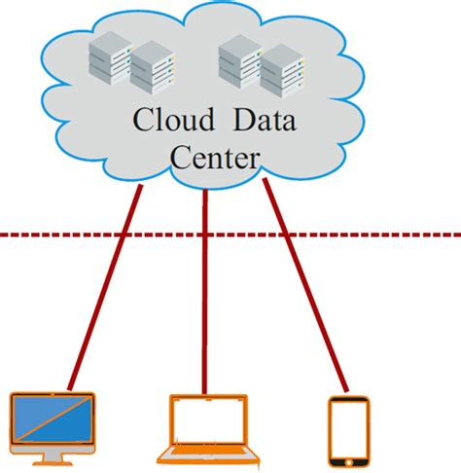
Figure 1.1: Traditional Cloud-Based AI Architecture

1.3 Shift Towards Edge Computing
The limitations of cloud-based AI have given rise to Edge Computing, a distributed computing paradigm that brings computation and data storage closer to the sources of data. Edge AI, an extension of this concept, specifically refers to running AI algorithms locally on edge devices. This shift is driven by the need for real-time processing, data privacy, bandwidth efficiency, and the ability to operate in environments with limited or no internet connectivity.
Edge AI represents a fundamental paradigm shift in how intelligence is deployed and consumed. Rather than depending on centralized cloud infrastructure, Edge AI distributes intelligence across a network of devices, enabling autonomous decision-making at the point of data generation. This report explores the architecture, working mechanisms, applications, benefits, and challenges of Edge AI in detail.

Chapter 2

Literature Review

2.1 Evolution of Edge Computing
The concept of edge computing can be traced back to the late 1990s when content delivery networks (CDNs) were introduced to serve web content from geographically closer locations. The evolution of this concept gained significant momentum with the advent of IoT, fog computing, and mobile edge computing (MEC). Researchers such as Satyanarayanan (2017) have extensively documented the transition from centralized cloud computing to distributed edge architectures, highlighting the technological enablers and market drivers behind this shift.

2.2 Research on Edge AI
Recent research has focused on optimizing deep learning models for deployment on resource-constrained edge devices. Howard et al. (2017) introduced MobileNets, a family of efficient neural network architectures designed for mobile and embedded vision applications. Google's TensorFlow Lite and NVIDIA's TensorRT have emerged as key frameworks for deploying optimized AI models on edge hardware. Federated learning, proposed by McMahan et al. (2017), offers a privacy-preserving approach to training AI models across distributed edge devices without sharing raw data.
The TinyML community has been particularly active in pushing the boundaries of on-device AI, demonstrating that meaningful machine learning inference can be performed on microcontrollers consuming only a few milliwatts of power. Banbury et al. (2021) provide a comprehensive benchmark for evaluating TinyML systems, covering aspects such as model accuracy, latency, and energy consumption across different hardware platforms.

2.3 Industry Adoption
Major technology companies have been at the forefront of Edge AI adoption. Apple's Neural Engine, integrated into its A-series and M-series chips, powers on-device features such as Face ID, computational photography, and Siri's speech recognition. Google's Edge TPU and NVIDIA's Jetson platform provide dedicated hardware acceleration for edge AI workloads. According to Gartner, by 2025, more than 75% of enterprise-generated data will be created and processed outside a traditional centralized data center or cloud, up from less than 10% in 2018.

Chapter 3

Cloud AI vs Edge AI

3.1 Cloud AI: Overview
Cloud AI refers to the paradigm where AI computations are performed on centralized cloud servers. Data from user devices is transmitted over the internet to data centers equipped with high-performance computing resources. The trained models residing on these servers process the data and return results to the requesting devices. This model benefits from economies of scale, access to virtually unlimited computational resources, and centralized management of AI models and data.

3.2 Edge AI: Overview
Edge AI, in contrast, brings AI processing directly to edge devices such as smartphones, IoT sensors, embedded systems, and autonomous vehicles. AI models are optimized and deployed to run locally, enabling real-time inference without cloud dependency. Edge AI leverages specialized hardware such as Neural Processing Units (NPUs), Graphics Processing Units (GPUs), and application-specific integrated circuits (ASICs) to achieve efficient on-device computation.

3.3 Comparative Analysis
Parameter | Cloud AI | Edge AI
Latency | High (100ms–1s) | Very Low (<10ms)
Privacy | Data sent to cloud | Data stays on device
Internet | Required | Not required
Computing Power | Virtually unlimited | Limited by hardware
Bandwidth | High consumption | Minimal usage
Cost | Recurring cloud costs | One-time device cost
Scalability | Easy to scale | Scales with devices
Fig 3.1: Cloud AI vs Edge AI Comparison
As shown in the comparative analysis, Edge AI and Cloud AI are not mutually exclusive. A hybrid approach that leverages edge devices for latency-sensitive inference while utilizing the cloud for model training and complex analytics provides the optimal balance between performance, privacy, and scalability.

Chapter 4

Architecture of Edge AI
The architecture of Edge AI can be understood as a three-layer framework comprising the Device Layer, the Edge Processing Layer, and the Optional Cloud Layer. Each layer plays a distinct role in the overall data processing pipeline.

4.1 Device Layer
The Device Layer consists of the physical hardware that generates and captures data. This includes a wide range of devices such as smartphones, wearable devices (smartwatches, fitness trackers), IoT sensors (temperature, humidity, motion sensors), cameras (surveillance, dashcams), drones, and industrial robots. These devices are equipped with various sensors including cameras, microphones, LiDAR, and accelerometers that continuously generate data streams.

4.2 Edge Processing Layer
The Edge Processing Layer is the core of the Edge AI architecture. This layer is responsible for running AI inference directly on or near the edge device. It leverages specialized hardware accelerators designed for efficient AI computation:
- Neural Processing Units (NPUs) — Dedicated AI inference chips (e.g., Apple Neural Engine, Google Edge TPU)
- Graphics Processing Units (GPUs) — NVIDIA Jetson series for parallel AI processing
- Field-Programmable Gate Arrays (FPGAs) — Customizable hardware for specific AI workloads
- Digital Signal Processors (DSPs) — Efficient for audio and signal processing AI tasks
- Microcontrollers (MCUs) — Ultra-low-power devices for TinyML applications

4.3 Optional Cloud Layer
While Edge AI reduces dependency on the cloud, the cloud still plays an important role in the overall ecosystem. The cloud layer is primarily used for model training, where large datasets and powerful computing resources are required to train complex deep learning models. Once trained, these models are compressed and deployed to edge devices. The cloud also serves as a platform for aggregating insights from multiple edge devices, performing complex analytics, and pushing model updates to the edge.

4.4 Communication Protocols
Edge AI systems utilize various communication protocols depending on the application requirements. MQTT (Message Queuing Telemetry Transport) is widely used for lightweight IoT communication. Bluetooth Low Energy (BLE) and Wi-Fi are common for short-range device communication. For wide-area connectivity, protocols like LoRaWAN and NB-IoT provide low-power, long-range communication suitable for remote edge deployments. The emergence of 5G technology further enhances Edge AI by providing ultra-low latency and high bandwidth for edge-cloud hybrid architectures.
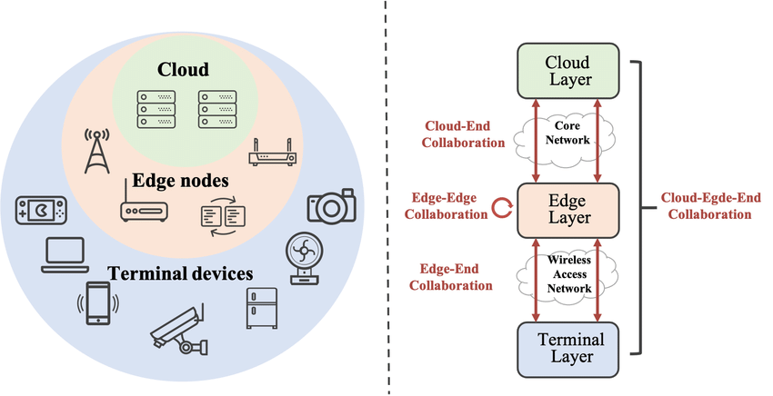
Figure 4.1: Edge AI Three-Layer Architecture

Chapter 5

Working of Edge AI

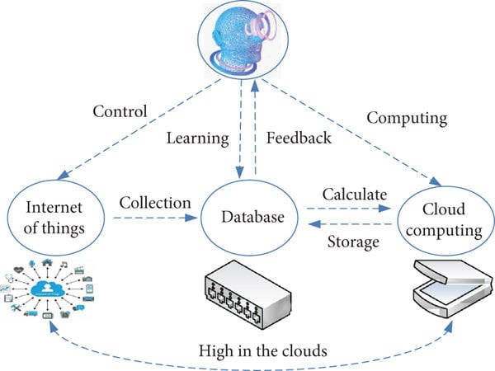

Figure 5.1: Edge AI Data Processing Pipeline

5.1 Data Collection
The Edge AI pipeline begins with data collection at the device level. Sensors, cameras, and microphones on edge devices continuously capture raw data from the environment. This data can include images, video streams, audio signals, temperature readings, motion data, and other sensor outputs. Unlike cloud-based systems where raw data is immediately transmitted to remote servers, Edge AI systems retain this data locally for on-device processing.

5.2 On-Device Inference
Once data is captured, it is pre-processed and fed into an optimized AI model running on the device. The model performs inference — the process of making predictions or decisions based on the input data — using the device's local computing resources. For example, a smart camera might run an object detection model to identify people or vehicles in a video feed, with the entire computation happening on the camera's embedded processor.
Frameworks commonly used for on-device inference include TensorFlow Lite (Google), Core ML (Apple), ONNX Runtime (Microsoft), and PyTorch Mobile (Meta). These frameworks provide tools for converting trained models into optimized formats suitable for edge deployment.

5.3 Model Optimization Techniques
Deploying complex AI models on resource-constrained edge devices requires significant optimization. Several techniques are employed to reduce model size, latency, and power consumption while maintaining acceptable accuracy:

5.3.1 Quantization
Quantization reduces the precision of the numerical representations used in the model. For example, converting 32-bit floating-point (FP32) weights to 8-bit integers (INT8) can reduce the model size by 4x and significantly improve inference speed on hardware that supports integer arithmetic. Post-training quantization and quantization-aware training are two common approaches.

5.3.2 Pruning
Pruning involves removing redundant or less important connections (weights) from a neural network. Structured pruning removes entire filters or channels, while unstructured pruning removes individual weights. This technique can reduce the number of parameters by 50-90% with minimal impact on accuracy, leading to smaller and faster models.

5.3.3 Knowledge Distillation
Knowledge distillation trains a smaller "student" model to mimic the behavior of a larger "teacher" model. The student model learns to reproduce the teacher's output probability distribution, effectively compressing the knowledge of the larger model into a more compact form suitable for edge deployment.
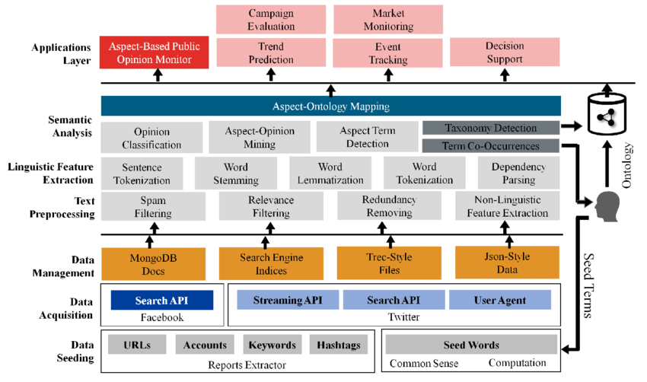
Figure 5.2: Model Optimization Techniques (Techniques like pruning, quantization, and compression for efficient edge deployment.)

Chapter 6

Applications of Edge AI

6.1 Healthcare
Edge AI is revolutionizing healthcare by enabling real-time patient monitoring and diagnostics at the point of care. Wearable devices equipped with Edge AI can continuously monitor vital signs such as heart rate, blood oxygen levels, and ECG patterns, detecting anomalies and alerting healthcare providers immediately. Portable diagnostic devices powered by Edge AI can analyze medical images (X-rays, retinal scans) in remote areas where cloud connectivity is unreliable, enabling timely diagnosis and treatment.
During the COVID-19 pandemic, Edge AI-powered thermal cameras were deployed at airports and public spaces to screen individuals for elevated body temperatures in real-time. Edge AI also enables personalized drug dosage recommendations and predictive analytics for patient deterioration in ICU settings.

6.2 Smart Homes
Smart home ecosystems increasingly leverage Edge AI to provide responsive and privacy-conscious automation. Smart speakers process voice commands locally using on-device natural language processing, eliminating the need to send audio recordings to the cloud. Smart security cameras use Edge AI for real-time person detection, facial recognition, and anomaly detection, generating alerts without transmitting video footage to external servers.
Smart thermostats, lighting systems, and appliances use Edge AI to learn user preferences and optimize energy consumption patterns. These devices can autonomously adjust settings based on occupancy detection and predictive models, resulting in up to 30% energy savings.

6.3 Autonomous Vehicles
Autonomous vehicles represent one of the most critical applications of Edge AI, where split-second decisions can be a matter of life and death. Self-driving cars are equipped with multiple sensors including LiDAR, radar, cameras, and ultrasonic sensors that generate enormous volumes of data in real-time. Edge AI processors on the vehicle — such as NVIDIA DRIVE Orin — process this sensor data locally to perform object detection, lane tracking, path planning, and collision avoidance with latencies measured in milliseconds.
Sending sensor data to the cloud for processing would introduce unacceptable delays, making Edge AI an absolute necessity for autonomous driving. Tesla's Full Self-Driving (FSD) computer and Waymo's custom AI hardware are prominent examples of purpose-built Edge AI platforms for autonomous vehicles.

6.4 Industrial IoT
In industrial settings, Edge AI enables predictive maintenance, quality control, and operational optimization. Sensors mounted on manufacturing equipment continuously monitor vibration patterns, temperature, and acoustic emissions. Edge AI models analyze this data in real-time to detect early signs of equipment failure, enabling maintenance to be scheduled proactively rather than reactively, reducing unplanned downtime by up to 50%.
Computer vision systems powered by Edge AI inspect products on assembly lines at high speed, identifying defects that are invisible to the human eye. Manufacturing facilities in remote locations benefit from Edge AI's ability to operate independently of cloud connectivity, ensuring continuous operation and real-time quality assurance.

Chapter 7

Advantages and Challenges

7.1 Advantages of Edge AI
Low Latency: Edge AI enables real-time processing with response times in the order of milliseconds, critical for applications such as autonomous driving and industrial automation.
Enhanced Privacy: Data remains on the device and is not transmitted to external servers, significantly reducing the risk of data breaches and ensuring compliance with data protection regulations such as GDPR and HIPAA.
Offline Capability: Edge AI systems can function without internet connectivity, making them suitable for deployment in remote or network-constrained environments.
Reduced Bandwidth: By processing data locally, Edge AI minimizes the amount of data that needs to be transmitted over the network, reducing bandwidth costs and network congestion.
Cost Efficiency: Edge AI reduces dependency on expensive cloud computing resources, with the one-time cost of edge hardware often being more economical than recurring cloud service fees.
Scalability: Each edge device operates independently, allowing the system to scale naturally as new devices are added without proportionally increasing cloud infrastructure requirements.

7.2 Challenges of Edge AI
Limited Computational Resources: Edge devices have constrained processing power, memory, and storage compared to cloud servers, limiting the complexity of AI models that can be deployed.
Battery and Energy Constraints: Portable and IoT edge devices operate on limited battery power, necessitating highly energy-efficient AI inference to avoid rapid battery depletion.
Model Optimization Complexity: Compressing and optimizing AI models for edge deployment requires specialized expertise in techniques such as quantization, pruning, and knowledge distillation, adding complexity to the development pipeline.
Hardware Heterogeneity: The wide variety of edge device architectures and capabilities makes it challenging to develop models that perform consistently across different platforms.
Model Update and Management: Deploying and updating AI models across thousands of distributed edge devices requires robust over-the-air (OTA) update mechanisms and version management.
Security Concerns: On-device models are vulnerable to adversarial attacks, model extraction (stealing), and tampering, requiring additional security measures for model protection.

Chapter 8

Conclusion
Edge AI represents a significant evolution in the deployment of artificial intelligence, shifting the focus from centralized cloud processing to distributed, on-device intelligence. This seminar report has explored the various facets of Edge AI, including its architecture, working principles, enabling technologies, real-world applications, advantages, and challenges.
The analysis demonstrates that Edge AI addresses critical limitations of cloud-based AI, including high latency, privacy concerns, internet dependency, and excessive bandwidth consumption. By processing data at the point of generation, Edge AI enables real-time decision-making, enhances user privacy, supports offline operation, and reduces operational costs.
Applications across healthcare, smart homes, autonomous vehicles, and industrial IoT demonstrate the transformative potential of Edge AI in diverse domains. The rapid development of specialized AI hardware, model optimization techniques, and enabling technologies such as 5G connectivity further accelerates the adoption and capabilities of Edge AI systems.
In conclusion, Edge AI is not a replacement for cloud AI but rather a complementary paradigm that extends the reach of intelligent systems to the edge of the network. The synergy between edge and cloud computing creates a powerful, flexible, and efficient AI infrastructure capable of meeting the diverse and evolving demands of modern applications.

Future Scope
The future of Edge AI is poised for remarkable growth driven by several converging technological advancements. The continued development of more powerful and energy-efficient AI-specific chipsets, such as next-generation NPUs and neuromorphic processors inspired by the human brain, will enable increasingly complex AI models to run on compact edge devices. The widespread deployment of 5G and the upcoming 6G networks will provide ultra-low latency and high-bandwidth connectivity, enabling seamless hybrid edge-cloud architectures where edge devices handle time-critical inference while the cloud supports model training and heavy analytics. Federated learning will gain mainstream adoption, allowing collaborative model training across millions of edge devices without compromising user privacy. The integration of Edge AI with augmented reality (AR), virtual reality (VR), and mixed reality (MR) will unlock immersive, real-time experiences in gaming, education, healthcare, and remote collaboration. Furthermore, the convergence of Edge AI with autonomous systems, smart cities, precision agriculture, and personalized medicine will drive a new era of intelligent automation, making AI a pervasive, invisible, and indispensable part of everyday life.

References
[1] M. Satyanarayanan, "The Emergence of Edge Computing," Computer, vol. 50, no. 1, pp. 30-39, 2017.
[2] A. G. Howard et al., "MobileNets: Efficient Convolutional Neural Networks for Mobile Vision Applications," arXiv:1704.04861, 2017.
[3] B. McMahan et al., "Communication-Efficient Learning of Deep Networks from Decentralized Data," AISTATS, 2017.
[4] C. R. Banbury et al., "MLPerf Tiny Benchmark," arXiv:2106.07597, 2021.
[5] Google, "TensorFlow Lite: Deploy machine learning models on mobile and edge devices," tensorflow.org/lite, 2024.
[6] NVIDIA, "NVIDIA Jetson: The AI Platform for Autonomous Machines," developer.nvidia.com/embedded-computing, 2024.
[7] Apple, "Core ML: Integrate machine learning models into your app," developer.apple.com/documentation/coreml, 2024.
[8] W. Shi et al., "Edge Computing: Vision and Challenges," IEEE Internet of Things Journal, vol. 3, no. 5, pp. 637-646, 2016.
[9] Y. Li et al., "Edge Intelligence: Paving the Last Mile of Artificial Intelligence with Edge Computing," Proceedings of the IEEE, vol. 107, no. 8, 2019.
[10] Z. Zhou et al., "Edge Intelligence: Architectures, Challenges, and Applications," arXiv:2003.12172, 2020.
[11] Gartner, "What Edge Computing Means for Infrastructure and Operations Leaders," Gartner Research, 2023.
[12] S. Dhar et al., "A Survey of On-Device Machine Learning: An Algorithms and Learning Theory Perspective," ACM Transactions on Internet of Things, 2021.
[13] P. Warden and D. Situnayake, "TinyML: Machine Learning with TensorFlow Lite on Arduino and Ultra-Low-Power Microcontrollers," O'Reilly Media, 2020.
[14] J. Chen and X. Ran, "Deep Learning With Edge Computing: A Review," Proceedings of the IEEE, vol. 107, no. 8, 2019.
[15] K. Cao et al., "An Overview on Edge Computing Research," IEEE Access, vol. 8, pp. 85714-85728, 2020.

