ASSIGNMENT - 7

1) Write a query that counts all orders for octobmer 3.
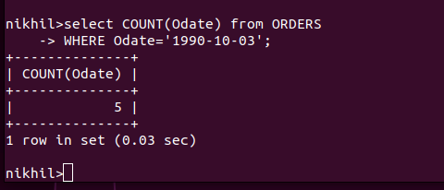

2) Write a query that counts the number ofdifferent non-NULL city values in the Customerstable.
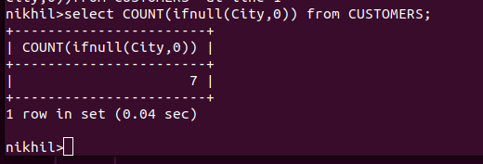

3) Write a query that selects each customer’s smallest order.

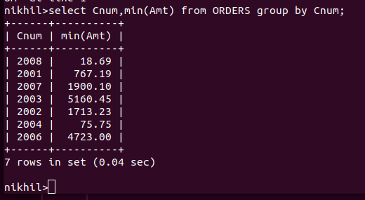

4) Write a query that selects the first customer, in alphabetical order, whose name begins with G.
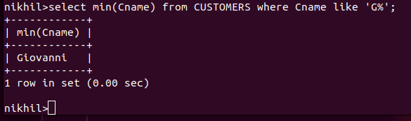

5) Write a query that selects the highest rating in each city.
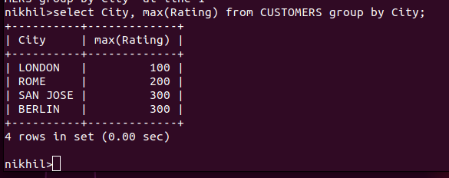

6) Write a query that counts the number ofsalespeople registering orders for each day. (If a salesperson has more than one order on a givenday, he or she should be counted only once.).
