ASSIGNMENT NO -6

1) Write two different queries that would produce all orders taken on October 3rd or 4th, 1990.
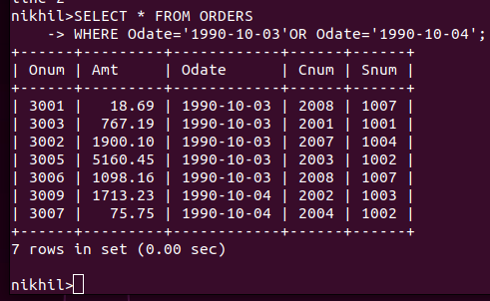

2) Write a query that selects all of the customers serviced by Peel or Motika. (Hint: the snum fieldrelates the two tables to one another).

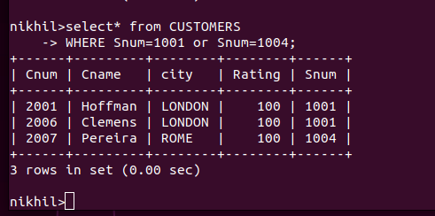

3) Write a query that will produce all the customers whose names begin with letter from ‘A’ to ‘G’.
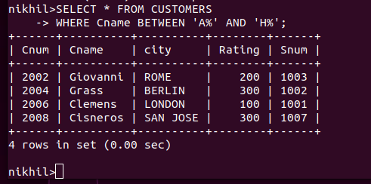

4) Write a query that selects all customers whose names begin with the letter ‘C’.

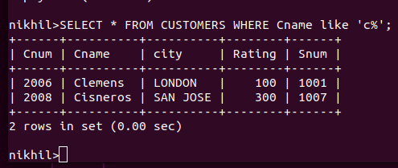

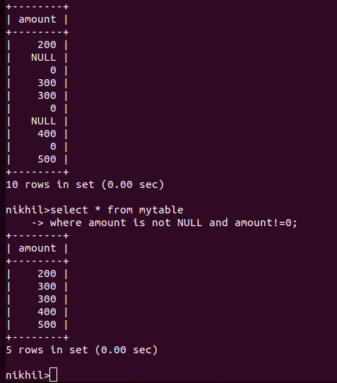
5) Write a query that selects all orders except those with zeroes or NULLs in the amt field.

