

Final Project

Sem 2

Submitted by

Nikhil Jagtap

2024-3108-0001-0002

Specialization: Business Analytics

Company: IBM

Project Title

Market Trend Analysis using Sentiments



# Executive Summary

This project conducts a comprehensive analysis of news articles related to IBM and the broader IT sector. By employing advanced text analytics techniques—specifically sentiment analysis and topic modelling it extracts actionable insights to understand public sentiment trends and identify prominent themes in the IT industry. The study highlights key drivers affecting IBM's market perception and provides the groundwork for benchmarking against the larger IT sector.

# Sector Information

The Information Technology (IT) sector is a vast and dynamic industry that encompasses a wide range of businesses, technologies, and services. Below is an analysis of the IT sector in 2025, including its growth trends, challenges, and the types of companies operating within it.

# Sector Analysis: IT in 2025

## Growth Trends

1. Market Growth:

- The global IT market is projected to grow from $8.92 trillion in 2024 to $9.61 trillion in 2025 at a CAGR of 7.7%.

- In India, IT exports are expected to reach $210 billion in FY25, representing 18% of global IT outsourcing spending.

2. Emerging Technologies:

- Artificial Intelligence (AI), Machine Learning (ML), cloud computing, and 5G are driving innovation across industries.

- Generative AI, quantum computing, and digital twin technologies are reshaping industries like healthcare, manufacturing, and finance.

3. Digital Transformation:

- Increasing adoption of digital transformation strategies is critical for businesses to remain competitive. This includes automation (e.g., Robotic Process Automation) and data-driven decision-making through big data analytics.

## Challenges

1. Skill Gaps:

- There is a significant need for upskilling in emerging technologies like AI, ML, and cloud computing to meet industry demands.

2. Global Competition:

- Countries like the Philippines and China are intensifying competition in IT outsourcing markets.

3. Cybersecurity Threats:

- Sophisticated cyberattacks pose risks to businesses globally.

# Types of Companies in the IT Sector

The IT sector comprises a diverse range of companies categorized into product-based firms, service providers, and specialized technology businesses.

## Product-Based Companies

These companies develop software or hardware products for end-users or enterprises.

- Operating System Developers: Microsoft, Apple, Google.

- Enterprise Software Providers: SAP, Salesforce (CRM), Oracle (ERP).

- Hardware Manufacturers: Intel (processors), NVIDIA (GPUs), Dell (PCs).

- Consumer Electronics Firms: Apple (smartphones), Samsung (TVs).

## Service-Based Companies

These firms provide IT services to businesses.

- IT Consulting Firms: Accenture, Deloitte.

- Managed Service Providers (MSPs): Rackspace Technology.

- Cloud Service Providers: Amazon Web Services (AWS), Microsoft Azure.

- Cybersecurity Firms: Palo Alto Networks, CrowdStrike.

## Outsourcing Companies

These companies handle specific IT functions for clients.

- Examples include Infosys, Tata Consultancy Services (TCS), and Wipro.

## Emerging Tech Companies

Focused on cutting-edge innovations:

- Blockchain & Cryptocurrency Firms: Coinbase, Ethereum Foundation.

- AI & Data Analytics Firms: Palantir Technologies, Splunk.

# Key Future Trends

1. Widespread adoption of hybrid cloud models and serverless computing for scalability.

2. Expansion of 5G networks enabling IoT and smart city applications.

3. Growth in autonomous systems like self-driving cars powered by AI.

4. Increased focus on sustainability through renewable energy-powered data centers.

The IT sector remains one of the most transformative industries globally, with opportunities driven by innovation and digital transformation across all verticals. However, addressing challenges such as skill shortages and cybersecurity will be critical for sustained growth.

IBM (International Business Machines Corporation) is one of the world's leading technology companies, with a history dating back to 1911. Based in Armonk, New York, IBM operates in 177 countries and is renowned for its contributions to the IT sector through innovative products and services. Below is a detailed overview of IBM's operations, products, and services in 2025.

# Overview of IBM

- Founded: June 16, 1911 (originally as Computing-Tabulating-Recording Company).

- Headquarters: Armonk, New York, USA.

- Revenue (2024): $62.73 billion.

- Employees (2024): Approximately 270,300 globally.

- Mission: To lead in creating advanced information technologies and translate them into value for customers through professional solutions and consulting services.

# Key Products

IBM offers a wide range of products spanning hardware, software, and advanced technologies:

## Software

- AI and Machine Learning: IBM’s AI solutions include Watson AI, which provides capabilities like natural language processing and predictive analytics.

- Cloud Solutions: Hybrid cloud platforms such as *IBM Cloud* allow businesses to integrate public and private cloud environments seamlessly.

- Blockchain Technology: IBM Blockchain enables secure transactions across industries like finance and supply chain management.

## Automation Tools

- Robotic Process Automation (RPA) tools to streamline business processes.

- Tools for IT operations automation to improve efficiency.

---

# Key Services

IBM provides a broad spectrum of services tailored to enterprise needs:

## 1. Consulting

IBM Consulting offers expertise in digital transformation, helping businesses leverage AI, cloud computing, and data analytics to achieve operational excellence.

## 2. Cloud Services

IBM’s hybrid cloud solutions are designed for scalability and security. The company supports private, public, and hybrid cloud architectures to meet diverse business needs.

## 3. Data Analytics

With tools like Watsonx.data, IBM enables enterprises to extract actionable insights from structured and unstructured data using AI-driven analytics.

## 4. Cybersecurity

IBM provides advanced cybersecurity solutions to protect businesses from evolving threats. These include threat intelligence platforms and managed security services.

# Emerging Technologies

1. Quantum Computing: Developing quantum systems that solve problems beyond the capabilities of classical computers.

2. Generative AI: Leveraging AI models for tasks like text-to-SQL conversion and multimodal data analysis.

3. Hybrid Architectures: Combining legacy systems with modern digital solutions for enhanced agility.

# Recent Achievements

1. In 2025, IBM was recognized as one of the Top 100 Software Companies by G2 for its innovative software solutions across multiple categories.

2. The company continues to modernize its *IBM i* platform by integrating AI-driven tools and DevOps practices.

# Strategic Vision

IBM’s vision is to remain a vital information technology company by enabling clients to solve complex problems using advanced technologies. It emphasizes sustainability, innovation, and global collaboration as core principles guiding its future growth.

# Problem Statement

IBM, as a leading technology company, operates in the dynamic IT sector, where understanding emerging market trends is critical to maintain competitiveness. The challenge lies in analyzing vast amounts of unstructured textual data—such as industry reports, social media posts, customer reviews, and competitor news—to extract actionable insights. Traditional methods often fail to capture the nuances of text data, resulting in missed opportunities and delayed responses to market shifts. The goal is to develop a comprehensive text analytics framework to address this challenge effectively

## 1. Motivation for Solving the Problem

IBM operates in a fiercely competitive IT sector, where understanding market trends is essential for innovation and sustaining leadership. Here's why solving this problem is crucial:

Enhancing Strategic Decisions: The ability to analyze unstructured data enables IBM to identify opportunities and threats, allowing for informed decisions on product development, marketing, and customer engagement.

Improving Customer Satisfaction: Market insights can help IBM address customer needs more precisely, resulting in improved satisfaction and loyalty.

Innovation and Growth: Identifying future trends and technologies supports IBM’s innovation and expansion into areas like quantum computing, hybrid cloud, and AI.

## 2. Scope of Business Analytics Project

Data Sources: Analysis of unstructured text data from social media, news articles, customer reviews, and industry reports.

Techniques: Application of text analytics techniques like sentiment analysis, topic modeling, and keyword extraction.

Focus Areas: Emphasis on detecting emerging technologies, customer preferences, and competitor strategies within the IT sector.

Visualization: Creation of dashboards and reports that provide actionable insights to IBM’s leadership team.

Target Outcomes:

- Identify emerging trends in the IT sector.

- Provide prescriptive recommendations to IBM for strategic decision-making.

- Enhance IBM’s ability to innovate and adapt in response to market demands.

## 3. Limitations of the Business Analytics Project

Data Quality: Text data may contain errors, biases, or irrelevant information, which can impact the accuracy of analysis.

Language Diversity: Analyzing multilingual data is challenging, as sentiment and meaning can vary across languages.

Unstructured Nature: Extracting meaningful insights from large volumes of unstructured data requires complex preprocessing and analysis techniques.

Time Constraints: Market trends can change rapidly, and the analysis must be conducted and acted upon in a timely manner to remain relevant.

Privacy Concerns: Using social media or customer feedback data requires adherence to data privacy regulations and ethical considerations.

# Literature Review on Market Trend Analysis Using Text Analytics

## Introduction

Market trend analysis is a crucial aspect of business intelligence, enabling companies like IBM to anticipate industry shifts, customer preferences, and competitive strategies. With the rise of big data and artificial intelligence (AI), text analytics has emerged as a powerful tool for extracting insights from unstructured textual data, such as social media posts, news articles, and customer reviews. This literature review explores existing research on market trend analysis, highlighting methodologies, challenges, and applications.

# Existing Research on Market Trend Analysis

1. Market Intelligence and Data-Driven Decision Making

Research indicates that market intelligence plays a vital role in strategic decision-making. A study on market intelligence trends highlights the exponential growth of data-driven decision-making in modern businesses, emphasizing the importance of text analytics in identifying emerging trends.

2. Predictive Analytics in Market Trend Analysis

Predictive analytics, powered by machine learning models, has been widely used to forecast market trends. A literature review on predictive data analytics in stock market trend analysis discusses how AI-driven models enhance trend prediction accuracy.

3. Text Analytics for Consumer Insights

Text analytics has been applied to extract consumer sentiment and preferences from online reviews and social media. Studies show that sentiment analysis and topic modeling help businesses understand customer needs and market dynamics.

4. Challenges in Market Trend Analysis

Despite advancements, market trend analysis faces challenges such as data quality issues, language diversity, and computational complexity. Researchers emphasize the need for robust preprocessing techniques to improve text analytics accuracy.

Detailed Debate and Analysis of Market Trend Analysis

Market trend analysis has evolved significantly with the integration of AI and text analytics.

- Sentiment Analysis vs. Topic Modeling

Sentiment analysis provides insights into consumer emotions, while topic modeling identifies recurring themes. Researchers argue that combining both techniques yields more comprehensive market insights.

## Conceptual Framework for Market Trend Analysis

A conceptual framework provides a structured approach to market trend analysis using text analytics. The framework consists of the following components:

1. Data Collection

- Sources: Social media, news articles, customer reviews, industry reports.

- Tools: Web scraping, APIs, text mining techniques.

2. Data Preprocessing

- Cleaning: Removing noise, stop words, and irrelevant data.

- Standardization: Converting text into structured formats.

3. Text Analytics Techniques

- Sentiment Analysis: Identifies positive, negative, and neutral sentiments.

- Topic Modeling: Detects recurring themes and emerging trends.

- Keyword Extraction: Highlights industry buzzwords.

4. Visualization and Interpretation

- Trend graphs, word clouds, sentiment heatmaps.

- Comparative analysis of IBM vs. competitors.

5. Strategic Recommendations

- Actionable insights for IBM’s market positioning.

## Unit of Analysis

The unit of analysis in this project is individual textual data entries that reflect market trends, customer opinions, and competitor activities. These entries include:

- Social media posts (Tweets, LinkedIn discussions related to IBM and the IT sector).

- News articles covering IBM's developments, emerging technologies, and competitor strategies.

- Customer reviews gathered from IBM's product pages and third-party review platforms.

- Industry reports detailing technological innovations and market dynamics.

## Data Collection

## Sources:

1. Social Media Or Google news Data:

- Platforms: Twitter, News, and technology-related forums.

- Tools: Use Twitter/News API or scraping tools like BeautifulSoup and Scrapy to collect posts and discussions mentioning IBM.

# Market Trend Analysis – Sentiments Analysis

# Introduction

IBM operates in a fast-paced and competitive IT environment. Public sentiment and emerging trends play a significant role in shaping a company’s reputation and strategic decisions. This project leverages text analytics on news data to uncover the sentiments and themes surrounding IBM’s market activities, helping drive data-informed strategies.

## Data Sources

The analysis is based on two structured CSV files:

- ibm_news.csv: Contains curated news articles directly related to IBM.

- it_sector_news.csv: Encompasses articles reflecting trends and developments in the wider IT sector.

- dataset was collected from google news api

Each dataset includes fields for article titles, descriptions, and publication dates, forming the basis for analysis.

## Methodology

Step 1: Data Loading and Preprocessing

- Import news data from CSV files using pandas.

- Apply preprocessing to cleanse the textual data:

- Convert all text to lowercase.

- Remove special characters, numbers, and extra spaces using the re library.

- Tokenize the text using nltk.

- Filter out common English stop words for cleaner results.

- Create a combined `title_des` column by merging article titles and descriptions to enhance the text corpus for analysis.

Step 2: Sentiment Analysis

- Perform sentiment scoring for the `title_des` column using TextBlob.

- Polarity Scores: Determine sentiment polarity (range: -1 to 1).

- Negative Sentiment: Polarity closer to -1.

- Positive Sentiment: Polarity closer to 1.

- Neutral Sentiment: Polarity near 0.

- Compute daily average sentiment for IBM and IT sector articles to monitor trends over time.

## Step 3: Topic Modeling

- Use CountVectorizer to convert text data into a document-term matrix.

- Apply Latent Dirichlet Allocation (LDA) to identify latent topics within the preprocessed text.

- Extract and rank the top 15 words for each topic, revealing the underlying themes in IBM and IT sector articles.

## Output

The project generates the following key outputs:

1. daily_sentiment_ibm.csv: Daily average sentiment trends for IBM-specific news.

2. preprocessed_ibm.csv: Cleaned and tokenized IBM news data.

3. top_words_ibm.csv: List of top words per topic discovered in IBM news articles.

4. daily_sentiment_of_it_sector.csv: Daily average sentiment trends for IT sector news.

5. preprocessed_it_sector.csv: Cleaned and tokenized IT sector news data.

These outputs provide quantitative and thematic insights for strategic business analysis.

# Findings

1. Sentiment Trends:

- IBM enjoys a positive sentiment trend in news coverage focused on hybrid cloud and AI solutions.

- Certain news articles reflect negative sentiments, particularly regarding competition in generative AI and cybersecurity.



Sentiments by days for IBM News:

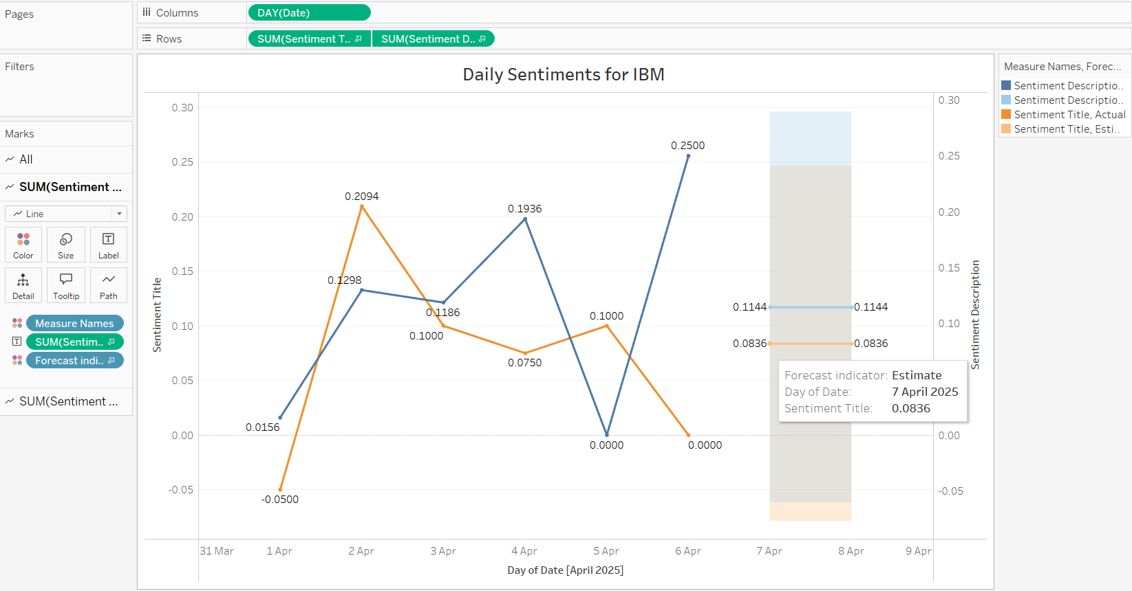

For IT Sector:

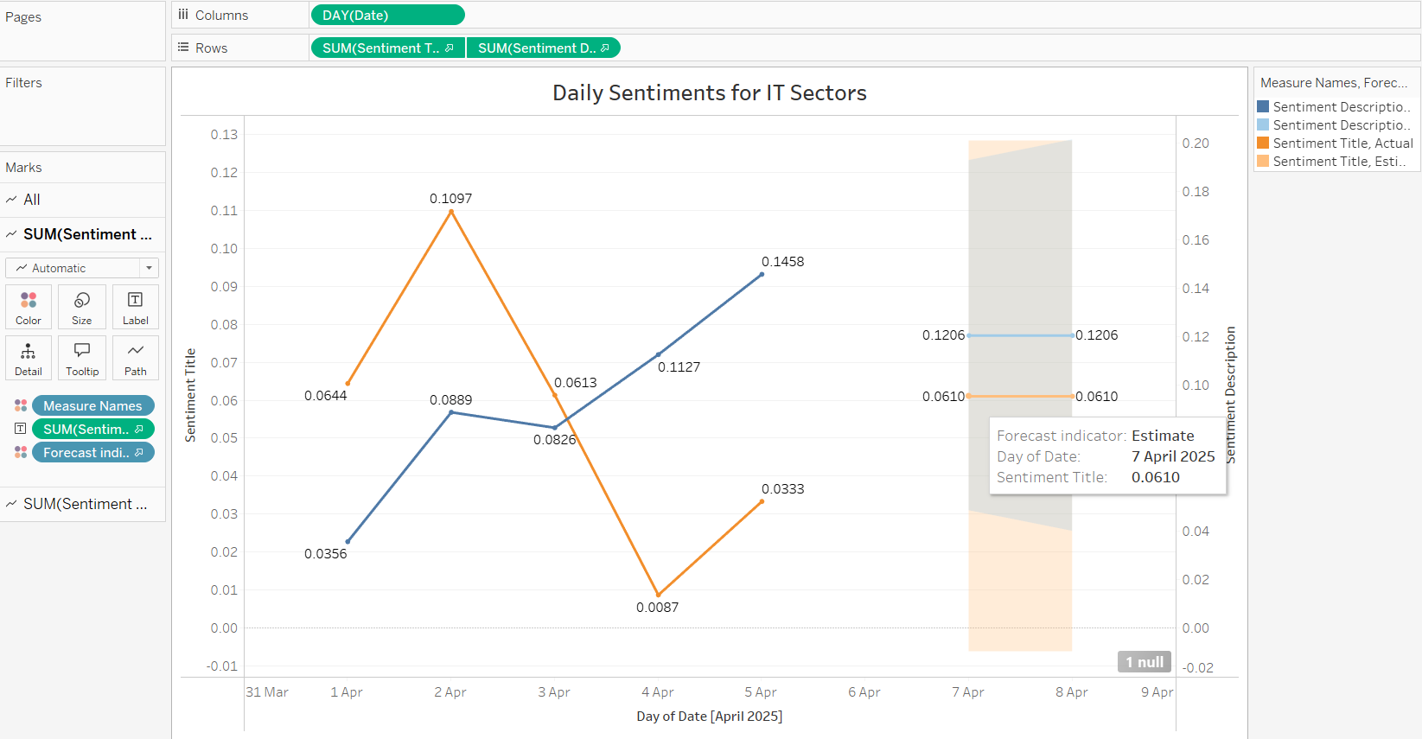

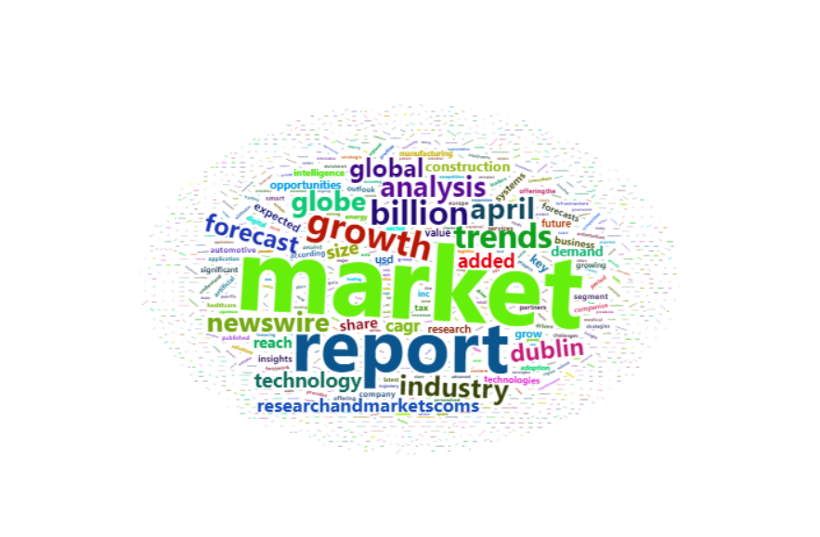

2. Topic Modeling Insights:

- IBM’s prominent themes include "hybrid cloud adoption," "AI innovation technologies," and "digital transformation."

- Broader IT sector topics feature "Microsoft technologies," "generative AI," and "automation."

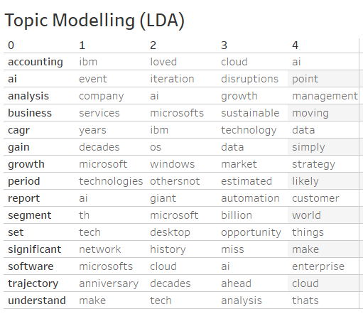

3. Comparative Analysis:

- IBM performs well in sentiment compared to competitors, but lags in attention toward emerging technologies like generative AI.

Github Repo

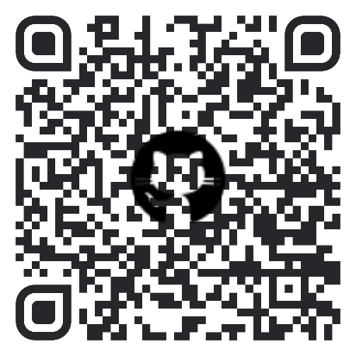

Scan me to get the project files

# Recommendations

1. Expand Investment in Emerging Technologies:

- Allocate resources to develop solutions for cybersecurity and generative AI, where competitors are gaining market presence.

3. Leverage Topic Insights:

- Collaborate with partners to explore opportunities in blockchain and cybersecurity innovations, topics gaining traction in the IT sector.

4. Improve Monitoring Capabilities:

- Use real-time analytics to track sentiment changes and address emerging challenges proactively.

# Further Development

- Visualize sentiment trends over time using tools like Tableau or Seaborn for clearer insights.

- Perform deeper comparisons between IBM's thematic focus and broader IT trends.

- Integrate predictive analytics to forecast sentiment trends and market dynamics.