

PES UNIVERSITY – Python for Computational Problem Solving (UE25CS151A)

Project Report

Jackfruit Mini Project – Maze Runner

Name | SRN
Nikhil Kandur Srinath | PES1UG25EC170
Ninad Pramoda Hebbar | PES1UG25CS342
Patel Arya Ajaykumar | PES1UG25CS361
Praful Kumar CM | PES1UG25CS366

Problem Statement
- To create a game using python.
- Traditional maze games are usually single-player.
- The objective of this project is to design and implement a two-player maze game where each player independently navigates a randomly generated maze and competes to reach the destination first.
- To enrich the competitiveness a scoring system as well as a timer is required to be implemented.
Approach / Data Structures Used
The project is built using Python and the Pygame library for graphical rendering and event handling.
Maze Generation Algorithm: We utilized the Recursive Backtracker algorithm. This ensures that the generated maze is a proper maze which ensures the solvability of the maze.
Data Structures Used:
- List of Dictionaries: A list is used to contain every single cell within the grid of the maze. And each one of these cells are represented by a dictionary containing values like the walls and position.
- Tuples: Used for coordinate pairs (x, y).
- Stack: A stack is used during the maze creation for the purpose of backtracking.
The game runs at 60 frames per second and thus registers keystrokes and applies changes 60 times a second hence allowing a smooth game.

Inputs
The program requires initial input via the console for player names, followed by real-time keyboard input for movement.

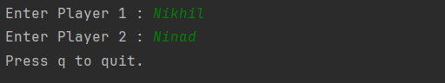
User Inputs
Output
The output is a display consisting of two differnet mazes, a timer, and the current score. Upon completion, the winner is announced on the display and a summary is printed to the console.
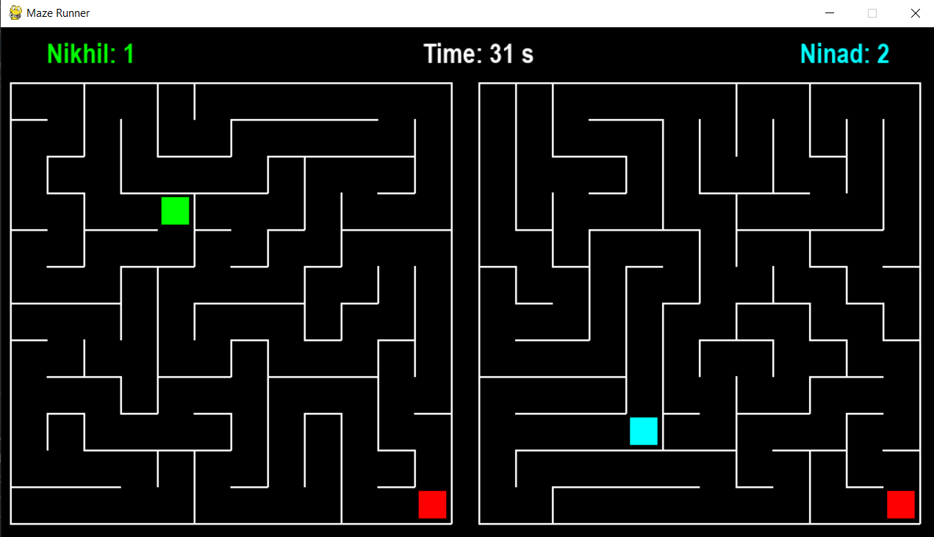
Game GUI
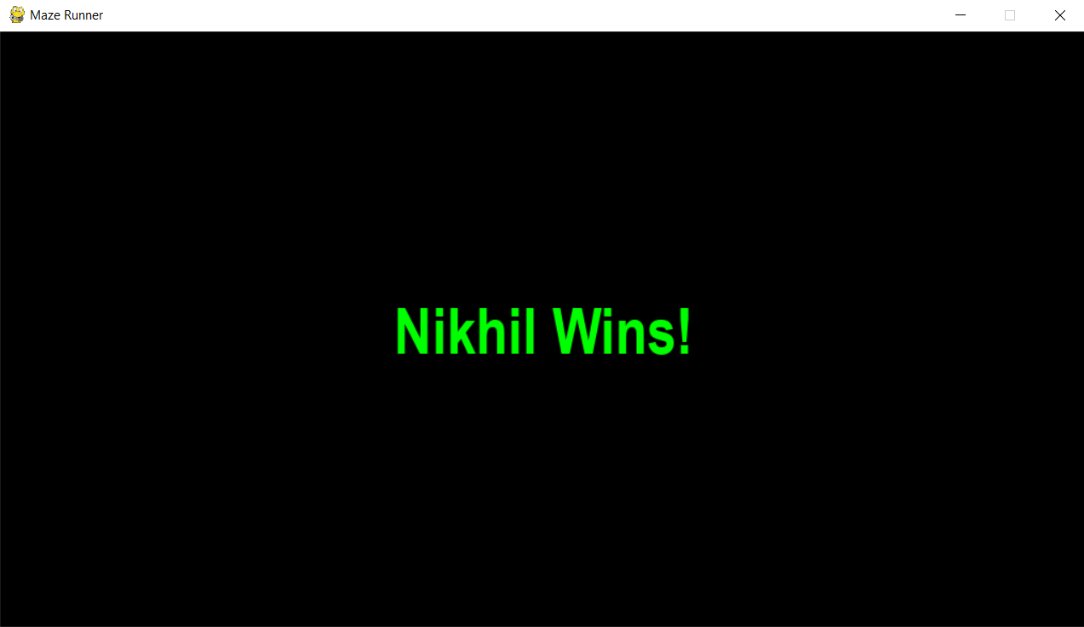
Winner Display
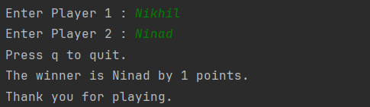
Final Game Output
Challenges Faced
- Maze Generation: Implementing the backtracker algorithm correctly to ensure the creation of a solvable and truly random maze.
- It was difficult to contain the grid of cells into a list as the maze grid is a 2-dimensional structure which needs to be stored in a 1-dimensional list.
Scope for Improvement
- The GUI can be improved with input within the Pygame interface.
- More levels can be added to increase the difficulty by increasing size of the maze.
GitHub Link
https://github.com/Nikhil-Kandur/Maze-Runner

