ASSIGNMENT 2

TASK 1

CODE :

using System;

public class Dt

{

public static string Format(DateTime date, DateTime current)

{

int yeardiff = current.Year - date.Year;

int monthdiff = current.Month - date.Month;

int hoursdiff = current.Hour - date.Hour;

int Daydiff = current.Day - date.Day;

int minutediff = current.Minute - date.Minute;

if (yeardiff>1)

return $" Difference is {yeardiff} years ago";

else if (monthdiff>1)

return $" Difference is {monthdiff} month ago";

else if (Daydiff>1)

return $" Difference is {Daydiff} days ago";

else if (hoursdiff>1)

return $" Difference is {hoursdiff} hour ago";

else

return $" Difference is {minutediff} minute ago";

}

}

class Program

{

static void Main(string[] args)

{

var prevDate = new DateTime(2022,8,19);

var today = DateTime.Now;

string a = Dt.Format(prevDate,today);

Console.WriteLine( a);

Console.ReadKey();

}

}

OUTPUT :

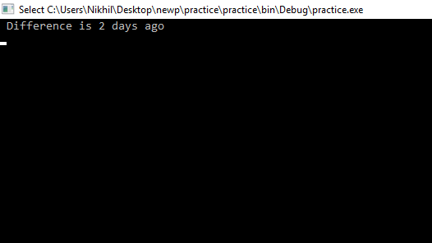

TASK 2

CODE :

using System;

using System.IO;

class ftask2

{

static void Main()

{

string myfile = @"C:\Users\Nikhil\Desktop\cs2\newfile.txt";

string[] _Lines;

int n, i, l, m;

Console.Write("\n\n Read last n number of lines from a file :\n");

if (File.Exists(myfile))

{

File.Delete(myfile);

}

Console.Write(" Input number of lines to write in the file :");

n= Convert.ToInt32(Console.ReadLine());

_Lines=new string[n];

Console.Write(" Input {0} strings below :\n", n);

for (i=0; i<n; i++)

{

Console.Write(" Input line {0} : ", i+1);

_Lines[i] = Console.ReadLine();

}

File.WriteAllLines(myfile, _Lines);

Console.Write("\n Input last how many numbers of lines you want to display :");

l = Convert.ToInt32(Console.ReadLine());

m=l;

if (l>=1 && l<=n)

{

Console.Write("\n The content of the last {0} lines of the file {1} is : \n", l, myfile);

if (File.Exists(myfile))

{

for (i=n-l; i<n; i++)

{

string[] lines = File.ReadAllLines(myfile);

Console.Write(" The last no {0} line is : {1} \n", m, lines[i]);

m--;

}

}

}

else

{

Console.WriteLine(" Line number is not correct..");

}

Console.ReadKey();

}

}

OUTPUT

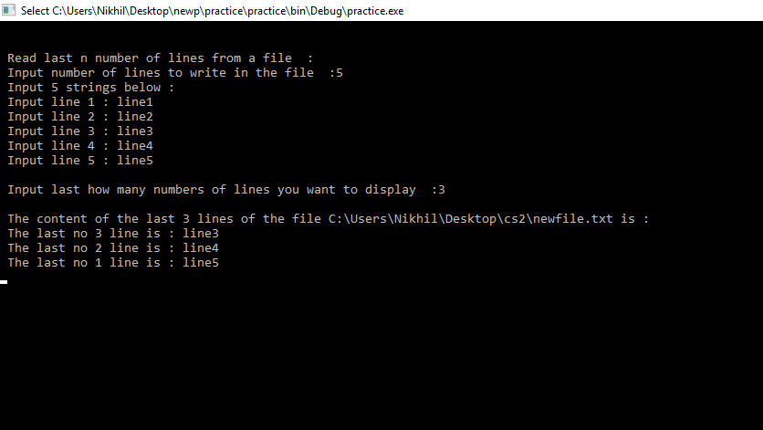

TASK 3

CODE :

using System;

using System.Linq;

namespace task3

{

class Program

{

static void Main(string[] args) {

int[] arr = { 1, 2, 3 , 8 , 4, 6};

Console.Write("Array is : ");

foreach (int i in arr) {

Console.Write(i +" ");

}

Solution s = new Solution();

Console.Write("\nSmallest Postive Integer that is missing in the Array is : {0} ", s.solution(arr));

Console.ReadKey();

}

}

class Solution

{

public int solution(int[] A)

{

if (!A.Contains(1))

{

return 1;

}

int res = A.Max();

foreach (var n in A)

{

if(n>0 && n<=res)

{

if (!A.Contains(n+1))

{

res = n+1;

}

}

}

return res;

}

}

}

OUTPUT :

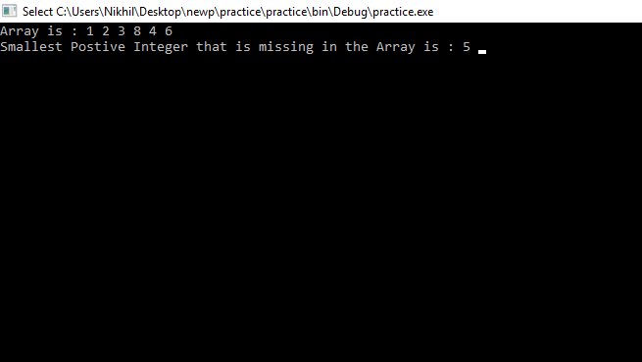

TASK 4

CODE :

using System;

namespace task4

{

class task

{

public static string Solution(int A, int B, int C, int D, int E, int F)

{

int[] d = { A, B, C, D, E, F };

Array.Sort(d);

if (d[4] < 6)

{

if (10 * d[0] + d[1] < 24)

return " Minimum Time Can Be " + d[0] + d[1] + ":" + d[2] + d[3] + ":" + d[4] + d[5];

else

return " Impossible To Make Time From These Digits.. ";

}

else if (d[3] < 6)

{

if (10 * d[0] + d[1] < 24)

return " Minimum Time Can Be " + d[0] + d[1] + ":" + d[2] + d[4] + ":" + d[3] + d[5];

else

return " Impossible To Make Time From These Digits..";

}

else if (d[2] < 6)

{

if (10 * d[0] + d[3] < 24)

return " Minimum Time Can Be " + d[0] + d[3] + ":" + d[1] + d[4] + ":" + d[2] + d[5];

else

return " Impossible To Make Time From These Digits.. ";

}

else

{

return " Impossible To Make Time From These Digits.. ";

}

}

static void Main()

{

Console.WriteLine(" Enter six digits :");

Console.Write("Enter first digit : ");

int a = Convert.ToInt32(Console.ReadLine());

Console.Write("Enter second digit : ");

int b = Convert.ToInt32(Console.ReadLine());

Console.Write("Enter third digit : ");

int c = Convert.ToInt32(Console.ReadLine());

Console.Write("Enter fourth digit : ");

int d = Convert.ToInt32(Console.ReadLine());

Console.Write("Enter fifth digit : ");

int e = Convert.ToInt32(Console.ReadLine());

Console.Write("Enter sixth digit : ");

int f = Convert.ToInt32(Console.ReadLine());

Console.WriteLine(Solution(a, b, c, d, e, f));

Console.ReadKey();

}

}

}

OUTPUT :

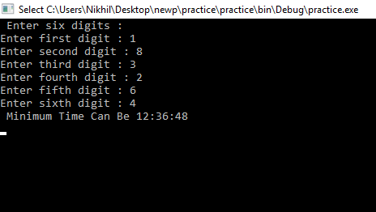

TASK 5

CODE :

using System;

namespace task5

{

class Program

{

static void Main(string[] args)

{

int temp;

Console.Write("Enter the string : ");

string s = Console.ReadLine();

string[] a = s.Split(' ');

int k = a.Length - 1;

temp = k;

for (int i = temp; i >= 0; i--)

{

Console.Write(a[i] + " " );

}

Console.ReadKey();

}

}

}

OUTPUT :

