Assignment 1

Task1

Code:

using System;

public class Task {

public static void Main()

{

Console.WriteLine("Enter letter: ");

char char1 = Convert.ToChar(Console.ReadLine());

Console.WriteLine("Enter letter: ");

char char2 = Convert.ToChar(Console.ReadLine());

Console.WriteLine("Enter letter: ");

char char3 = Convert.ToChar(Console.ReadLine());

Console.WriteLine("===== OUTPUT =====");

Console.WriteLine("{0} {1} {2}", char3, char2, char1);

Console.ReadKey();

}

}

Output

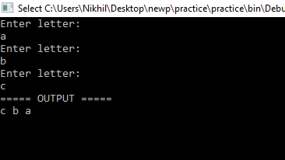

TASK 2

Code :

using System;

public class Task2

{

public static void Main()

{

Console.Write("Enter a number: ");

int _number = Convert.ToInt32(Console.ReadLine());

Console.Write("Enter the desired width: ");

int width = Convert.ToInt32(Console.ReadLine());

int height = width;

for (int r = 0; r < height; r++)

{

for (int c = 0; c < width; c++)

{

Console.Write(_number);

}

Console.WriteLine();

width--;

}

Console.ReadKey();

}

}

OUTPUT

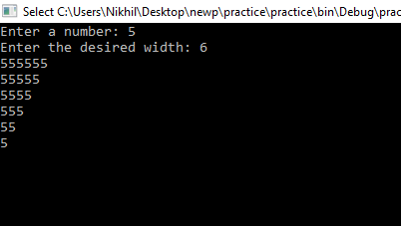

TASK 3

CODE:

using System;

using System.Collections;

public class Task3

{

public static void Main()

{

string username, password;

int ctr = 0, dd = 0;

Console.Write("\n\n Check your username and password :\n");

Console.Write("---------------------------------\n");

Hashtable ht = new Hashtable();

ht.Add("Nikhil", "Nikhil123");

ht.Add("Manish", "Manish123");

ht.Add("Neeraj", "Neeraj123");

ht.Add("Vikas", "Vikas123");

ht.Add("Vishesh", "Vishesh123");

do

{

Console.Write("Enter your username : ");

username = Console.ReadLine();

Console.Write("Enter your password : ");

password = Console.ReadLine();

if (ht.ContainsKey(username) && ht.ContainsValue(password))

{

dd=1;

ctr=3;

}

else

{

dd=0;

ctr++;

}

}

while(ctr!=3 &&

(!ht.ContainsKey(username) || !ht.ContainsValue(password)));

if (dd == 0)

{

Console.Write("\n Login attempt more than three times, Login Failed.. Try later! \n\n");

}

else

if (dd==1)

{

Console.Write("\n Logged In Succesfully.......\n\n");

}

Console.ReadKey();

}

}

OUTPUT :

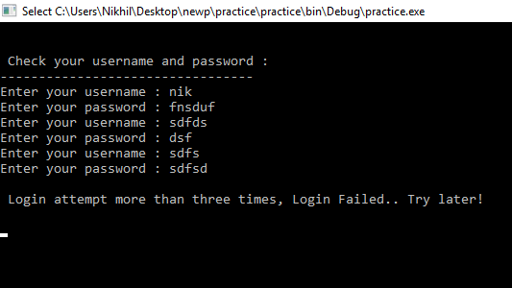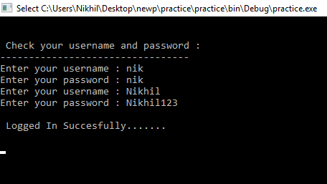

TASK4

using System;

public class Task4

{

public static void Main()

{

int FirstNumber,SecondNumber;

char operation;

string Recur;

do

{

Console.Write("Input first number : ");

FirstNumber = Convert.ToInt32(Console.ReadLine());

Console.WriteLine("Operations Available are {+,-,*,/}");

Console.Write("Input operation : ");

operation = Convert.ToChar(Console.ReadLine());

Console.Write("Input second number: ");

SecondNumber = Convert.ToInt32(Console.ReadLine());

Console.WriteLine("\n\nxxxxxxxxxx OUTPUT xxxxxxxxxxxxxxx");

if (operation=='+')

Console.WriteLine("{0} + {1} = {2} \n", FirstNumber, SecondNumber, FirstNumber+SecondNumber);

else if (operation=='-')

Console.WriteLine("{0} - {1} = {2} \n", FirstNumber, SecondNumber, FirstNumber-SecondNumber);

else if ((operation=='x') || (operation=='*'))

Console.WriteLine("{0} * {1} = {2} \n", FirstNumber, SecondNumber, FirstNumber*SecondNumber);

else if (operation=='/')

Console.WriteLine("{0} / {1} = {2} \n", FirstNumber, SecondNumber, FirstNumber/SecondNumber);

else

Console.WriteLine(" You Entered the Wrong Character ");

Console.WriteLine("Perform Operation Again : Press Y if yes Or Press N if not...Y/N : ");

Recur=Console.ReadLine();

}

while ( Recur == "Y" || Recur == "y" );

Console.ReadKey();

}

}

OUTPUT :

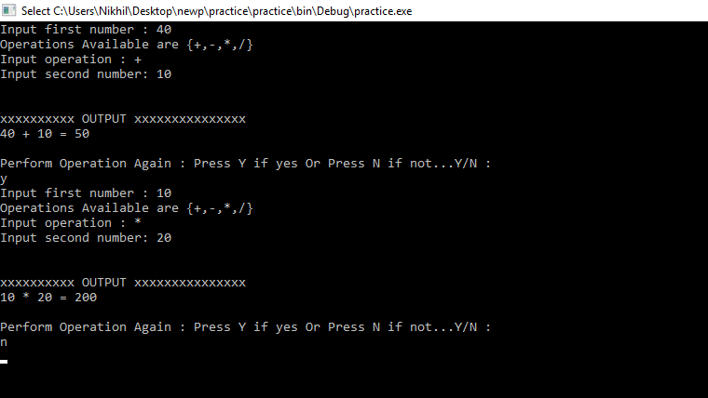

TASK 5 :

CODE :

using System;

public class Task5

{

public static void Main()

{

double r, pr;

double Pi = 3.14;

Console.WriteLine("xxxxxxxxxxxxxxx Perimeter of Circle xxxxxxxxxxxxxxx");

Console.WriteLine("Enter the radius of the circle : ");

r = Convert.ToDouble(Console.ReadLine());

pr = 2*Pi*r;

Console.WriteLine("Perimeter of Circle : {0}", pr);

Console.Read();

}

}

OUTPUT :

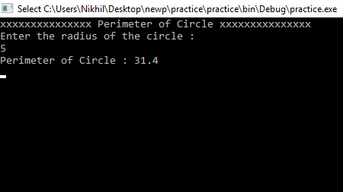

TASK 6 :

CODE :

using System;

public class Task6

{

public static void Main()

{

float distance;

float hour, min, sec;

float timeSec;

float mps;

float kph, mph;

Console.Write("Enter distance(metres) : ");

distance = Convert.ToSingle(Console.ReadLine());

Console.Write("Enter timeSec(hour) : ");

hour = Convert.ToSingle(Console.ReadLine());

Console.Write("Enter timeSec(minutes) : ");

min = Convert.ToSingle(Console.ReadLine());

Console.Write("Enter timeSec(seconds) : ");

sec = Convert.ToSingle(Console.ReadLine());

timeSec = (hour*3600) + (min*60) + sec;

mps = distance/timeSec;

kph = (distance/1000.0f)/(timeSec/3600.0f);

mph = kph / 1.609f;

Console.WriteLine("Your speed in metres/sec is {0}", mps);

Console.WriteLine("Your speed in km/h is {0}", kph);

Console.WriteLine("Your speed in miles/h is {0}", mph);

Console.ReadKey();

}

}

OUTPUT :

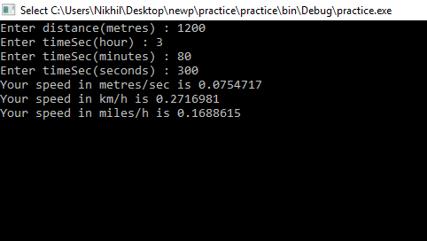

TASK 7

CODE :

using System;

public class Task7

{

public static void Main()

{

char s;

string i;

do

{

Console.Write("Enter a symbol: ");

s=Convert.ToChar(Console.ReadLine());

if ((s == 'a') || (s == 'e') || (s == 'i') ||

(s == 'o') || (s == 'u'))

Console.WriteLine("It is a lowercase vowel.");

else if ((s >= '0') && (s <= '9'))

Console.WriteLine("Character You enter is a digit.");

else

Console.Write("You Enter a another symbol.");

Console.Write("Do you Want to Enter another symbol. Press Y if yes OR N if No...Y/N.. ");

i=Console.ReadLine();

}

while (i=="Y" || i=="y");

Console.ReadKey();

}

}

OUTPUT :

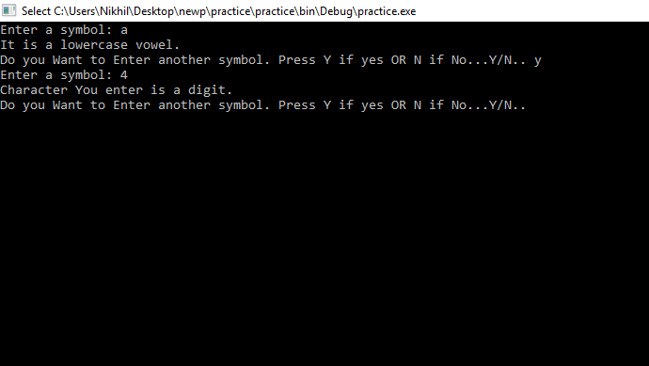

TASK 8

CODE :

using System;

public class Task8

{

public static void Main()

{

int firstnumber, secondnumber;

bool eq;

Console.Write("Input First number: ");

firstnumber = Convert.ToInt32(Console.ReadLine());

Console.Write("Input Second number: ");

secondnumber = Convert.ToInt32(Console.ReadLine());

eq = ((firstnumber % 2 == 0)

&& (secondnumber % 2 ==0)) ? true : false;

Console.WriteLine(eq ?

" Both numbers are Even" :

" Odd Number is there ");

Console.ReadKey();

}

}

OUTPUT :

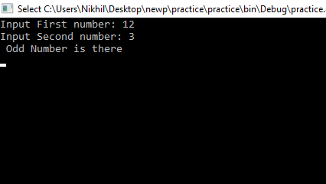

TASK 9

CODE :

using System;

public class Task9

{

public static void Main()

{

string result;

Console.Write("Input a Number : ");

int number = Convert.ToInt32(Console.ReadLine());

result = "";

while (number > 1)

{

int remainder = number % 2;

result = Convert.ToString(remainder) + result;

number /= 2;

}

result = Convert.ToString(number) + result;

Console.WriteLine("Binary : {1}",number, result);

Console.ReadKey();

}

}

OUTPUT

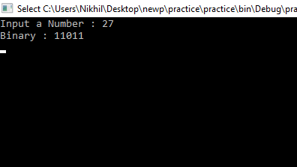

TASK 10

CODE :

using System;

namespace task10

{

class Program

{

static void Main(string[] args)

{

Console.WriteLine("xxxxxxxxxxxxxxxx Output xxxxxxxxxxxxxxxx ");

Console.WriteLine(Abs(53));

Console.WriteLine(Abs(30));

Console.WriteLine(Abs(51));

Console.ReadKey();

}

public static int Abs(int n)

{

const int x = 51;

if (n > x)

{

return (n - x)*3;

}

return x - n;

}

}

}

OUTPUT :

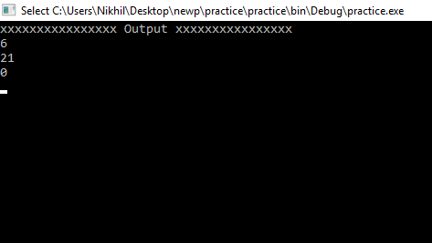

TASK 11

CODE :

using System;

namespace task11

{

class Program

{

static void Main(string[] args)

{

string a;

Console.Write("Enter the String : ");

a = Console.ReadLine();

Console.Write("Enter the Position : ");

int b= Convert.ToInt32(Console.ReadLine());

Console.WriteLine("xxxxxxxxxx Output After Removing the character xxxxxxxxxx");

if (b<a.Length)

{

Console.WriteLine(Rem(a, b));

}

else

{

Console.WriteLine("Enter the value of position Correctly ");

}

Console.ReadLine();

}

public static string Rem(string str, int n)

{

return str.Remove(n, 1);

}

}

}

OUTPUT :

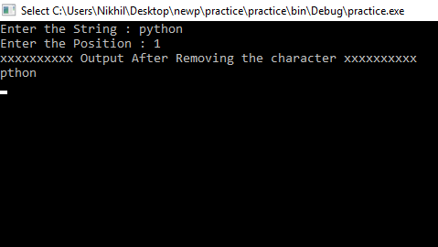

TASK 12

CODE :

using System;

namespace task12

{

class Program

{

static void Main(string[] args)

{

Console.WriteLine("xxxxxxxxxxxxxxx OUTPUT xxxxxxxxxxxxxxx ");

Console.WriteLine(St("abcd"));

Console.WriteLine(St("a"));

Console.WriteLine(St("xy"));

Console.ReadLine();

}

public static string St(string str)

{

return str.Length > 1

? str.Substring(str.Length - 1) + str.Substring(1, str.Length - 2) + str.Substring(0, 1) : str;

}

}

}

OUTPUT

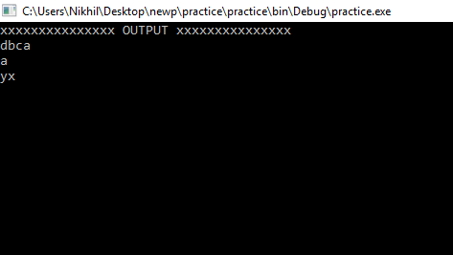

TASK 13

CODE :

using System;

namespace task13

{

class Program

{

static void Main(string[] args)

{

int[] arr = test(new[] { 10, 20, 30 }, new[] { 40, 50, 60 });

Console.WriteLine( " Array1 : 10,20,30 " );

Console.WriteLine(" Array2 : 40,50,60 ");

Console.Write("New array formed from previous arrays : ");

foreach (var i in arr)

{

Console.Write(i.ToString()+" ");

}

Console.ReadKey();

}

public static int[] test(int[] arr1, int[] arr2)

{

return new int[] { arr1[0], arr1[1], arr1[2], arr2[0], arr2[1], arr2[2] };

}

}

}OUTPUT :

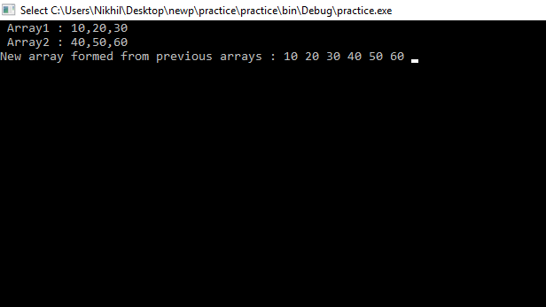

TASK 14

CODE :

using System;

namespace task14

{

class Program

{

static void Main(string[] args)

{

Console.WriteLine("Enter the Length of string, You want to find in the array of strings : ");

int a = Convert.ToInt32(Console.ReadLine());

Console.WriteLine("Number of Strings: ");

Console.WriteLine(test(new[] { "a", "b", "bb", "c", "ccc" }, a));

Console.ReadKey();

}

static int test(string[] st, int l)

{

int counter = 0;

for (int i = 0; i < st.Length; i++)

{

if (st[i].Length == l) counter++;

}

return counter;

}

}

}

OUTPUT

CODE:

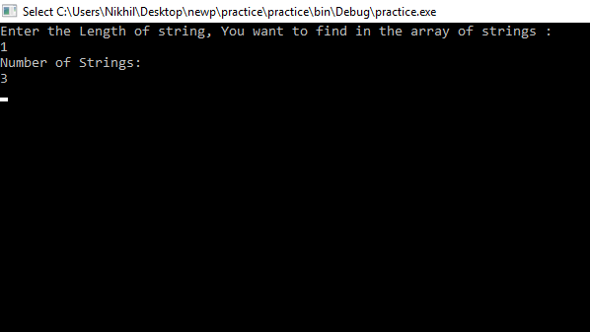

TASK 15

CODE :

using System;

namespace task15

{

class Program

{

static void Main(string[] args)

{

Console.Write ("Enter the value : ");

int value = Convert.ToInt32(Console.ReadLine());

for (int power = 0; power <= 32; power++)

{

Console.WriteLine($"{value}^{power} = {(long)Math.Pow(value, power):N0} (0x{(long)Math.Pow(value, power):X})");

}

Console.ReadKey();

}

}

}

OUTPUT :

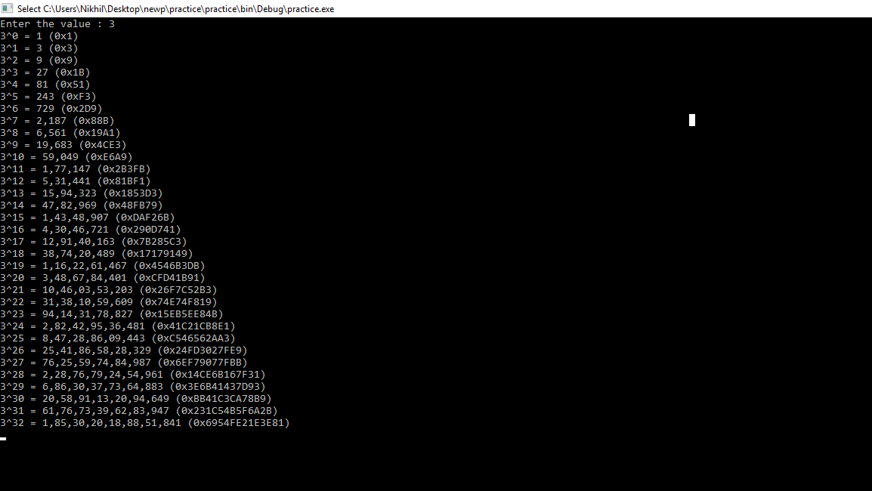

TASK 16

CODE :

using System;

using System.Text;

namespace task16

{

class Program

{

static void Main(string[] args)

{

int n;

string a;

do

{

Console.Write(" Enter the Number : ");

n = Convert.ToInt32(Console.ReadLine());

Console.WriteLine("Original integer value: " + n);

Console.WriteLine("Roman numerals of the said integer value : ");

Console.WriteLine(IntRoman(n));

Console.Write("Do you Want to Perform the function Again .... Y/N : ");

a =Console.ReadLine();

}

while (a=="y" || a=="Y");

Console.ReadKey();

}

public static string IntRoman(int n)

{

string[] roman_symbol = { "MMM", "MM", "M", "CM", "DCCC", "DCC", "DC", "D", "CD", "CCC", "CC", "C", "XC", "LXXX", "LXX", "LX", "L", "XL", "XXX", "XX", "X", "IX", "VIII", "VII", "VI", "V", "IV", "III", "II", "I" };

int[] int_value = { 3000, 2000, 1000, 900, 800, 700, 600, 500, 400, 300, 200, 100, 90, 80, 70, 60, 50, 40, 30, 20, 10, 9, 8, 7, 6, 5, 4, 3, 2, 1 };

var roman_num = new StringBuilder();

var index_num = 0;

while (n != 0)

{

if (n >= int_value[index_num])

{

n -= int_value[index_num];

roman_num.Append(roman_symbol[index_num]);

}

else

{

index_num++;

}

}

return roman_num.ToString();

}

}

}

OUTPUT

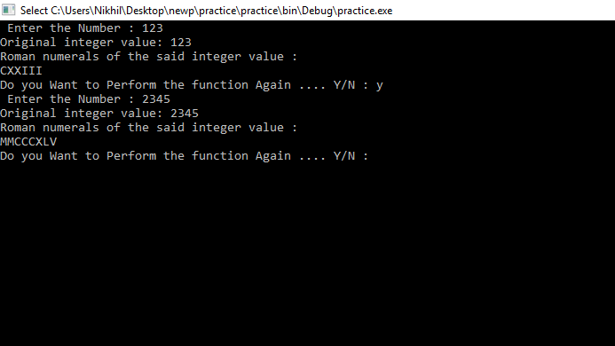

TASK 17

using System;

class Task

{

static void Main(string[] args)

{

Console.Write(" How many numbers to sum : ");

int n = Convert.ToInt32(Console.ReadLine());

Console.Write(" The sum of first {0} natural numbers is : {1}\n\n", n, Rec(1, n));

Console.ReadKey();

}

static int Rec(int m, int n)

{

if (n == m)

return n;

return n + Rec(m, n - 1);

}

}

OUTPUT :

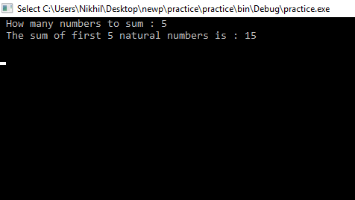

TASK 18

CODE :

using System;

public class task18

{

static void Main()

{

Console.Write(" Enter any number : ");

int number = Convert.ToInt32(Console.ReadLine());

Console.Write(" The digits in the number {0} are : ", number);

Individual(number);

Console.ReadKey();

}

static void Individual(int n)

{

if (n < 10)

{

Console.Write("{0} ", n);

return;

}

Individual(n / 10);

Console.Write(" {0} ", n % 10);

}

}

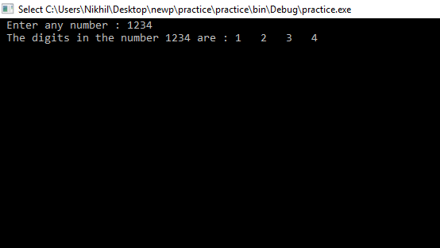

TASK 19

CODE :

using System;

using System.Linq;

using System.Collections.Generic;

class TAsk19

{

static void Main(string[] args)

{

var arr1 = new[] { 4, 9, 7, 8, 6, 5,3 };

Console.Write("\n Find the number and its square of an array using LINQ : ");

Console.Write("\nxxxxxxxxxxxxxxxxxxxxxxxxxxxxxxxxxxxxxxxxxxxxxxxxxxxxxxxxxxxx\n");

var sqNo = from int Number in arr1

let SqrNo = Number * Number

select new { Number, SqrNo };

foreach (var a in sqNo)

Console.WriteLine(a);

Console.ReadLine();

}

}OUTPUT

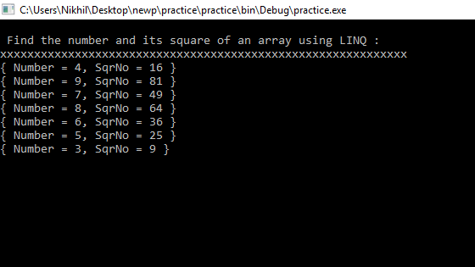

TASK 20

CODE :

using System;

using System.Linq;

using System.Collections;

class task20

{

static void Main(string[] args)

{

string str;

Console.Write("Input the string : ");

str= Console.ReadLine();

var FreQ = from i in str

group i by i into i

select i;

Console.Write("The frequency of the characters are :\n");

foreach (var item in FreQ)

{

Console.WriteLine("Character "+item.Key + ": " + item.Count()+" times");

}

Console.ReadKey();

}

}

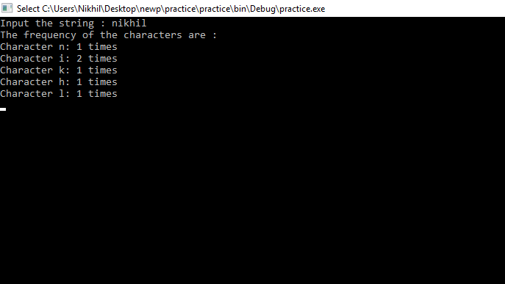

TASK 21

CODE :

using System;

using System.Collections.Generic;

using System.Linq;

using System.Text;

class task21

{

static void Main(string[] args)

{

string start, end;

char c;

string[] cities =

{

"ROME","LONDON","NAIROBI","CALIFORNIA","ZURICH","NEW DELHI","AMSTERDAM","ABU DHABI", "PARIS"

};

Console.Write("\nThe cities are : 'ROME','LONDON','NAIROBI','CALIFORNIA','ZURICH','NEW DELHI','AMSTERDAM','ABU DHABI','PARIS' \n");

Console.Write("\n Input starting character for the string : ");

c = Convert.ToChar(Console.ReadLine());

start=c.ToString().ToUpper();

Console.Write("\n Input ending character for the string : ");

c = Convert.ToChar(Console.ReadLine());

end=c.ToString().ToUpper();

var y = from x in cities

where x.StartsWith(start)

where x.EndsWith(end)

select x;

foreach (var item in y)

{

Console.Write("The city starting with {0} and ending with {1} is : {2} \n", start , end, item);

}

Console.ReadLine();

}

}

OUTPUT :

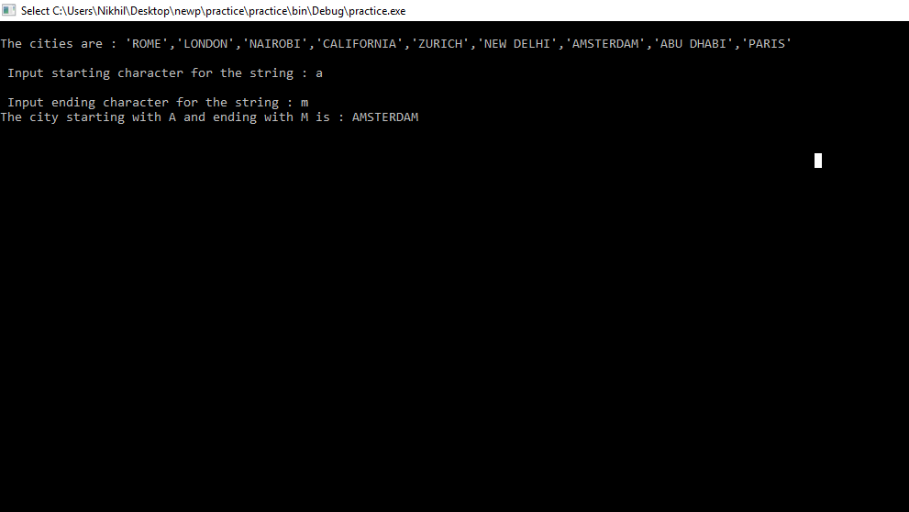

TASK 22

CODE :

using System;

using System.Collections.Generic;

using System.Linq;

using System.Text;

class Task

{

static void Main(string[] args)

{

List<int> mylist = new List<int>();

mylist.Add(5);

mylist.Add(7);

mylist.Add(13);

mylist.Add(24);

mylist.Add(6);

mylist.Add(9);

;

Console.WriteLine("\n The list Contain : ");

foreach (var lstnum in mylist)

{

Console.WriteLine(lstnum);

}

Console.Write("How many records you want to display ? : ");

int n = Convert.ToInt32(Console.ReadLine());

mylist.Sort();

mylist.Reverse();

Console.Write("The top {0} records from the list are : \n", n);

foreach (int topn in mylist.Take(n))

{

Console.WriteLine(topn);

}

Console.ReadKey();

}

}

OUTPUT :

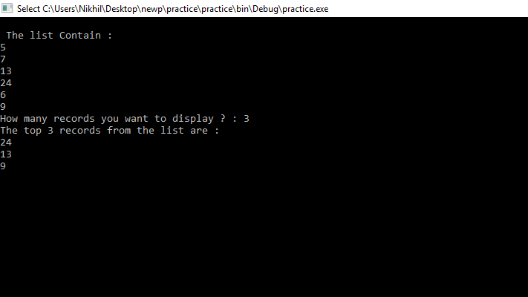

TASK 23

CODE :

using System;

using System.Collections.Generic;

using System.Linq;

using System.Text;

using System.IO;

class task23

{

public static void Main()

{

string[] arr1 = { "aaa.frx", "bbb.TXT", "xyz.dbf", "abc.pdf", "aaaa.PDF", "xyz.frt", "abc.xml", "ccc.txt", "zzz.txt" };

Console.Write("\nThe files are : aaa.frx, bbb.Txt, xyz.dbf,abc.pdf");

Console.Write("\n aaaa.PDF,xyz.frt, abc.xml, ccc.txt, zzz.txt\n");

Console.Write("\n Here is the group of extension of the files : \n\n");

var separate= arr1.Select(file => Path.GetExtension(file).TrimStart('.').ToLower())

.GroupBy(z => z, (ex, c) => new

{

Extension = ex,

Count = c.Count()

});

foreach (var m in separate)

Console.WriteLine("{0} File(s) with {1} Extension ", m.Count, m.Extension);

Console.ReadLine();

}

}

OUTPUT :

