DATA 266 Laboratory 1 Report
LLM, Sentiment Classification, and CycleGAN
Team Pair: 42
Repository: llm-sentiment-cyclegan-lab
Submitted work documented: Anushka Rajesh Khadatkar (Member A) and Nikhil Khaneja (Member B)
Partner: Nikhil Khaneja — Member B sections included (Tasks 1–3)
Date: October 2026
This report follows the DATA 266 Lab 1 requirements and records the reproducible evidence currently present in the shared Git repository. Results are reported only where artifacts exist; pending human review, Kaggle ranking, and the partner’s implementation are explicitly marked pending.

Repository and evidence index
Repository link: https://github.com/Nikhil-Khaneja/llm-sentiment-cyclegan-lab
Evidence | Location
Task 1 notebook/config/results | Anushka: task1_llm/member_anushka/ | Nikhil: task1_llm/member_nikhil/
Task 2 notebook/config/results | Anushka: task2_sentiment/member_anushka/ | Nikhil: task2_sentiment/member_nikhil/
Task 3 notebook/config/results/submission | Anushka: task3_gan/member_anushka/ | Nikhil: task3_gan/member_nikhil/
Reproducibility manifests | reproducibility/manifests/ (Anushka: task*_anushka_*) | reproducibility/manifests/nikhil/
Raw logs | reproducibility/raw_logs/ (Anushka: task*_anushka/) | reproducibility/raw_logs/nikhil/
Combined report destination | report/ (this document can be added here)

Executive summary
Anushka’s repository contribution contains independently runnable implementations for all three lab tasks. The LLM is a 10.93M-parameter character Transformer trained on TinyStories. The sentiment study compares a baseline, CNN, and BiGRU; the BiGRU is the strongest classifier on the recorded test set. The CycleGAN uses a ResNet generator and PatchGAN discriminator pair, with both quantitative translation metrics and checkpoint visualizations recorded. Nikhil’s contribution is intentionally not scored in this report because the requested partner artifacts were not supplied.
Nikhil’s Member B contribution covers the same three tasks with deliberately different designs: a 1.65M-parameter 2-block × 8-head character Transformer (validation perplexity 2.326), a last-token baseline, a k=7 CNN and a BiLSTM with attention pooling for Yelp (BiLSTM-attention test accuracy 0.9538), and a 9-block × 32-channel CycleGAN trained at 128×128 (course-script FID 108.03, MiFID 0.413). All Nikhil runs used an NVIDIA GeForce RTX 5090.

1. Task 1 — character language model
Objective: train a compact causal language model and evaluate optimization, language-model quality, generation diversity, stability, and efficiency.

Anushka — Task 1 implementation and results
Summary: Anushka implemented and executed a character-level causal Transformer on TinyStories. The run reached low validation cross-entropy with a modest train–validation gap, maintained numerical stability, and produced reproducible language-model quality, diversity, and efficiency measurements. The evidence includes the executed notebook, configuration, checkpoint/output artifacts, training curves, manifest, requirements, and raw log.

Area | Anushka’s recorded evidence
Implementation | Character tokenizer; token/position embeddings; six pre-LN Transformer blocks; six attention heads; final language-model head
Data and split | TinyStories stream; 100,000 train and 10,000 validation windows; sequence length 512; vocabulary 107
Optimization | AdamW; warmup 800; cosine decay; gradient clipping 1.0; bf16; seed 3963; 20 epochs
Evaluation focus | Cross-entropy, perplexity, BPC, accuracy, diversity, repetition, gradient stability, throughput, memory, and elapsed time
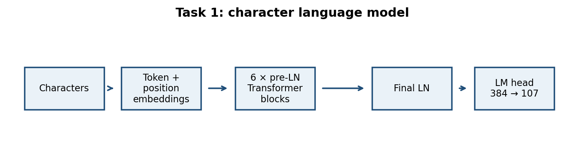
Figure 1. Task 1 architecture reconstructed from the configuration and results documentation.
- Data: streamed TinyStories; 100,000 training windows and 10,000 validation windows, each 512 characters; character vocabulary size 107.
- Model: token and position embeddings, six pre-LN Transformer blocks, six attention heads, d_model 384, feed-forward width 1536, dropout 0.15, and a 384→107 language-model head.
- Optimization: AdamW, warmup 800 steps, cosine decay, gradient clipping at 1.0, bf16, seed 3963, 20 epochs.
Metric | Recorded value
Parameters | 10,926,443
Train / validation CE | 0.5252 / 0.5651
Train / validation perplexity | 1.691 / 1.760
Train / validation BPC | 0.758 / 0.815
Validation top-1 accuracy | 82.01%
Train–validation CE gap | 0.0399
Distinct-1 / 2 / 3 | 0.107 / 0.489 / 0.778
Repeated 4-gram rate | 0.102
Mean / max gradient norm | 0.201 / 2.26
Non-finite steps | 0
Training throughput | 399K tokens/s
Peak memory / total time | 14,805 MB / 2,572.7 s
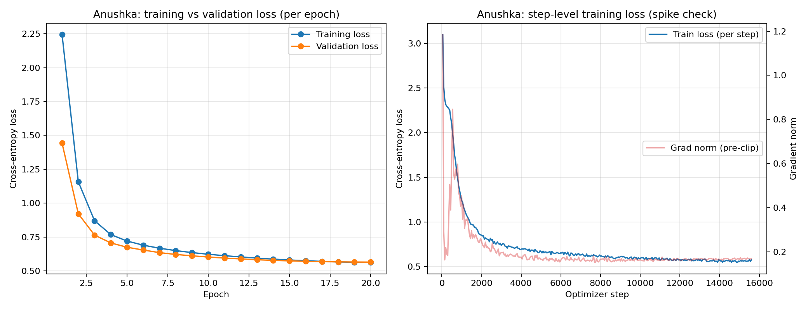
Figure 2. Task 1 training and validation loss curve from the repository output.

Task 1 interpretation and failure analysis
- The small CE gap and zero non-finite steps indicate stable optimization with moderate generalization separation.
- Generation review identified repetition/circular actions, entity or coherence confusion, and spelling/grammar degradation at high temperature.
- The repeated 4-gram rate is a useful warning signal: generations are not uniformly diverse even though distinct-n scores increase with n-gram length.
- Reproduction evidence includes the notebook, configuration, checkpoint/output files, manifest, requirements, and raw log under the repository paths listed above.

Nikhil — Task 1 implementation and results
Summary: Nikhil implemented and executed a compact character-level causal Transformer on TinyStories using the Member B design (2 blocks, 8 attention heads) on the shared 100,000 / 10,000 sequence split. The 12-epoch run completed in 211 s with no non-finite steps and no loss spikes; the best epoch was the last one.
Area | Nikhil’s recorded evidence
Implementation | Hand-written causal multi-head self-attention (no prebuilt attention modules); character vocabulary of 80; token and position embeddings; pre-LN blocks; 256→80 language-model head
Data and split | TinyStories, 208,918 stories; story-level validation hold-out; 100,000 train and 10,000 validation windows of 128 characters
Optimization | AdamW, lr 2.5e-4, cosine decay to 1e-5, 500 warm-up steps, gradient clipping 1.0, batch 64, 12 epochs, seed 1337
Evaluation focus | Cross-entropy, perplexity, bits per character, next-character accuracy, distinct-n and repeated 4-gram rate at temperature 0.9 and greedy, gradient norms, stability, throughput, memory
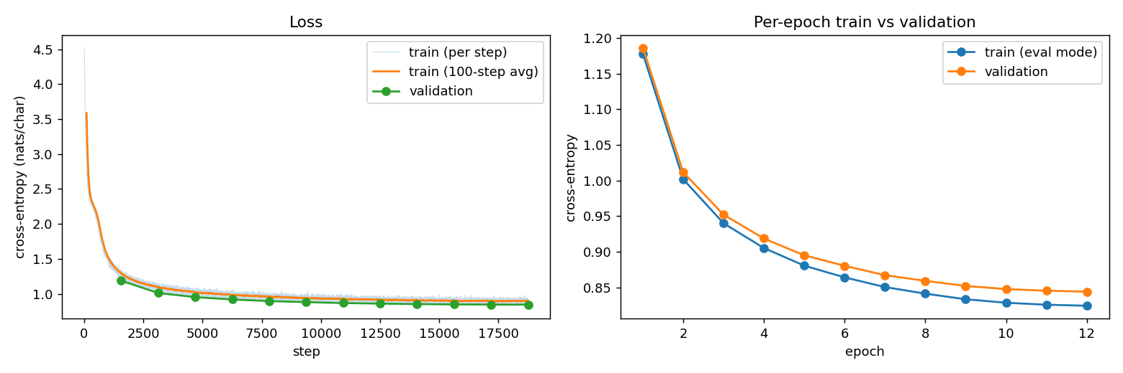
Figure 10. Task 1 (Nikhil) training and validation loss curves from the repository output.
- Data: TinyStories; 100,000 training windows and 10,000 validation windows, each 128 characters; character vocabulary size 80.
- Model: token and position embeddings, two pre-LN Transformer blocks, eight attention heads, d_model 256, feed-forward width 1024, dropout 0.10, and a 256→80 language-model head.
- Optimization: AdamW, warm-up 500 steps, cosine decay, gradient clipping at 1.0, batch size 64, seed 1337, 12 epochs, generation temperature 0.9.
Metric | Recorded value
Parameters | 1,653,840
Train / validation CE | 0.8242 / 0.8440
Validation perplexity | 2.326
Validation BPC | 1.218
Train / validation top-1 accuracy | 73.69% / 73.20%
Train–validation CE gap | 0.0198
Distinct-1 / 2 / 3 (temperature 0.9) | 0.313 / 0.771 / 0.921
Repeated 4-gram rate (temperature 0.9 / greedy) | 0.000 / 0.260
Mean / max gradient norm | 0.757 / 6.71
Non-finite steps / loss spikes | 0 / 0
Training throughput | 759K tokens/s
Training time / peak accelerator memory | 211 s / 541 MB

Nikhil — Task 1 interpretation and failure analysis
- [To be written by Nikhil: interpretation of the validation gap, generation review and failure cases, and comparison with Anushka’s larger model.]
- Reproduction evidence: notebook task1_llm/member_nikhil/src/task1_gpt_nikhil.ipynb, config gpt_nikhil_B.yaml, best/last checkpoints, manifest and raw log under reproducibility/manifests/nikhil/ and reproducibility/raw_logs/nikhil/.

2. Task 2 — Yelp sentiment classification
Objective: compare three sentiment architectures under a common data split and report predictive quality, calibration/uncertainty, robustness, error review, and efficiency.

Anushka — Task 2 implementation and results
Summary: Anushka trained and evaluated three sentiment classifiers under the same balanced Yelp split: a mean-pooling baseline, a convolutional model, and a bidirectional GRU. The BiGRU achieved the strongest recorded accuracy, macro-F1, ROC-AUC, PR-AUC, and MCC, while the slice analysis identified long reviews as the principal robustness weakness. Calibration, confidence intervals, paired-model testing, throughput, memory, and the required 20-row error-review artifact are included in the repository evidence.
Area | Anushka’s recorded evidence
Data pipeline | 504K train, 56K validation, 38K test; balanced labels; 30K vocabulary; maximum length 200
Model comparison | Baseline mean pooling; CNN with 3/4/5-gram filters; bidirectional GRU
Evaluation focus | Accuracy; macro/micro/weighted precision, recall, and F1; ROC-AUC; PR-AUC; MCC; Brier; ECE; bootstrap intervals
Robustness and review | McNemar comparisons; review-length slices; 20 selected error cases across four required categories; manual annotations pending
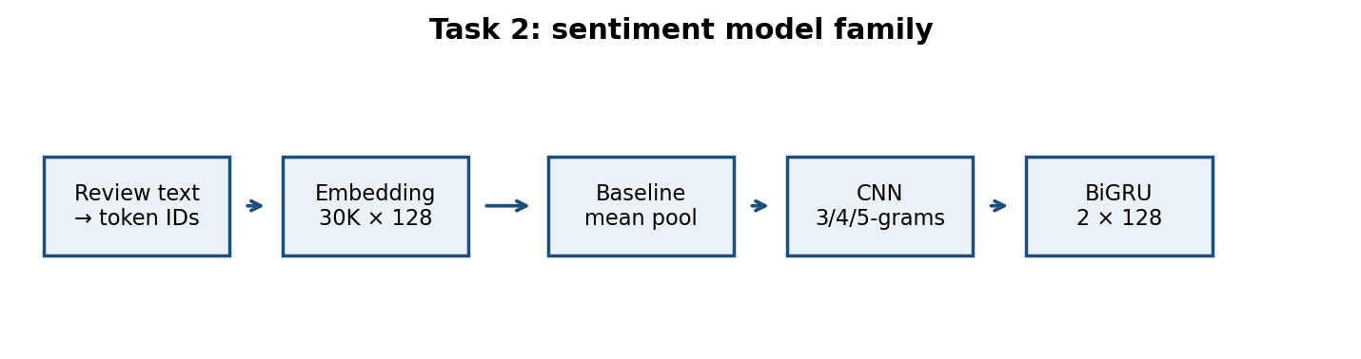
Figure 3. Task 2 model-family architecture.
- Data split: 504K training, 56K validation, and 38K test examples; balanced labels. Vocabulary size 30K; maximum sequence length 200; batch size 64; 10 epochs; seed 3963; NVIDIA Tesla T4.
- Models: mean-pooling baseline, CNN with 3/4/5-gram filters, and bidirectional GRU.

Model | Accuracy | Macro-F1 | ROC-AUC | PR-AUC | MCC | Train s | Peak MB
Baseline | 0.9350 | 0.9350 | 0.9813 | 0.9812 | 0.8701 | 465.6 | 90.8
CNN | 0.9426 | 0.9426 | 0.9856 | 0.9846 | 0.8851 | 888.6 | 198.6
BiGRU | 0.9476 | 0.9476 | 0.9865 | 0.9862 | 0.8953 | 843.4 | 355.4
Model | Precision macro / weighted | Recall macro / weighted | Brier / ECE | Params | Test eps | Accuracy 95% CI | Macro-F1 95% CI
Baseline | 0.9351 / 0.9351 | 0.9350 / 0.9350 | 0.0497 / 0.0142 | 3,848,386 | 21,419 | [.9327,.9374] | [.9327,.9374]
CNN | 0.9426 / 0.9426 | 0.9426 / 0.9426 | 0.0517 / 0.0472 | 4,086,530 | 16,051 | [.9404,.9449] | [.9404,.9449]
BiGRU | 0.9477 / 0.9477 | 0.9476 / 0.9476 | 0.0461 / 0.0409 | 4,071,298 | 13,873 | [.9452,.9497] | [.9452,.9497]
The BiGRU is the best recorded model on accuracy, macro-F1, ROC-AUC, PR-AUC, and MCC. McNemar tests support a meaningful improvement over the baseline: baseline-only versus BiGRU errors were 860 versus 1,340, χ²=104.29, p=1.75×10⁻²⁴. The BiGRU’s long-review slice is weakest (macro-F1 0.9071; error rate 0.0825), which is the clearest robustness target.
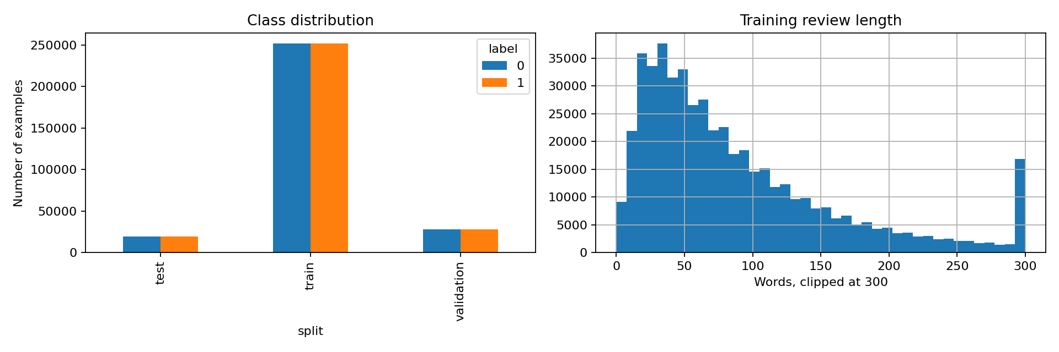
Figure 4. Task 2 data distribution evidence.
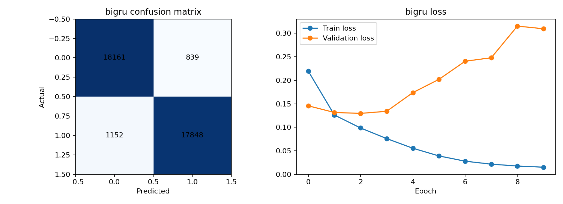
Figure 5. Task 2 BiGRU evaluation evidence.

Task 2 error review and limitations
The repository contains the generated 20-row error-review artifact, covering the required categories: five confident false positives, five confident false negatives, five near-threshold cases, and five slice-specific cases. The manual annotation fields are not yet completed. Therefore, this report does not invent observations or fixes. The required next step is to annotate each row with error type, evidence-based observation, and one testable remediation, then rerun the affected slice or evaluation.

Nikhil — Task 2 implementation and results
Summary: Nikhil trained and evaluated three sentiment classifiers on the same balanced Yelp split: a last-token pooling baseline, a single-kernel (k=7) CNN, and a bidirectional LSTM with learned attention pooling. The BiLSTM with attention was the strongest model on every reported measure; the last-token baseline reached only 0.654 accuracy.
Area | Nikhil’s recorded evidence
Data pipeline | 560K train / 38K test, perfectly balanced, no missing or duplicate rows; stratified 504K train / 56K validation split; lowercasing, punctuation removal, stopword removal (negations kept), Porter stemming; 30K vocabulary; max length 256
Model comparison | B1 embedding → last-token pooling; B2 single k=7 CNN with global max pooling; B3 one-layer BiLSTM with attention pooling; all embeddings learned from scratch
Evaluation focus | Accuracy; macro/micro/weighted precision, recall and F1; confusion matrix; ROC-AUC; PR-AUC; MCC; Brier; ECE; bootstrap 95% CIs; McNemar; slice robustness; efficiency
Robustness and review | McNemar comparisons against the baseline; review-length, negation and contrast slices; 20 error-review candidates generated for the strongest model
- Data split: 504K training, 56K validation, and 38K test examples; balanced labels. Vocabulary size 30K; maximum sequence length 256; batch size 128 (B1, B2) and 64 (B3); 8 epochs; seed 42; NVIDIA GeForce RTX 5090.
- Models: last-token baseline (3.84M parameters), k=7 CNN (3.95M), BiLSTM with attention pooling (4.17M).
Model | Accuracy | Macro-F1 | ROC-AUC | PR-AUC | MCC | Train s | Peak MB
B1 last-token | 0.6539 | 0.6539 | 0.7207 | 0.7091 | 0.3078 | 50.7 | 91.5
B2 CNN k=7 | 0.9424 | 0.9424 | 0.9868 | 0.9871 | 0.8850 | 74.4 | 559.0
B3 BiLSTM+attn | 0.9538 | 0.9538 | 0.9910 | 0.9911 | 0.9077 | 755.3 | 607.1
Model | Precision macro / weighted | Recall macro / weighted | Brier / ECE | Params | Train eps | Accuracy 95% CI | Macro-F1 95% CI
B1 last-token | 0.6539 / 0.6539 | 0.6539 / 0.6539 | 0.2112 / 0.0087 | 3,840,129 | 79,532 | [.6488,.6588] | [.6488,.6588]
B2 CNN k=7 | 0.9426 / 0.9426 | 0.9424 / 0.9424 | 0.0430 / 0.0030 | 3,954,945 | 54,166 | [.9400,.9448] | [.9400,.9448]
B3 BiLSTM+attn | 0.9539 / 0.9539 | 0.9538 / 0.9538 | 0.0354 / 0.0163 | 4,170,497 | 5,338 | [.9518,.9557] | [.9518,.9557]
The BiLSTM with attention pooling is the best model on accuracy, macro-F1, ROC-AUC, PR-AUC, MCC and Brier score. McNemar tests against the last-token baseline are decisive: baseline-only-correct versus experiment-only-correct counts were 1,112 versus 12,075 for the CNN (χ²=9,112) and 811 versus 12,205 for the BiLSTM-attention model (χ²=9,972), both with p below 10⁻³⁰⁰. The BiLSTM is about ten times slower to train than the CNN (755 s versus 74 s) for a 1.1-point accuracy gain.
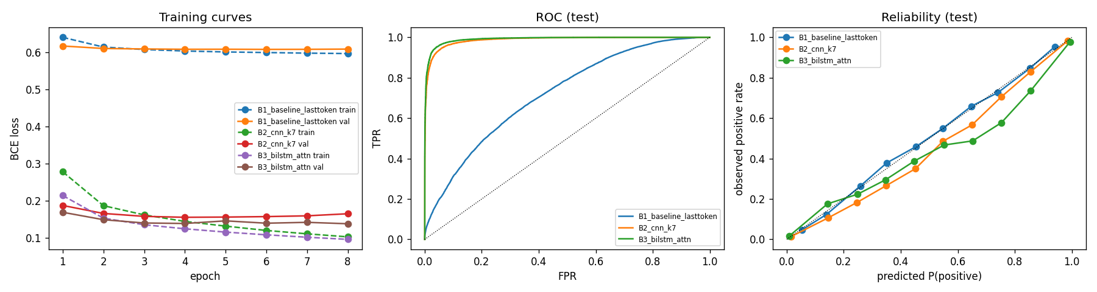
Figure 11. Task 2 (Nikhil) training curves, ROC and reliability evidence.
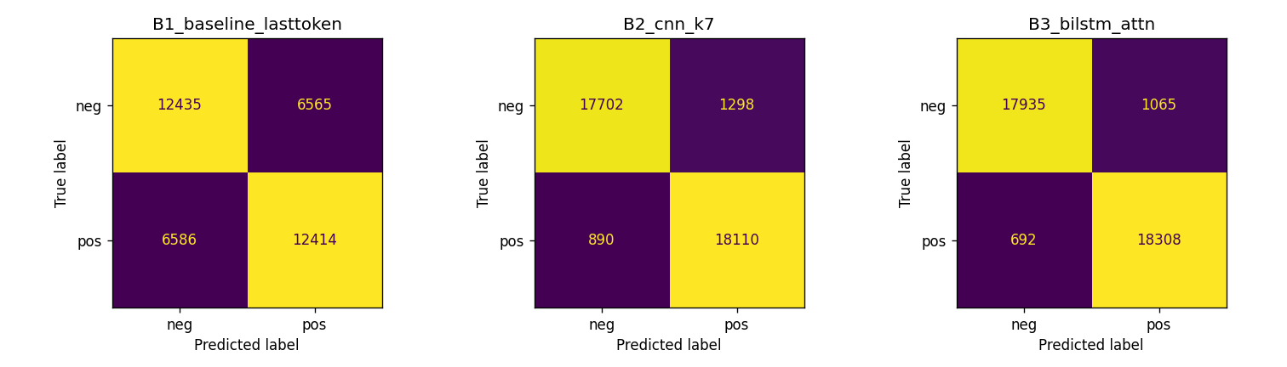
Figure 12. Task 2 (Nikhil) confusion matrices for the three models.

Nikhil — Task 2 error review and limitations
The repository contains the generated 20-row error-review candidate file for the strongest model (task2_sentiment/member_nikhil/outputs/sentiment_nikhil_B_20260929-1913/error_review_candidates_B3_bilstm_attn.csv). [Manual error types and one testable fix per error are to be completed by Nikhil.]

3. Task 3 — CycleGAN
Objective: translate between Monet paintings and photographs while measuring image quality, coverage, cycle consistency, content preservation, training stability, and submission performance.

Anushka — Task 3 implementation and results
Summary: Anushka trained a two-direction CycleGAN between Monet paintings and photographs for 50 epochs. The implementation records generator and discriminator architecture, LSGAN/cycle/identity objectives, augmentation and optimization settings, image-quality metrics in both directions, cycle/content diagnostics, loss curves, translations, checkpoint evidence, and submission metrics. Quantitatively, A→B has stronger fidelity and precision, while B→A has stronger recall and coverage; the remaining human audit and leaderboard fields are explicitly pending.
Area | Anushka’s recorded evidence
Architecture | Two ResNet generators with nine residual blocks; two 70×70 PatchGAN discriminators; total 28,285,832 parameters
Training | 50 epochs; batch 1; resize 286/random crop 256/flip; Adam 2e-4; 25 constant plus 25 decay epochs; seed 3963
Evaluation focus | FID, KID, precision, recall, density, coverage, cycle L1, identity L1, LPIPS, content cosine, loss curves, and stability
Submission evidence | Checkpoint outputs, translations, course-script metrics, submission FID/MiFID; human audit and Kaggle rank pending
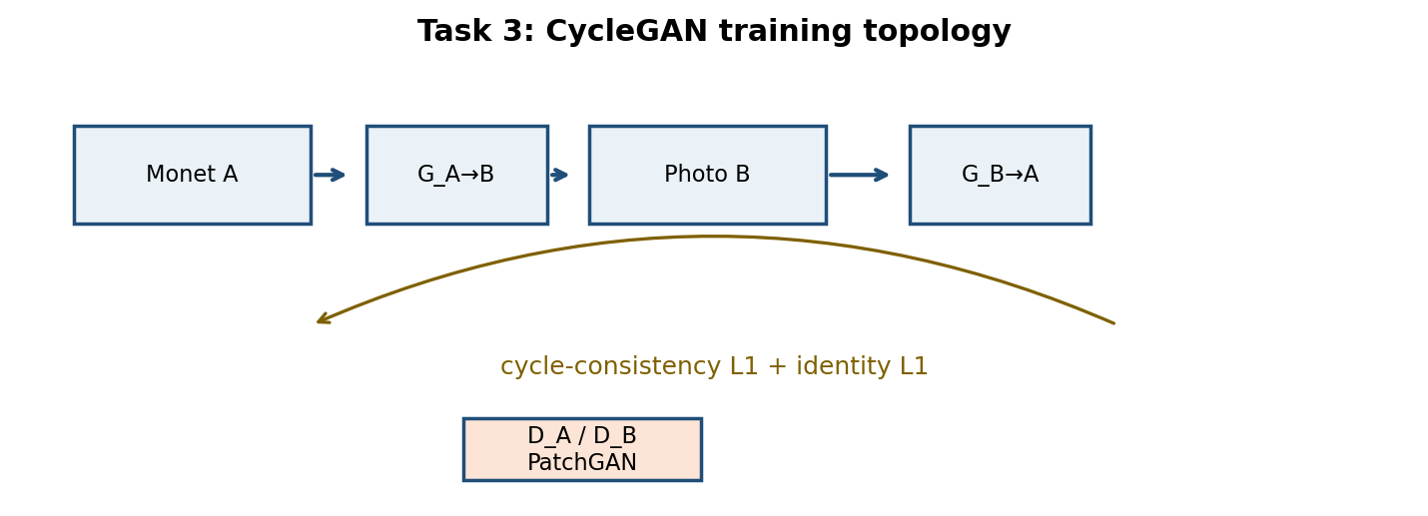
Figure 6. Task 3 CycleGAN architecture and loss relationships.
- Domains: A=Monet and B=photo; A→B uses G_A2B and B→A uses G_B2A.
- Generators: 11.38M parameters each; 7×7 stem, two downsampling convolutions, nine residual blocks, two transposed convolutions, tanh output, instance normalization, and reflection padding.
- Discriminators: 2.76M parameters each; 70×70 PatchGAN. Total parameters: 28,285,832.
- Training: LSGAN, cycle L1 weight 10, identity L1 weight 5, batch size 1, resize 286/random crop 256/flip, Adam 2e-4 with β=(0.5,0.999), 25 constant plus 25 decay epochs, history pool 50, seed 3963.

Direction | FID | KID | Precision | Recall | Coverage | Cycle L1 | LPIPS trans. | Content cosine
A→B | 81.16 | 0.0163±0.0007 | 0.740 | 0.469 | 0.554 | 0.0345 | 0.338 | 0.792
B→A | 88.58 | 0.0143±0.0010 | 0.504 | 0.643 | 0.897 | 0.0467 | 0.385 | 0.741
Efficiency/stability | Value
Training time / throughput | 22,507 s / 26.84 images/s
Peak train / evaluation memory | 9,974 / 11,898 MB
Non-finite steps | 0
Course-script FID A→B / B→A | 98.75 / 95.02
Submission FID / MiFID | 96.886 / 0.4097
Human audit and Kaggle rank | Pending
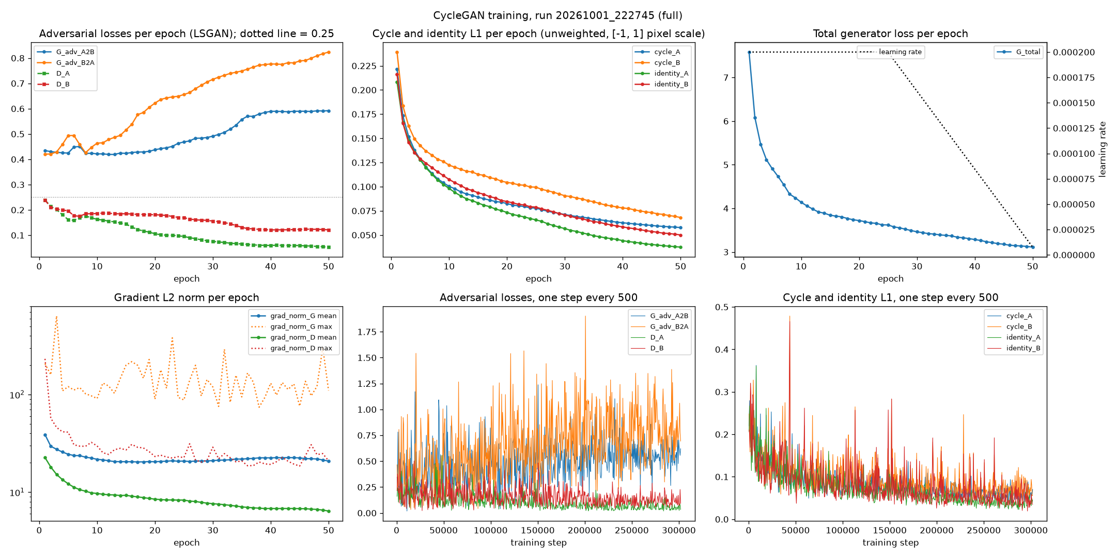
Figure 7. CycleGAN loss curves for the final recorded run.
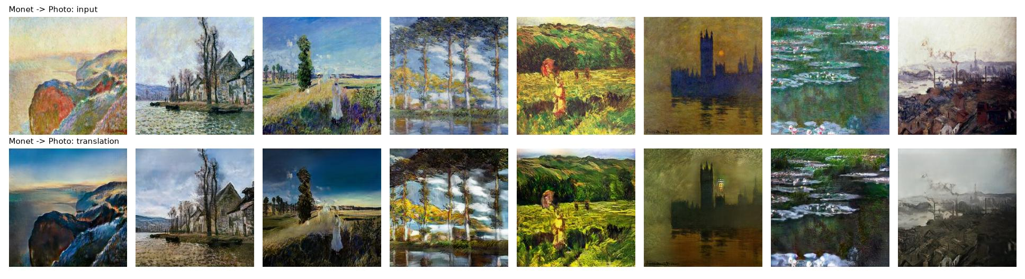
Figure 8. Example A→B translations.
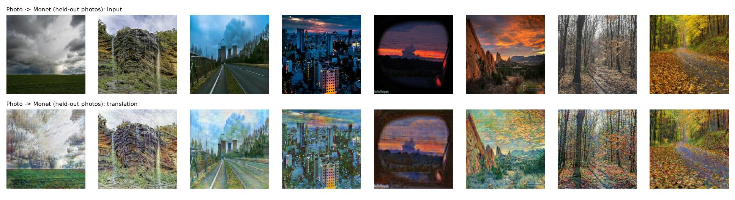
Figure 9. Example B→A translations.

Task 3 interpretation and failure analysis
- A→B has better FID, precision, and content cosine, while B→A has stronger recall and coverage. This indicates an asymmetry between fidelity and diversity across directions.
- Cycle checks are strong for own-domain reconstruction (approximately 0.034–0.045 L1) but worse for translated/reconstructed mismatch cases, indicating residual style/content distortion.
- The recorded run is numerically stable, but human audit and Kaggle public/private rank remain pending and should be added before final submission.

Nikhil — Task 3 implementation and results
Summary: Nikhil trained a two-direction CycleGAN between Monet paintings and photographs for 50 epochs using the Member B design (9 residual blocks, 32 generator base channels, batch 1) at 128×128 training resolution. Training was numerically stable. Under the course evaluation script the submission scores FID 108.03 and MiFID 0.413, which is behind Anushka’s entry.
Area | Nikhil’s recorded evidence
Architecture | Two ResNet generators with nine residual blocks and 32 base channels; two 70×70 PatchGAN discriminators; instance normalization
Training | 50 epochs; batch 1; resize 143 / random crop 128 / flip; 1,000 photos held out for evaluation; LSGAN, cycle weight 10, identity weight 5; Adam 2e-4
Evaluation focus | FID, KID, precision, recall, density, coverage, cycle L1, LPIPS, content cosine, stability, efficiency, course-script FID/MiFID
Submission evidence | Checkpoint outputs, translations, course-script metrics in task3_gan/member_nikhil/submission_course_script.csv
- Domains: A=Monet and B=photo; A→B uses G_AB and B→A uses G_BA.
- Generators: 2.85M parameters each; 7×7 stem, two downsampling convolutions, nine residual blocks, two transposed convolutions, tanh output, instance normalization and reflection padding.
- Discriminators: 2.76M parameters each; 70×70 PatchGAN. Total parameters: 11,230,600.
- Training: LSGAN, cycle L1 weight 10, identity L1 weight 5, batch size 1, resize 143 / random crop 128 / flip, Adam 2e-4 with β=(0.5, 0.999), 25 constant plus 25 decay epochs, history pool 50, seed 7.
Direction | FID | KID | Precision | Recall | Coverage | Cycle L1 | LPIPS trans. | Content cosine
A→B | 88.71 | 0.0272±0.0010 | 0.753 | 0.356 | 0.448 | 0.0477 | 0.388 | 0.698
B→A | 89.87 | 0.0175±0.0011 | 0.571 | 0.623 | 0.920 | 0.0551 | 0.344 | 0.689
Efficiency/stability | Value
Training time / throughput | 27,580 s / 22.70 images/s
Peak training memory | 464 MB
Non-finite steps | 0
Course-script FID A→B / B→A | 108.34 / 107.72
Submission FID / MiFID | 108.032 / 0.4129
Human audit and Kaggle rank | Audit pending; the team 42 leaderboard entry (rank 21 on 6 Oct 2026) is Anushka’s submission
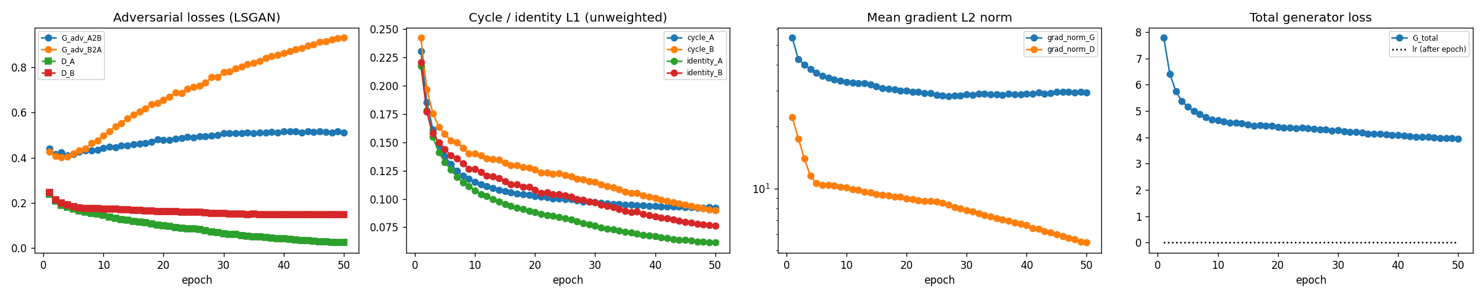
Figure 13. Task 3 (Nikhil) CycleGAN loss curves for the final recorded run.
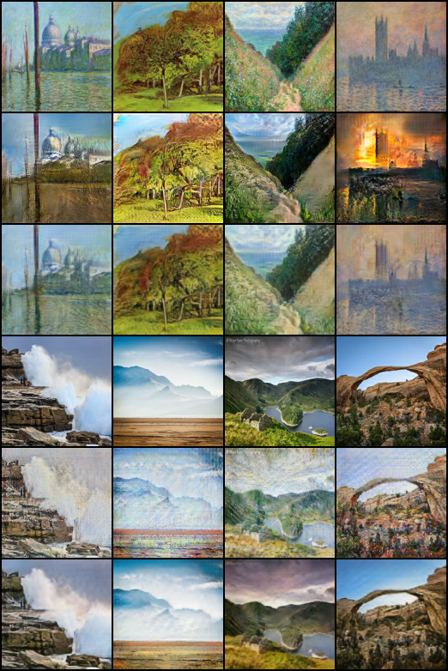
Figure 14. Task 3 (Nikhil) sample translations and reconstructions at epoch 50.

Nikhil — Task 3 interpretation and failure analysis
- [To be written by Nikhil: direction asymmetry, cycle-consistency checks, comparison with Anushka’s run, and the human-audit results.]

4. Reproducibility and implementation evidence
The repository uses task-specific notebooks and source paths under src/ or the member task directories, with root-level reproducibility/manifests and reproducibility/raw_logs. The manifests record the environment and requirements for Anushka’s runs. The raw logs provide execution evidence, while output folders contain metrics, plots, checkpoints, and generated samples. A fresh evaluator should begin at the root README, then follow each task README and the linked manifest/log paths.
Required evidence | Status for Anushka
Notebook/source code | Present for Tasks 1–3
Configuration files | Present for Tasks 1–3
Checkpoints | Present for Tasks 1–3
Metrics reports and plots | Present for Tasks 1–3
Root reproducibility manifests | Present
Raw execution logs | Present
Task 2 20-row review template | Present; manual annotations pending
Human audit/Kaggle rank for Task 3 | Pending
Evidence status for Nikhil (Member B):
Required evidence | Status for Nikhil
Notebook/source code | Present for Tasks 1–3 (executed notebooks)
Configuration files | Present for Tasks 1–3
Checkpoints | Present for Tasks 1–3
Metrics reports and plots | Present for Tasks 1–3
Root reproducibility manifests | Present (reproducibility/manifests/nikhil)
Raw execution logs | Present (reproducibility/raw_logs/nikhil)
Task 2 20-row review template | Candidate file present; manual annotations pending
Human audit/Kaggle rank for Task 3 | Audit pending; own Kaggle entry not submitted

5. Ownership statement
Anushka Rajesh Khadatkar (Member A): implementation, execution, metrics, plots, checkpoints, reproducibility manifests/logs, and analysis documented in this report for Tasks 1–3. Nikhil Khaneja (Member B): implementation, execution, metrics, plots, checkpoints, reproducibility manifests/logs and recorded results for Tasks 1–3 on a different model design; his written interpretation and failure analysis sections are marked for completion. Each member’s numbers come from their own runs; no result is copied between members.

6. Submission checklist
- Add this report to the repository under report/ and link it from the root README.
- Verify the repository URL and Team Pair 42 identifier before submission.
- Complete and commit the 20 manual Task 2 error annotations; record the testable fix and rerun evidence.
- Complete the Task 3 human audit and add Kaggle public/private scores and rank when available.
- Nikhil’s Member B artifacts are included above; complete his marked interpretation and failure-analysis sections before submission.
- Retain manifests, requirements, raw logs, checkpoints, metrics, plots, and notebooks so the reported numbers can be reproduced.

Appendix A — source paths
- task1_llm/member_anushka/src/Part1_LLM.ipynb
- task2_sentiment/member_anushka/src/Part2_MemberA_Yelp_Sentiment.ipynb
- task3_gan/member_anushka/src/Part3_CycleGAN.ipynb
- reproducibility/manifests/task1_llm_anushka_manifest.json
- reproducibility/manifests/task2_sentiment_anushka_manifest.json
- reproducibility/manifests/task3_gan_anushka_manifest.json
- reproducibility/raw_logs/task1_llm_anushka/
- reproducibility/raw_logs/task2_sentiment_anushka/
- reproducibility/raw_logs/task3_gan_anushka/
- task1_llm/member_nikhil/src/task1_gpt_nikhil.ipynb
- task2_sentiment/member_nikhil/src/task2_sentiment_nikhil.ipynb
- task3_gan/member_nikhil/src/task3_cyclegan_nikhil.ipynb
- reproducibility/manifests/nikhil/
- reproducibility/raw_logs/nikhil/

