Python

Roll No: 2601105
Name: Nikhil Nitesh Khude

1.Write a program to read a file and count how many vowels are present in its content

Ans:-
#Write a program to read a file and count how many vowels are present in its content
f = open("Day-1/data.txt", "r")
content=f.read()

count = 0
for ch in content:
if ch.lower() in "aeiou":
count += 1

print("Total vowels:", count)

f.close()

Outpur:-
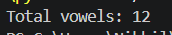

Q.2 Read all lines from a file into a list. Print the total number of lines and display the 2nd and 4th line

Ans:-

Q.2 Read all lines from a file into a list. Print the total number of lines and display the 2nd and 4th line

Ans:- f = open("Day-1/data.txt", "r")

lines = f.readlines()

print("Total number of lines:", len(lines))
print("2nd line:", lines[1], end="")
print("4th line:", lines[3], end="")

f.close()

Ans:-

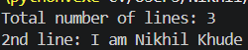

Q.3 Take a sentence from the user, split it into words, and store them in a list. Print the longest word

Ans:-
sentence = input("Enter a sentence: ")

words = sentence.split()

longest = max(words, key=len)

print("List of words:", words)S
print("Longest word:", longest)

Output:-
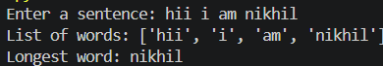

Q.4 Read a file, split its content into words, and store them in a list.

  - Print the total number of words.
  - Print all unique words

Ans:- f = open("Day-1/data.txt", "r")

content = f.read()
words = content.split()

print("Total number of words:", len(words))

unique_words = set(words)
print("Unique words:", unique_words)

f.close()

unique_words = list(dict.fromkeys(words))
print("Unique words:", unique_words)

Output:-
