Function-Oriented Modelling
Definition
Function-oriented modelling (also called process-oriented or structured modelling) views the software system as a collection of functions (or processes) that accept input data, transform that data, and produce output data. The emphasis is on what the system does rather than on the data objects themselves.
Core Philosophy
- The system is decomposed hierarchically into smaller and smaller functions.
- Data moves from one function to another.
- The primary modelling tool is the Data Flow Diagram (DFD).
- This approach was dominant in traditional (non-object-oriented) software engineering.
Key Characteristics

- Top-down hierarchical decomposition
- Clear separation between data and processing
- Focus on data transformation rather than control flow or object interactions
- Strong support for modularity and functional independence
Main Work Products
- Data Flow Diagrams (DFDs) – the central model
- Data Dictionary – precise definition of every data item and data store
- Process Specifications (mini-specs or Program Design Language – PDL)
- Structure Charts – produced after transform or transaction mapping
Requirements (Analysis) Model Design Model
───────────────────────────── ─────────────────────────────
Flow-oriented elements (DFDs) ───► Architectural Design
Scenario-based elements ───► Interface Design
Class-based elements ───► Data / Class Design
Behavioural elements ───► Component-Level Design

Advantages
- Excellent for systems whose primary purpose is data transformation (e.g., payroll, inventory, sensor monitoring, billing)
- Easy to understand data movement
- Natural mapping to call-and-return architectures via structured design (transform mapping)
Limitations
- Does not model complex state-dependent behaviour well
- Can become difficult when requirements change frequently
- Less natural for highly interactive or event-driven systems
Practical Example – SafeHome Security Function
The entire security function is first shown as a single process in the Level-0 (context) DFD. It is then refined into Level-1 processes such as “Monitor Sensors”, “Process Password”, “Generate Alarm”, etc. Further refinement continues until each process is simple enough to be implemented as a single module.
DESIGN CONCEPTS
Design concepts have evolved over the history of software engineering. Each concept provides the software designer with a foundation from which more sophisticated design methods can be applied.

1. Abstraction
Definition
When you consider a modular solution to any problem, many levels of abstraction can be posed.
- Highest level of abstraction: The solution is stated in broad terms using the language of the problem environment.
- Lower levels of abstraction: A more detailed description of the solution is provided.
- Lowest level of abstraction: The solution is stated in a manner that can be directly implemented (i.e., close to programming language statements).
Two Important Types
- Procedural Abstraction
A sequence of instructions that have a specific and limited function.
The name of the procedural abstraction implies the function, but specific details are suppressed.
Example: OpenDoor() implies a sequence of steps (check lock, turn handle, push door), but the detailed steps are hidden.
- Data Abstraction
A named collection of data that describes a data object.
Example: door might include attributes such as type, swing direction, opening mechanism, weight, etc.
Importance
Abstraction allows the designer to focus on essential characteristics while suppressing unnecessary details at each stage of design.

2. Architecture
Definition
Software architecture alludes to “the overall structure of the software and the ways in which that structure provides conceptual integrity for a system.”
In its simplest form, architecture is:
- The structure or organization of program components (modules)
- The manner in which these components interact
- The structure of data that are used by the components
Goal of Software Design
To derive an architectural rendering of a system.
Shaw and Garlan’s Properties of Architectural Design
- Structural Properties
Defines the components of a system (modules, objects, filters, etc.) and the manner in which those components are packaged and interact with one another.
Example: Objects encapsulate both data and the processing that manipulates the data and interact via method invocation.
- Extra-functional Properties
Addresses how the architecture achieves requirements for performance, capacity, reliability, security, adaptability, and other system characteristics.
- Families of Related Systems
The design should draw upon repeatable patterns that are commonly encountered in the design of families of similar systems. This enables reuse of architectural building blocks.

3. Patterns
Definition
A pattern is a named nugget of insight which conveys the essence of a proven solution to a recurring problem within a certain context amidst competing concerns.
A design pattern describes a design structure that solves a particular design problem within a specific context and amid “forces” that may impact how the pattern is applied.
Intent of Each Design Pattern
It enables a designer to determine:
- Whether the pattern is applicable to the current work
- Whether the pattern can be reused (saving design time)
- Whether the pattern can serve as a guide for developing a similar but functionally or structurally different pattern

4. Separation of Concerns
Definition
Separation of concerns suggests that any complex problem can be more easily handled if it is subdivided into pieces that can each be solved and/or optimized independently.
Key Insight
For two problems p1 and p2:
- If the perceived complexity of p1 > perceived complexity of p2, then effort to solve p1 > effort to solve p2.
- The perceived complexity of two problems when combined is often greater than the sum of their individual complexities.
This leads to the classic divide-and-conquer strategy: It is easier to solve a complex problem when you break it into manageable pieces.
Implication
This concept has direct and important implications for software modularity.

5. Modularity
Definition
Modularity is the most common manifestation of separation of concerns.
Software is divided into separately named and addressable components (modules) that are integrated to satisfy problem requirements.
Famous Statement
“Modularity is the single attribute of software that allows a program to be intellectually manageable.”
Why Modularize?
- Without modularity, the number of control paths, span of reference, number of variables, and overall complexity would make understanding almost impossible.
- Breaking the design into many modules makes understanding easier and reduces the cost required to build the software.
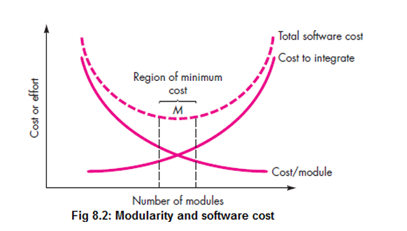
Important Caution (Figure 8.2 in Pressman)
If you subdivide software indefinitely, the effort to develop individual modules becomes very small. However, the effort required to integrate the modules grows.
This produces a total cost curve that has a minimum point (called M).
- Too few modules → Undermodularity
- Too many modules → Overmodularity
Both increase overall cost. Designers should stay in the vicinity of the optimal number M.
Benefits of Proper Modularization
- Development can be more easily planned
- Software increments can be defined and delivered
- Changes can be more easily accommodated
- Testing and debugging can be conducted more efficiently
- Long-term maintenance can be conducted without serious side effects

6. Information Hiding
Principle
Modules should be “characterized by design decisions that (each) hides from all others.”
In other words, modules should be specified and designed so that information (algorithms and data) contained within a module is inaccessible to other modules that have no need for such information.
How it Works
- Abstraction helps define the procedural and informational entities.
- Hiding defines and enforces access constraints to both procedural detail and local data structures.
Greatest Benefit
When modifications are required during testing and later during software maintenance.
Because most data and procedural detail are hidden, inadvertent errors introduced during modification are less likely to propagate to other locations within the software.

7. Functional Independence
Definition
Functional independence is a direct outgrowth of separation of concerns, modularity, abstraction, and information hiding.
It is achieved by developing modules with:
- “Single-minded” function
- An “aversion” to excessive interaction with other modules
Practical Meaning
Each module should address a specific subset of requirements and have a simple interface when viewed from other parts of the program structure.
Benefits
- Independent modules are easier to maintain and test
- Secondary effects caused by design or code modification are limited
- Error propagation is reduced
- Reusable modules become possible
Summary Statement (Pressman)
“Functional independence is a key to good design, and design is the key to software quality.”
How Independence is Measured Independence is assessed using two qualitative criteria:

Cohesion
- Indication of the relative functional strength of a module.
- A cohesive module performs a single task and requires little interaction with other components.
- Ideal: A module should do just one thing (high cohesion).

Coupling
- Indication of the relative interdependence among modules.
- Depends on interface complexity, point of entry/reference, and data that pass across the interface.
- Goal: Lowest possible coupling.
- Simple connectivity results in software that is easier to understand and less prone to the “ripple effect”.

8. Refinement
Definition
Stepwise refinement is a top-down design strategy.
A program is developed by successively refining levels of procedural detail.
Process
- Begin with a macroscopic statement of function (a procedural abstraction) at a high level of abstraction.
- Elaborate the original statement, providing more and more detail at each successive refinement.
- Continue until programming language statements are reached.
Nature of Refinement
It is a process of elaboration. It helps reveal low-level details as design progresses while maintaining traceability to the original high-level statement.

9. Aspects
Definition
As requirements analysis occurs, a set of “concerns” is uncovered. These include requirements, use cases, features, data structures, quality-of-service issues, variants, intellectual property boundaries, collaborations, patterns, and contracts.
Ideal Situation
A requirements model can be organized so that each concern can be isolated and considered independently.
Reality
Some concerns span the entire system and cannot be easily compartmentalized. These are called cross-cutting concerns.
Definition of Cross-Cutting
Requirement A crosscuts requirement B if a software decomposition has been chosen in which B cannot be satisfied without taking A into account.

10. Refactoring
Definition
Refactoring is a reorganization technique that simplifies the design (or code) of a component without changing its function or behaviour.
Pressman’s Quote
“Refactoring is the process of changing a software system in such a way that it does not alter the external behavior of the code [design] yet improves its internal structure.”
What is Examined During Refactoring
- Redundancy
- Unused design elements
- Inefficient or unnecessary algorithms
- Poorly constructed or inappropriate data structures
- Any other design failure
Result
Software that is easier to integrate, easier to test, and easier to maintain.

11. Object-Oriented Design Concepts
The object-oriented paradigm is widely used in modern software engineering. Key concepts include classes and objects, inheritance, messages, and polymorphism.

Design Classes
As the design model evolves, design classes refine the analysis classes by providing the design detail needed for implementation. They also implement the software infrastructure that supports the business solution.
Five Types of Design Classes (representing different layers of the design architecture)
- User Interface Classes
Define all abstractions necessary for human-computer interaction (HCI). Often based on a metaphor (checkbook, order form, fax machine, etc.).
- Business Domain Classes
Often refinements of analysis classes. Identify attributes and services (methods) required to implement elements of the business domain.
- Process Classes
Implement lower-level business abstractions required to fully manage the business domain classes.
- Persistent Classes
Represent data stores (e.g., a database) that persist beyond the execution of the software.
- System Classes
Implement software management and control functions that enable the system to operate and communicate within its computing environment and with the outside world.

Four Characteristics of a Well-Formed Design Class
- Complete and Sufficient
The class should be the complete encapsulation of all attributes and methods that can reasonably be expected (based on a knowledgeable interpretation of the class name).
- Primitiveness
Methods should be focused on accomplishing one service. Once a service is implemented with a method, the class should not provide another way to accomplish the same thing.
- High Cohesion
A cohesive design class has a small, focused set of responsibilities and single-mindedly applies attributes and methods to implement those responsibilities.
- Low Coupling
Collaboration between design classes should be kept to an acceptable minimum.
Highly coupled systems are difficult to implement, test, and maintain.
Law of Demeter: A method should only send messages to methods in neighboring classes (limited knowledge of other classes).

Summary of Key Design Concepts (Quick Revision)
Concept | Core Idea | Main Benefit
Abstraction | Suppress unnecessary details | Manage complexity
Architecture | Overall structure & conceptual integrity | Big-picture understanding
Patterns | Proven solutions to recurring problems | Reuse of design knowledge
Separation of Concerns | Divide complex problems | Easier solution
Modularity | Divide into named, addressable components | Intellectual manageability
Information Hiding | Hide internal details | Reduced error propagation
Functional Independence | High cohesion + Low coupling | Key to good design & quality
Refinement | Successive elaboration | Controlled detail addition
Aspects | Cross-cutting concerns | Better handling of system-wide issues
Refactoring | Improve structure without changing behaviour | Better maintainability
Design Classes | Refined classes with design detail | Implementation readiness

Coupling vs Cohesion
Cohesion and Coupling are the two most important qualitative measures used to evaluate the quality of a modular design.
Together they determine Functional Independence of modules.
Pressman says:
“Functional independence is a key to good design, and design is the key to software quality.”
Goal of Good Design:
- High Cohesion (module is focused)
- Low Coupling (modules are loosely connected)
Coupling and Cohesion are two key concepts in software engineering that are used to measure the quality of a software system’s design. Both coupling and cohesion are important factors in determining the maintainability, scalability, and reliability of a software system.
- Coupling measures the degree of dependency or interaction between different modules.
- Cohesion measures how closely the elements within a module work together to perform a single, well-defined task.
A good software design generally aims for:
High Cohesion + Low Coupling
- Cohesion → How closely related the tasks inside one module are.
- Coupling → How much one module depends on another module.
Think of a college:
- A Department of AI&DS handling teaching, labs, examinations, and projects related to AI&DS has high cohesion.
- If the AI&DS department cannot perform any task without constantly depending on ECE, Mechanical, and Civil departments, it has high coupling.

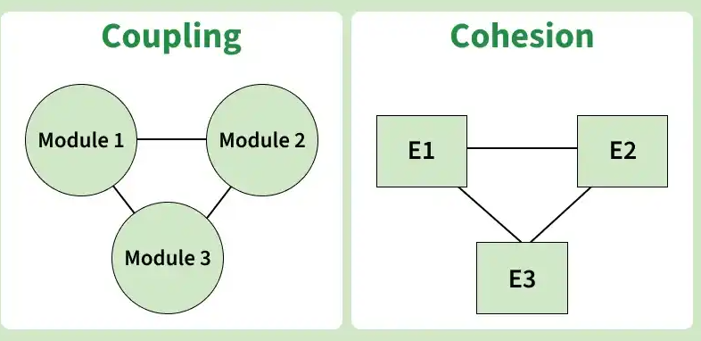

1. Cohesion
Cohesion tells us how strongly the things inside one module are related to each other.
Goal:
A good module should do only one job.

Real-Life Example
Imagine a person in an office:
- High Cohesion (Good):
One person is only responsible for making coffee.
He does nothing else.
→ This is highly cohesive.
- Low Cohesion (Bad):
One person is responsible for making coffee + cleaning the office + paying electricity bills + writing reports + managing security.
→ Everything is mixed. This is low cohesion.
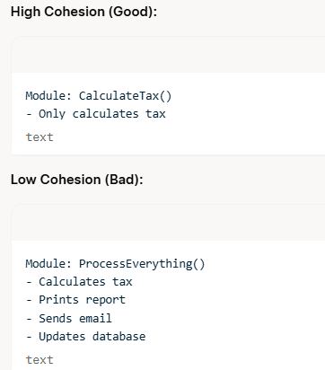
Cohesion is a measure of the relative functional strength of a module.
It indicates how closely the elements (instructions, data, statements) inside a single module are related to each other.
A module with high cohesion performs a single, well-defined task and has very little interaction with other modules.

Ideal Characteristic
A cohesive module should be “single-minded” — it should ideally do just one thing.

Why High Cohesion is Desirable
- Easier to understand
- Easier to develop and test
- Easier to maintain
- Reduces side effects when changes are made
- Increases reusability
Level | Type of Cohesion | Description | Example | Quality
1 | Coincidental | Elements inside the module have no meaningful relationship | Random collection of unrelated statements | Worst
2 | Logical | Elements are grouped because they are of the same category | One module that handles all types of errors | Poor
3 | Temporal | Elements are grouped because they are executed at the same time | Initialization module (open files + set variables + display screen) | Fair
4 | Procedural | Elements are related by the sequence in which they must be executed | Read → Validate → Process in one module | Fair
5 | Communicational | All elements operate on the same data | All operations on a single customer record | Good
6 | Sequential | Output of one element is input to the next | Pipeline of processing steps | Good
7 | Functional | Module performs one and only one specific function | CalculateIncomeTax() | Best

2. Coupling
Coupling tells us how much one module depends on another module.
Goal:
Modules should be as independent as possible.

Real-Life Example
Imagine two friends:
- Low Coupling (Good):
You and your friend only talk when needed.
You don’t depend on each other for daily work.
If one of you is busy, the other can still work normally.
- High Coupling (Bad):
You and your friend are completely dependent on each other.
If one person is absent or changes plans, the other person’s entire work gets disturbed.
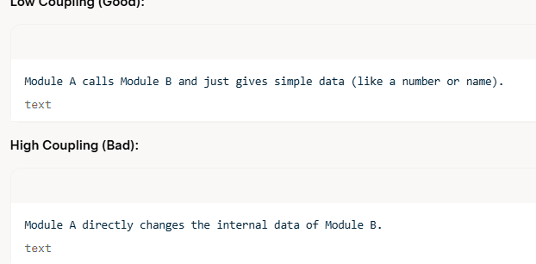
Coupling is a measure of the relative interdependence among modules.
It indicates how strongly one module is connected to or depends on other modules.
Coupling depends on:
- Complexity of the interface between modules
- Point at which one module refers to or enters another module
- Nature of the data that passes across the interface
We should always strive for the lowest possible coupling.

Why Low Coupling is Desirable
- Changes in one module have minimum impact on other modules (reduces ripple effect)
- Modules can be developed and tested more independently
- System is easier to understand and maintain
- Error propagation is reduced

Types of Coupling (from Highest/Undesirable to Lowest)
Level | Type of Coupling | Description | Example | Quality
1 | Content Coupling | One module directly modifies the internal data or code of another module | Directly changing local variables of another module or using goto | Worst
2 | Common Coupling | Multiple modules share global data | Several modules reading/writing the same global variables | Poor
3 | Control Coupling | One module passes a control flag that directs the internal logic of another | Passing a flag that decides which path the called module should take | Fair
4 | Stamp Coupling | Modules share a composite data structure (even if only part is needed) | Passing an entire structure when only one field is required | Fair
5 | Data Coupling | Modules communicate only through simple data parameters | Passing simple values like numbers or strings | Best
6 | Routine Call Coupling | One module simply calls another module | Normal function/procedure call | Acceptable

Cohesion vs Coupling
Cohesion | Coupling
Cohesion refers to the degree to which elements within a module work together to fulfill a single, well-defined purpose. | Coupling refers to the degree of interdependence between software modules. High coupling means that modules are closely connected and changes in one module may affect other modules.
Cohesion is the concept of an intro-module. | Coupling is the concept of inter-module.
Cohesion represents the relationship within a module. | Coupling represents the relationships between modules.
Increasing cohesion is good for software. | Increasing coupling is avoided for software.
Cohesion represents the functional strength of modules. | Coupling represents the independence among modules.
Highly cohesive gives the best software. | Whereas loosely coupling gives the best software.
In cohesion, the module focuses on a single thing. | In coupling, modules are connected to the other modules.
Cohesion is created between the same module. | Coupling is created between two different modules.

