Product Design
Team 44
Guntesh, Khushi, Mohana, Nikhil, Aryan

UML Diagram
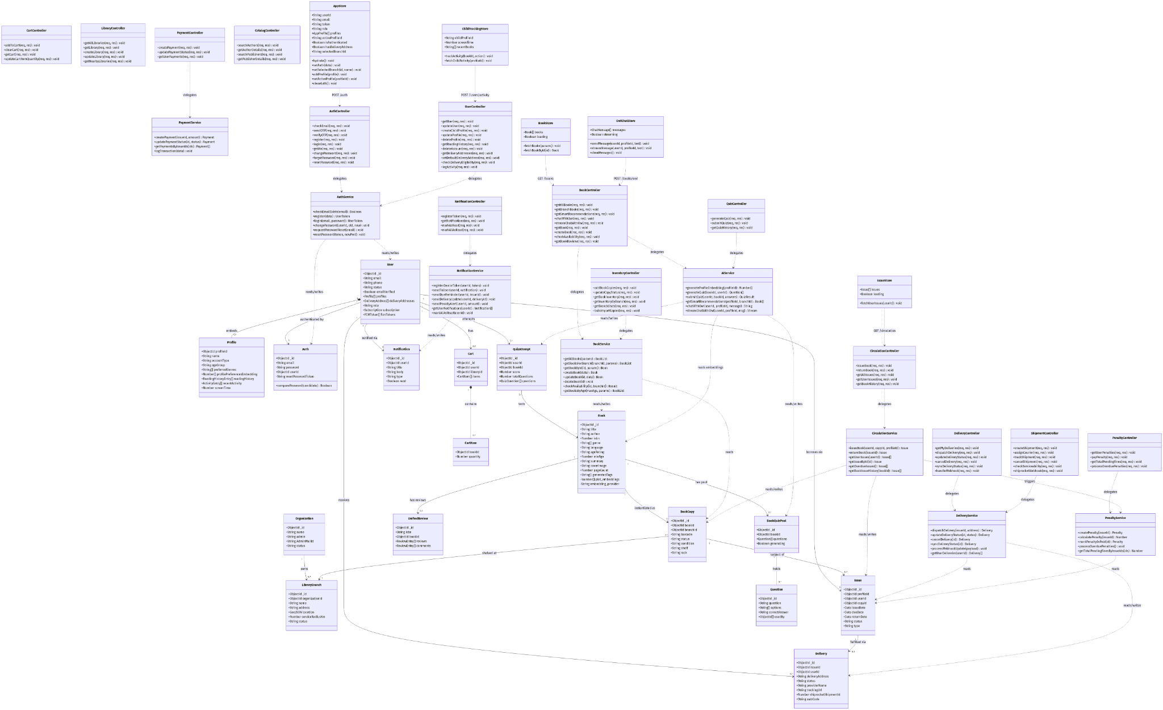

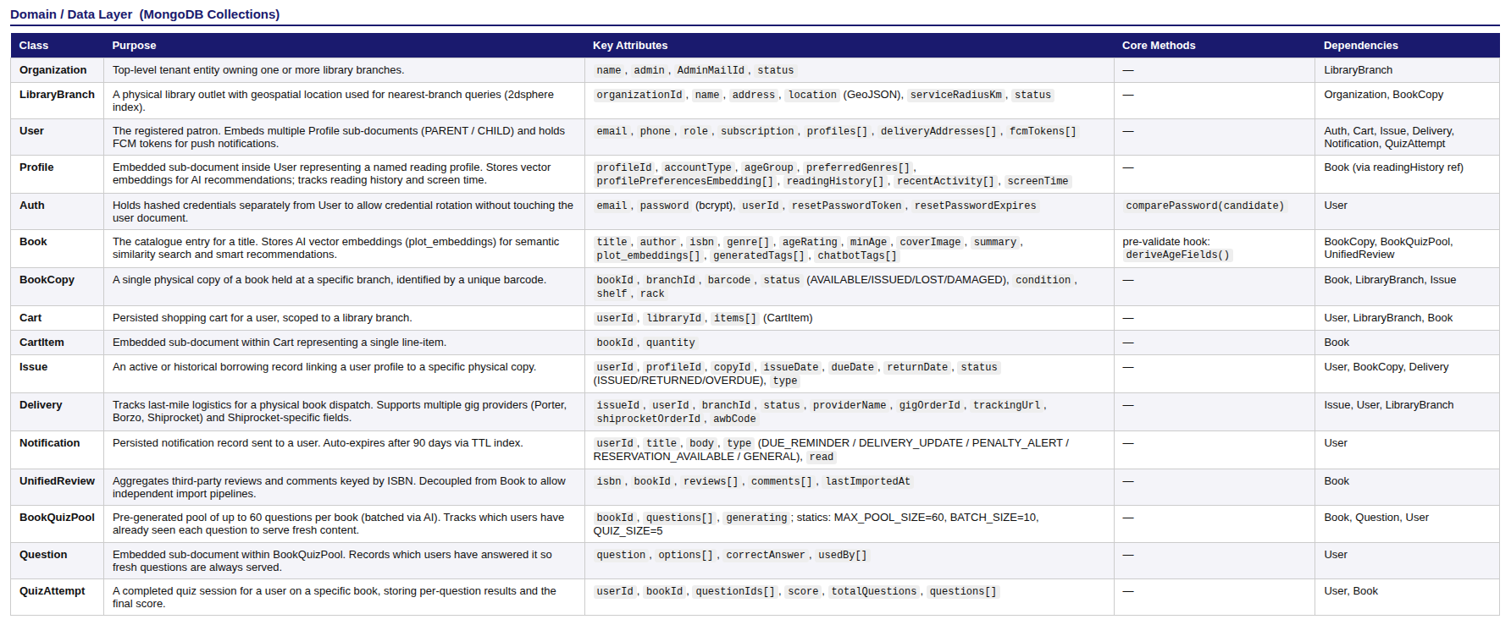
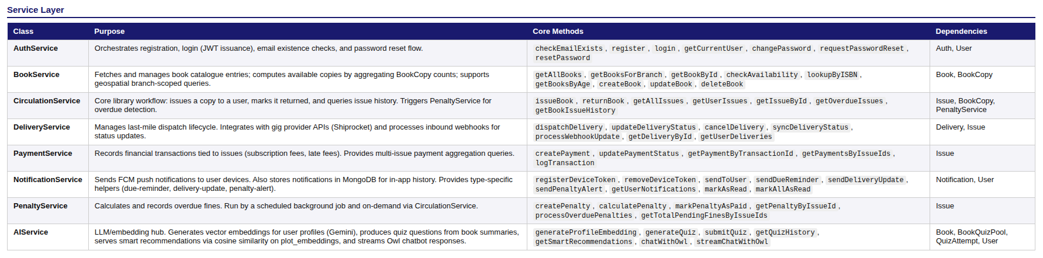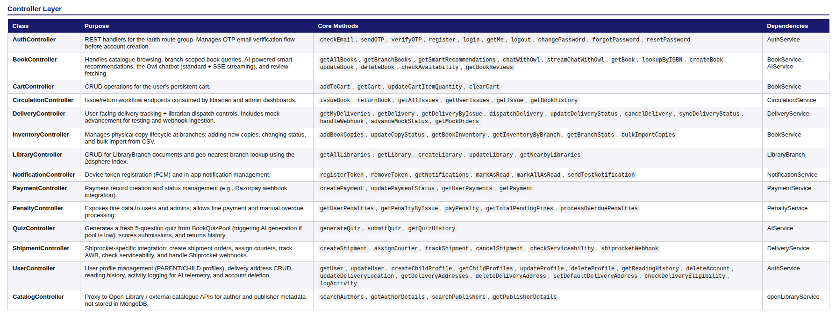
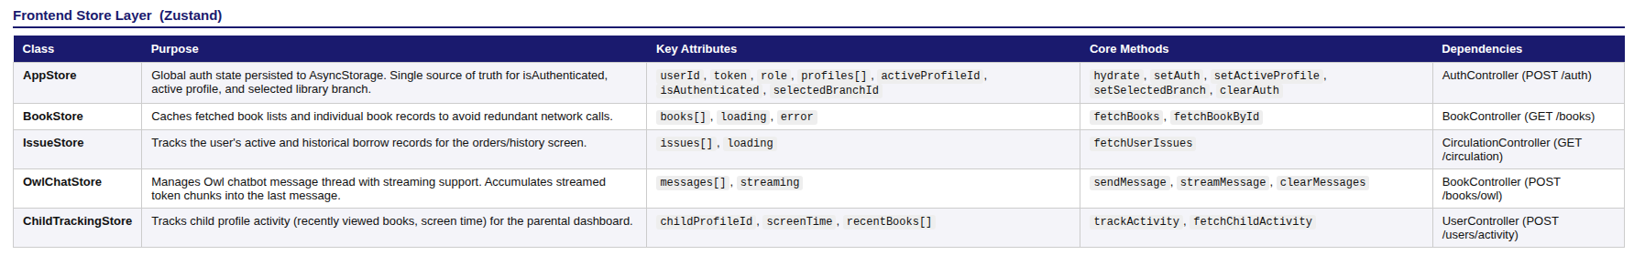

Sequence Diagram(s)

Book Order & Cart Checkout Flow
The core transactional pipeline. Before an order is confirmed, the backend must cross-reference Subscription policies and real-time physical library branch availability to ensure no dead-lock collisions occur.
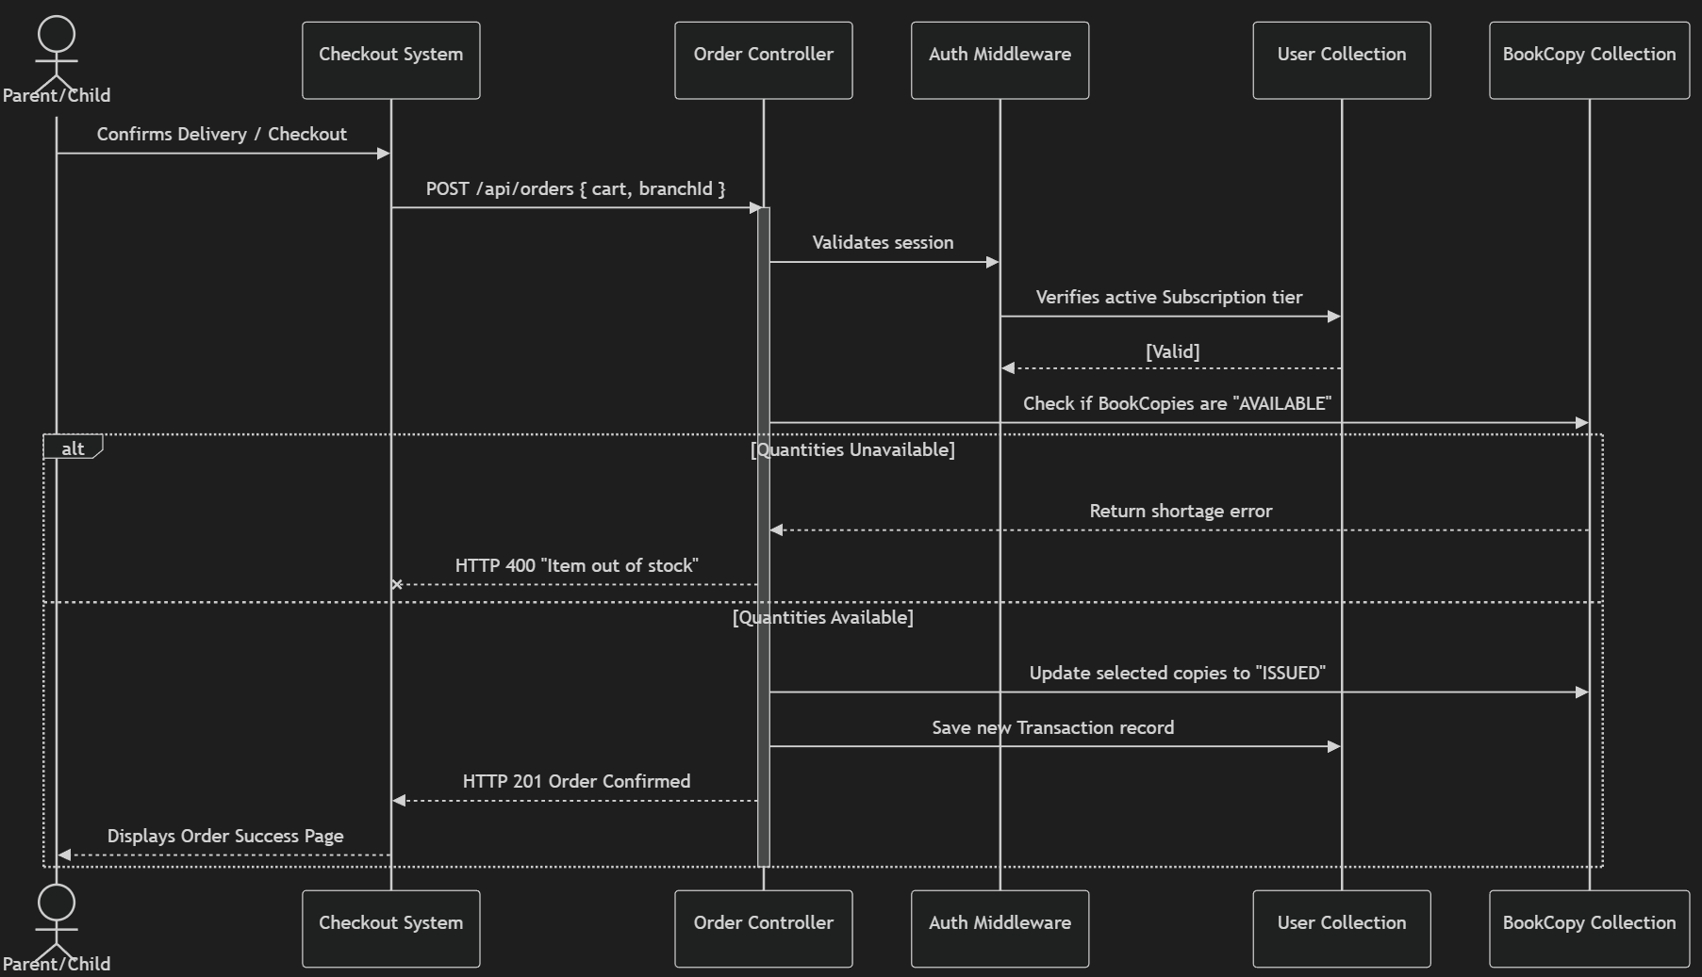

Librarian Bulk Import & Metadata Fallback
This flow charts how an Excel spreadsheet is digested. Because external APIs routinely fail (e.g., 503 Service Unavailable limits), the system is sequenced to dynamically fall back across different APIs to ensure library data is securely recorded
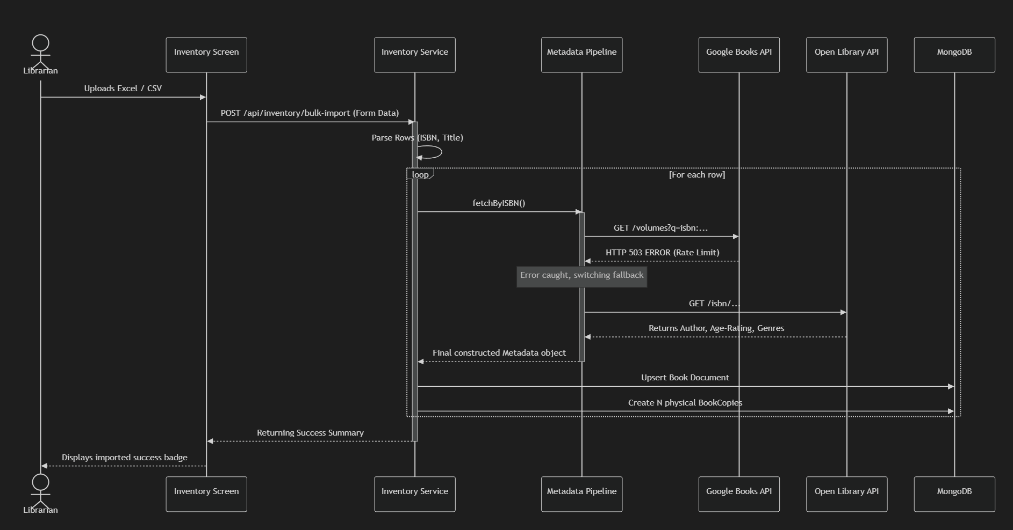

AI RAG Chatbot Search Flow
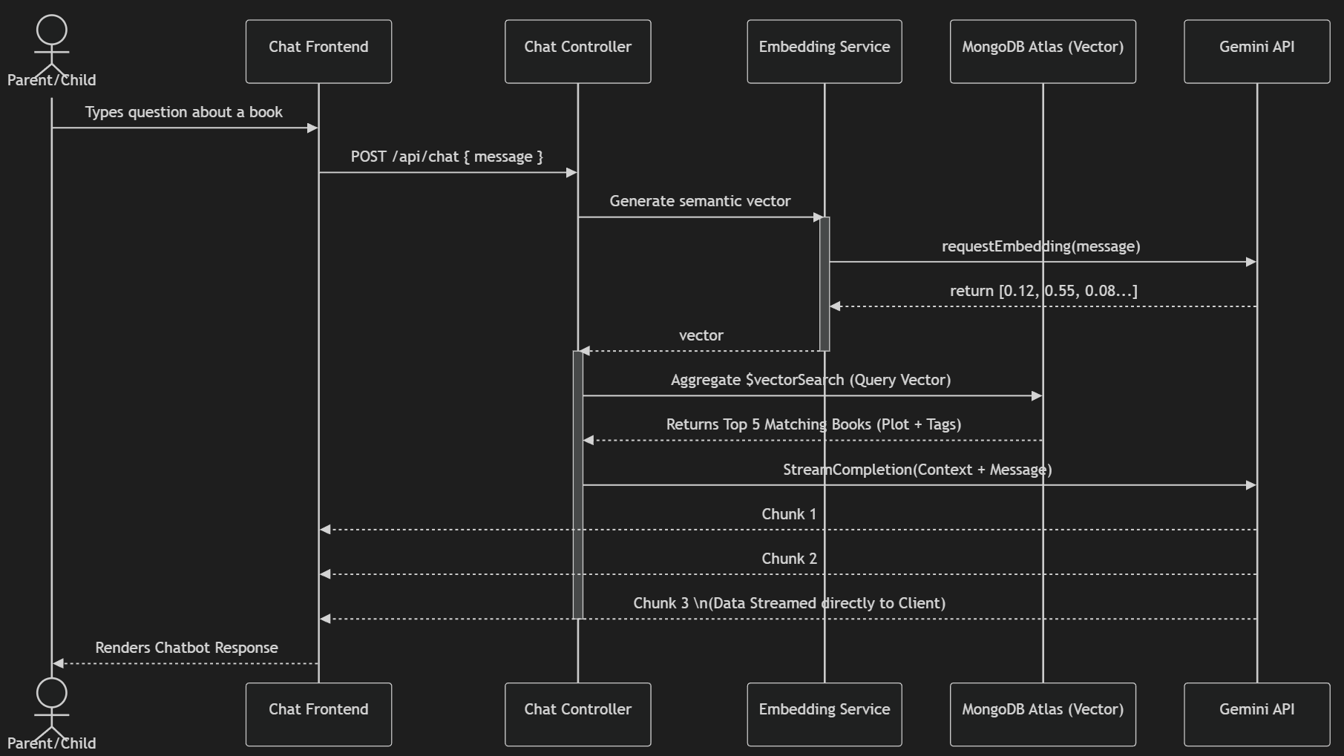

AI Quiz Generation & Pooling
This diagram shows how the system prevents the user from waiting for real-time generative AI. When a quiz is requested, it serves pre-generated questions. If the pool is low, the server responds to the user instantly while firing off a background script to fetch more questions.
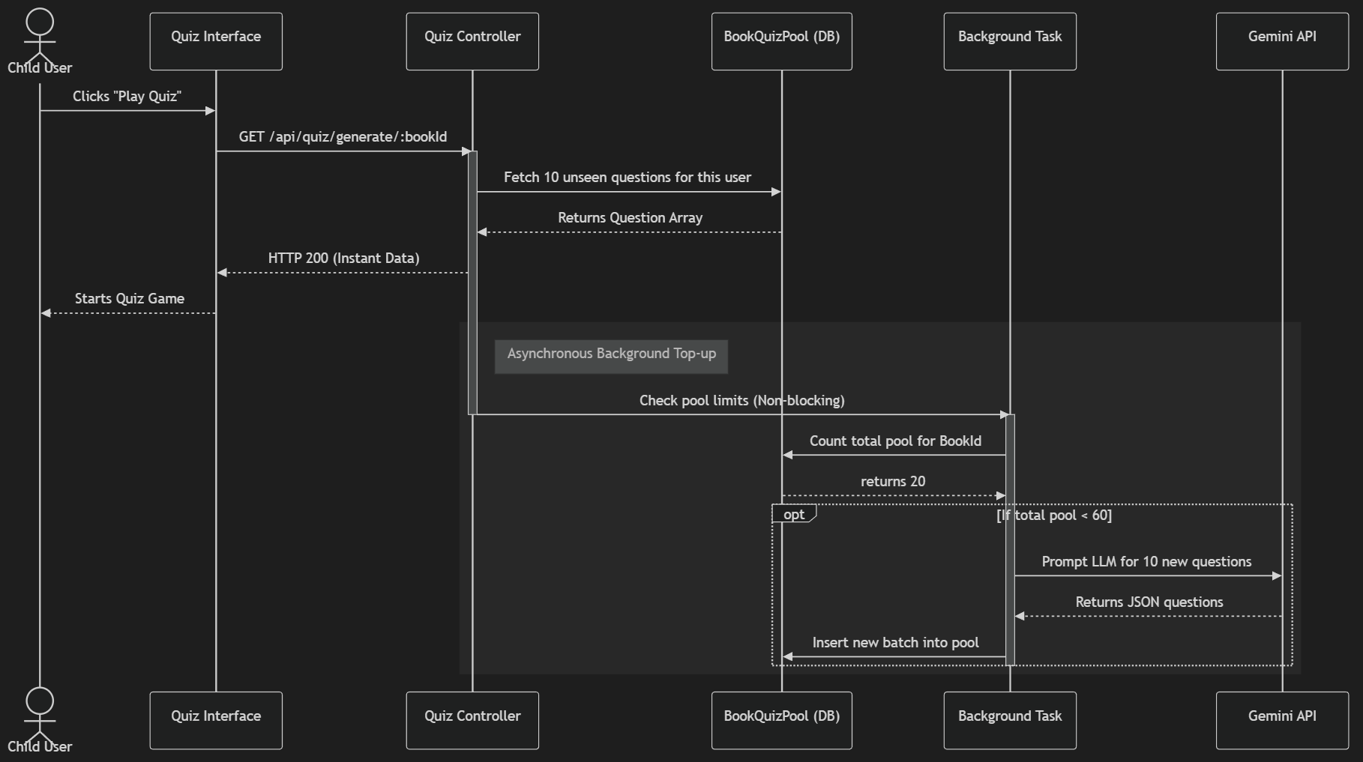

Design Rationale

Design Rationale & Alternative Considerations
The following section documents the evolution of the system architecture, capturing the core engineering problems encountered, the alternative solutions evaluated, and the rationale behind the final implementation choices.

1. AI Microservice Ecosystem: Language and Framework
- Issue: Selecting the appropriate technology stack for the Retrieval-Augmented Generation (RAG) microservice.
- Alternatives Considered:
  - Python/FastAPI: The industry standard for AI and data science, offering native support for standard ML libraries.
  - Node.js / Express (JavaScript): Expanding the existing backend ecosystem to handle AI orchestration.
- Final Design & Rationale: The team opted for a Node.js microservice architecture. While Python offers robust AI libraries, introducing a second language into a MERN/React Native stack would increase deployment complexity and force context-switching during development. By utilizing Node.js for the RAG pipeline, the entire codebase shares a unified JavaScript/TypeScript ecosystem. This tradeoff prioritizes development velocity, easier CI/CD integration, and seamless API communication between the primary backend and the AI service.

2.RAG Vectorization: Local Execution vs. Cloud Embeddings
- Issue: Determining how to process, store, and query vector embeddings for the conversational librarian without degrading application performance.
- Alternatives Considered:
  - Local Processing (ChromaDB + Local LLMs): Running models directly on the server hardware. This ensures absolute data privacy and zero API costs.
  - Cloud Embeddings & Cloud LLM APIs: Offloading the vectorization and generation workload to dedicated cloud providers.
- Final Design & Rationale: The system utilizes Cloud Embeddings. By pivoting to Cloud Embeddings, the system achieves sub-second retrieval times and offloads compute-heavy tasks whereas in the case of Local Processings which needs a server and client strictly said no to. The tradeoff involves relying on external API availability and incurring minor operational costs(which the client refused), which is vastly outweighed by the superior user experience and system stability.

3. Multi-Branch Inventory Data Architecture
- Issue: Structuring the database to support isolated, branch-specific book inventories (e.g., ensuring users only see/borrow books physically present at their selected local library).
- Alternatives Considered:
  - Database-per-Branch: Creating isolated database instances or distinct collections for each physical library location.
  - Single Master Database with Metadata Filtering: Storing all books globally and attaching branch tags to the data models.
- Final Design & Rationale: The final design uses a Single Master Database with Metadata Filtering. Maintaining separate databases would lead to massive data duplication (e.g., saving "Harry Potter" 50 times for 50 branches) and risk RAM exhaustion when multiple branch data sets are loaded into the RAG vector search simultaneously. Using a master database with strict indexing and metadata filtering (leveraged via React Native Expo location services) ensures highly efficient queries, zero data redundancy, and highly scalable onboarding for new library branches.

4. E-Commerce Constraints: Single-Library Cart Logic
- Issue: Handling user checkout flows when the platform hosts multiple independent local libraries.
- Alternatives Considered:
  - Universal Cart: Allowing users to add books from any branch into a single cart and calculating split deliveries.
  - Strict Single-Library Cart: Forcing the user to checkout from only one library at a time.
- Final Design & Rationale: The platform enforces a Strict Single-Library Cart constraint. A universal cart introduces exponential complexity in delivery routing, multi-party payment splitting, and asynchronous stock reservation. By restricting the cart to a single libraryId, the backend transaction logic (and Nodemailer receipt generation) remains lightweight and fault-tolerant. The tradeoff sacrifices a small degree of user convenience for operational feasibility and guaranteed fulfillment in a hyper-local delivery model.

5. LLM Conversational Memory Management
- Issue: Retaining chat history for the RAG chatbot to understand contextual follow-up questions without crashing the model's context window.
- Alternatives Considered:
  - Full History Injection: Passing the entire MongoDB chat history array to the LLM on every prompt.
  - Rolling-Window / Context Summarization: Trimming the memory payload or asynchronously summarizing it in the background.
- Final Design & Rationale: The system utilizes a Rolling-Window Context approach. Feeding the full history to the model rapidly exhausts token limits, increases API costs, and slows down generation times. By injecting only the most recent semantic context alongside the retrieved book data, the application guarantees hallucination-free, highly relevant responses while keeping payloads lightweight.

6. Email Delivery System: Authentication & Notifications
- Issue: Selecting an email delivery mechanism for critical user workflows, specifically account verification and secure password resets.
- Alternatives Considered:
  - Enterprise Transactional APIs (SendGrid, Mailgun, AWS SES): Industry-standard services designed for high deliverability and massive scale.
  - Nodemailer with Gmail SMTP: A Node.js module paired with a standard Google account using App Passwords.
- Final Design & Rationale: The system utilizes Nodemailer integrated with Gmail SMTP. While enterprise APIs offer superior analytics and scale, they often require verified custom domains, strict DNS configurations (DKIM/SPF), and paid tiers that introduce unnecessary overhead for a prototype or early-stage application. Nodemailer provides a completely free, highly reliable, and easily configurable solution within the Node.js ecosystem. The tradeoff is the daily sending limit imposed by standard Gmail accounts (typically 500 emails/day), which is perfectly acceptable for the current local-library scope and user base.

7. User Identity and Hierarchy: Handling Child Profiles
- Issue: Structuring user accounts for an application where the primary consumers (children aged 2-10) do not possess email addresses, smartphones, or payment methods.
- Alternatives Considered:
  - Independent Accounts via Usernames: Allowing users to register with just a username and password, bypassing email requirements.
  - Parent-Child Hierarchical Accounts: Requiring an adult to create a primary account that manages multiple dependent sub-profiles.
- Final Design & Rationale: The architecture relies on Parent-Child Hierarchical Accounts. Allowing independent child accounts introduces severe friction for password recovery and violates standard online privacy guidelines for minors. In the chosen design, the "Parent" entity holds the secure credentials (email/password), manages the delivery address, and handles the cart transactions. The "Child" entities exist strictly as sub-profiles containing independent reading histories, age ratings, and vector-based recommendation preferences. This tradeoff slightly complicates the MongoDB schema but perfectly aligns with the real-world usage model of families sharing a single device or billing account.

8. UI/UX Access Control: App Interface for Minors
- Issue: Designing a React Native interface that is engaging and safe for children to explore books, while ensuring they cannot accidentally trigger actions like bulk-ordering books or modifying account settings.
- Alternatives Considered:
  - Unified Interface: Displaying all options (Recommendations, Cart, Penalty Management, Profile Settings) to whoever holds the device.
  - Bifurcated UI (Kids Mode vs. Parent Mode): Creating two distinct application states controlled by a security gate (e.g., a PIN).
- Final Design & Rationale: The frontend implements a Bifurcated UI with a PIN-gated Parent Mode. A unified interface risks children unintentionally adding items to the cart or encountering complex "Penalty Management" screens. By separating the UI, the "Kids Mode" is heavily visual, featuring the RAG-powered conversational librarian and book discovery tools. To access the checkout flow, view fines, or change passwords, the user must enter a Parent PIN. This design requires building essentially two different frontend experiences within the same Expo app, increasing development time, but it is necessary to prevent accidental transactions and provide an age-appropriate user experience.

.

