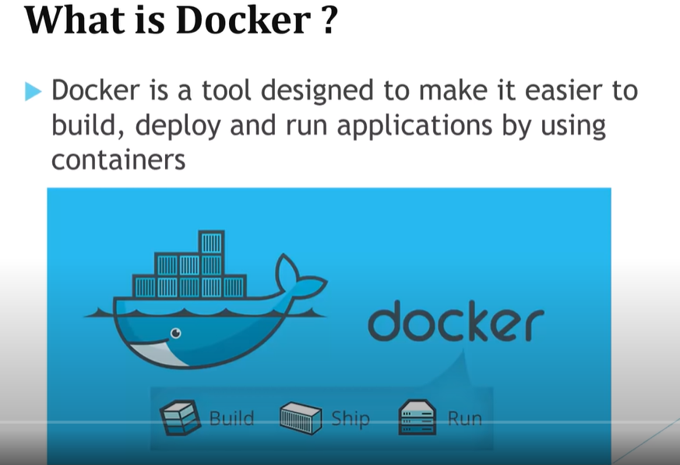

Problems faced :

1. Sometimes the code was working on the dev environment but it was not working on the qa or prod env due to so many reasons i.e there could be version mismatch, software update or library corrupted etc.

How docker resolves this issue :

Containers allow a developer to package up application with all the parts it needs such as libraries and other dependencies and ship it out as one package. After that, on all the env, same code will be deployed and it will be working same throughout.

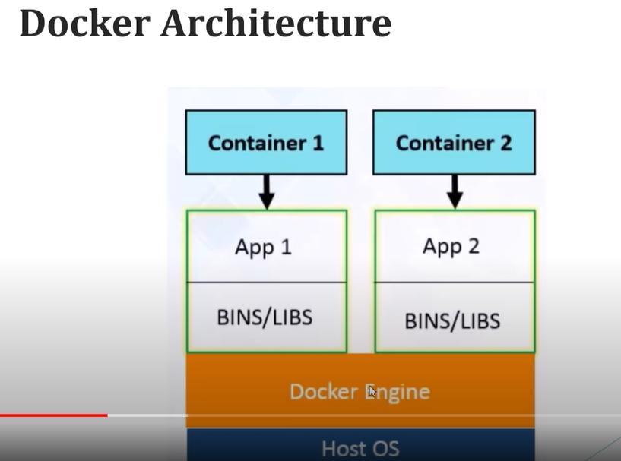

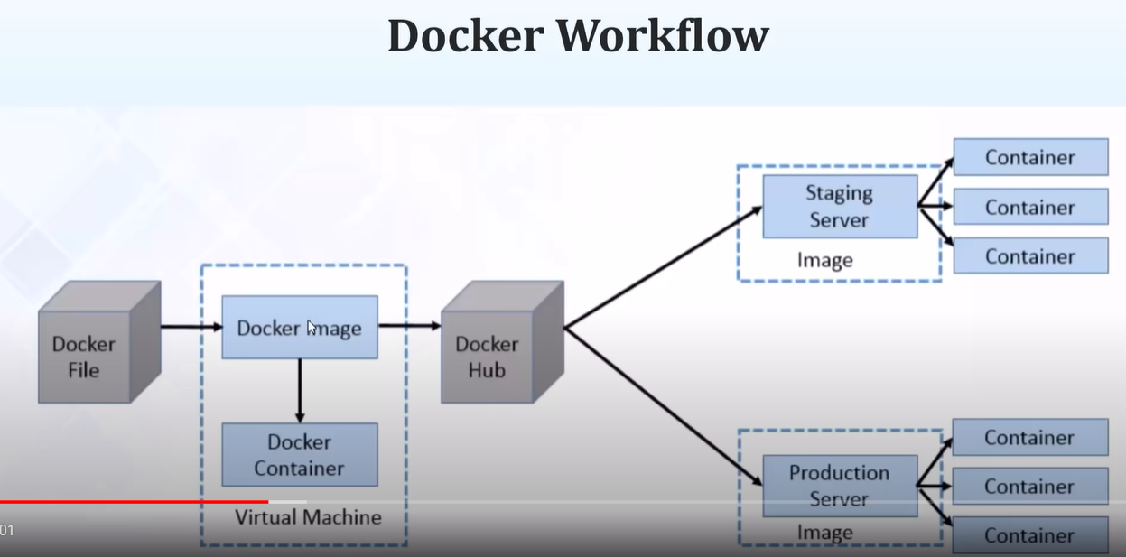

DockerHub : Dockerhub is a repository like github which is used to store docker images.

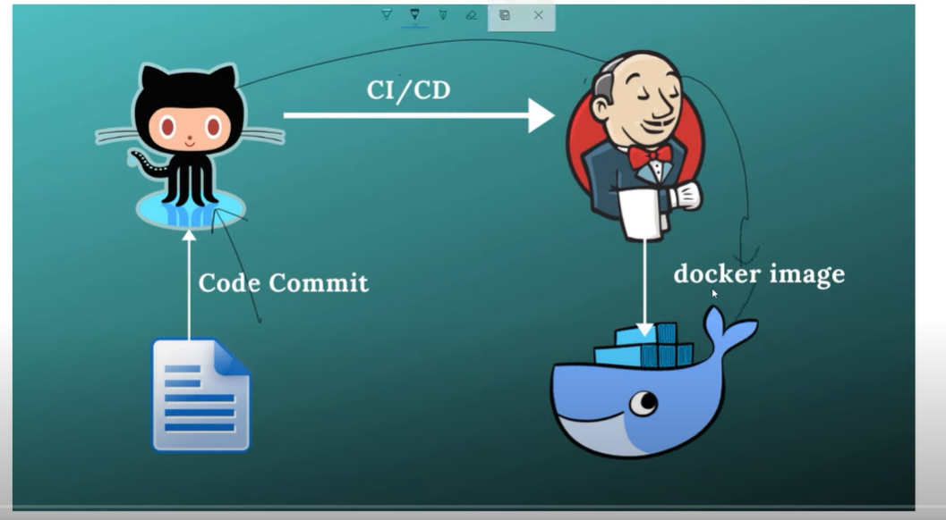

First the code will be pushed to our repository. We can maintain a CI/CD pipeline using Jenkins and Jenkins only will dockerise our image and push it to dockerhub.

Docker compose :

It is basically a container orchestration tool like Kubernetes.

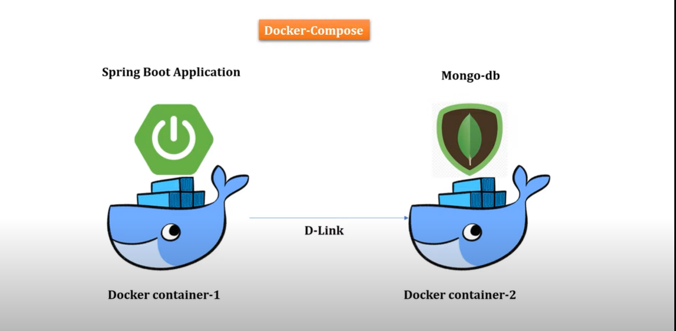

Commands :

* To build docker images:
  + docker build -t spring-boot-docker.jar .
* To check the list of docker images
  + docker image ls
* To delete a docker image
  + docker image rm -f spring-boot-docker.jar
* To run docker image
  + docker run -p 9090:8080 spring-boot-docker.jar (the first port is the localhost port and the second on is the port of the image)
* To login to docker
  + docker login
* To provide a tag for the existing image
  + docker tag spring-boot-docker.jar {{username}}/spring-boot-docker.jar
* To push the image to the dockerhub
  + docker push {{username}}/spring-boot-docker.jar
* To login to docker with username and password mentioned
  + docker login -u "nikhilprabhat" -p "Indigo$123" docker.io
* To initialise docker image of mysql
  + docker run --name mysql-standalone -e MYSQL_ROOT_PASSWORD=password -e MYSQL_DATABASE=db -e MYSQL_USER=sa -e MYSQL_PASSWORD=password -d mysql:latest
* To check how many containers running
  + docker container ls
* To run spring boot container with mysql container
  + docker run -p 8081:8081 --link mysql-standalone:mysql -d spring-mysql-docker.jar
* To stop container
  + docker stop 453b24298da1
* To check list of all containers
  + Docker ps

Check for docker networking also for more details