**Jenkins**

Jenkins is an open source automation tool written in Java programming language that allows continuous integration. Jenkins **builds** and **tests** our software projects which continuously making it easier for developers to integrate changes to the project, and making it easier for users to obtain a fresh build. It also allows us to continuously **deliver** our software by integrating with a large number of testing and deployment technologies.

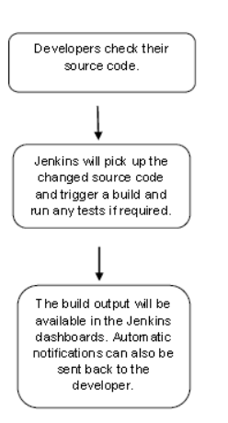

**Continuous Integration with Jenkins**

Continuous Integration (CI) is a development practice in which the developers are needs to commit changes to the source code in a shared repository at regular intervals. Every commit made in the repository is then built. This allows the development teams to detect the problems early.

Continuous integration requires the developers to have regular builds. The general practice is that whenever a code commit occurs, a build should be triggered

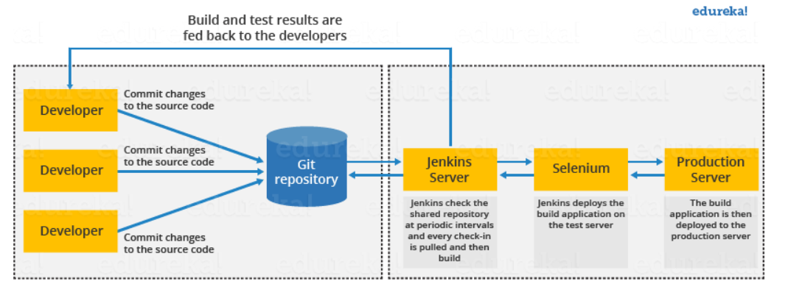

**Jenkins Architecture**

Jenkins architecture has two components:

* Jenkins Master/Server
* Jenkins Slave/Node/Build Server

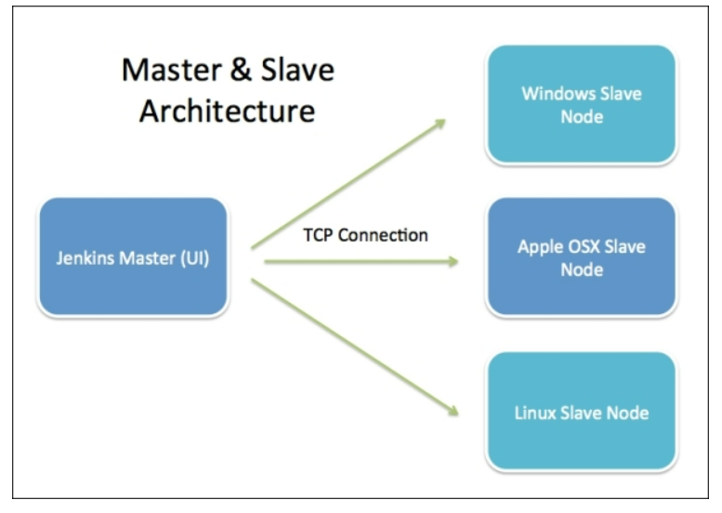

* **Jenkins Master :** The main server of Jenkins is the Jenkins Master. It is a web dashboard which is nothing but powered from a war file. By default it runs on 8080 port. With the help of Dashboard, we can configure the jobs/projects but the build takes place in Nodes/Slave.
  + Scheduling build jobs.
  + Dispatching builds to the nodes/slaves for the actual execution.
  + Monitor the nodes/slaves (possibly taking them online and offline as required).
  + Recording and presenting the build results.
  + A Master/Server instance of Jenkins can also execute build jobs directly.
* **Jenkins Slave :** Jenkins slave is used to execute the build jobs dispatched by the master. We can configure a project to always run on a particular slave machine, or particular type of slave machine, or simple let the Jenkins to pick the next available slave/node.

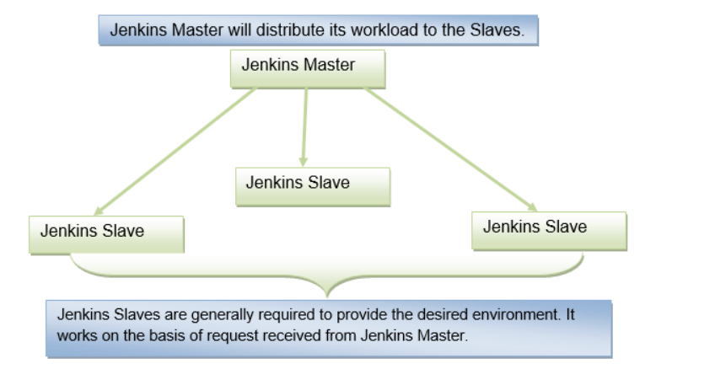

**ELK**

