**Kubernetes**

Kubernetes is a container orchestration technology developed in Google lab to manage containerized applications in different kind of environments such as physical, virtual, and cloud infrastructure. It is an open source system which helps in creating and managing containerization of application.

**Key Objects of Kubernetes**

* **Pod :** It is the smallest and simplest basic unit of Kubernetes application.This unit indicates the process running in the cluster.
* **Node :** A node is nothing but a single host which is used to run physical and virtual machines. A node in the Kubernetes is also known as minion.
* **Service :** A service in Kubernetes is a logical set of pods which work together. With the help of services, users can easily manage load balancing configurations.
* **ReplicaSet :** A ReplicaSet in the Kubernetes is used to identify the particular no of pod replicas running at a given time.

**Features of Kubernetes**

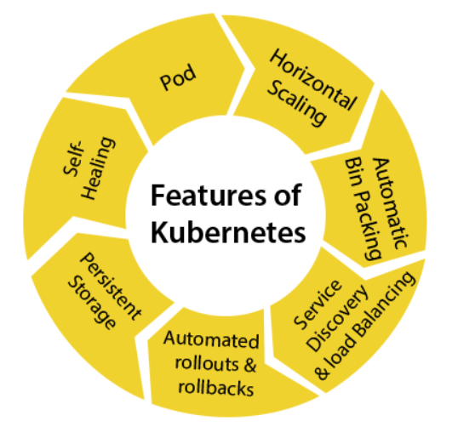

* **Pod :** It is a deployment unit in Kubernetes with a single internet protocol address.
* **Horizontal Scaling :** This features automatically increases or decreases the no of pods according to CPU Utilisation.
* **Automatic Bin Packing :** Kubernetes helps the user to declare the maximum and minimum resources of computers for their containers.
* **Service Discovery and Load Balancing :** Kubernetes assigns the IP address to a set of containers and also balances the load across them
* **Automated rollout and rollbacks :** Using the rollouts, kubernetes distributes the changes and updates to an application or configuration. If any issue comes, then it rolls back all the changes.
* **Self Healing :** For all those containers which stopped due to some failures, Kubernetes restarts them automatically and if it doesn’t respond to the health status to users, it stops them from working.

**Kubernetes Architecture**

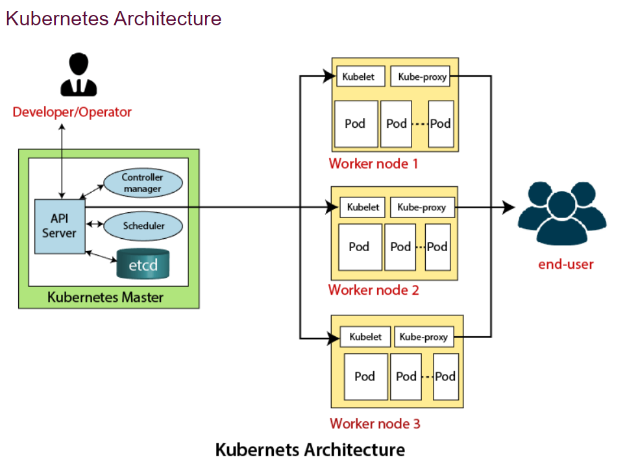

It consists of mainly two components :

* Master Node (Control Plane)
* Slave/Worker Node

**Master Node**

The master node in a kubernetes architecture is used to manage the state of the cluster.It is an entrypoint for all types of administrative tasks. In Kubernetes cluster, more than one master node is always present for sake of fault tolerance.

* **API Server** : It executes the REST commands which are sent by the users. It validates the requests, process and executes them.After the execution of REST commands, the resulting state of a cluster is saved in **etcd**.
* **Scheduler** : It schedules the task to the worker nodes. For every worker node ,It is used to store the resource usage information. In other words, it is a process that is responsible for assigning pods to the available worker nodes.
* **ETCD** : It is an open source, simple and distributed key value storage which is used to store the cluster data. It is a part of master node, written in GO programming language.

**Worker Node**

The worker node in a Kubernetes is also known as minions. A worker node is a physical machine that executes the applications using pods.

* **Kubelet :** It ensures that that the pods and containers are running smoothly by communicating with master node. It also starts , stops and maintains the containers.
* **KubeProxy :** The main aim of the component is request forwarding.

**Docker**