NATIONAL INSTITUTE OF TECHNOLOGY DELHI



Session (2024-2025)

Practical Lab File

“Deep Learning And Applications”

(CSBB 424)

Submitted To:
Dr. Arjun Singh Rawat
(Assistant Professor)
Computer Science and
Engineering Department

Submitted By:
Shashank Shekhar Verma
(221230059)
B.Tech. (VI semester)
Electrical Engineering

Table of Content

S.  No. | Experiment Name | Date of Submission | Remarks
1 | Regression problem using linear regression and custom ANN model | 07.01.25
2 | Binary classification using logistic regression and custom ANN model | 14.01.25
3 | Multiclass classification using custom ANN Model | 21.01.25
4 | Train models using pretrained model and custom model: VGG16, ResNet50, MobileNet, Efficient NetB1, DenseNet121, Xception | 28.01.25
5 | Brain Tumor Segmentation using UNET Architecture | 11.02.25
6 | Next word predictor using RNN, LSTM, BILSTM, GRU, and Attention based (all variants) | 18.03.25
7 | Landslide detection using UNet (all variants) | 25.03.25
8 | Text summarization using transformer | 01.04.25
9 | Plant disease prediction using swin and vision transformer | 08.04.25
10 | Generate fake images using GAN | 15.04.25
11 | Objection detection using YOLO, RCNN, fast CNN, Faster RCNN, other pretrained models in Tensorflow 2.0 | 22.02.25

Experiment-1

AIM:
To implement Regression problem using linear regression and custom ANN model for housing price prediction dataset on Kaggle.

SOFTWARE USED:
Jupyter Notebook

DATASET USED:
Housing Price Prediction dataset

SOURCE CODE AND OUTPUT:

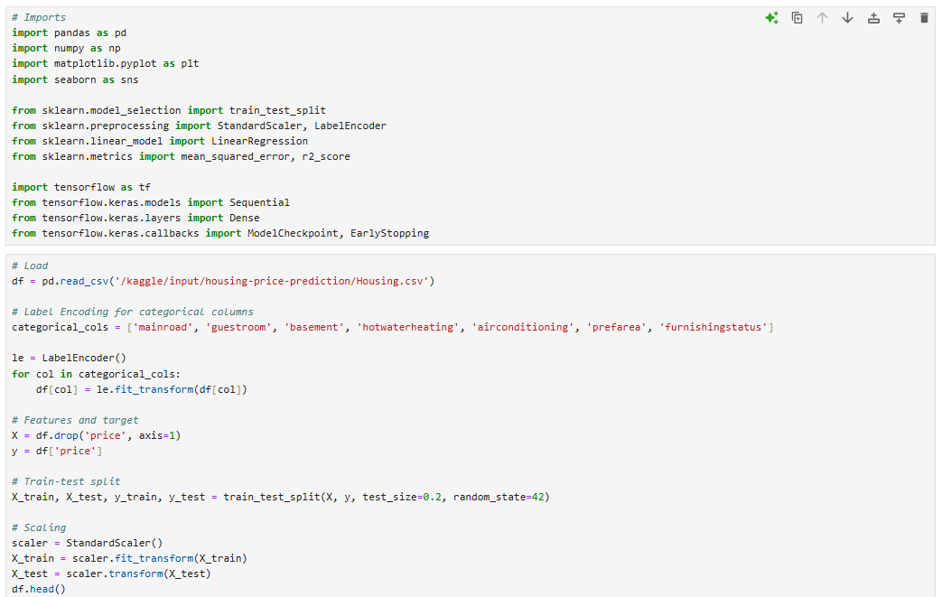
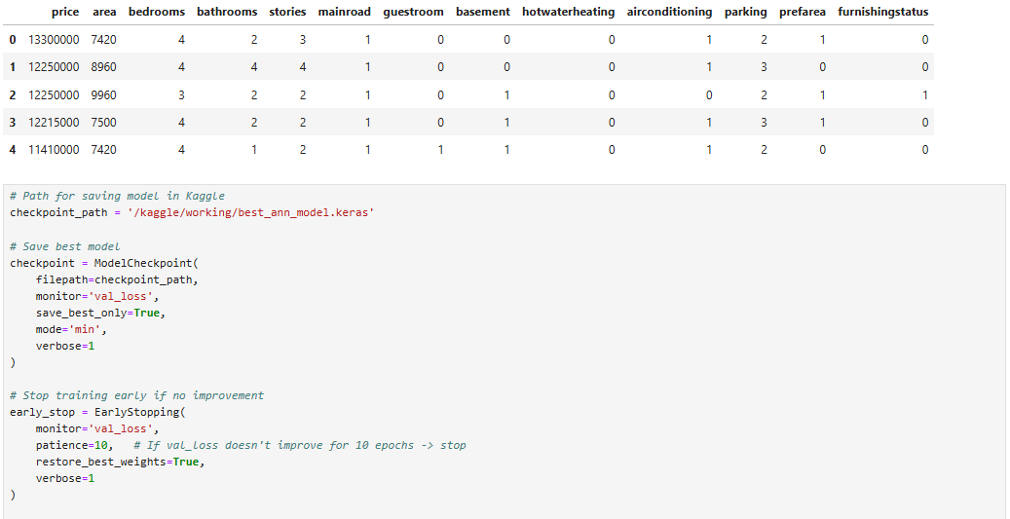
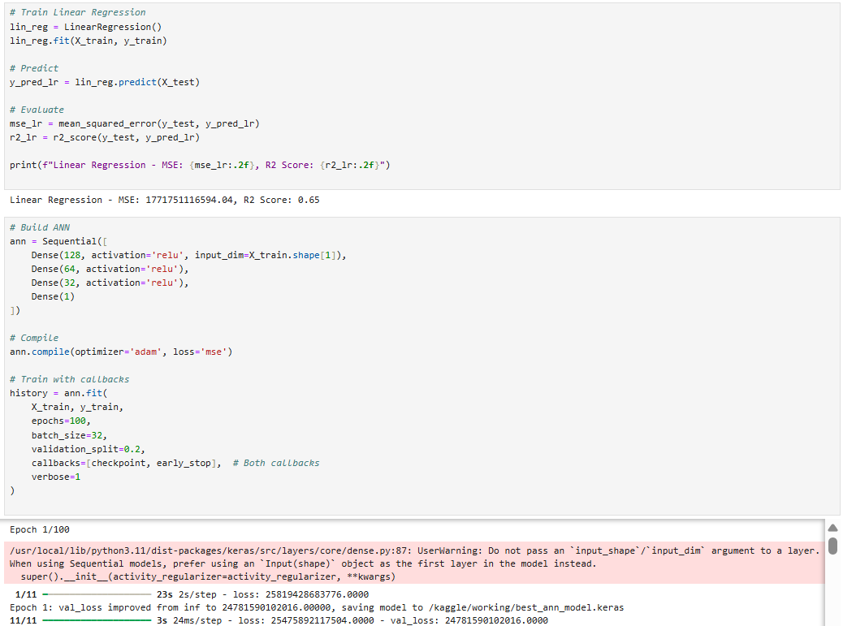
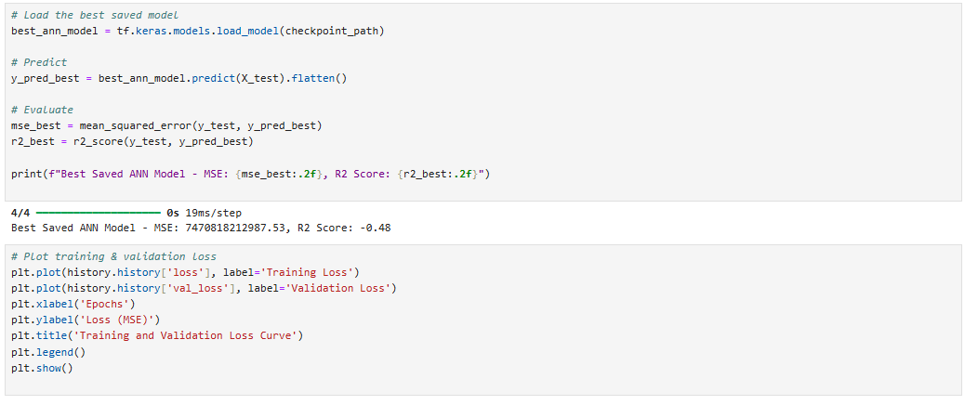
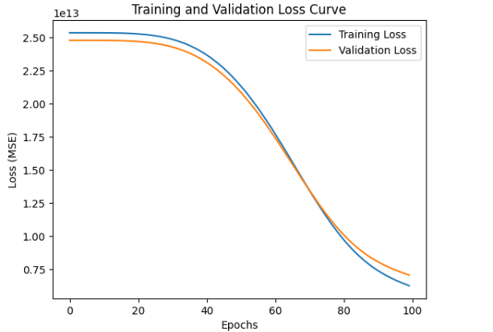
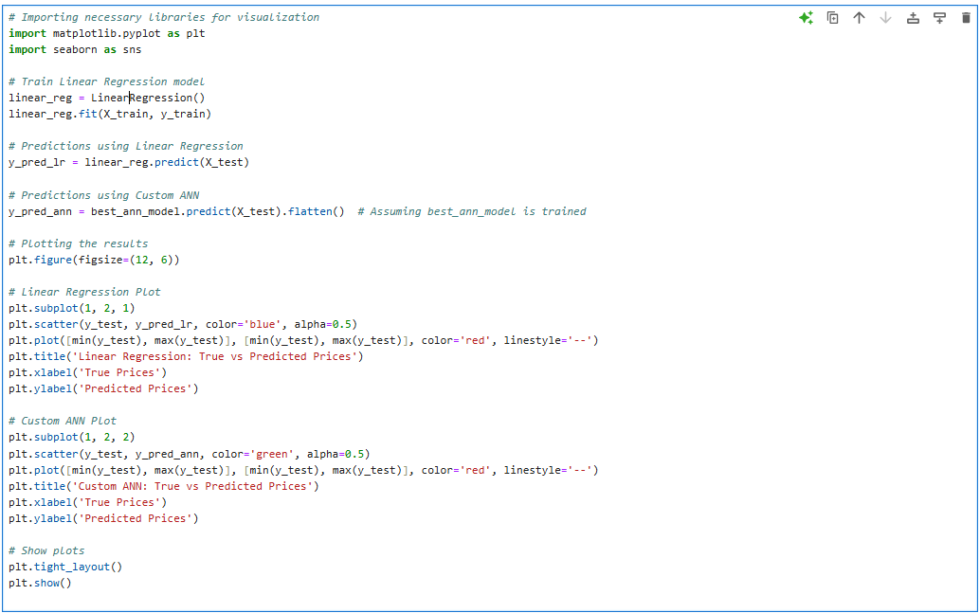
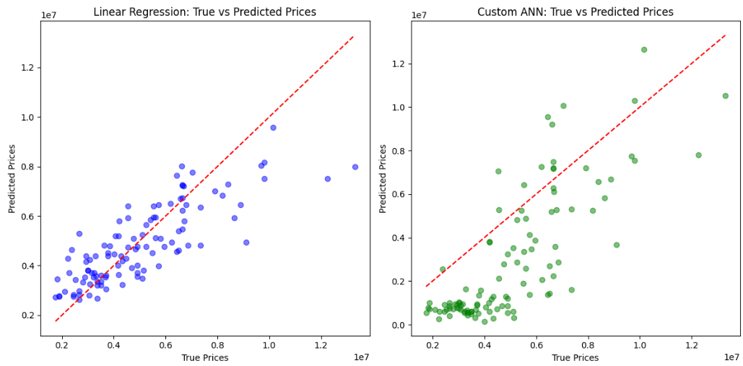

Experiment-2

AIM:
To implement Binary classification using logistic regression and custom ANN model for titanic dataset.

SOFTWARE USED:
Jupyter Notebook

DATASET USED:
Titanic Dataset

SOURCE CODE AND OUTPUT:
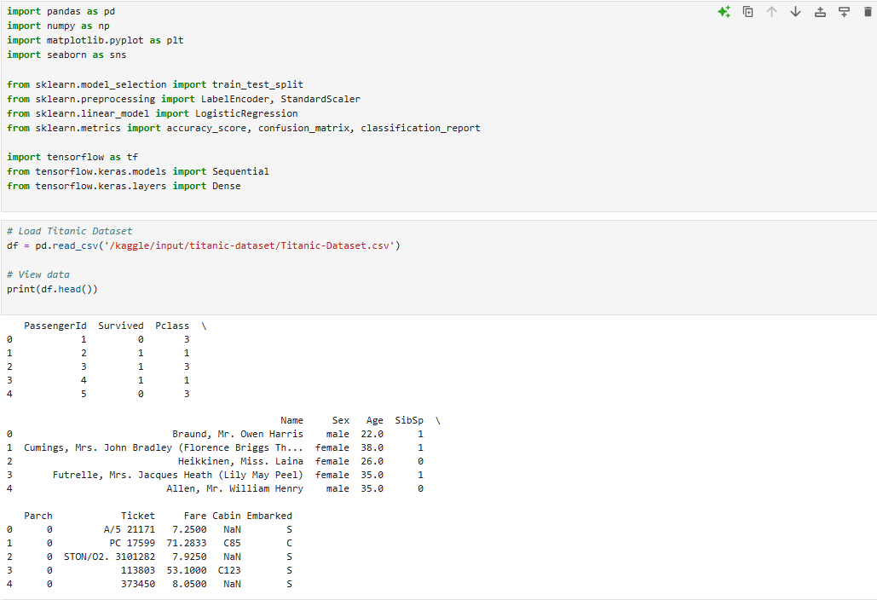
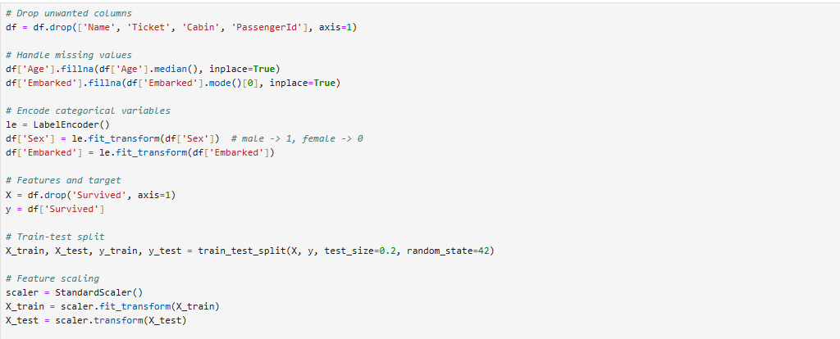
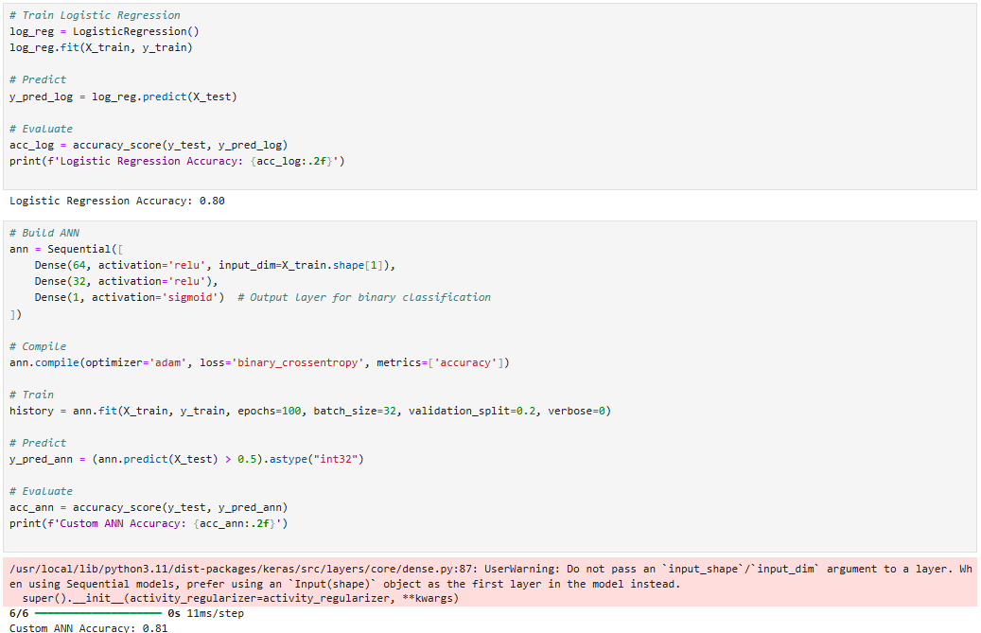
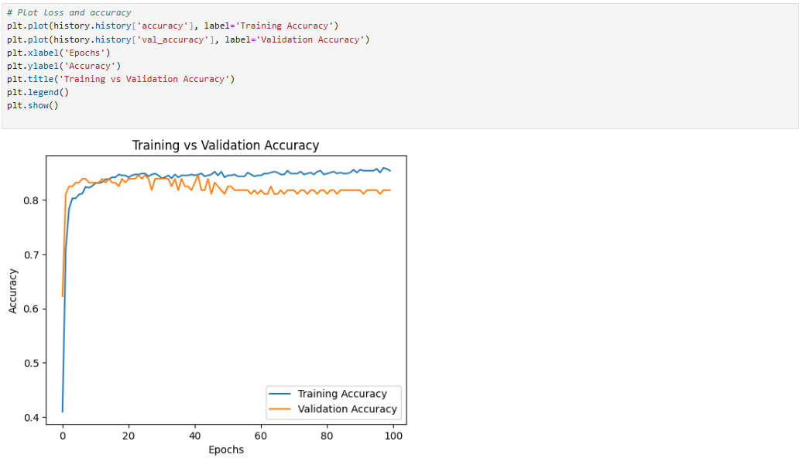

Experiment-3

AIM:
To implement Multiclass classification using custom ANN model.

SOFTWARE USED:
Jupyter Notebook

DATASET USED:
MNIST Dataset

SOURCE CODE AND OUTPUT:
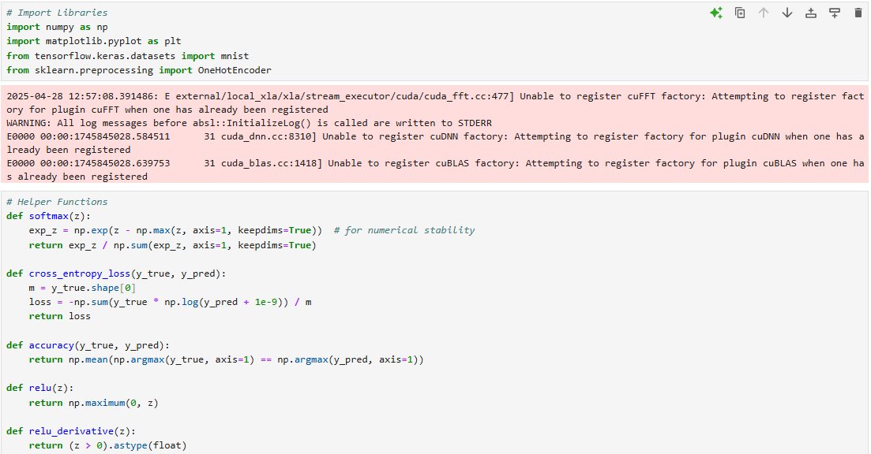
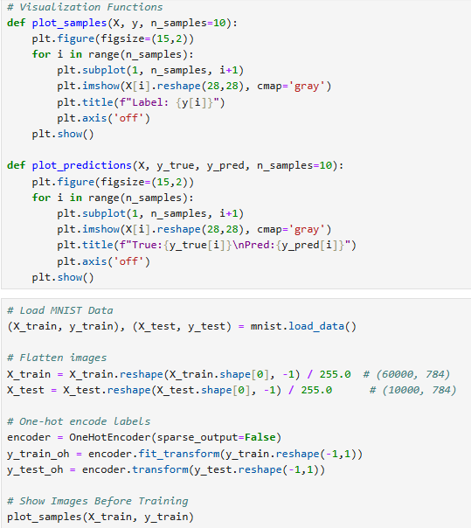

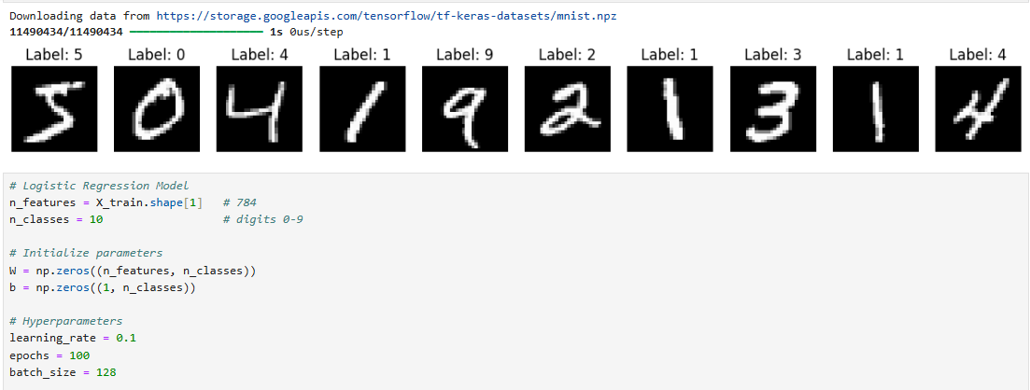
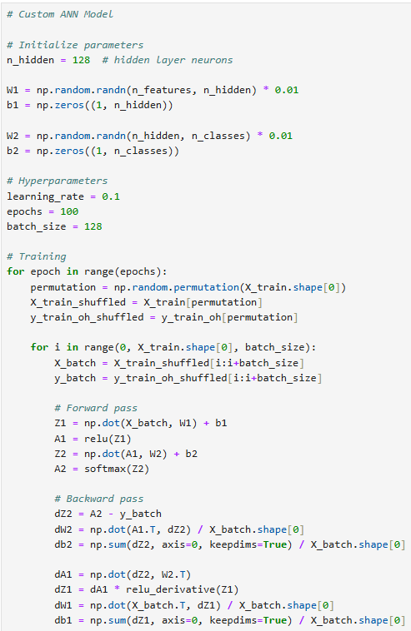
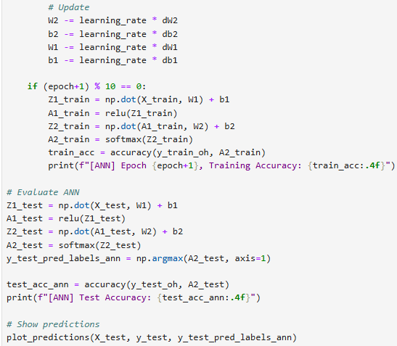
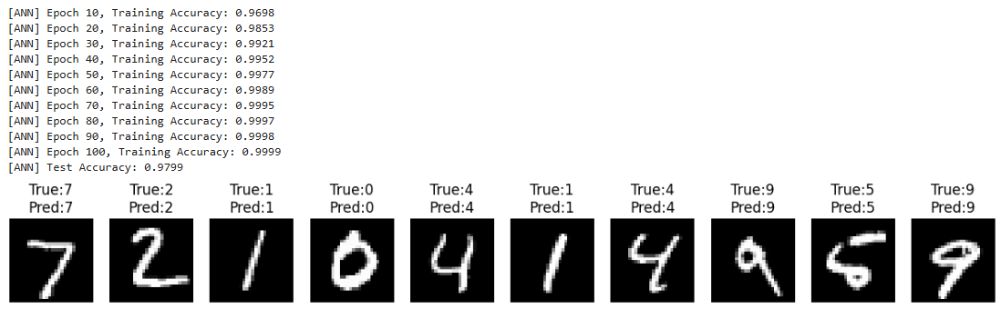
Experiment-4

AIM:
To implement Train models using pretrained model and custom model: VGG16, ResNet50, MobileNet, Efficient NetB1, DenseNet121, Xception.

SOFTWARE USED:
Jupyter Notebook

DATASET USED:
CIFAR dataset

SOURCE CODE AND OUTPUT:
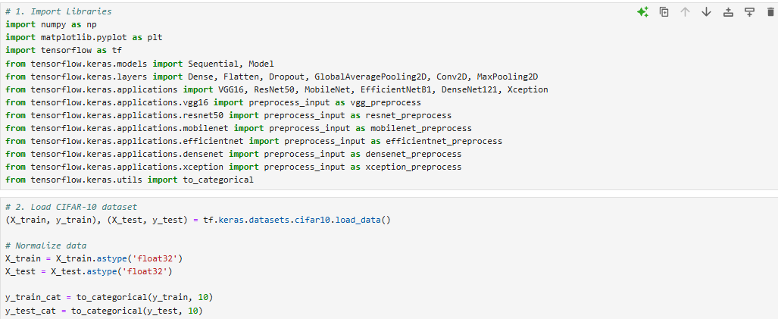
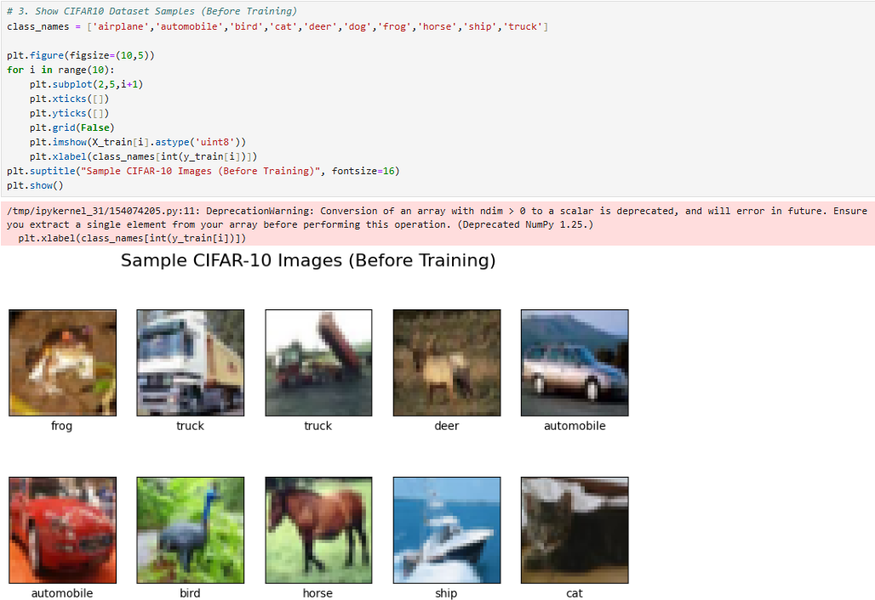
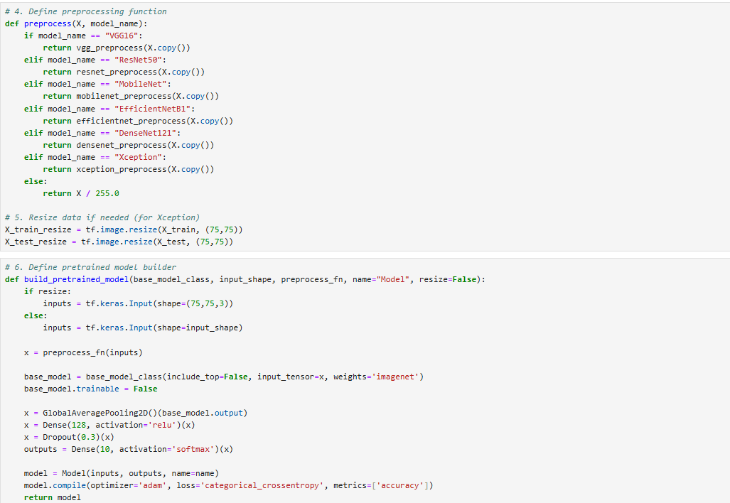
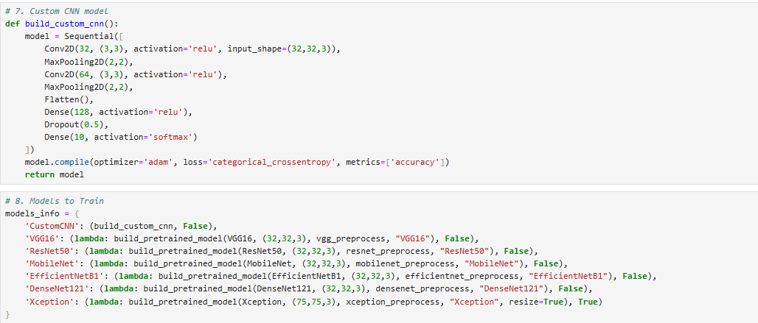
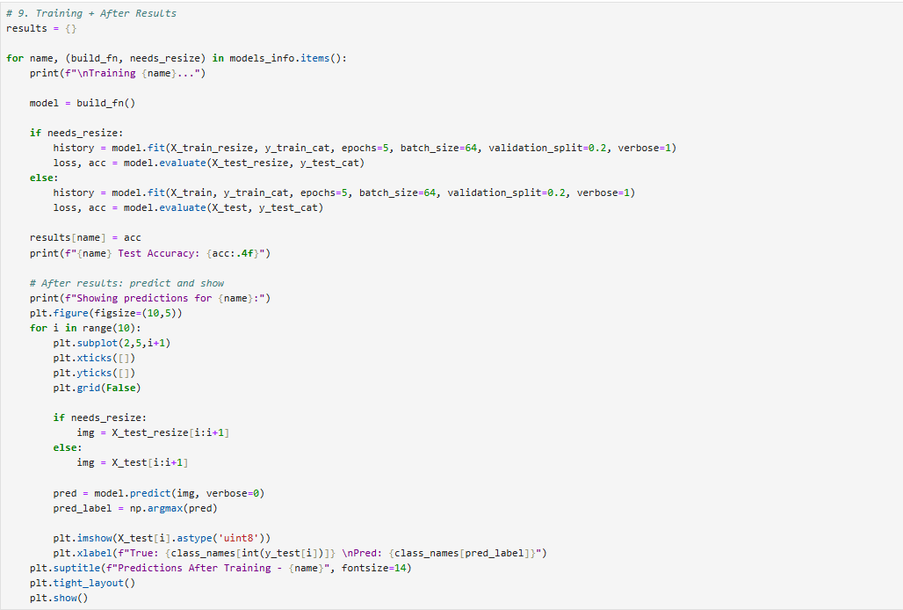
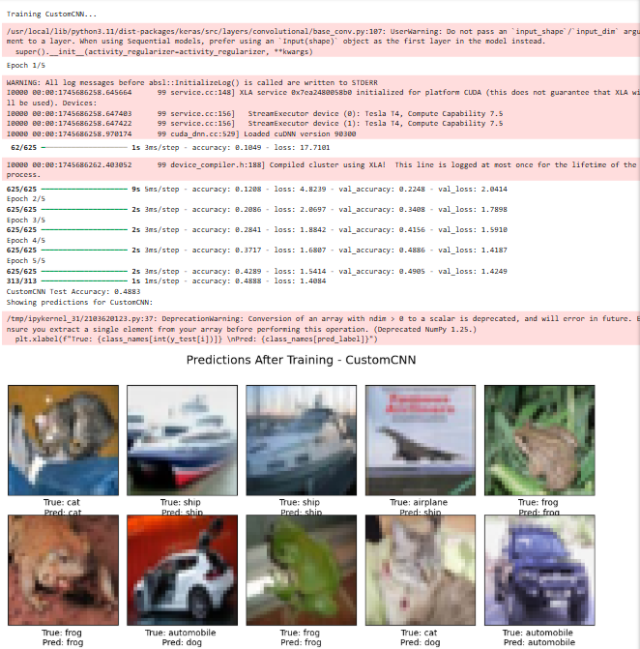
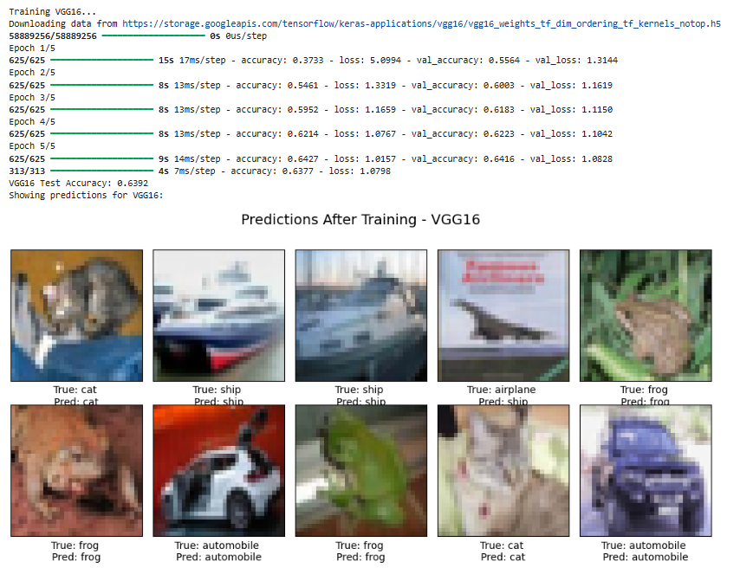
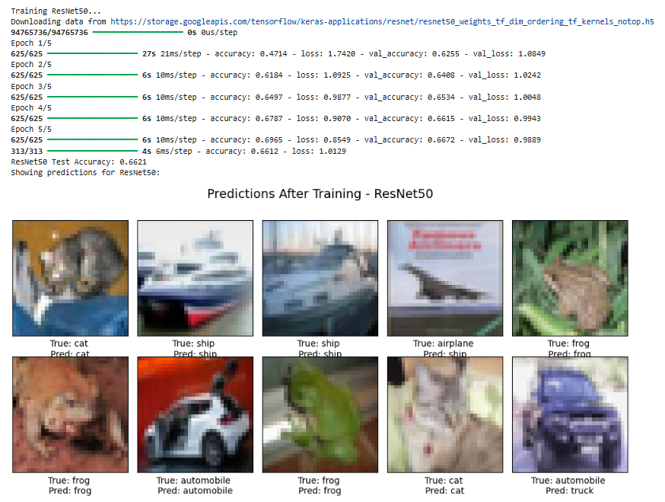

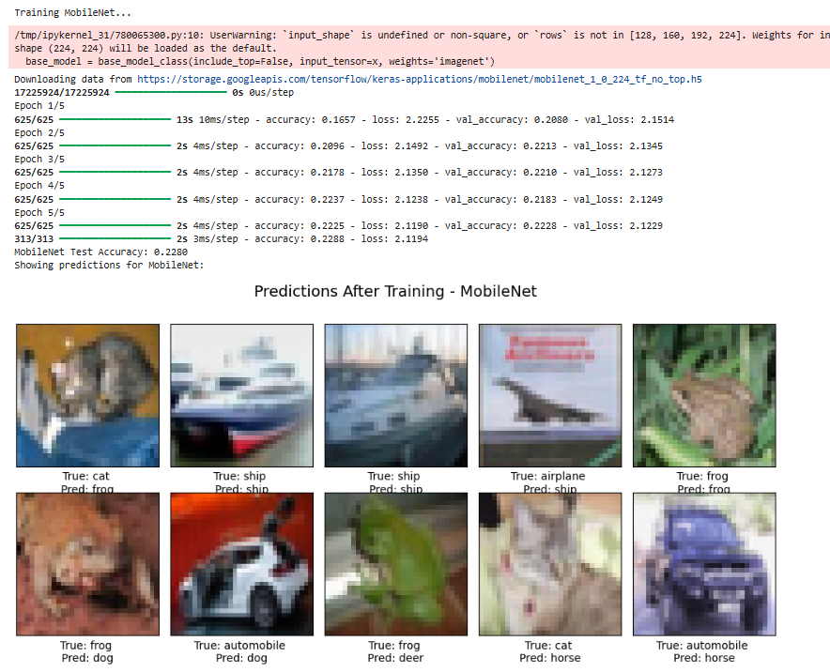
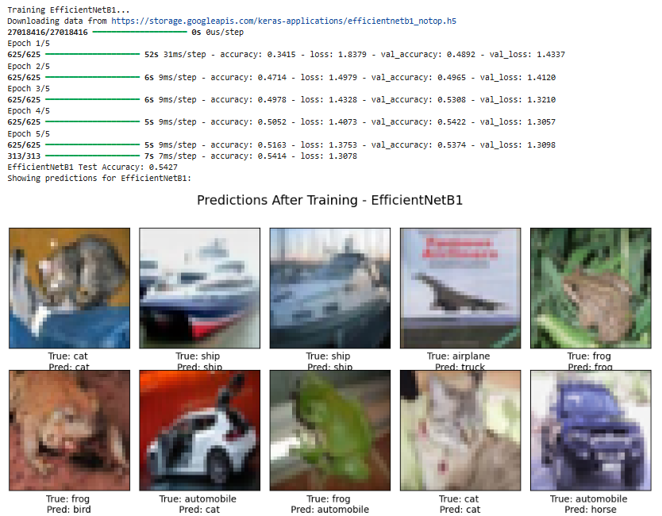
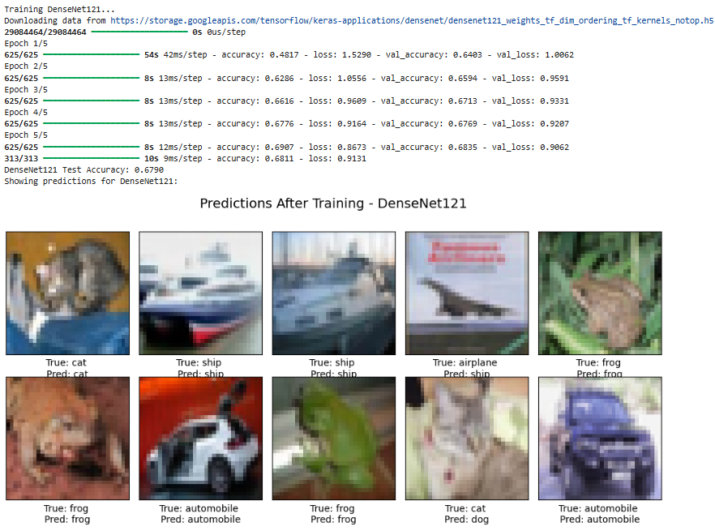
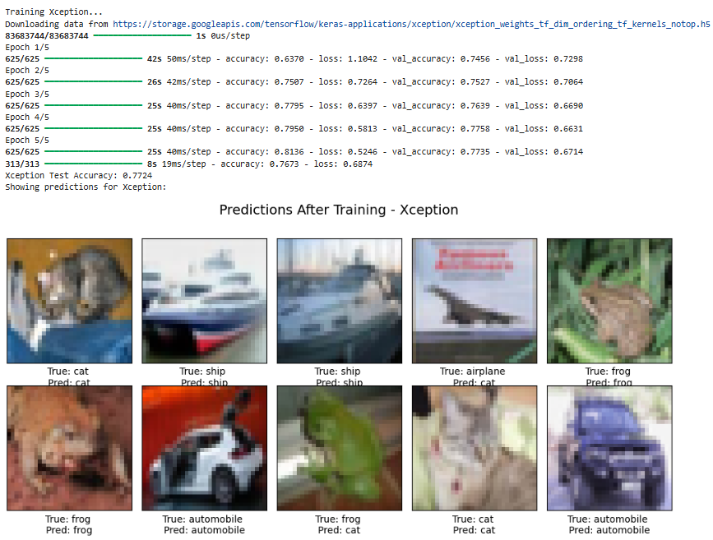

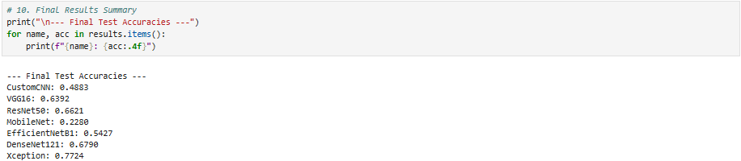

Experiment-5

AIM:
To implement Brain Tumor Segmentation using UNET Architecture.

SOFTWARE USED:
Jupyter Notebook

DATASET USED:
Brain Tumor Segmentation

SOURCE CODE AND OUTPUT:
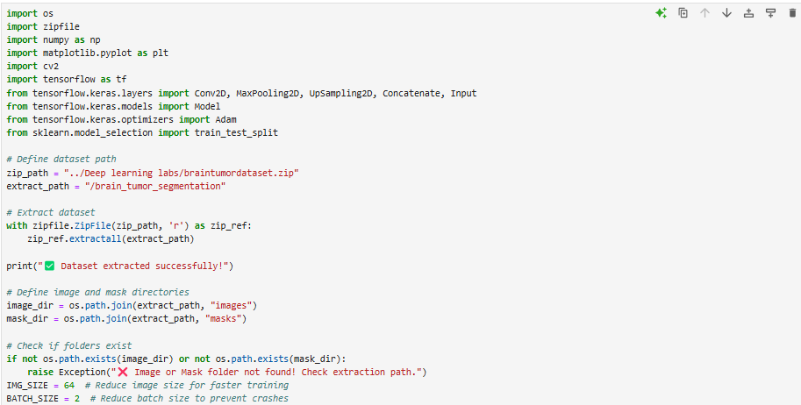
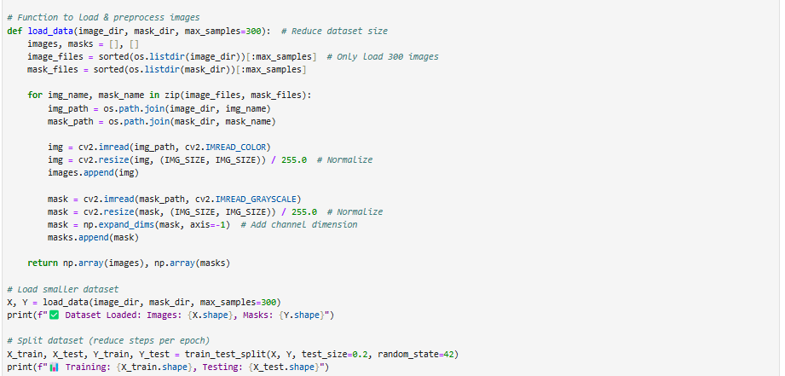

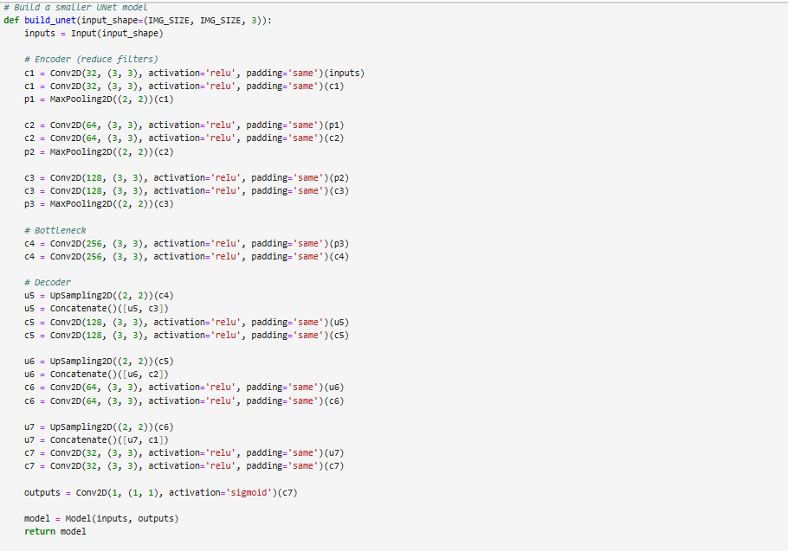
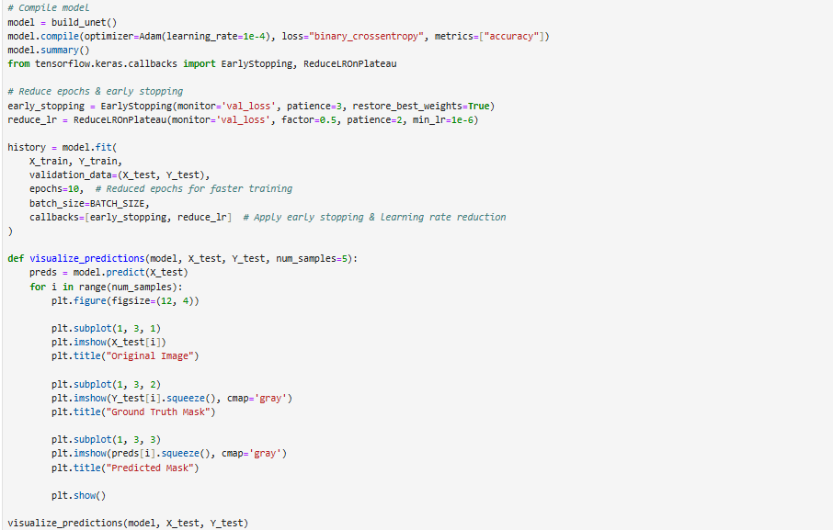

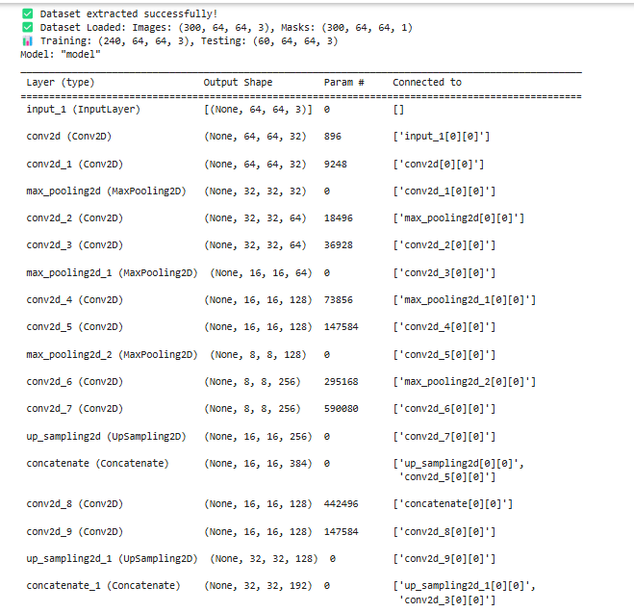
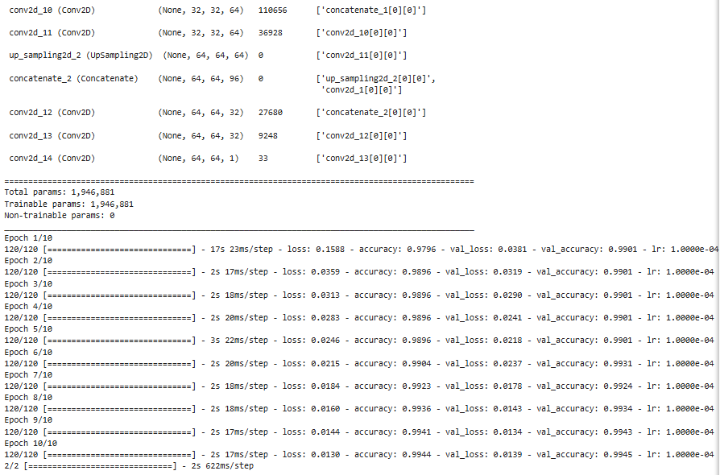

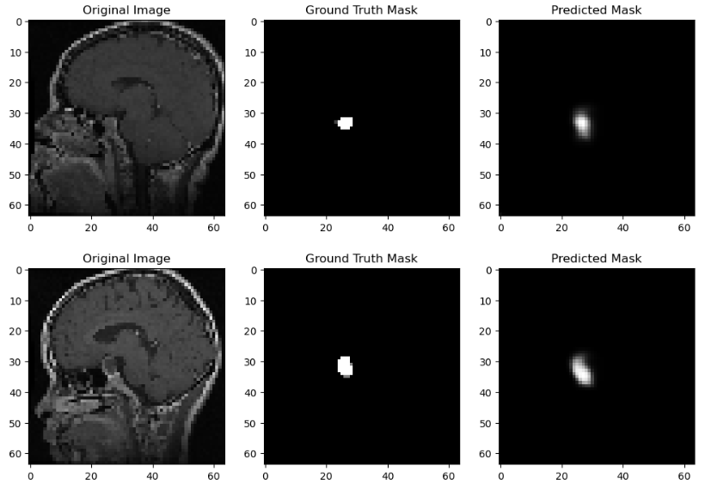
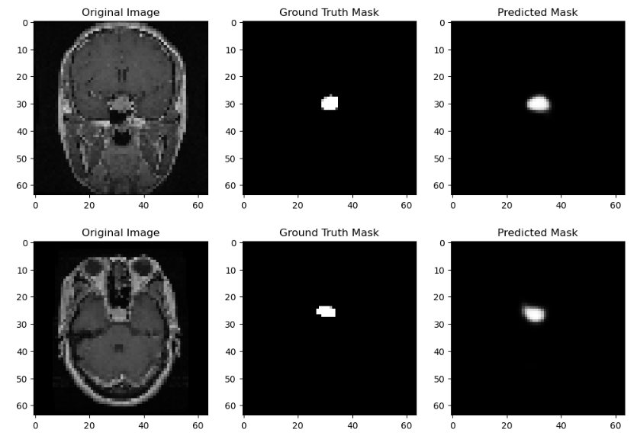
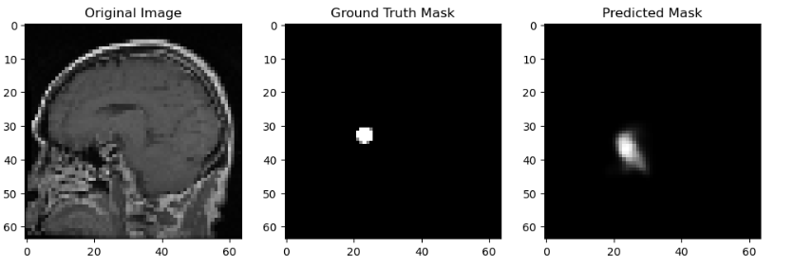
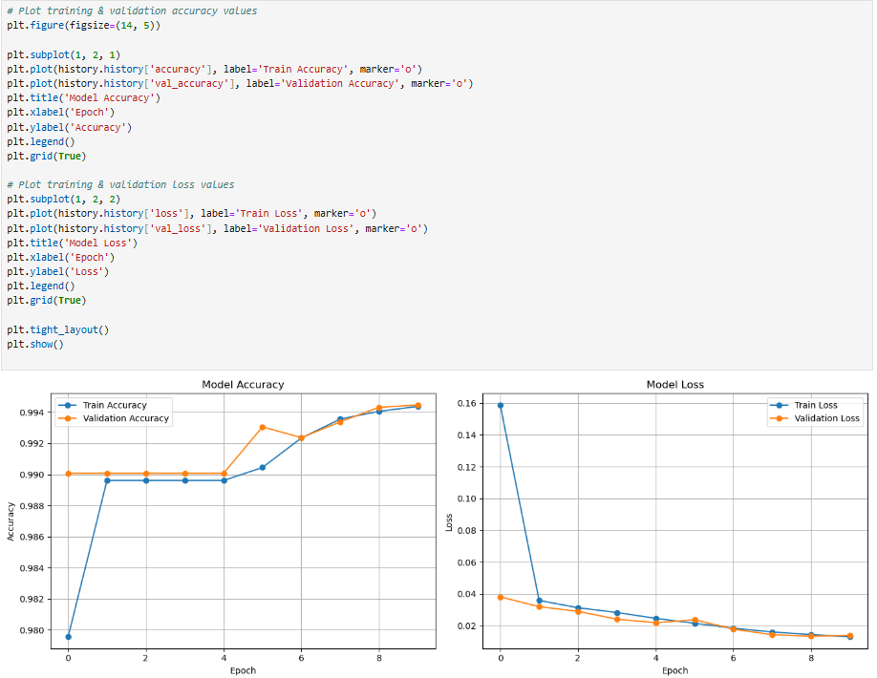

Experiment-6

AIM:
To implement Next word predictor using RNN, LSTM, BILSTM, GRU, and Attention based (all variants).

SOFTWARE USED:
Jupyter Notebook

DATASET USED:
None

SOURCE CODE:
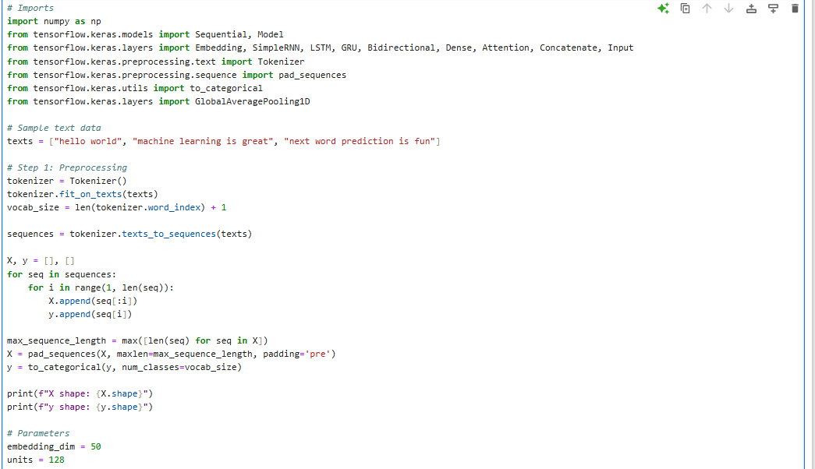
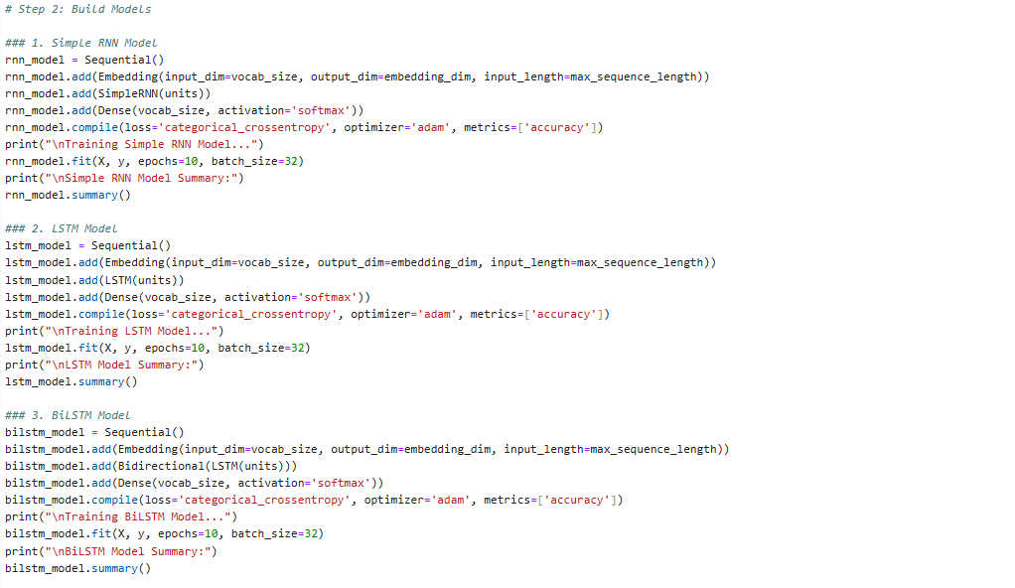
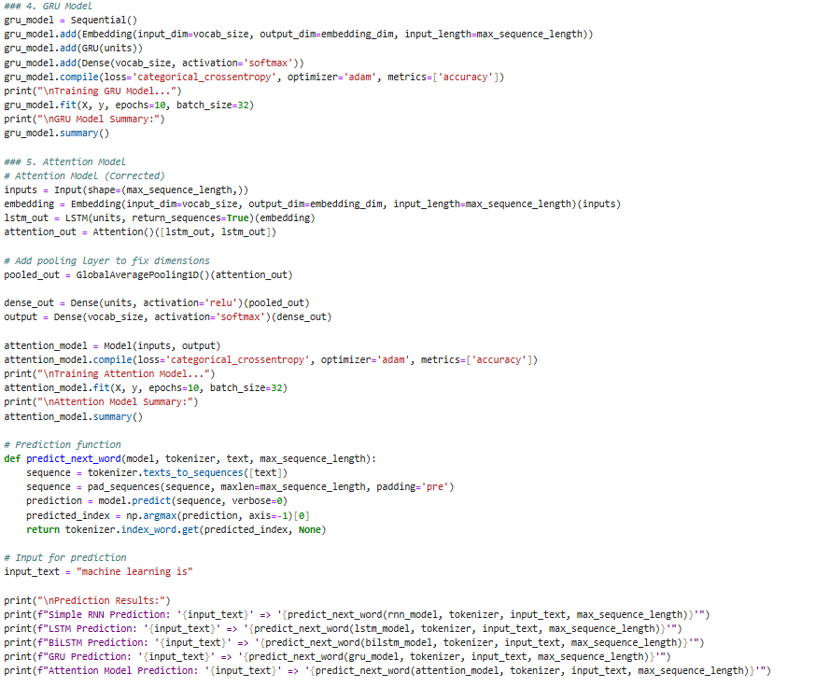
OUTPUT:
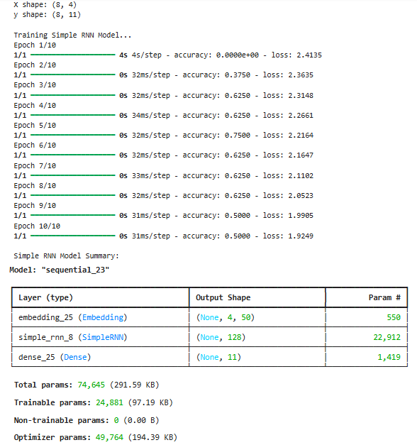
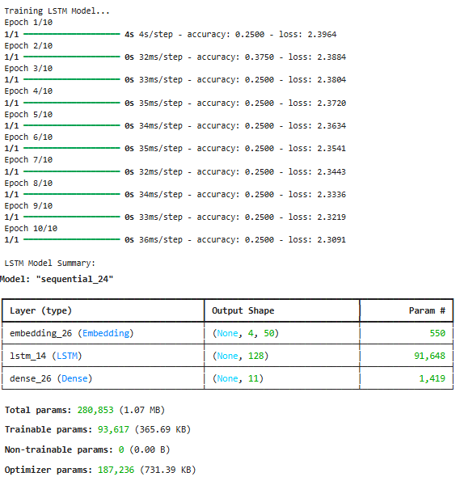
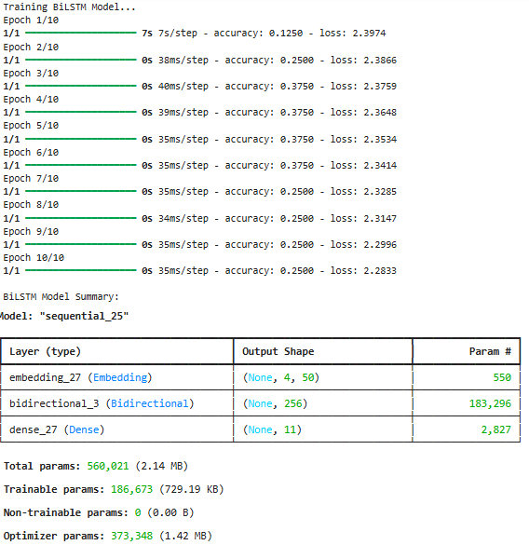

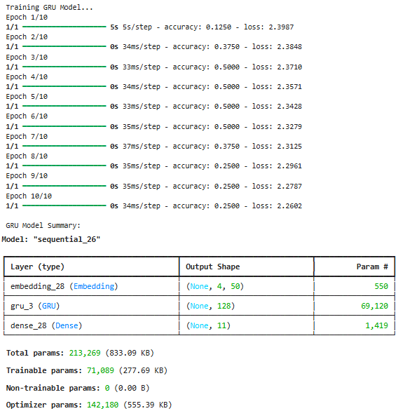
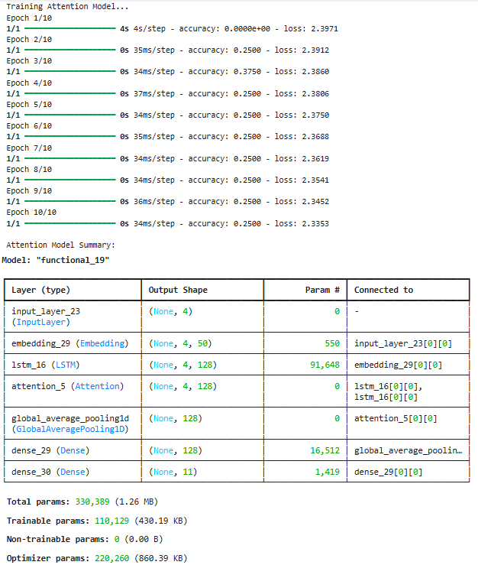
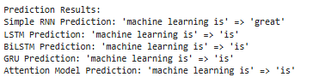

Experiment-7

AIM:
To implement Landslide detection using UNet (all variants).

SOFTWARE USED:
Jupyter Notebook

DATASET USED:
landslide4sense

SOURCE CODE AND OUTPUT:
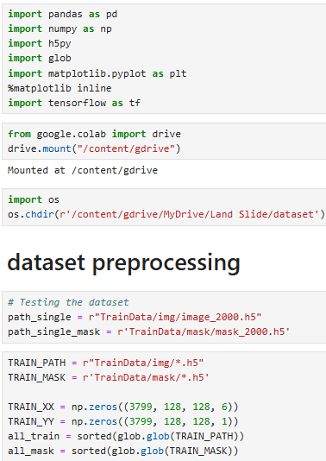
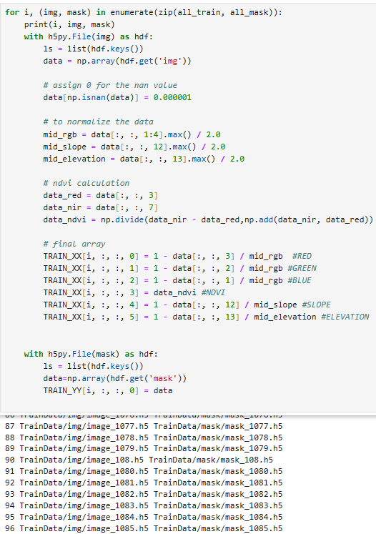
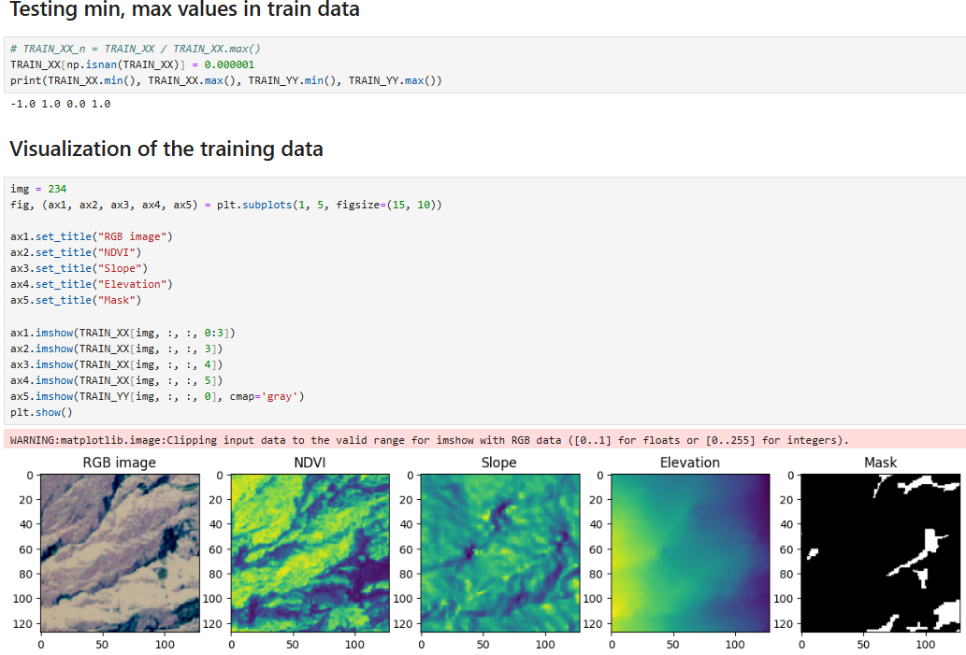
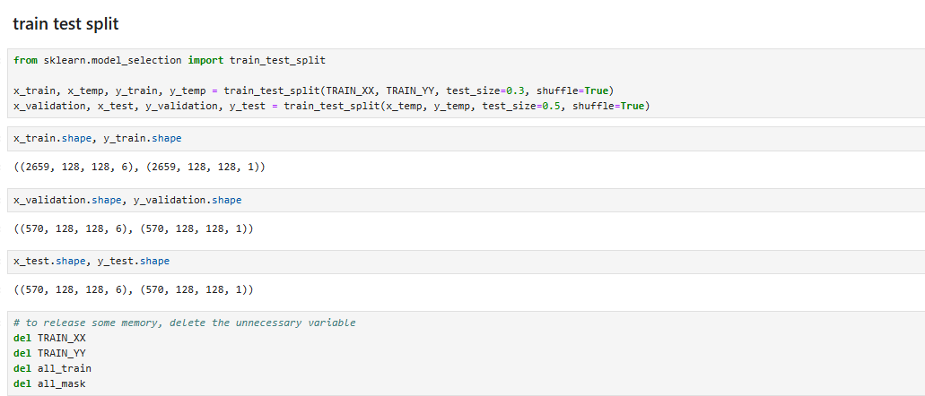
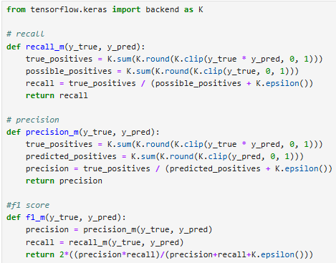

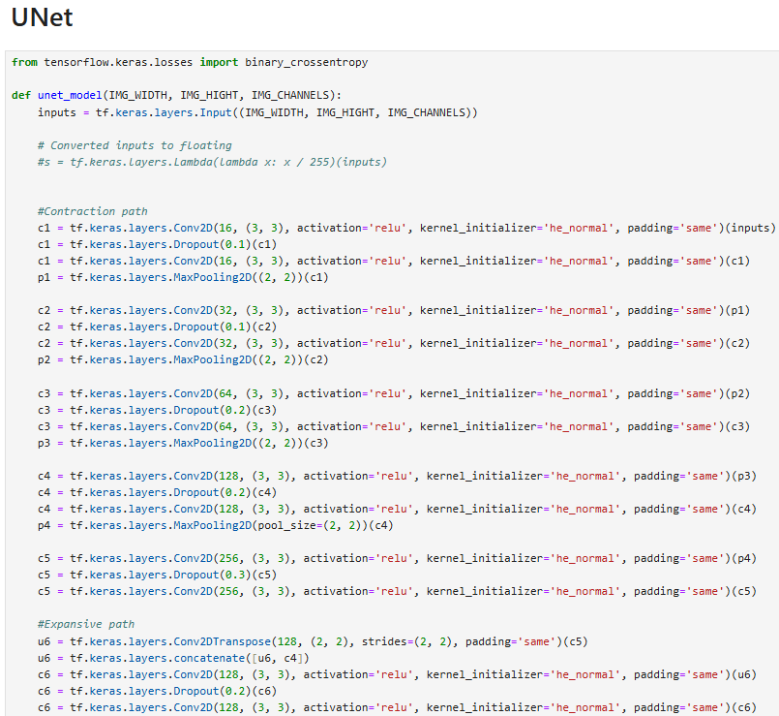
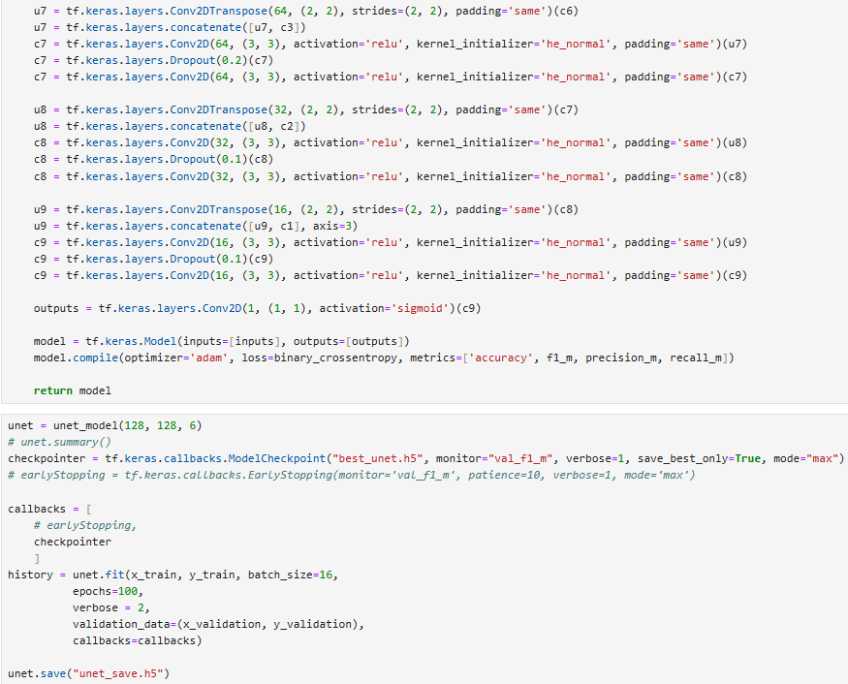

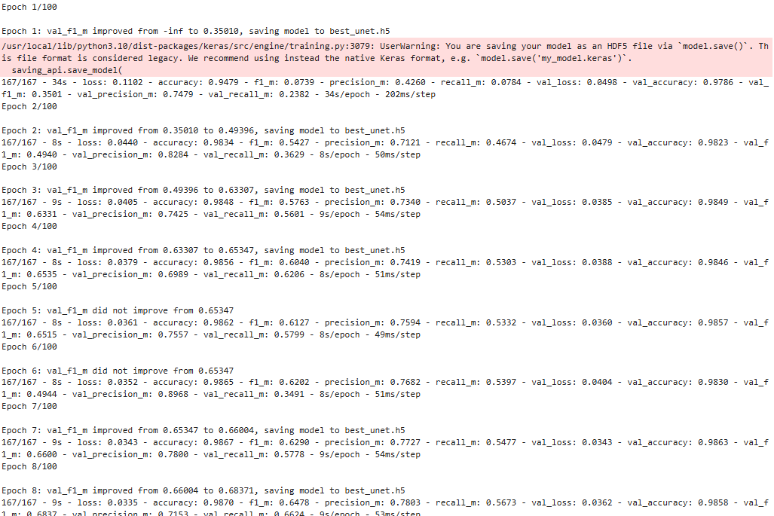
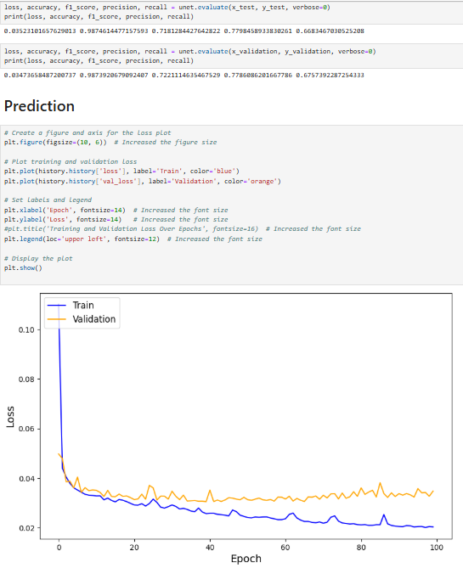
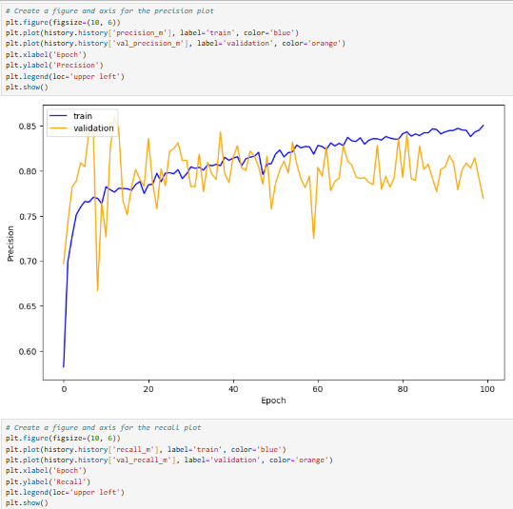
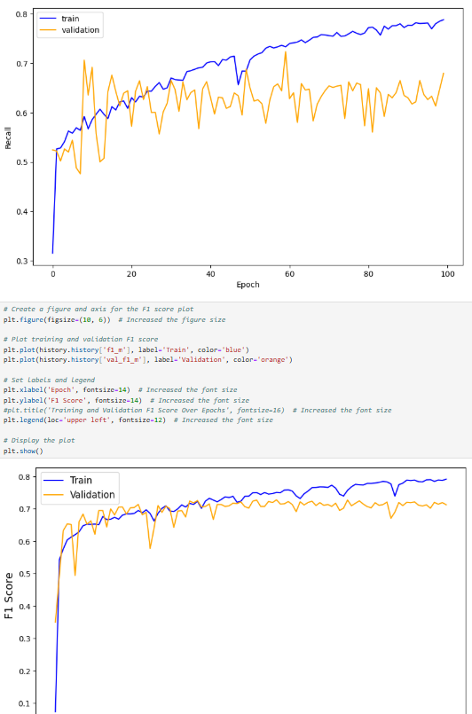
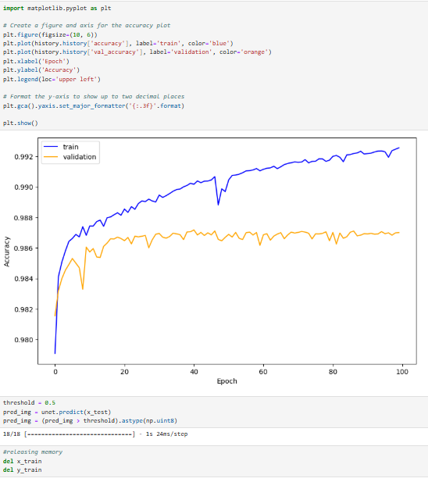
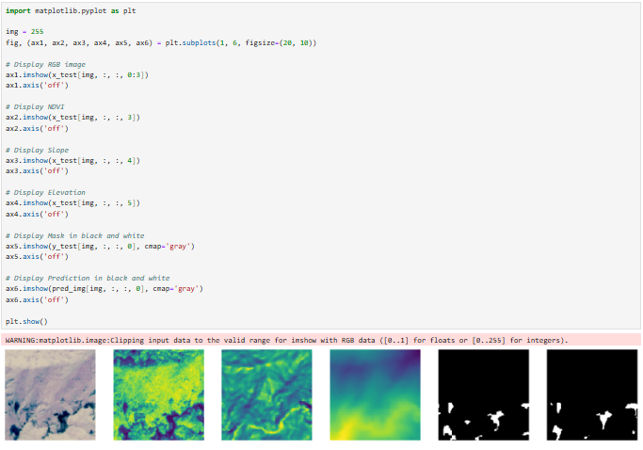

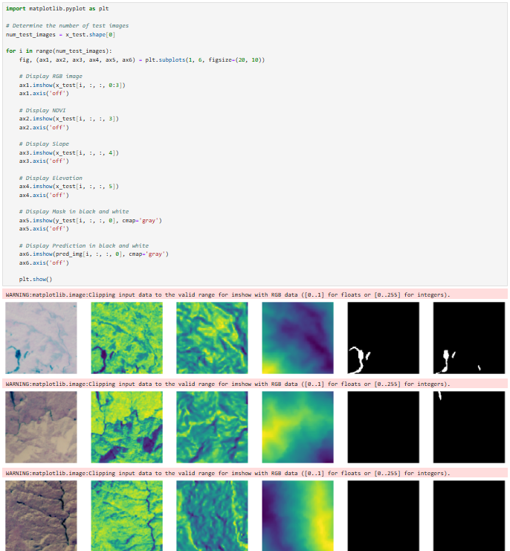
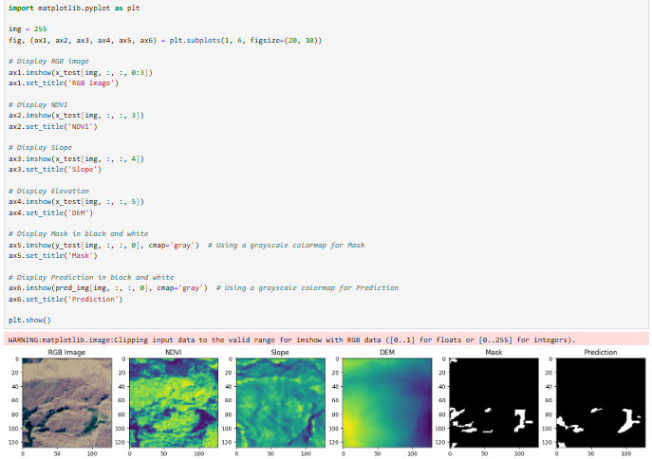

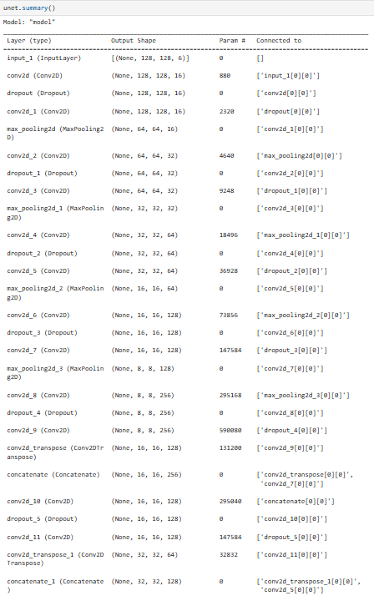
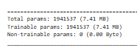

Experiment-8

AIM:
To implement Text summarization using transformer.

SOFTWARE USED:
Jupyter Notebook

DATASET USED:
None

SOURCE CODE AND OUTPUT:
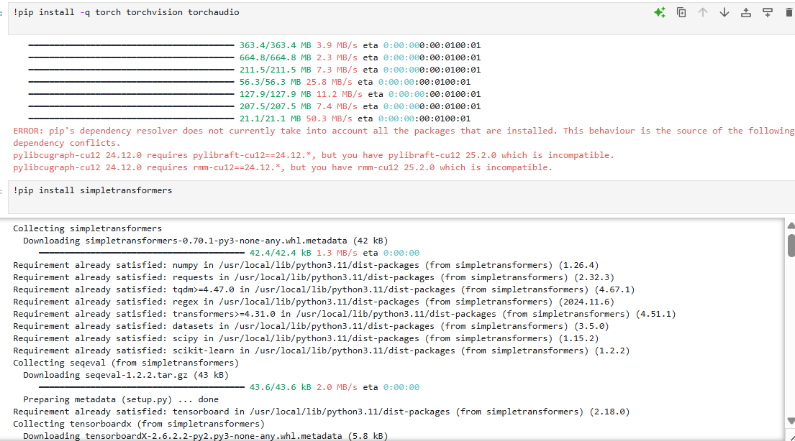
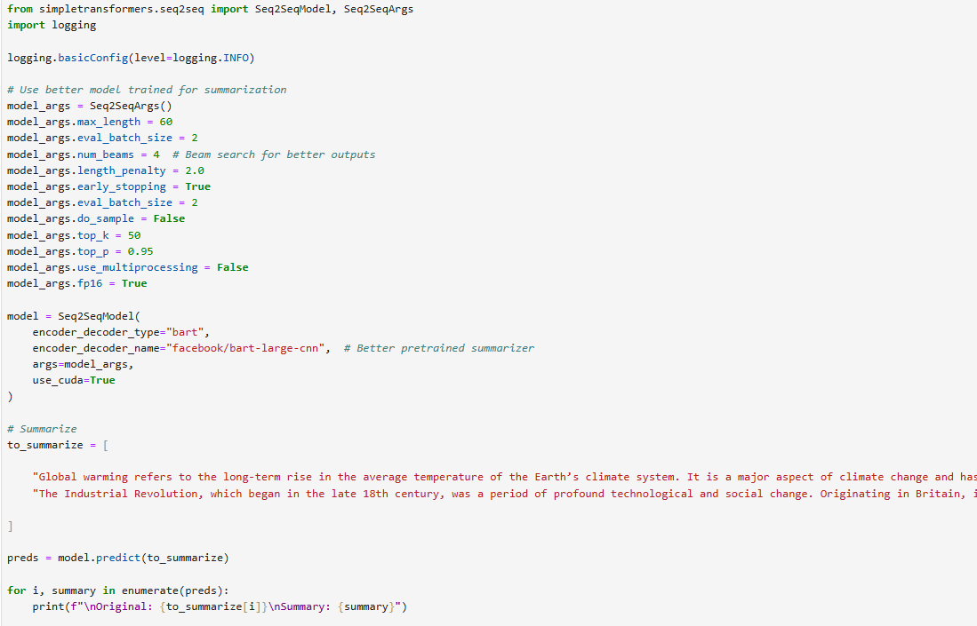
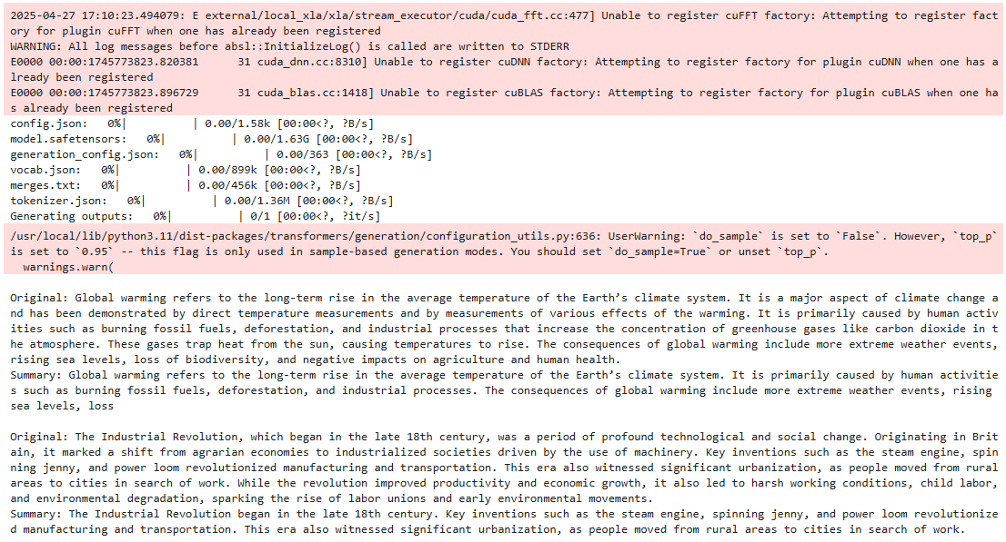

Experiment-9

AIM:
To implement Plant disease prediction using swin and vision transformer.

SOFTWARE USED:
Jupyter Notebook

DATASET USED:
Sugarcane Leaf Disease Dataset

SOURCE CODE AND OUTPUT:
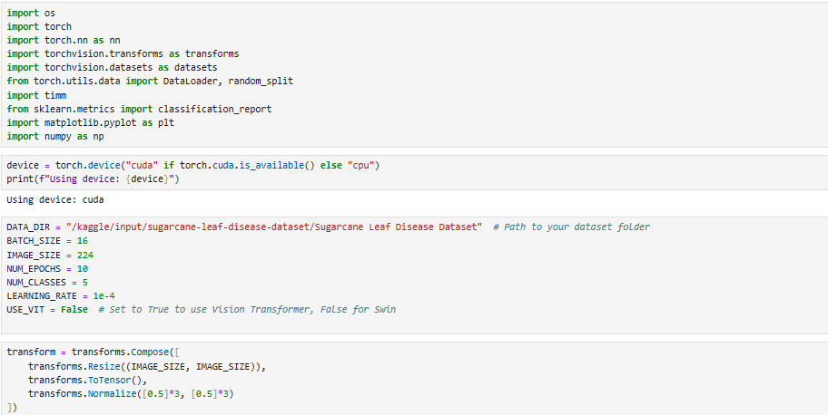
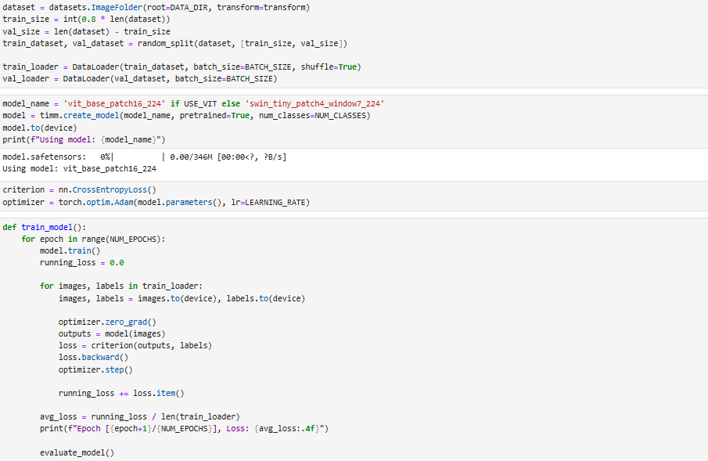
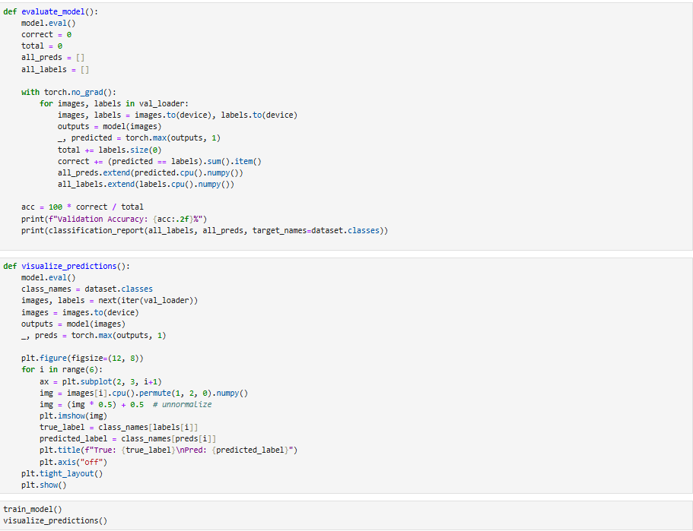
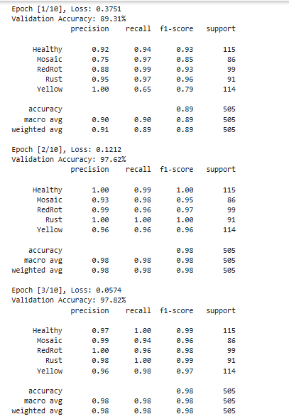
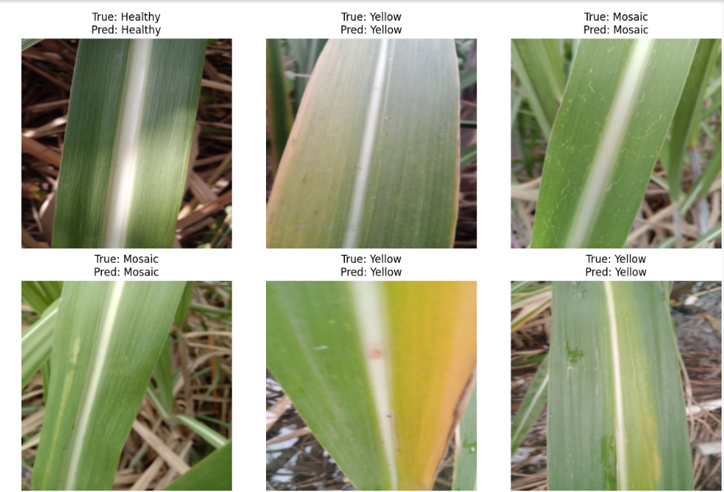
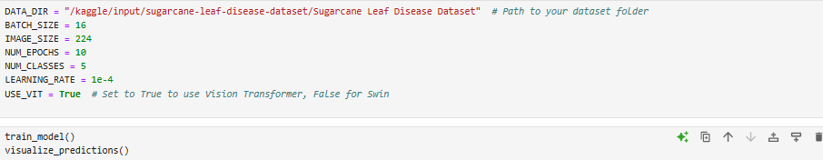
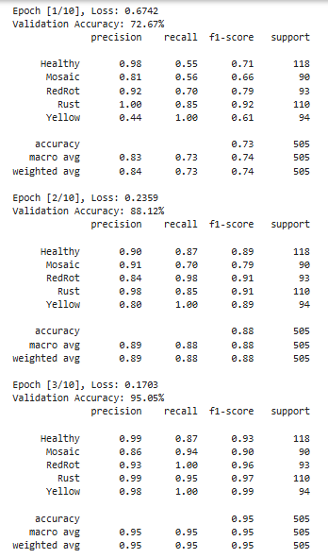
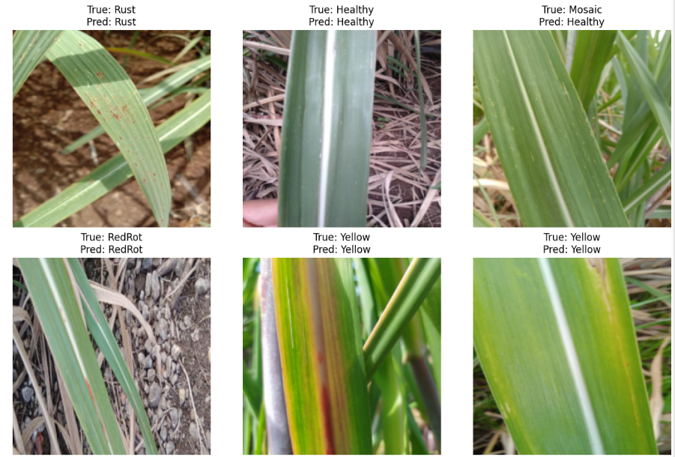

Experiment-10

AIM:
To Generate fake images using GAN.

SOFTWARE USED:
Jupyter Notebook

DATASET USED:
CelebA

SOURCE CODE AND OUTPUT:
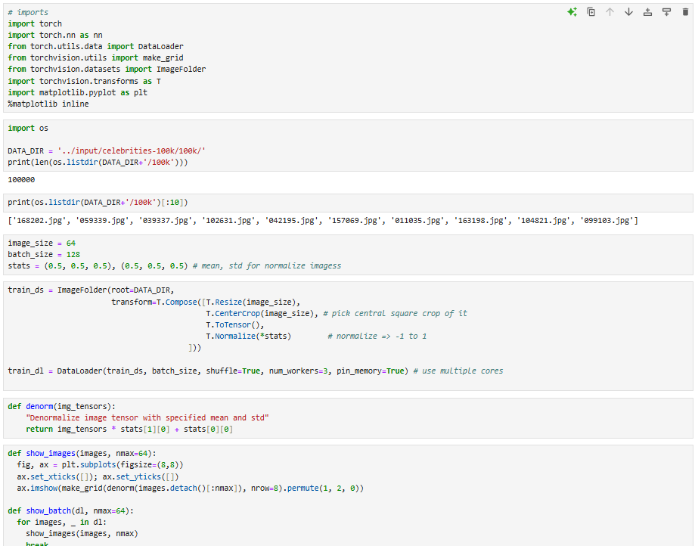

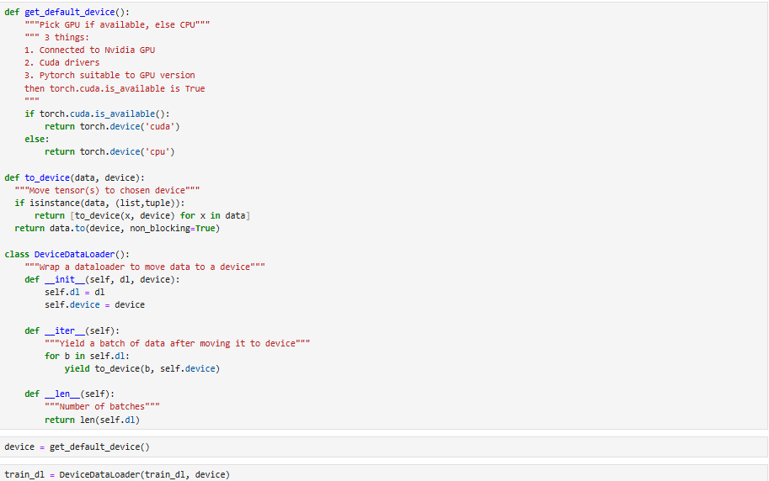
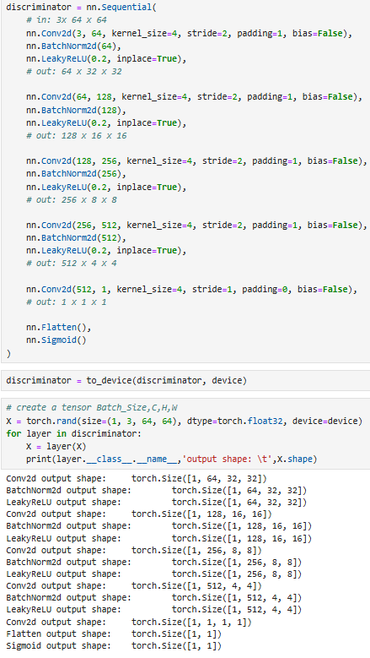
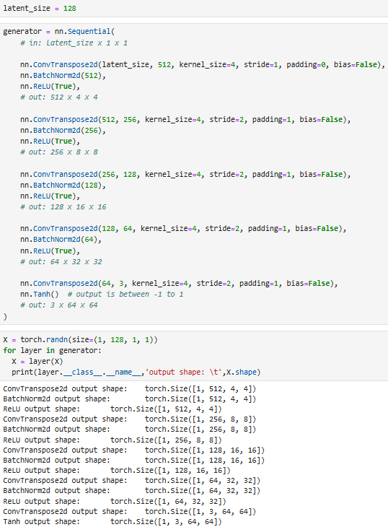
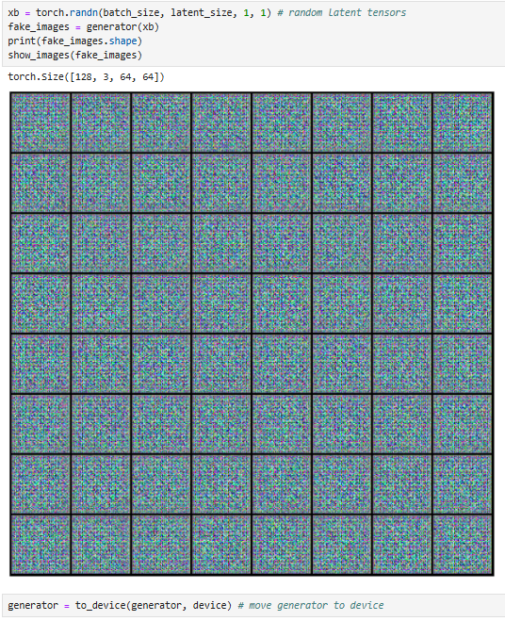

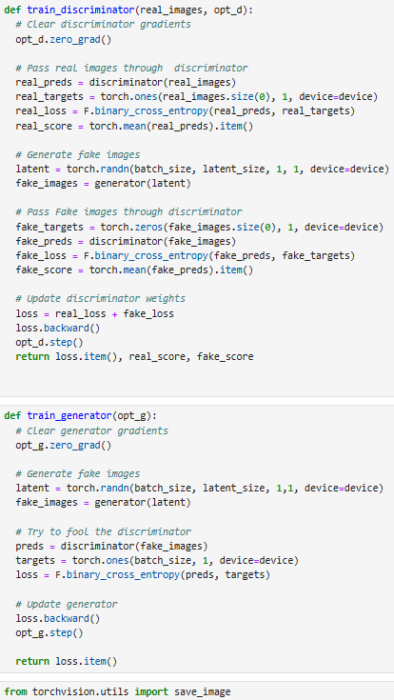
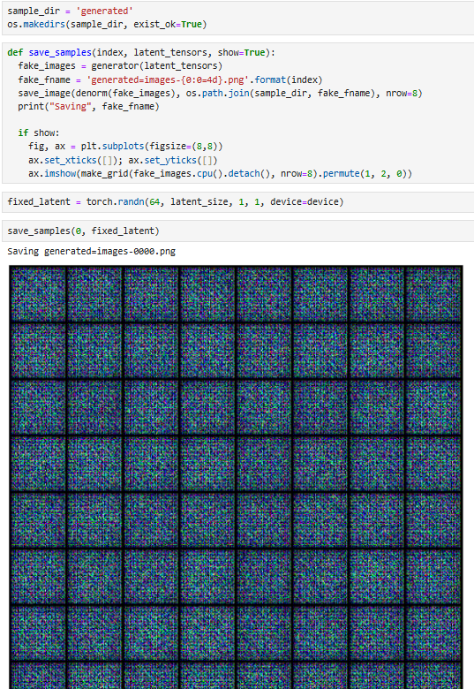
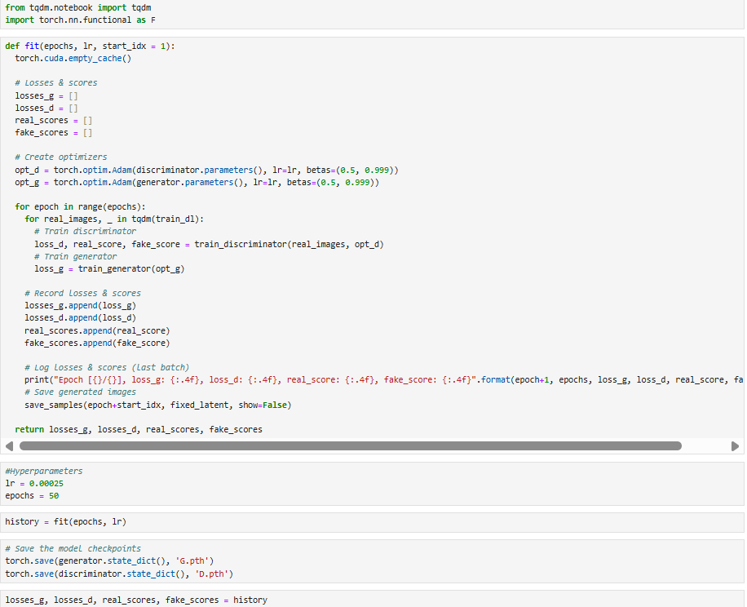
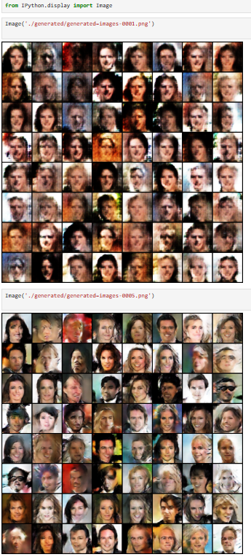
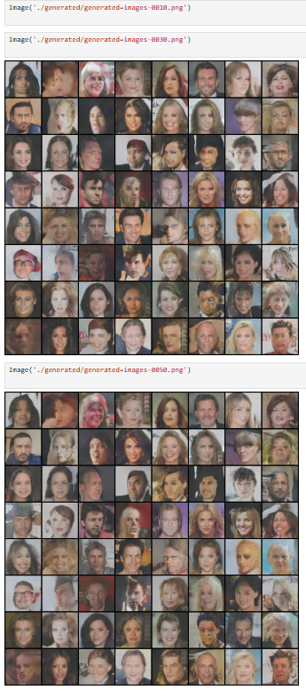
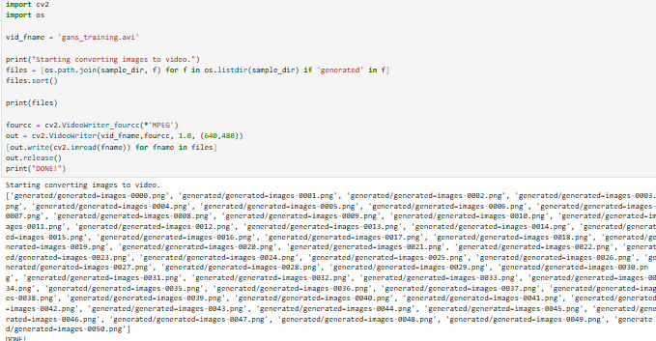

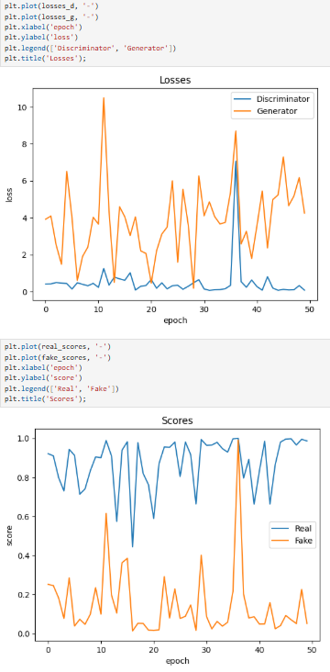

Experiment-11

AIM:
To implement Objection detection using YOLO, RCNN, fast CNN, Faster RCNN, other pretrained models in Tensorflow 2.0.

SOFTWARE USED:
Jupyter Notebook

DATASET USED:
Pothole Detection Dataset

SOURCE CODE AND OUTPUT:
