PS D:\BDA_Sem1\Mini_Project\Speech-Enhancement\Data\LibriSpeech\Codes> python main.py --mode training --training_from_scratch

2024-09-05 17:32:01.130027: I tensorflow/core/util/port.cc:153] oneDNN custom operations are on. You may see slightly different numerical results due to floating-point round-off errors from different computation orders. To turn them off, set the environment variable `TF_ENABLE_ONEDNN_OPTS=0`.

2024-09-05 17:32:01.573282: I tensorflow/core/util/port.cc:153] oneDNN custom operations are on. You may see slightly different numerical results due to floating-point round-off errors from different computation orders. To turn them off, set the environment variable `TF_ENABLE_ONEDNN_OPTS=0`.

2.17.0

DescribeResult(nobs=9748480, minmax=(array([-80.]), array([0.])), mean=array([-37.61270051]), variance=array([249.14939227]), skewness=array([-0.52176604]), kurtosis=array([-0.02935997]))

DescribeResult(nobs=9748480, minmax=(array([-62.31722984]), array([79.85915723])), mean=array([8.92827704]), variance=array([215.37710449]), skewness=array([0.67160963]), kurtosis=array([0.1179309]))

(595, 128, 128)

(595, 128, 128)

DescribeResult(nobs=9748480, minmax=(array([-0.68]), array([0.92])), mean=array([0.16774599]), variance=array([0.09965976]), skewness=array([-0.52176604]), kurtosis=array([-0.02935997]))

DescribeResult(nobs=9748480, minmax=(array([-0.83313695]), array([0.90072143])), mean=array([0.0357107]), variance=array([0.0320311]), skewness=array([0.67160963]), kurtosis=array([0.1179309]))

2024-09-05 17:32:04.857506: I tensorflow/core/platform/cpu_feature_guard.cc:210] This TensorFlow binary is optimized to use available CPU instructions in performance-critical operations.

To enable the following instructions: AVX2 AVX_VNNI FMA, in other operations, rebuild TensorFlow with the appropriate compiler flags.

Model: "functional"

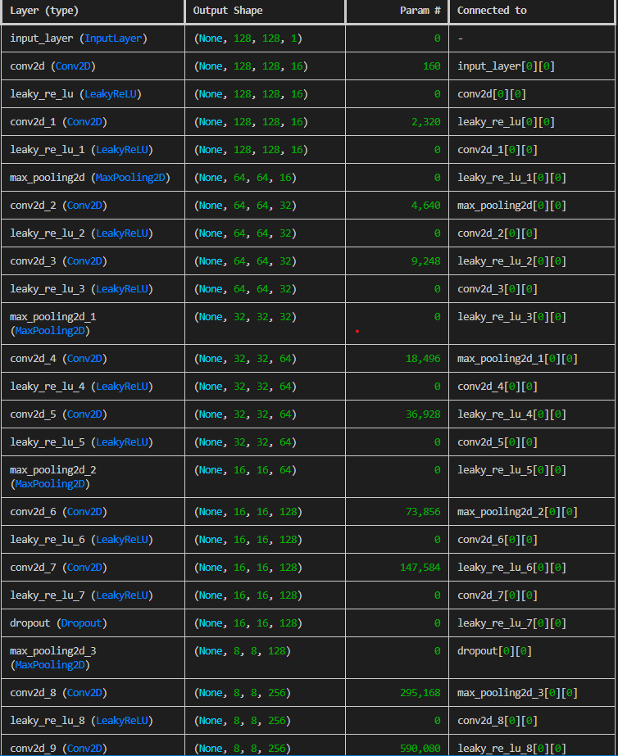

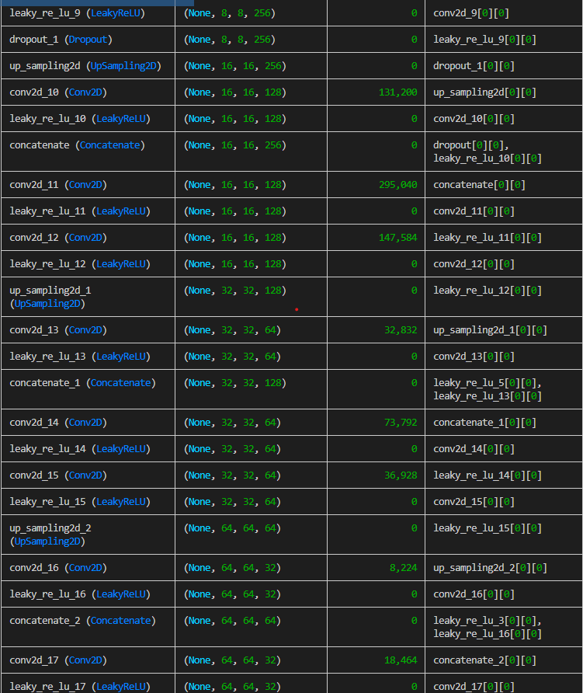

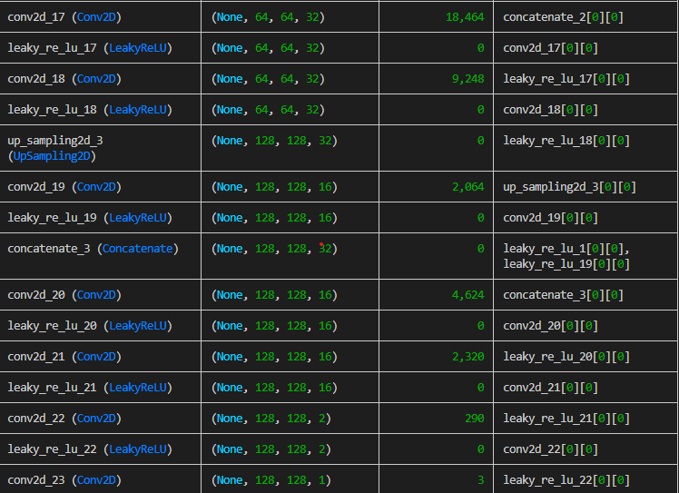

Total params: 1,941,093 (7.40 MB)

Trainable params: 1,941,093 (7.40 MB)

Non-trainable params: 0 (0.00 B)

Epoch 1/10

2024-09-05 17:32:08.234713: E tensorflow/core/grappler/optimizers/meta_optimizer.cc:966] remapper failed: INVALID_ARGUMENT: Mutation::Apply error: fanout 'StatefulPartitionedCall/gradient_tape/functional_1/leaky_re_lu_12_1/LeakyRelu/LeakyReluGrad' exist for missing node 'StatefulPartitionedCall/functional_1/conv2d_12_1/add'.

2024-09-05 17:32:08.316738: E tensorflow/core/util/util.cc:131] oneDNN supports DT_INT32 only on platforms with AVX-512. Falling back to the default Eigen-based implementation if present.

27/27 ━━━━━━━━━━━━━━━━━━━━ 0s 165ms/step - loss: 0.1290 - mae: 0.3616

Epoch 1: val_loss improved from inf to 0.01699, saving model to D:\BDA_Sem1\Mini_Project\Speech-Enhancement\Data\LibriSpeech\Weights\model_best.keras

27/27 ━━━━━━━━━━━━━━━━━━━━ 8s 186ms/step - loss: 0.1263 - mae: 0.3563 - val_loss: 0.0170 - val_mae: 0.1478

Epoch 2/10

27/27 ━━━━━━━━━━━━━━━━━━━━ 0s 159ms/step - loss: 0.0124 - mae: 0.1259

Epoch 2: val_loss improved from 0.01699 to 0.01381, saving model to D:\BDA_Sem1\Mini_Project\Speech-Enhancement\Data\LibriSpeech\Weights\model_best.keras

27/27 ━━━━━━━━━━━━━━━━━━━━ 5s 170ms/step - loss: 0.0124 - mae: 0.1258 - val_loss: 0.0138 - val_mae: 0.1331

Epoch 3/10

27/27 ━━━━━━━━━━━━━━━━━━━━ 0s 158ms/step - loss: 0.0113 - mae: 0.1191

Epoch 3: val_loss did not improve from 0.01381

27/27 ━━━━━━━━━━━━━━━━━━━━ 4s 164ms/step - loss: 0.0113 - mae: 0.1191 - val_loss: 0.0168 - val_mae: 0.1472

Epoch 4/10

27/27 ━━━━━━━━━━━━━━━━━━━━ 0s 158ms/step - loss: 0.0110 - mae: 0.1171

Epoch 4: val_loss improved from 0.01381 to 0.01320, saving model to D:\BDA_Sem1\Mini_Project\Speech-Enhancement\Data\LibriSpeech\Weights\model_best.keras

27/27 ━━━━━━━━━━━━━━━━━━━━ 5s 169ms/step - loss: 0.0110 - mae: 0.1170 - val_loss: 0.0132 - val_mae: 0.1302

Epoch 5/10

27/27 ━━━━━━━━━━━━━━━━━━━━ 0s 158ms/step - loss: 0.0106 - mae: 0.1137

Epoch 5: val_loss improved from 0.01320 to 0.01191, saving model to D:\BDA_Sem1\Mini_Project\Speech-Enhancement\Data\LibriSpeech\Weights\model_best.keras

27/27 ━━━━━━━━━━━━━━━━━━━━ 5s 169ms/step - loss: 0.0106 - mae: 0.1137 - val_loss: 0.0119 - val_mae: 0.1239

Epoch 6/10

27/27 ━━━━━━━━━━━━━━━━━━━━ 0s 158ms/step - loss: 0.0106 - mae: 0.1141

Epoch 6: val_loss improved from 0.01191 to 0.01067, saving model to D:\BDA_Sem1\Mini_Project\Speech-Enhancement\Data\LibriSpeech\Weights\model_best.keras

27/27 ━━━━━━━━━━━━━━━━━━━━ 5s 169ms/step - loss: 0.0106 - mae: 0.1141 - val_loss: 0.0107 - val_mae: 0.1168

Epoch 7/10

27/27 ━━━━━━━━━━━━━━━━━━━━ 0s 158ms/step - loss: 0.0096 - mae: 0.1074

Epoch 7: val_loss did not improve from 0.01067

27/27 ━━━━━━━━━━━━━━━━━━━━ 4s 165ms/step - loss: 0.0096 - mae: 0.1074 - val_loss: 0.0109 - val_mae: 0.1170

Epoch 8/10

27/27 ━━━━━━━━━━━━━━━━━━━━ 0s 158ms/step - loss: 0.0094 - mae: 0.1059

Epoch 8: val_loss did not improve from 0.01067

27/27 ━━━━━━━━━━━━━━━━━━━━ 4s 165ms/step - loss: 0.0094 - mae: 0.1060 - val_loss: 0.0108 - val_mae: 0.1174

Epoch 9/10

27/27 ━━━━━━━━━━━━━━━━━━━━ 0s 166ms/step - loss: 0.0093 - mae: 0.1049

Epoch 9: val_loss improved from 0.01067 to 0.01044, saving model to D:\BDA_Sem1\Mini_Project\Speech-Enhancement\Data\LibriSpeech\Weights\model_best.keras

27/27 ━━━━━━━━━━━━━━━━━━━━ 5s 178ms/step - loss: 0.0094 - mae: 0.1049 - val_loss: 0.0104 - val_mae: 0.1153

Epoch 10/10

27/27 ━━━━━━━━━━━━━━━━━━━━ 0s 172ms/step - loss: 0.0091 - mae: 0.1032

Epoch 10: val_loss did not improve from 0.01044

27/27 ━━━━━━━━━━━━━━━━━━━━ 5s 179ms/step - loss: 0.0091 - mae: 0.1032 - val_loss: 0.0135 - val_mae: 0.1337