**Navigating to the Cloud Storage Console**

**Step 1: Access the Google Cloud Console**

* Open your web browser and go to the Google Cloud Console: <https://console.cloud.google.com/>

**Step 2: Select Your Project**

* If you have multiple projects, select the one you want to work with from the dropdown menu in the top navigation bar.

**Step 3: Navigate to Cloud Storage**

* In the navigation menu on the left side of the console, click on **Storage**. This will expand the Storage section.
* Under **Storage**, click on **Cloud Storage**. This will take you to the Cloud Storage console.

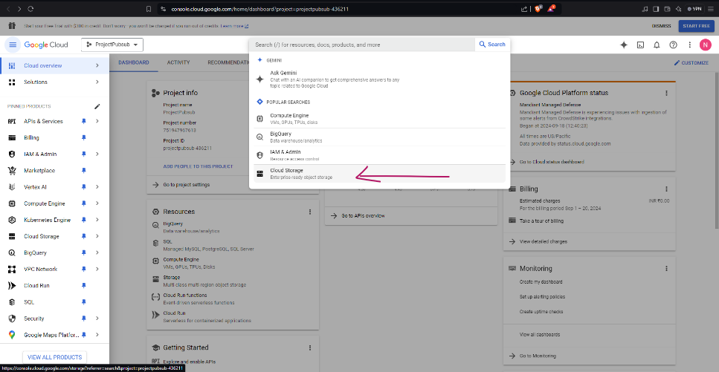

**Creating a Bucket**

**Step 1: Enter Bucket Name and Location**

* In the "Create Bucket" dialog, enter a globally unique name for your bucket.
* Choose a location for your bucket. The default is "us-central1" (Central US), but you can select a different region based on your needs. **For this example, let's select "us-east1" (South Carolina).**

**Step2: Configure Optional Settings (if necessary)**

* **Storage Class:** Choose a storage class based on your data access patterns and cost requirements. For most use cases, the default "Standard" class is suitable.
* **Labels:** Add labels to organize your buckets. For example, you could add a label like "department:sales" to categorize the bucket.
* **Access Control:** Configure access control lists (ACLs) to manage who can access your bucket and its objects. By default, the bucket owner has full access. You can grant permissions to other users or groups as needed.
* **Object Versioning:** Enable object versioning to keep multiple versions of an object. This is useful for data recovery and auditing purposes.
* **Encryption:** Choose an encryption type for your data. The default is "Customer-managed encryption (CMEK)", which allows you to use your own encryption key.

**Step 3: Create the Bucket**

* Click the **CREATE** button.

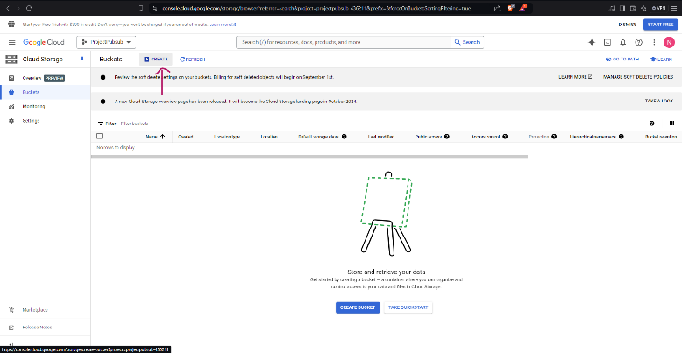

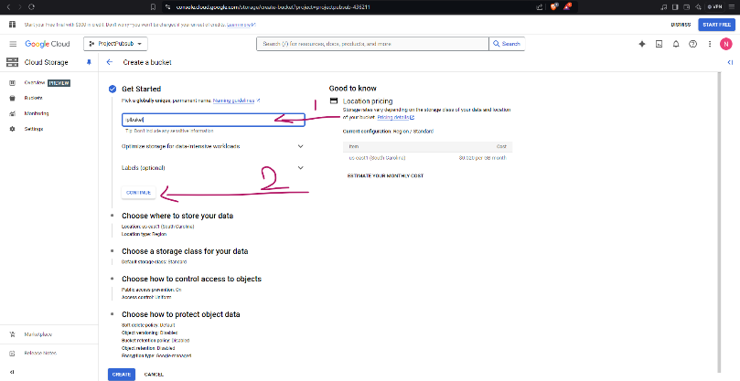

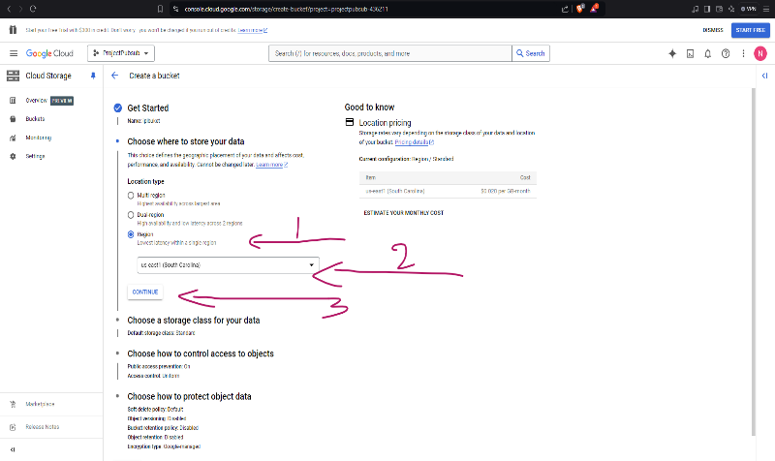

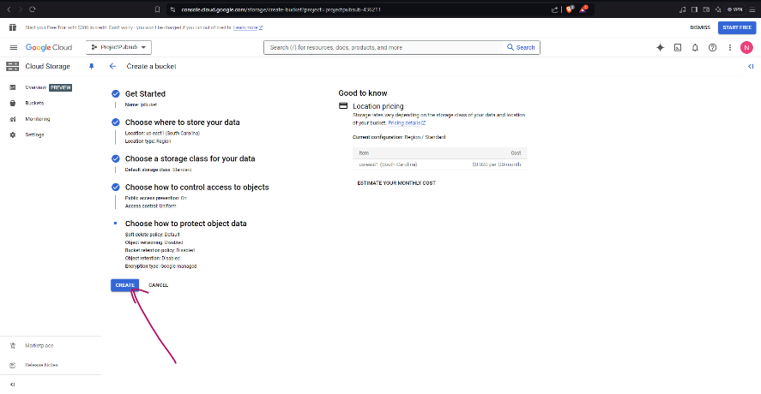

**Bucket Details**

**Step 1: View Bucket Details**

* Once you've created your bucket, you'll see its details listed in the console. This includes the bucket name, location, storage class, public access settings, and other information.

**Step 2: Navigate to the Folder Browser**

* In the bucket details view, you should see a section labeled "Folder browser."

**Step 3: Create a Folder**

* Click on the "Create folder" button.
* A dialog box will appear. Enter a name for your folder.
* Click the "Create" button.

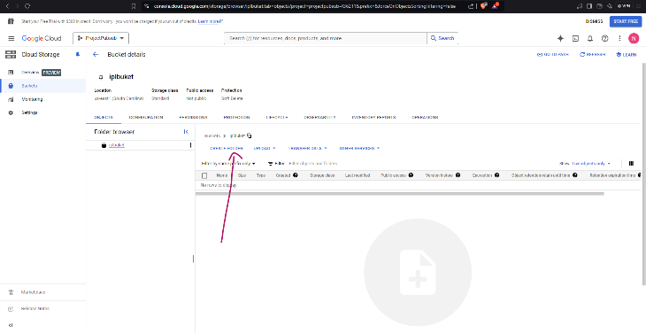 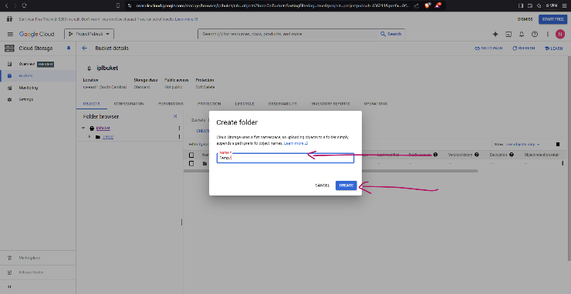

**Navigating to** **BigQuery**

**Step 1: Navigate to BigQuery**

* In the top navigation bar, click on the **Menu** icon (three horizontal lines).
* In the search bar, type "BigQuery" and press Enter.
* This will take you to the BigQuery console.

**Step 2: Create a Dataset**

* Click on the "Create dataset" button.
* A dialog box will appear. Enter a name for your dataset.
* Choose a location for your dataset.
* Configure other optional settings as needed (e.g., default table expiration, labels).
* Click the "Create dataset" button.

**Step 3: Enter Dataset Details**

* In the dialog box that appears:
  + Enter a **Name** for your dataset.
  + Choose a **Location** for your dataset. The default is "US" (United States). **For this example, let's select "US-EAST1" (South Carolina).**
  + Select a **Dataset type**. The default is "Regional", which is suitable for most use cases.

**Step 4: Create the Dataset**

* Click the "Create dataset" button.

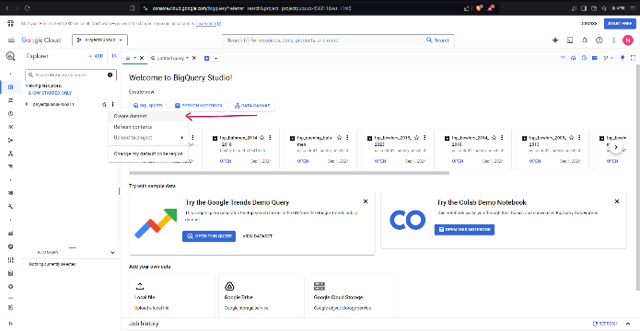 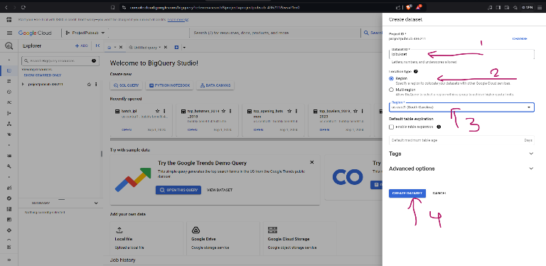

**Creating a Table in BigQuery**

**Step 1: Create a Table**

* Click on the "Create table" button.

**Step 2: Choose a Source**

* Select the desired source for your table data. In this case, you've chosen "Create table from scratch."

**Step 3: Enter Table Details**

* Enter a **Name** for your table.
* Choose a **Schema** for your table. This involves defining the column names, data types, and other properties.
* Configure **Partition and cluster settings** if necessary. Partitioning divides your table into smaller partitions based on a column, which can improve query performance. Clustering orders data within partitions based on a column, which can further enhance query speed.

**Step 4: Create the Table**

* Click the "CREATE TABLE" button to create the table.

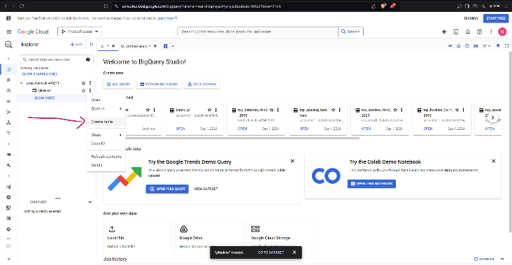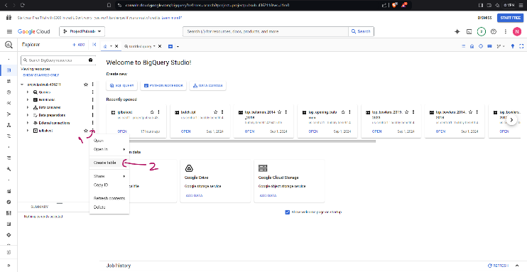

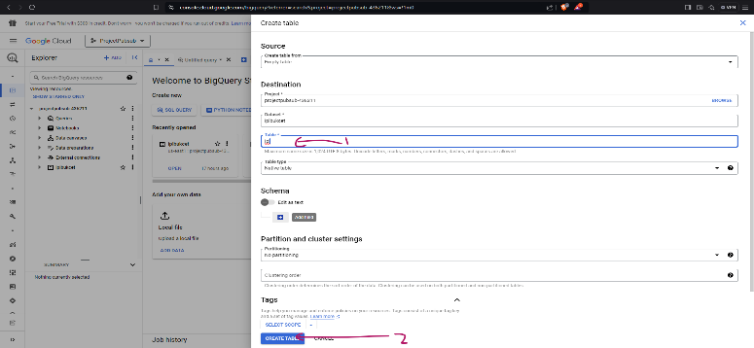

**Creating a Pub/Sub Topic**

**Step 1: Access the Pub/Sub Console**

* Navigate to the Pub/Sub console.

**Step 2: Create a Topic**

* Click on the "Create topic" button.

**Step 3: Enter Topic Details**

* In the dialog box that appears:
  + Enter a **Name** for your topic.
  + Choose a **Location** for your topic. The default is "US" (United States), but you can select a different region if needed.
  + **Message retention:** Select the desired message retention period for your topic.
  + **Encryption:** Choose an encryption type for your data. The default is "Google-managed encryption key" (GMEK), but you can also use a Cloud KMS key.
  + **Schema:** If you want to define a schema for your messages, select "Enable schema" and choose a schema type.

**Step 4: Create the Topic**

* Click the "CREATE" button.

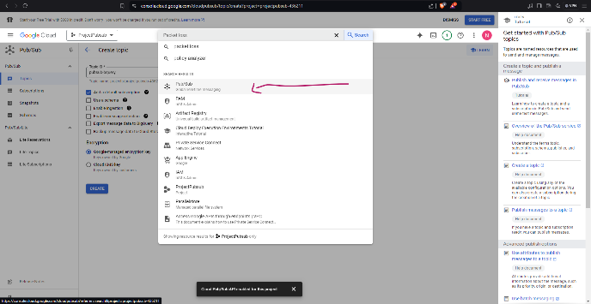 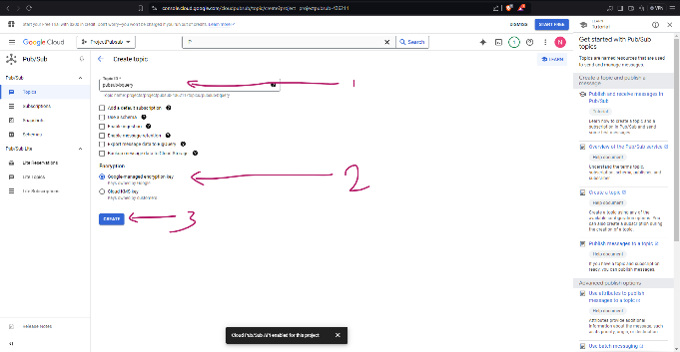

**Creating a Dataflow Job**

**Step 1: Access the Dataflow Console**

* Navigate to the Dataflow console.

**Step 2: Create a Job from Template**

* Click on the "Create job from template" button.

**Step 3: Choose a Template**

* Select the desired template based on your use case. In this case, you've chosen "Pub/Sub to BigQuery".

**Step 4: Configure Job Parameters**

* Enter the required parameters for the job:
  + **Job name:** Give your job a unique name.
  + **Region:** Select the region where you want the job to run. In this screenshot, "us-east1" (South Carolina) is selected.
  + **Source topic:** Select the Pub/Sub topic you created earlier from the dropdown list.
  + **Destination table:** Enter the name of the BigQuery table where you want to write the messages.
  + **Streaming mode:** Choose the streaming mode for the job (e.g., "Exactly once").
  + **Encryption:** Select the encryption key to use for data.

**Step 5: Create the Job**

* Click the "CREATE JOB" button to start the Dataflow job.
* **Run the Job:** Once the job is created, you can click the "Run" button to start the execution.
* **Command-Line Interface (CLI):** To run Dataflow jobs from the command line, you can use the gcloud dataflow jobs run command.

