Week of 2/2/15

Summary:
- Tuesday:
  - Nothing planned when coming into the office.
  - Decided to look at the issues for Ensemble-MD at https://github.com/radical-cybertools/radical.ensemblemd/issues
  - Tried looking into “Allow to turn on/off global barriers in the Pipeline pattern”, but wasn't able to get very far into it.
- Wednesday: group call
- Friday:
  - Began reading up on ATLAS Panda and summarizing the main features of the system.
  - Read up a little bit about some of the problems that the scientists were running into.
  - If possible, I might try to write some PanDA code just to see how the system works.

PanDA Highlights

Principal Design Features:
- coherent, homogeneous processing system over diverse and heterogeneous processing resources. Insulates users from complexity of the underlying processing infrastructure
- Uses pilot jobs for acquisition of processing resources.
- Uses database system to cache information about all levels of the system. Used by pilots to configure themselves appropriately for the queue they land on.
- Uses input and output files as datasets. Movement of datasets is built-in
- Automated pre-staging of input data so that results can be delivered as early as possible.
- Easy integration of local resources.
- Simple Client interface
- Support all job sources: regional/group/user production, interactive analysis
- Tight integration with data management system
- Job scheduling and brokerage done within the system; no reliance on middleware
- Job dispatching done within the system rather than via grid submission
- Designed to support interactive analysis, user-level job submission, regional group production
- Dataset based organization matches DDM and analysis work model
- Use of DDM to pre-stage input data and immediately return outputs, all asynchronously, minimizes data transport latencies and delivers earliest possible first results

Architecture and Workflow
- Submit jobs to PanDA via a simple python client interface
  - Define job sets, associated datasets, and input/output files.
- Job specs submitted to PanDA server via secure http. Submission info returned to client
- Brokerage module assigns work from global job queue based on job type, priority, input data and its locality, available CPU resources, etc.
- Job sets are dispatched along with their input data to the appropriate sites.
- Jobs not released to processing site until their input data is accessible from the processing site. (Data is sent first, then job goes one data is confirmed to be there)
- Once a pilot is launched on a worker node, it contacts the dispatcher for jobs that fit the hardware description on the worker node.
  - If no job is available, the pilot can either exit immediately or stall and ask for another job later on.
- Important point: pilot bypasses the scheduling system by acquiring many resources and then requesting a multitude of jobs from the dispatcher.

Monitoring and Logging in Panda:
- Single, comprehensive web interface
- Make internals of system very visible
- Quickly identify underutilized and dysfunctional resources
- Provide dynamic, real-time info repository on resource availability, performance for intelligent brokering
- Gather statistics on performance and efficiency

Analysis of Pilot Delivery:
- Interactive analysis relies on fast pilot delivery/job pickup
- Analysis pilot delivery scheme works poorly when system is saturated with long-running production jobs; new pilots are few and infrequent
  - Possible solution: Send analysis pilots to dedicated short queues. Decouple analysis and production pilot delivery.

Observations:
- PanDA seems to have a lot more components to it than RADICAL-Pilot does. If RADICAL-Pilot can provide the same functionality as PanDA but with much fewer components, then what exactly are the extra modules providing in PanDA?
- What is DDM?

Resources

- The ATLAS PanDA Pilot on Operation
- The ATLAS Pana Production and Distributed Analysis System by Torre Wenaus, Brookhaven National Laboratory

PanDA Architecture

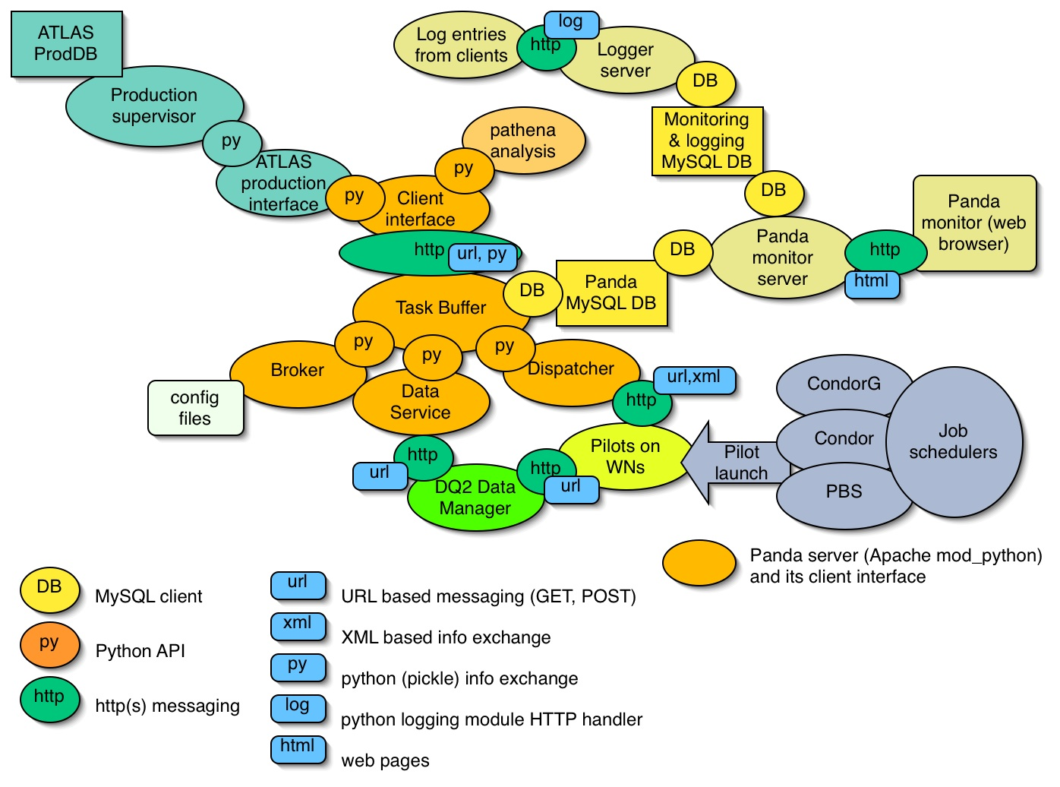

PanDA Job Flow

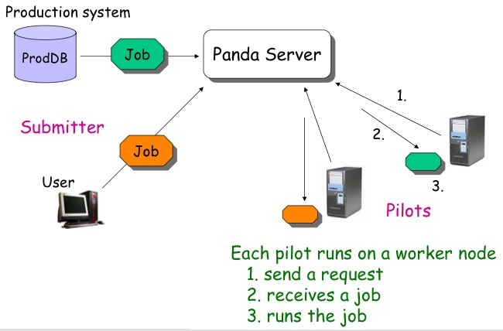

PanDA Workflow

