# 🐔Poultry Disease Prediction using Deep Learning

Internship Project Report

Submitted by: Nikhil Srimanth Ponnada

Internship Company: Smart Internz/Smart Bridge

Date: June 25, 2025

## 📖Abstract

This project aims to develop a deep learning-based web application for predicting poultry diseases from images.   
Farmers often struggle with identifying diseases early, which can lead to widespread infection and economic loss.   
Using a pre-trained deep learning model integrated with a Flask backend and a simple HTML frontend,   
this application enables users to upload an image of an infected poultry and receive a disease prediction in real-time.

## 📌Table of Contents

1. Introduction  
2. Objectives  
3. System Architecture  
4. Technology Stack  
5. Dataset  
6. Model Architecture  
7. Implementation  
8. Results and Screenshots  
9. Challenges Faced  
10. Future Enhancements  
11. Conclusion

## 1. 🔍Introduction

Poultry farming is a significant sector in agriculture and plays a crucial role in food production and rural economy.   
However, poultry are susceptible to a variety of diseases, which can spread rapidly and lead to high mortality rates.   
This project introduces a deep learning-based solution that assists in the early identification of poultry diseases through image analysis.

## 2. 🔍 Objectives

- To develop a web-based system that can predict poultry diseases from images.  
  
- To integrate a deep learning model into a user-friendly web interface.  
  
- To assist farmers and researchers in early detection and prevention of poultry diseases.

## 3. System Architecture

The system consists of the following components:  
  
1. Frontend for image upload.  
  
2. Flask backend to process requests.  
  
3. Pre-trained deep learning model for disease classification.  
  
4. Result display with disease name.  
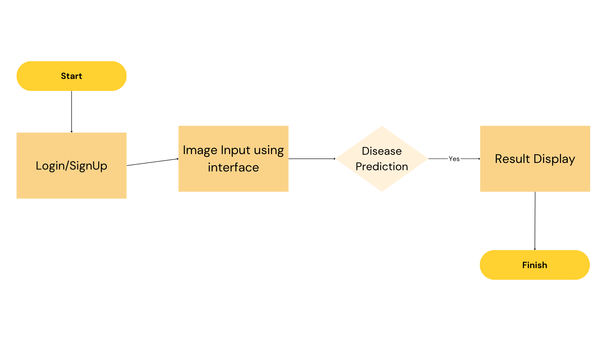

## 4. 🧰 Technology Stack

- Python  
- Flask  
- TensorFlow / Keras  
- HTML, CSS  
- OpenCV (optional for preprocessing)  
- Jupyter Notebook (for training)

## 5. 📁 Dataset

The dataset consists of poultry images categorized by different disease types. Each image is labeled, and preprocessing includes resizing, normalization, and augmentation.

## 6. Model Architecture

The model used is a Convolutional Neural Network (CNN), optionally based on a pretrained ResNet50. It includes several convolutional layers followed by dense layers.   
The final output layer uses Softmax activation to classify into disease categories.

## 7. Implementation

- The frontend is built using HTML and CSS for image upload.  
  
- Flask backend handles image submission and prediction.  
  
- The model is loaded using TensorFlow's load_model function.  
  
- Predictions are returned and displayed on the result page.

## 8. Results and Screenshots

The application predicts diseases with high ~ 90% accuracy and provides real-time feedback.

## 9. Challenges Faced

- Dataset imbalance  
- Image noise and varying lighting  
- Deployment issues on cloud  
- Integrating model with web interface

## 10. Future Enhancements

- Add more disease classes  
- Improve model accuracy with more data  
- Provide treatment suggestions  
- Enable multi-language support

## 11. Conclusion

This project demonstrates the practical application of deep learning in agriculture, particularly in poultry health monitoring. The web app is a helpful tool for farmers to detect diseases early and take preventive measures.