**Queue ADT**

[http://btechsmartclass.com/DS/images/Next.png](http://btechsmartclass.com/DS/U2_T8.html)

**What is a Queue?**

Queue is a linear data structure in which the insertion and deletion operations are performed at two different ends. In a queue data structure, adding and removing of elements are performed at two different positions. The insertion is performed at one end and deletion is performed at other end. In a queue data structure, the insertion operation is performed at a position which is known as '**rear**' and the deletion operation is performed at a position which is known as '**front**'. In queue data structure, the insertion and deletion operations are performed based on **FIFO (First In First Out)** principle.

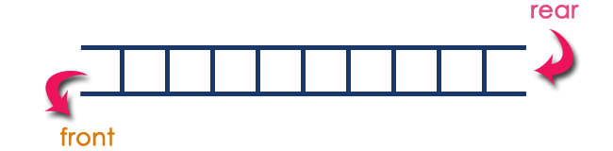

In a queue data structure, the insertion operation is performed using a function called "**enQueue()**" and deletion operation is performed using a function called "**deQueue()**".  
  
Queue data structure can be defined as follows...

**Queue data structure is a linear data structure in which the operations are performed based on FIFO principle.**

A queue can also be defined as

**"Queue data structure is a collection of similar data items in which insertion and deletion operations are performed based on FIFO principle".**

**Example**

Queue after inserting 25, 30, 51, 60 and 85.

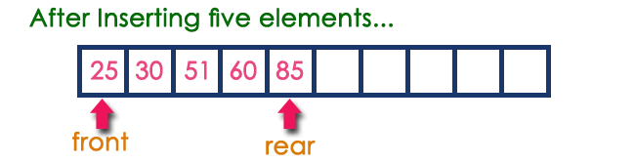

**Operations on a Queue**

The following operations are performed on a queue data structure...

1. **enQueue(value) - (To insert an element into the queue)**
2. **deQueue() - (To delete an element from the queue)**
3. **display() - (To display the elements of the queue)**

Queue data structure can be implemented in two ways. They are as follows...

1. **Using Array**
2. **Using Linked List**

When a queue is implemented using array, that queue can organize only limited number of elements. When a queue is implemented using linked list, that queue can organize unlimited number of elements.