**Double Ended Queue (Dequeue)**

[http://btechsmartclass.com/DS/images/Next.png](http://btechsmartclass.com/DS/U3_T1.html)

Double Ended Queue is also a Queue data structure in which the insertion and deletion operations are performed at both the ends (**front** and **rear**). That means, we can insert at both front and rear positions and can delete from both front and rear positions.

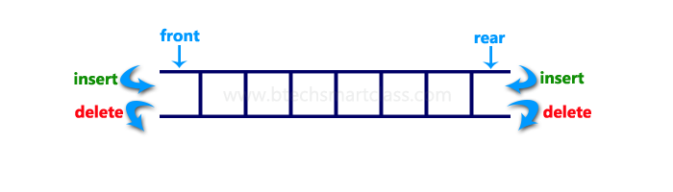

Double Ended Queue can be represented in TWO ways, those are as follows...

1. Input Restricted Double Ended Queue
2. Output Restricted Double Ended Queue

**Input Restricted Double Ended Queue**

In input restricted double ended queue, the insertion operation is performed at only one end and deletion operation is performed at both the ends.

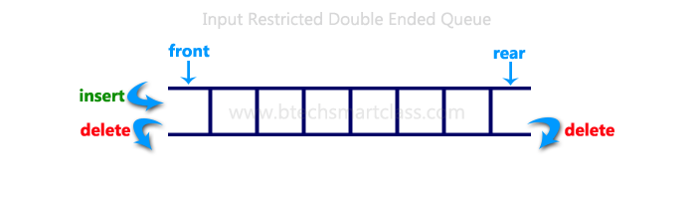

**Output Restricted Double Ended Queue**

In output restricted double ended queue, the deletion operation is performed at only one end and insertion operation is performed at both the ends.

