**Expressions**

[http://btechsmartclass.com/DS/images/Next.png](http://btechsmartclass.com/DS/U2_T5.html)

**What is an Expression?**

In any programming language, if we want to perform any calculation or to frame a condition etc., we use a set of symbols to perform the task. These set of symbols makes an expression.  
  
An expression can be defined as follows...

**An expression is a collection of operators and operands that represents a specific value.**

In above definition, **operator** is a symbol which performs a particular task like arithmetic operation or logical operation or conditional operation etc.,  
  
**Operands** are the values on which the operators can perform the task. Here operand can be a direct value or variable or address of memory location.

**Expression Types**

Based on the operator position, expressions are divided into THREE types. They are as follows...

1. **Infix Expression**
2. **Postfix Expression**
3. **Prefix Expression**

**Infix Expression**

In infix expression, operator is used in between operands.  
  
The general structure of an Infix expression is as follows...

**Operand1 Operator Operand2**

**Example**

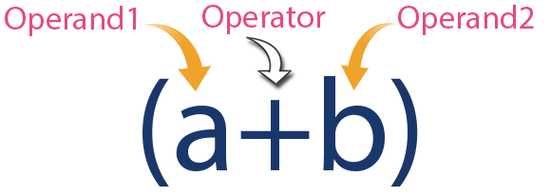

**Postfix Expression**

In postfix expression, operator is used after operands. We can say that "**Operator follows the Operands**".  
  
The general structure of Postfix expression is as follows...

**Operand1 Operand2 Operator**

**Example**

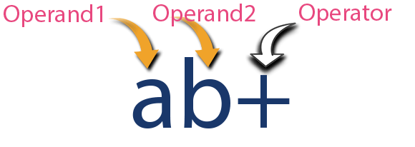

**Prefix Expression**

In prefix expression, operator is used before operands. We can say that "**Operands follows the Operator**".  
  
The general structure of Prefix expression is as follows...

**Operator Operand1 Operand2**

**Example**

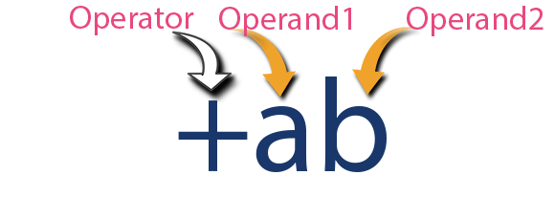

Any expression can be represented using the above three different types of expressions. And we can convert an expression from one form to another form like **Infix to Postfix**, **Infix to Prefix**, **Prefix to Postfix** and vice versa.