**Binary Tree Representations**

[http://btechsmartclass.com/DS/images/Next.png](http://btechsmartclass.com/DS/U3_T4.html)

A binary tree data structure is represented using two methods. Those methods are as follows...

1. **Array Representation**
2. **Linked List Representation**

Consider the following binary tree...

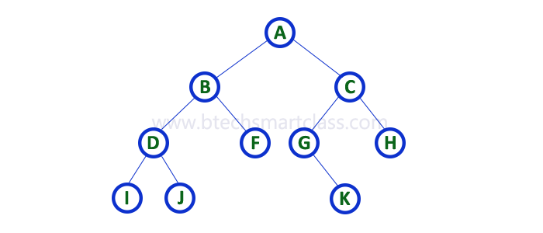

**1. Array Representation**

In array representation of binary tree, we use a one dimensional array (1-D Array) to represent a binary tree.  
Consider the above example of binary tree and it is represented as follows...

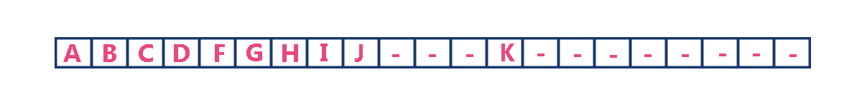

To represent a binary tree of depth **'n'** using array representation, we need one dimensional array with a maximum size of **2n+1 - 1**.

**2. Linked List Representation**

We use double linked list to represent a binary tree. In a double linked list, every node consists of three fields. First field for storing left child address, second for storing actual data and third for storing right child address.  
In this linked list representation, a node has the following structure...



The above example of binary tree represented using Linked list representation is shown as follows...

