**Circular Queue**

[http://btechsmartclass.com/DS/images/Next.png](http://btechsmartclass.com/DS/U2_T11.html)

In a normal Queue Data Structure, we can insert elements until queue becomes full. But once if queue becomes full, we can not insert the next element until all the elements are deleted from the queue. For example consider the queue below...  
  
After inserting all the elements into the queue.

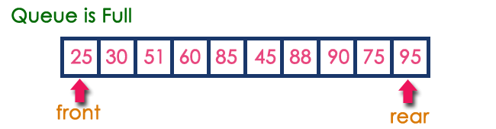

Now consider the following situation after deleting three elements from the queue...

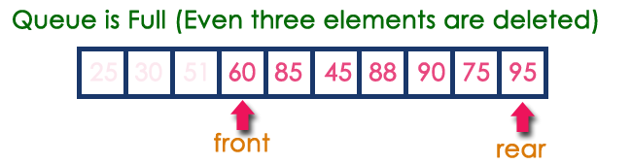

This situation also says that Queue is Full and we can not insert the new element because, '**rear**' is still at last position. In above situation, even though we have empty positions in the queue we can not make use of them to insert new element. This is the major problem in normal queue data structure. To overcome this problem we use circular queue data structure.

**What is Circular Queue?**

A Circular Queue can be defined as follows...

**Circular Queue is a linear data structure in which the operations are performed based on FIFO (First In First Out) principle and the last position is connected back to the first position to make a circle.**

Graphical representation of a circular queue is as follows...

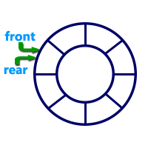

**Implementation of Circular Queue**

To implement a circular queue data structure using array, we first perform the following steps before we implement actual operations.

* **Step 1:** Include all the **header files** which are used in the program and define a constant **'SIZE'**with specific value.
* **Step 2:** Declare all **user defined functions** used in circular queue implementation.
* **Step 3:** Create a one dimensional array with above defined SIZE (**int cQueue[SIZE]**)
* **Step 4:** Define two integer variables **'front'** and '**rear**' and initialize both with **'-1'**. (**int front = -1, rear = -1**)
* **Step 5:** Implement main method by displaying menu of operations list and make suitable function calls to perform operation selected by the user on circular queue.

**enQueue(value) - Inserting value into the Circular Queue**

In a circular queue, enQueue() is a function which is used to insert an element into the circular queue. In a circular queue, the new element is always inserted at **rear** position. The enQueue() function takes one integer value as parameter and inserts that value into the circular queue. We can use the following steps to insert an element into the circular queue...

* **Step 1:** Check whether **queue** is **FULL**. (**(rear == SIZE-1 && front == 0) || (front == rear+1)**)
* **Step 2:** If it is **FULL**, then display **"Queue is FULL!!! Insertion is not possible!!!"** and terminate the function.
* **Step 3:** If it is **NOT FULL**, then check **rear == SIZE - 1 && front != 0** if it is **TRUE**, then set **rear = -1**.
* **Step 4:** Increment **rear** value by one (**rear++**), set **queue[rear]** = **value** and check '**front == -1**' if it is **TRUE**, then set **front = 0**.

**deQueue() - Deleting a value from the Circular Queue**

In a circular queue, deQueue() is a function used to delete an element from the circular queue. In a circular queue, the element is always deleted from **front** position. The deQueue() function doesn't take any value as parameter. We can use the following steps to delete an element from the circular queue...

* **Step 1:** Check whether **queue** is **EMPTY**. (**front == -1 && rear == -1**)
* **Step 2:** If it is **EMPTY**, then display **"Queue is EMPTY!!! Deletion is not possible!!!"** and terminate the function.
* **Step 3:** If it is **NOT EMPTY**, then display **queue[front]** as deleted element and increment the **front**value by one (**front ++**). Then check whether **front == SIZE**, if it is **TRUE**, then set **front = 0**. Then check whether both **front - 1** and **rear** are equal (**front -1** == **rear**), if it **TRUE**, then set both **front**and **rear** to '**-1**' (**front** = **rear** = **-1**).

**display() - Displays the elements of a Circular Queue**

We can use the following steps to display the elements of a circular queue...

* **Step 1:** Check whether **queue** is **EMPTY**. (**front == -1**)
* **Step 2:** If it is **EMPTY**, then display **"Queue is EMPTY!!!"** and terminate the function.
* **Step 3:** If it is **NOT EMPTY**, then define an integer variable '**i**' and set '**i** = **front**'.
* **Step 4:** Check whether '**front <= rear**', if it is **TRUE**, then display '**queue[i]**' value and increment '**i**' value by one (**i++**). Repeat the same until '**i <= rear**' becomes **FALSE**.
* **Step 5:** If '**front <= rear**' is **FALSE**, then display '**queue[i]**' value and increment '**i**' value by one (**i++**). Repeat the same until'**i <= SIZE - 1**' becomes **FALSE**.
* **Step 6:** Set **i** to **0**.
* **Step 7:** Again display '**cQueue[i]**' value and increment **i** value by one (**i++**). Repeat the same until '**i <= rear**' becomes **FALSE**.

**Program to implement Queue using Array**

#include<stdio.h>

#include<conio.h>

#define SIZE 5

void enQueue(int);

void deQueue();

void display();

int cQueue[SIZE], front = -1, rear = -1;

void main()

{

int choice, value;

clrscr();

while(1){

printf("\n****** MENU ******\n");

printf("1. Insert\n2. Delete\n3. Display\n4. Exit\n");

printf("Enter your choice: ");

scanf("%d",&choice);

switch(choice){

case 1: printf("\nEnter the value to be insert: ");

scanf("%d",&value);

enQueue(value);

break;

case 2: deQueue();

break;

case 3: display();

break;

case 4: exit(0);

default: printf("\nPlease select the correct choice!!!\n");

}

}

}

void enQueue(int value)

{

if((front == 0 && rear == SIZE - 1) || (front == rear+1))

printf("\nCircular Queue is Full! Insertion not possible!!!\n");

else{

if(rear == SIZE-1 && front != 0)

rear = -1;

cQueue[++rear] = value;

printf("\nInsertion Success!!!\n");

if(front == -1)

front = 0;

}

}

void deQueue()

{

if(front == -1 && rear == -1)

printf("\nCircular Queue is Empty! Deletion is not possible!!!\n");

else{

printf("\nDeleted element : %d\n",cQueue[front++]);

if(front == SIZE)

front = 0;

if(front-1 == rear)

front = rear = -1;

}

}

void display()

{

if(front == -1)

printf("\nCircular Queue is Empty!!!\n");

else{

int i = front;

printf("\nCircular Queue Elements are : \n");

if(front <= rear){

while(i <= rear)

printf("%d\t",cQueue[i++]);

}

else{

while(i <= SIZE - 1)

printf("%d\t", cQueue[i++]);

i = 0;

while(i <= rear)

printf("%d\t",cQueue[i++]);

}

}

}

**Output**

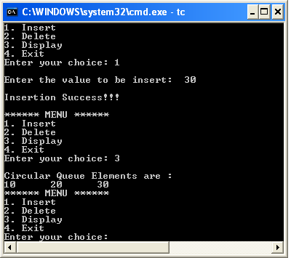

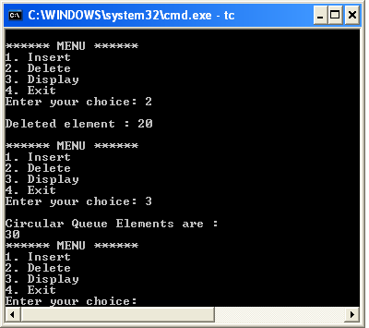

**Double Ended Queue (Dequeue)**

[http://btechsmartclass.com/DS/images/Next.png](http://btechsmartclass.com/DS/U3_T1.html)

Double Ended Queue is also a Queue data structure in which the insertion and deletion operations are performed at both the ends (**front** and **rear**). That means, we can insert at both front and rear positions and can delete from both front and rear positions.

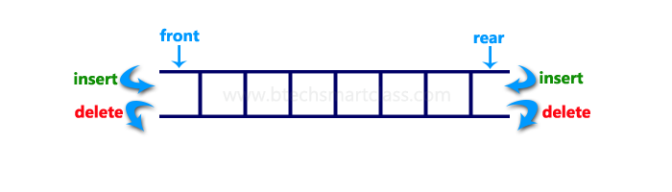

Double Ended Queue can be represented in TWO ways, those are as follows...

1. Input Restricted Double Ended Queue
2. Output Restricted Double Ended Queue

**Input Restricted Double Ended Queue**

In input restricted double ended queue, the insertion operation is performed at only one end and deletion operation is performed at both the ends.

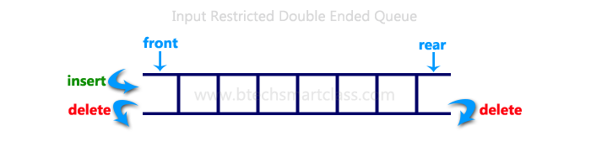

**Output Restricted Double Ended Queue**

In output restricted double ended queue, the deletion operation is performed at only one end and insertion operation is performed at both the ends.

