To enhance the performance of binary tree, we use special type of binary tree known as **Binary Search Tree**. Binary search tree mainly focus on the search operation in binary tree. Binary search tree can be defined as follows...

**Binary Search Tree is a binary tree in which every node contains only smaller values in its**

**left subtree and only larger values in its right subtree.**

In a binary search tree, all the nodes in left subtree of any node contains smaller values and all the nodes in right subtree of that contains larger values as shown in following figure...

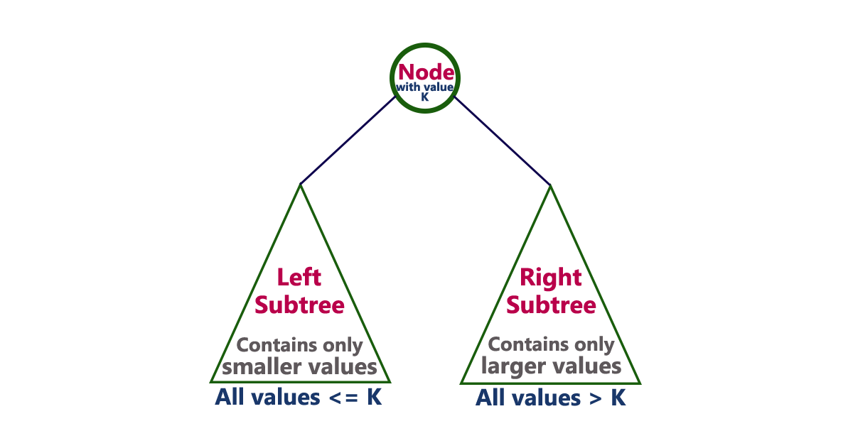

**Example**

The following tree is a Binary Search Tree. In this tree, left subtree of every node contains nodes with smaller values and right subtree of every node contains larger values.

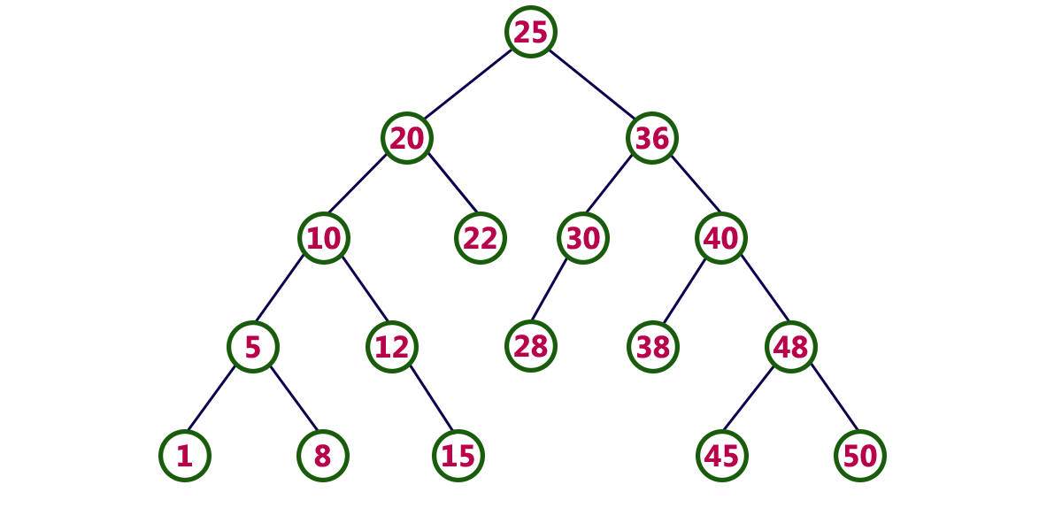

**Every Binary Search Tree is a binary tree but all the Binary Trees need not to be binary search trees.**

Construct a Binary Search Tree by inserting the following sequence of numbers...

#### 10,12,5,4,20,8,7,15 and 13

Above elements are inserted into a Binary Search Tree as follows...

