General Tree Graphical Picture:
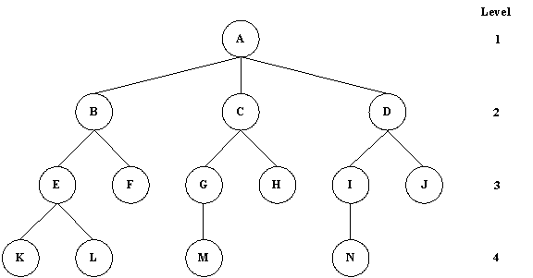

Binary Tree
Regular Binary Tree ( 2 )
Skewed Left Binary Tree ( 1 )
Skewed Right Binary Tree ( 3 )
Definition: A binary tree is a finite set of nodes that is either empty or consists of a root
and two disjoint binary trees called the left subtree and the right subtree.
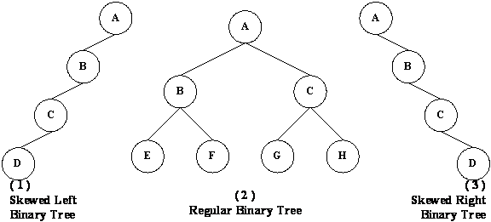

Binary Tree Traversals Types
Inorder Traversal (Left, Parent, Right)
Preorder Traversal (Parent, Left, Right)
Postorder Traversal (Left, Right, Parent)
Level Order Traversal (Top to Bottom, Left to Right)

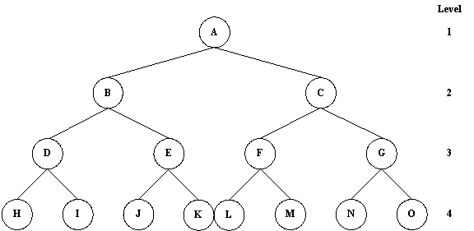

Inorder Tree Traversal
Result of binary tree example:
H, D, I, B, J, E, K, A, L, F, M, C, N, G, O

Preorder Tree Traversal
A, B, D, H, I, E, J, K, C, F, L, M, G, N, O

Postorder Tree Traversal
H, I, D, J, K, E, B, L, M, F, N, O, G, C, A

Binary Search Tree
Definition: A binary search tree is a binary tree. It may be empty. If it is not empty, it satisfies the following properties:
(1) Every element has a key, and no two elements have the same key, that is, the keys are unique.
(2) The keys in a nonempty left subtree must be smaller than the key in the root of the subtree.
(3) The keys in a nonempty right subtree must be larger than the key in the root of the subtree.
(4) The left and right subtrees are also binary search trees.
20 15 12 17 25 22 30

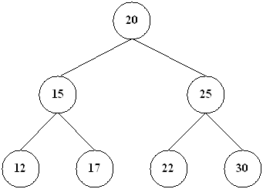

Root is a specially designed node (or data items) in a tree. It is the first node in the
hierarchical arrangement of the data items. ‘A’ is a root node in the Fig. 8.1. Each data
item in a tree is called a node.

A tree is an ideal data structure for representing hierarchical data. A tree can be
theoretically defined as a finite set of one or more data items (or nodes) such that :
1. There is a special node called the root of the tree.
2. Removing nodes (or data item) are partitioned into number of mutually exclusive
(i.e., disjoined) subsets each of which is itself a tree, are called sub tree.

Consider a binary tree T in Fig. 8.3. Here ‘A’ is the root node of the binary tree T.
Then ‘B’ is the left child of ‘A’ and ‘C’ is the right child of ‘A’ i.e., ‘A’ is a father of ‘B’ and ‘C’.
The node ‘B’ and ‘C’ are called brothers, since they are left and right child of the same
father. If a node has no child then it is called a leaf node. Nodes D,H,I,F,J are leaf node in
Fig. 8.3.

The tree is said to be strictly binary tree, if every non-leaf made in a binary tree has non-empty left and right sub trees. A strictly binary tree with n leaves always contains 2n–1 nodes.

The tree in Fig. 8.4 is strictly binary tree, where as the tree in Fig. 8.3 is not. That is every node in the strictly binary tree can have either no children or two children. They are also called 2-tree or extended binary tree.

A complete binary tree at depth ‘d’ is the strictly binary tree, where all the leaves are
at level d. Fig. 8.6 illustration the complete binary tree of depth 2.

A binary tree with n nodes, n > 0, has exactly n – 1 edges. A binary tree of depth d,
d > 0, has at least d and at mast 2d – 1 nodes in it. If a binary tree contains n nodes at level
l, then it contains at most 2n nodes at level l + 1. A complete binary tree of depth d is the
binary tree of depth d contains exactly 2 l nodes at each level l between 0 and d.
Finally, let us discuss in briefly the main difference between a binary tree and
ordinary tree is:
1. A binary tree can be empty where as a tree cannot.
2. Each element in binary tree has exactly two sub trees (one or both of these sub
trees may be empty). Each element in a tree can have any number of sub trees.
3. The sub tree of each element in a binary tree are ordered, left and right sub trees.
The sub trees in a tree are unordered.
If a binary tree has only left sub trees, then it is called left skewed binary tree. Fig.
8.7(a) is a left skewed binary tree.

