# Name: Nikhil

# CMS-ID: 023-23-0338

# Course: BS(CS) – III A

# Class: Data Structure

# Date: 16 – Dec – 2024

# Exercise LAB #14

Program #01:

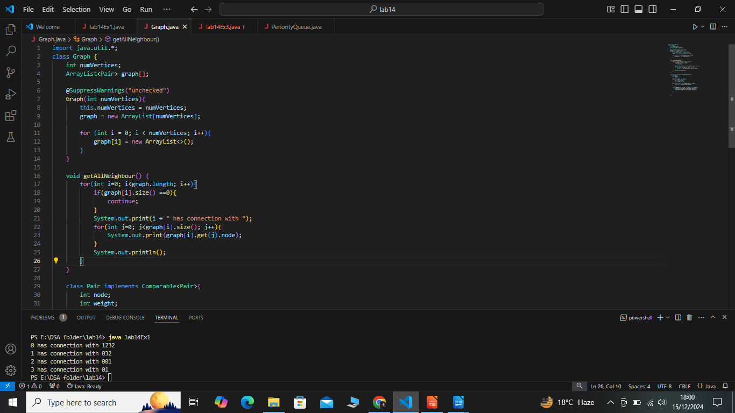 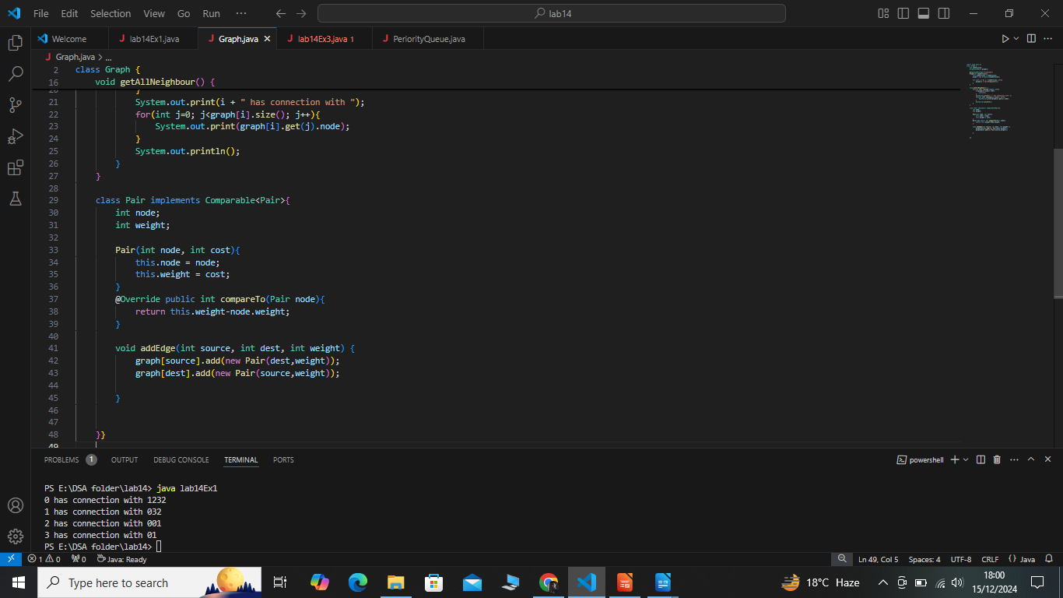

**Main Method:**

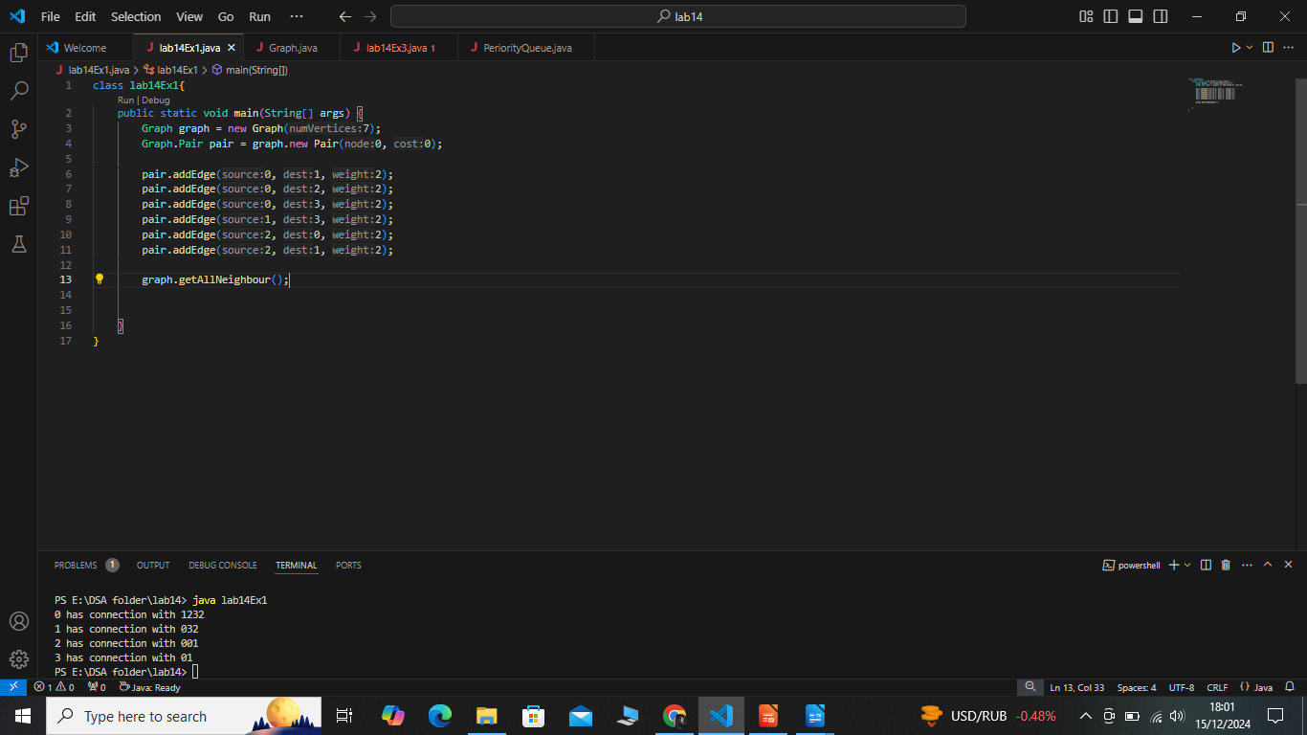 **Output:**

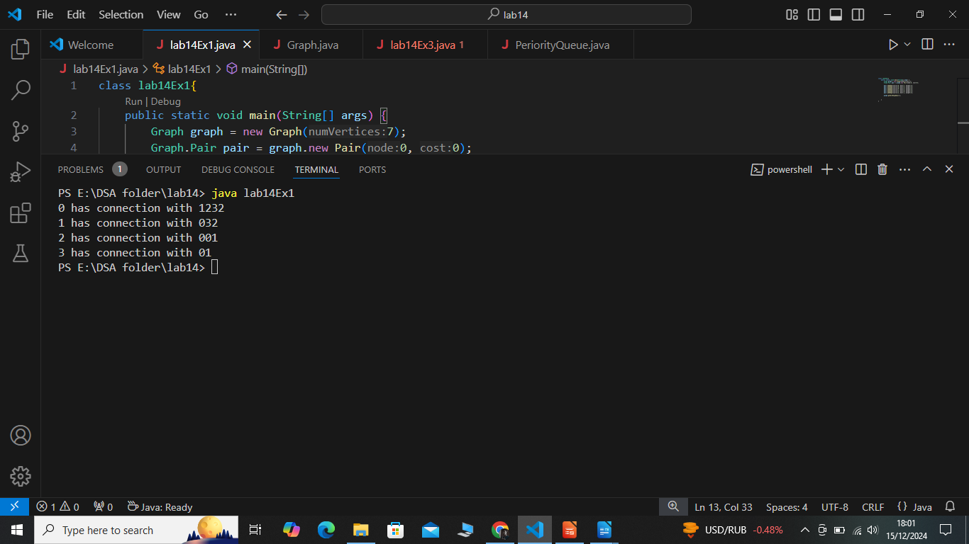

**Program #02:**

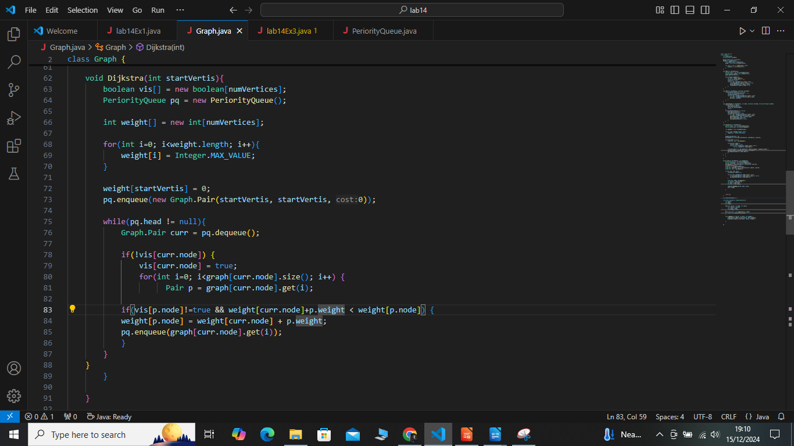

**Program #03:**

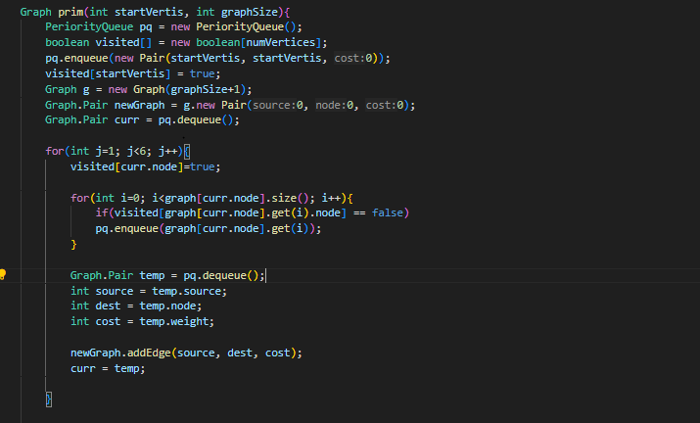 **Main class:**

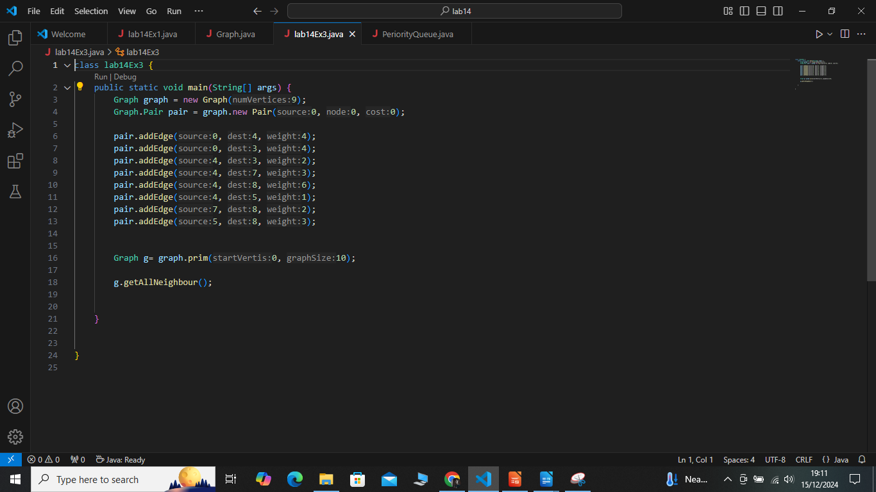

**Output:**

