PROJECT

WEATHER WEB APP

NIKHIL GUPTA

2019UCO1719

COE - 3

TISMEET SINGH

2019UCO1693

COE - 3

KARTIKEYA AGARWAL

2019UCO1692

COE - 3

COURSE CODE - CECSC04

COURSE NAME – WEB TECHNOLOGY

The Final Look….

[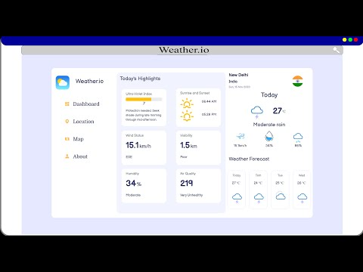](https://www.youtube.com/embed/zT_4Pw3rnW4?feature=oembed)

Click to Play

Link to our repository

<https://github.com/Nikhil-codecracker/WeatherWebApp>

Link to our page

<https://nikhil-codecracker.github.io/WeatherWebApp>

SNIPPETS OF OUR PROJECT….

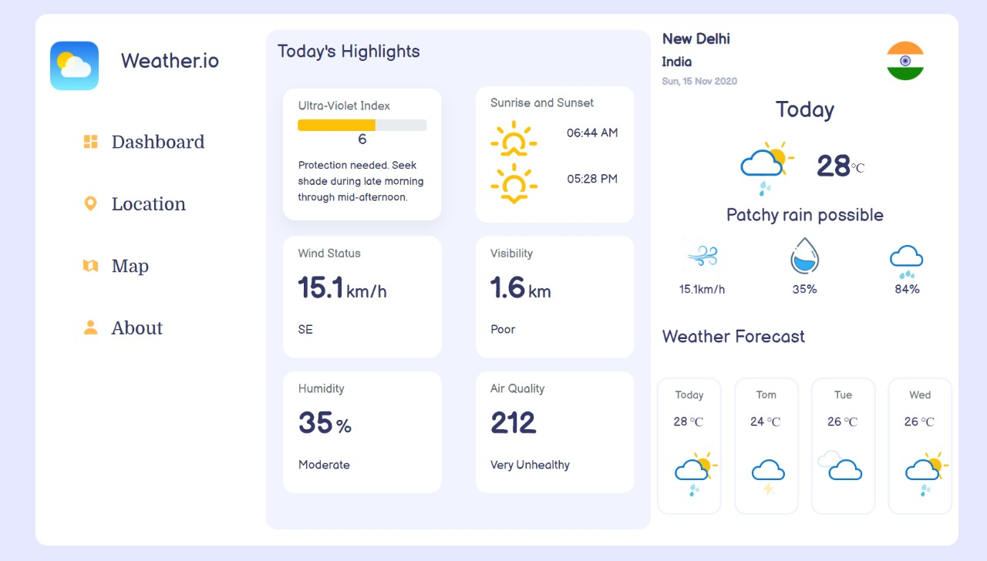

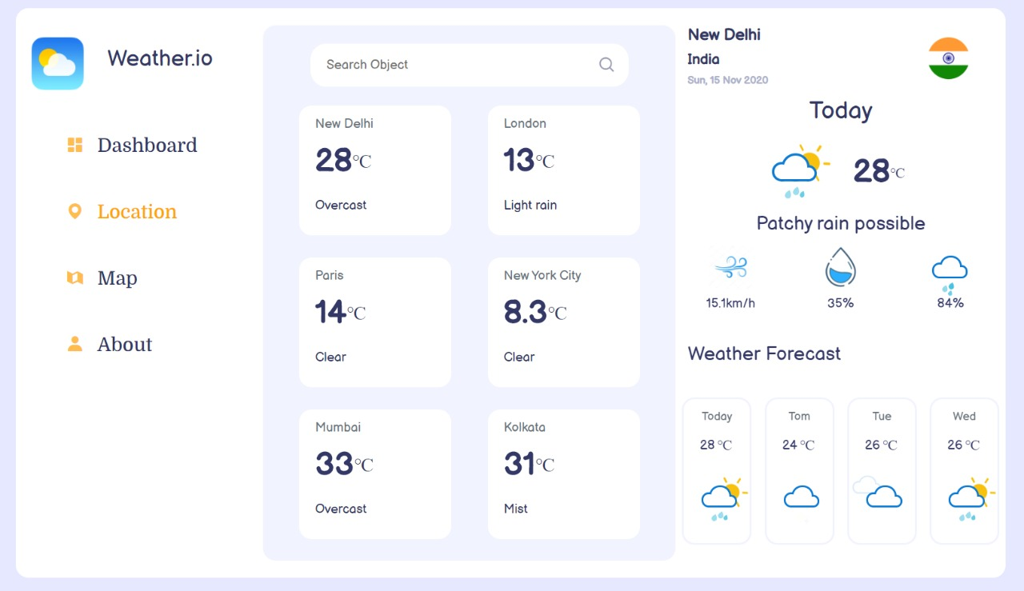

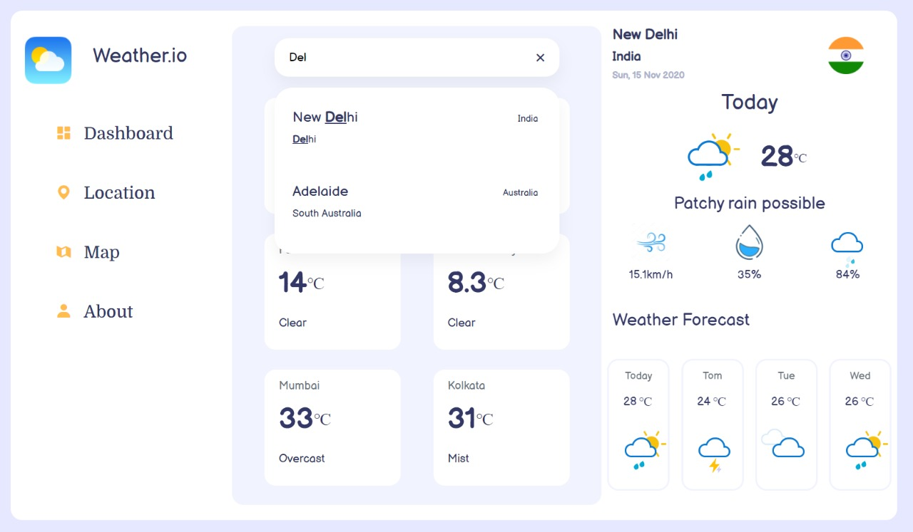

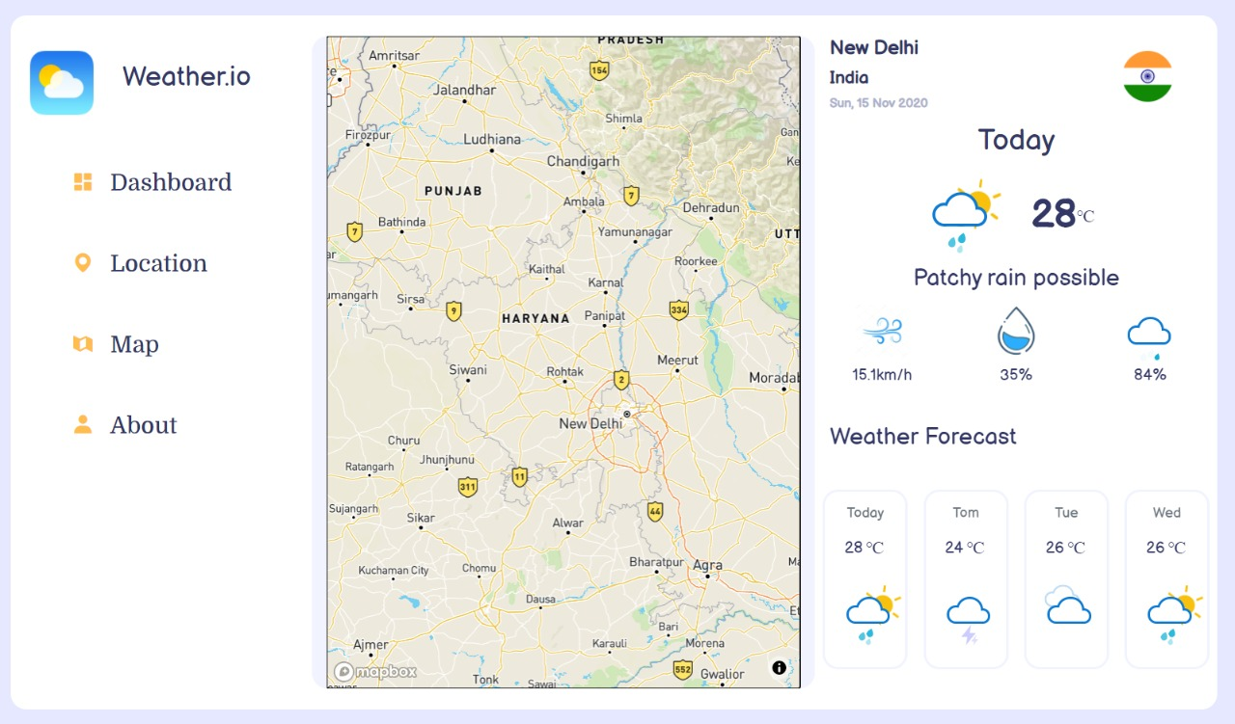

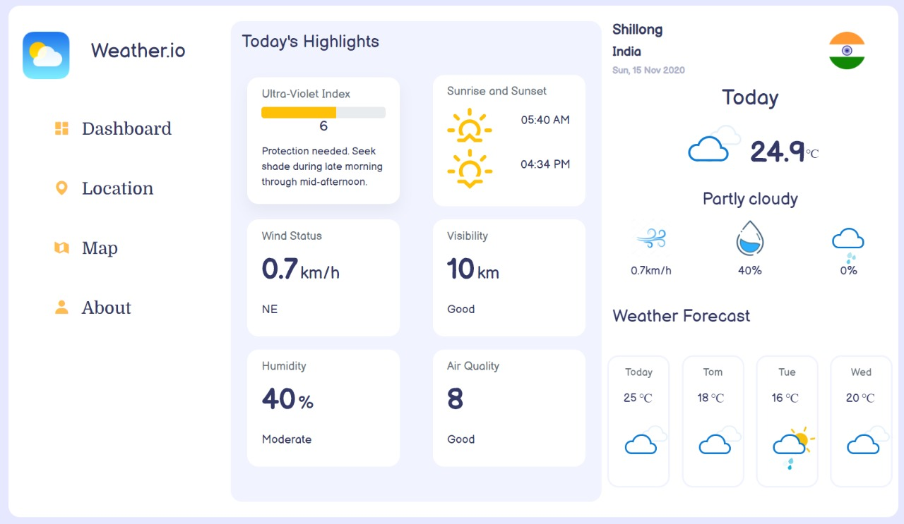

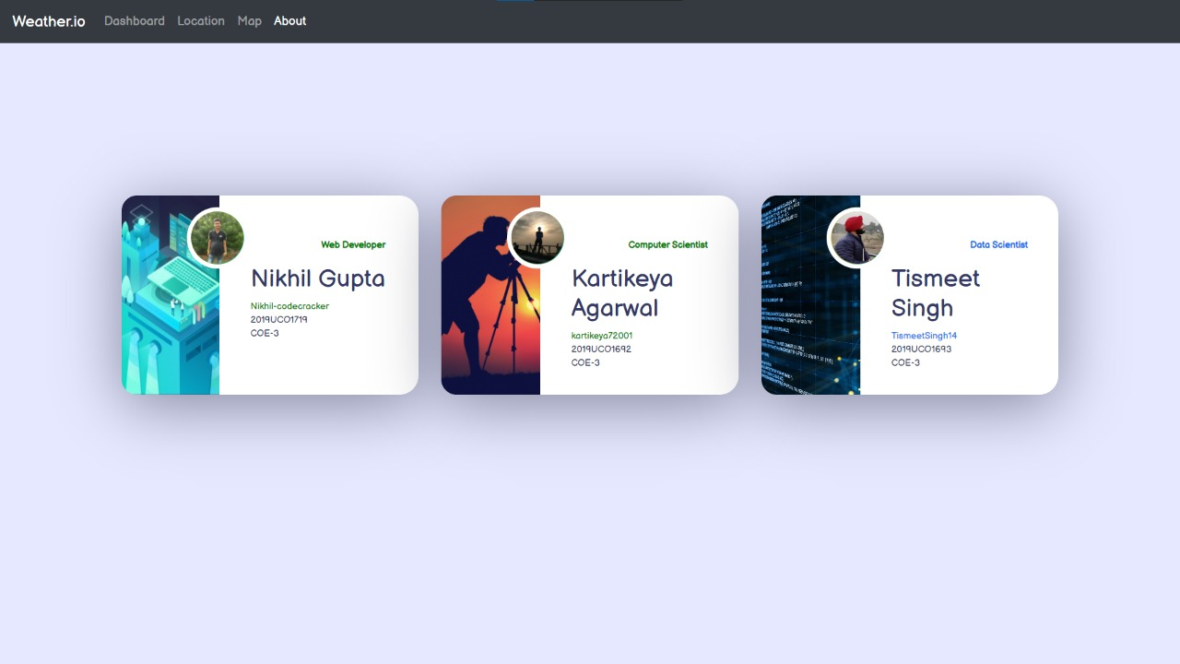

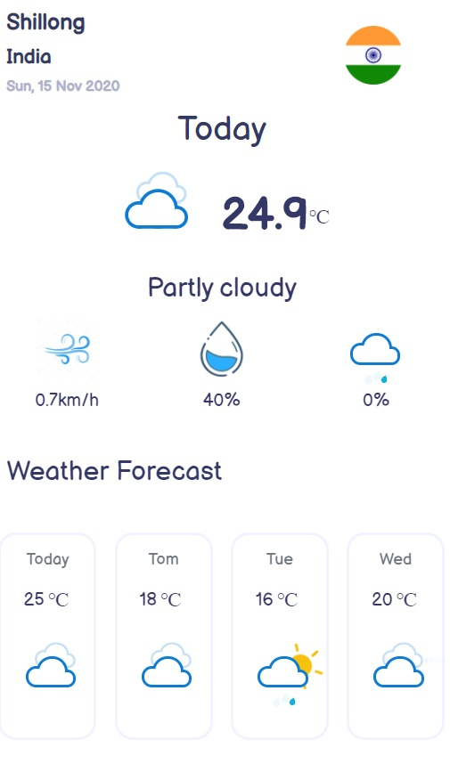

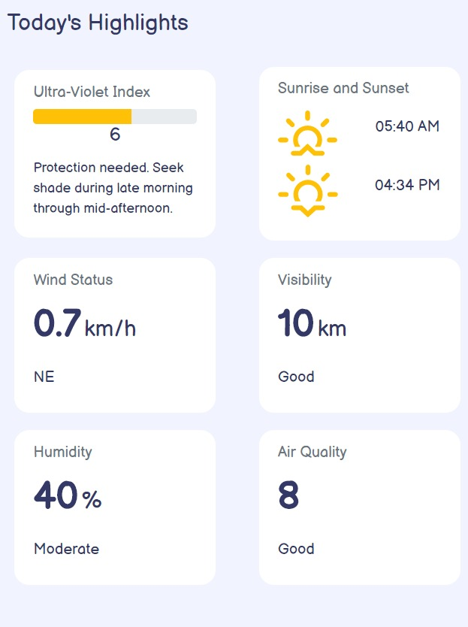

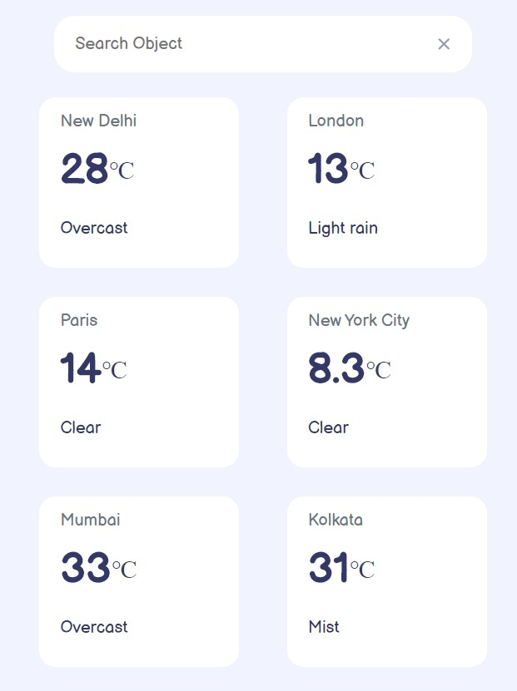

HTML



<!DOCTYPE html>

<html>

<head>

  <title>Weather.io</title>

  <meta name="viewport" content="width=device-width, initial-scale=1.0">

  <meta http-equiv="ScreenOrientation" content="autoRotate:disabled">

  <link rel="stylesheet" href="style.css">

  <link rel="stylesheet" href="./bootstrap/bootstrap.min.css">

  <script src="https://ajax.googleapis.com/ajax/libs/jquery/3.5.1/jquery.min.js"></script>

  <link href="https://fonts.googleapis.com/css2?family=Domine:wght@500&display=swap" rel="stylesheet">

  <link href='https://cdn.jsdelivr.net/npm/boxicons@2.0.6/css/boxicons.min.css' rel='stylesheet'>

  <link href="https://fonts.googleapis.com/css2?family=Balsamiq+Sans&display=swap" rel="stylesheet">

  <link href='https://api.mapbox.com/mapbox-gl-js/v1.12.0/mapbox-gl.css' rel='stylesheet' />

  <script src='https://api.mapbox.com/mapbox-gl-js/v1.12.0/mapbox-gl.js'></script>

</head>

<body style="font-family: 'Balsamiq Sans', cursive;">

  <div class="container" id="main-container" style="background-color: white;">

    <div class="row alignment2 setup-for-mob-view" style="height: 100%;">

      <div class="col-sm-3" style="height:100%">

        <div class="img">

          <div class="row">

            <div class="col-6">

              <img src="images/weather-icon2.png" style="width: 60%; margin: 2rem 0 0 0rem;">

            </div>

            <div class="col-2">

              <h3 class="alignment2 mainheading" style="margin: 3rem 0 0 0;">Weather.io</h3>

            </div>

          </div>

        </div>

        <div class="row">

          <div class="col-12 ">

            <a href="#dashboard" class="nav" id="dashboard"><i class="bx bxs-dashboard ico"></i> Dashboard</a>

          </div>

        </div>

        <div class="row">

          <div class="col-12 ">

            <a href="#location" class="nav" id="location"><i class="bx bxs-map ico"></i> Location</a>

          </div>

        </div>

        <div class="row">

          <div class="col-12 ">

            <a href="#map" class="nav" id="Map"><i class="bx bxs-map-alt ico"></i> Map</a>

          </div>

        </div>

        <div class="row">

          <div class="col-12 ">

            <a href="#about" class="nav about-media" id="about"><i class="bx bxs-user ico"></i> About</a>

          </div>

        </div>

      </div>

      <div class="col-sm-5 highlight alignment1">

        <div id="innerconsole">

          <h4 style="margin-top: 1rem;" class="today-highlight">Today's Highlights</h4>

          <div class="row" style="height:30%;">

            <div class="col-sm-6 alignment2" >

              <div class="card" style="width: 18rem; ">

                <div class="card-body">

                  <h6 class="card-subtitle media2query mb-2 text-muted">Ultra-Violet Index</h6>

                  <div class="progress">

                    <div class="progress-bar bg-warning" id="bar" style="width:0%"></div>

                  </div>

                  <h5 class="card-title" style="text-align: center;" id="uv-index"><strong></strong></h5>

                  <p class="card-text" style="font-size: 0.9rem;" id="uv-desc"></p>

                </div>

              </div>

            </div>

            <div class="col-sm-6 alignment2" >

              <div class="card" style="width: 18rem;">

                <div class="card-body">

                  <h6 class="card-subtitle media2query mb-2 text-muted">Sunrise and Sunset</h6>

                  <div class="row" style="padding: 5px 0;">

                    <div class="col-6">

                      <span class="iconify sun" data-icon="wi-sunrise" data-inline="false"

                        style="color: orange; font-size: 3rem;"></span>

                    </div>

                    <div class="col-6 alignment2">

                      <h5 class="card-title" id="sunrise" style="font-size: 1rem;"></h5>

                    </div>

                  </div>

                  <div class="row" style="padding: 5px 0;">

                    <div class="col-6">

                      <span class="iconify" data-icon="wi-sunset" data-inline="false"

                        style="color: orange; font-size: 3.5rem;"></span>

                    </div>

                    <div class="col-6 alignment2">

                      <h5 class="card-title" id="sunset" style="font-size: 1rem;"></h5>

                    </div>

                  </div>

                </div>

              </div>

            </div>

          </div>

          <div class="row" style="height:30%;">

            <div class="col-sm-6 alignment2" >

              <div class="card" style="width: 18rem; ">

                <div class="card-body">

                  <h6 class="card-subtitle media2query mb-2 text-muted">Wind Status</h6>

                  <p class="speed"><strong id="wind-speed"></strong><span class="unit">km/h</span></p>

                  <h6 id="wind-dir" class="media-query">WSW</h6>

                </div>

              </div>

            </div>

            <div class="col-sm-6 alignment2" >

              <div class="card" style="width: 18rem; ">

                <div class="card-body">

                  <h6 class="card-subtitle media2query mb-2 text-muted">Visibility</h6>

                  <p class="speed"><strong id="vis-val"></strong><span class="unit">km</span></p>

                  <h6 id="vis-status" class="media-query">Average</h6>

                </div>

              </div>

            </div>

          </div>

          <div class="row" style="height:30%;">

            <div class="col-sm-6 mediacardouter alignment2" style="margin-top: -2rem">

              <div class="card" style="width: 18rem; ">

                <div class="card-body">

                  <h6 class="card-subtitle media2query mb-2 text-muted">Humidity</h6>

                  <p class="speed"><strong id="humidity"></strong><span class="unit">%</span></p>

                  <h6 id="humidity-status" class="media-query"></h6>

                </div>

              </div>

            </div>

            <div class="col-sm-6 mediacardouter alignment2" style="margin-top: -2rem">

              <div class="card" style="width: 18rem; ">

                <div class="card-body">

                  <h6 class="card-subtitle media2query mb-2 text-muted">Air Quality</h6>

                  <p class="speed"><strong id="aqi-val">152</strong></p>

                  <h6 id="aqi-status" class="media-query">Unhealthy</h6>

                </div>

              </div>

            </div>

          </div>

        </div>

        <div id="search" class="search-part" style="display: none;">

          <div class="con-search notValue">

            <div class="con-input">

              <input onblur="handleBlur()" onfocus="handleFocus(event)" placeholder="Search Object"

                oninput="handleSearch(event)" type="text" id="inp">

              <i class="bx bx-search"></i>

              <i onclick="handleRemove()" class="bx bx-x"></i>

            </div>

            <div class="content-results">

              <div class="con-results">

                <div class="not-results">Not Results</div>

              </div>

            </div>

          </div>

          <div class="row" style="height:12rem">

            <div class="col-6 card-media-margin">

              <div class="card loc" style="width: 12rem;cursor: pointer; " id="card1">

                <div class="card-body">

                  <h6 class="card-subtitle mb-2 text-muted">New Delhi</h6>

                  <p class="speed"><strong id="New Delhi"></strong><span class="celcius"><sup>&#8451;</sup></span>

                  <h6 id="New Delhicond"></h6>

                </div>

              </div>

            </div>

            <div class="col-6 card-media-margin">

              <div class="card loc" style="width: 12rem;cursor: pointer; " id="card2">

                <div class="card-body">

                  <h6 class="card-subtitle mb-2 text-muted">London</h6>

                  <p class="speed"><strong id="London"></strong><span class="celcius"><sup>&#8451;</sup></span>

                  <h6 id="Londoncond"></h6>

                </div>

              </div>

            </div>

          </div>

          <div class="row" style="height:12rem">

            <div class="col-6 card-media-margin">

              <div class="card loc" style="width: 12rem;cursor: pointer; " id="card3">

                <div class="card-body">

                  <h6 class="card-subtitle mb-2 text-muted">Paris</h6>

                  <p class="speed"><strong id="Paris"></strong><span class="celcius"><sup>&#8451;</sup></span>

                  <h6 id="Pariscond"></h6>

                </div>

              </div>

            </div>

            <div class="col-6 card-media-margin">

              <div class="card loc" style="width: 12rem;cursor: pointer; " id="card4">

                <div class="card-body">

                  <h6 class="card-subtitle mb-2 text-muted">New York City</h6>

                  <p class="speed"><strong id="New York City"></strong><span class="celcius"><sup>&#8451;</sup></span>

                  <h6 id="New York Citycond"></h6>

                </div>

              </div>

            </div>

          </div>

          <div class="row" style="height:12rem">

            <div class="col-6 card-media-margin">

              <div class="card loc" style="width: 12rem;cursor: pointer; " id="card5">

                <div class="card-body">

                  <h6 class="card-subtitle mb-2 text-muted">Mumbai</h6>

                  <p class="speed"><strong id="Mumbai"></strong><span class="celcius"><sup>&#8451;</sup></span>

                  <h6 id="Mumbaicond"></h6>

                </div>

              </div>

            </div>

            <div class="col-6 card-media-margin">

              <div class="card loc" style="width: 12rem;cursor: pointer; " id="card6">

                <div class="card-body">

                  <h6 class="card-subtitle mb-2 text-muted">Kolkata</h6>

                  <p class="speed"><strong id="Kolkata"></strong><span class="celcius"><sup>&#8451;</sup></span>

                  <h6 id="Kolkatacond"></h6>

                </div>

              </div>

            </div>

          </div>

        </div>

        <!-- Map Function -->

        <div id='map' style='display:none'>

        </div>

      </div>

      <div class="col-sm-4">

        <!--START OF TOP DETAILS-->

        <div class="row" style="padding: 5px 0;">

          <div class="col-6 ">

            <h5 class="location mb-2" id="city"></h5>

            <h6 class="country-name" id="country"></h6>

            <h6 class="day-date" id="date"></h6>

          </div>

          <div class="col-6 alignment2">

            <img src="images/netherlands.png" style="width: 30%; margin: -0.2rem -4rem 0 0rem;" id="country-image">

          </div>

        </div>

        <!--END OF TOP DETAILS-->

        <!--START OF TEMPERATURE DETAILS-->

        <h4 class="today mb-2 text-center">Today</h4>

        <div class="row" style="padding: 5px 0;">

          <div class="col-6 ">

            <!-- START OF SUN ICON-->

            <div class="anim-icon" style="margin-left:5.5rem;margin-bottom: -1.5rem;" id="sunny-icon">

              <div class="sunny">

                <div class="rays"></div>

              </div>

            </div>

            <!-- END OF SUN ICON-->

            <!--START OF MIST ICON-->

            <div class="anim-icon" style="margin-left:5.5rem;margin-bottom: -1.5rem;" id="misty-icon">

              <div class="cloud"></div>

              <div class="fog"></div>

            </div>

            <!--END OF MIST ICON-->

            <!--START OF SNOW ICON-->

            <div class="anim-icon" style="margin-left:5.5rem;margin-bottom: -1.5rem;" id="snowy-icon">

              <div class="cloud"></div>

              <div class="snow">

                <div class="flake"></div>

                <div class="flake"></div>

              </div>

            </div>

            <!--END OF SNOW ICON-->

            <!--START OF RAIN ICON-->

            <div class="anim-icon" style="margin-left:5.5rem;margin-bottom: -1.5rem;" id="rainy-icon">

              <div class="cloud"></div>

              <div class="rain"></div>

            </div>

            <!--END OF RAIN ICON-->

            <!--START OF CLOUDY ICON-->

            <div class="anim-icon" style="margin-left:5.5rem;margin-bottom: -1.5rem;" id="cloudy-icon">

              <div class="cloud"></div>

              <div class="cloud"></div>

            </div>

            <!--END OF CLOUDY ICON-->

            <!--START OF THUNDERSTORM ICON-->

            <div class="anim-icon" style="margin-left:5.5rem;margin-bottom: -1.5rem;" id="thunderstorm-icon">

              <div class="cloud"></div>

              <div class="lightning">

                <div class="bolt"></div>

                <div class="bolt"></div>

              </div>

            </div>

            <!--END OF THUNDERSTORM ICON-->

            <!--START OF SUN SHOWER ICON-->

            <div class="anim-icon" style="margin-left:5.5rem;margin-bottom: -1.5rem;" id="sunCloud-icon">

              <div class="cloud"></div>

              <div class="sunny">

                <div class="rays"></div>

              </div>

              <div class="rain"></div>

            </div>

            <!--END OF SUN SHOWER ICON-->

          </div>

          <div class="col-6 alignment2">

            <p class="temper" id="today">

            <p class="cel"><sup>&#8451;</sup></p>

            </p>

          </div>

        </div>

        <div class="row">

          <div class="col alignment2">

            <h4 id="weather"></h4>

          </div>

        </div>

        <!--START OF TEMPERATURE DETAILS-->

        <!--START OF WEATHER DETAILS (ICONS)-->

        <div class="row">

          <div class="col-4 alignment2">

            <!--WIND ICON-->

            <img src="images/wind.png" style="width: 50%; margin: 0rem 0 0 0rem;">

          </div>

          <div class="col-4 alignment2">

            <!--HUMIDITY ICON-->

            <img src="images/humidity.png" style="width: 50%; margin: 0rem 0 0 0rem;">

          </div>

          <div class="col-4 alignment2">

            <!--START OF RAIN ICON-->

            <div class="anim-icon" style="font-size:0.4em">

              <div class="cloud"></div>

              <div class="rain"></div>

            </div>

            <!--END OF RAIN ICON-->

          </div>

        </div>

        <div class="row" style="margin-top:0.3rem">

          <div class="col-4">

            <h6 class="alignment2" id="windspeedright"></h6>

          </div>

          <div class="col-4">

            <h6 class="alignment2" id="humidityright"></h6>

          </div>

          <div class="col-4">

            <h6 class="alignment2" id="precipitation"></h6>

          </div>

        </div>

        <!--END OF WEATHER DETAILS (ICONS)-->

        <div class="row">

          <div class="col">

            <h4 style="margin: 2rem 0 1rem;">Weather Forecast</h4>

          </div>

        </div>

        <div class="row">

          <div class="col-3" style="padding-left: 0;">

            <div class="card cardx" style="width: 5.5rem; ">

              <div class="card-body">

                <h6 class="card-subtitle mb-2 text-muted time">Today</h6>

                <p class="speedx" id="day"></p>

                <!--START OF CLOUDY ICON-->

                <div class="anim-icon" style="font-size: 0.4em;margin-left:-2em;" id = "day-today-icon">

                  <!-- <div class="cloud"></div>

                  <div class="cloud"></div> -->

                </div>

                <!--END OF CLOUDY ICON-->

              </div>

            </div>

          </div>

          <div class="col-3" style="padding-left: 0;">

            <div class="card cardx" style="width: 5.5rem; ">

              <div class="card-body">

                <h6 class="card-subtitle mb-2 text-muted time">Tom</h6>

                <p class="speedx" id="day1"></p>

                <!--START OF THUNDERSTORM ICON-->

                <div class="anim-icon" style="font-size: 0.4em;margin-left:-2em;" id = "day-tomorrow-icon">

                  <!-- <div class="cloud"></div>

                  <div class="lightning">

                    <div class="bolt"></div>

                    <div class="bolt"></div>

                  </div> -->

                </div>

                <!--END OF THUNDERSTORM ICON-->

              </div>

            </div>

          </div>

          <div class="col-3" style="padding-left: 0;">

            <div class="card cardx" style="width: 5.5rem; ">

              <div class="card-body">

                <h6 class="card-subtitle mb-2 text-muted time" id="daytwo"></h6>

                <p class="speedx" id="day2"></p>

                <!--START OF SUN SHOWER ICON-->

                <div class="anim-icon" style="font-size: 0.4em;margin-left:-2em;" id = "day-2-icon">

                  <!-- <div class="cloud"></div>

                  <div class="sunny">

                    <div class="rays"></div>

                  </div>

                  <div class="rain"></div> -->

                </div>

                <!--END OF SUN SHOWER ICON-->

              </div>

            </div>

          </div>

          <div class="col-3" style="padding-left: 0;">

            <div class="card cardx" style="width: 5.5rem; ">

              <div class="card-body">

                <h6 class="card-subtitle mb-2 text-muted time" id="daythree"></h6>

                <p class="speedx" id="day3"></p>

                <!--START OF SNOW ICON-->

                <div class="anim-icon" style="font-size: 0.4em;margin-left:-2em;" id = "day-3-icon">

                  <!-- <div class="cloud"></div>

                  <div class="snow">

                    <div class="flake"></div>

                    <div class="flake"></div> -->

                  </div>

                </div>

                <!--END OF SNOW ICON-->

              </div>

            </div>

          </div>

        </div>

      </div>

    </div>

  </div>

  <div id="about-space" style="display: none;">

    <nav class="navbar navbar-expand-lg navbar-dark bg-dark">

      <a class="navbar-brand" href="#">Weather.io</a>

      <button class="navbar-toggler" type="button" data-toggle="collapse" data-target="#navbarNavAltMarkup"

        aria-controls="navbarNavAltMarkup" aria-expanded="false" aria-label="Toggle navigation">

        <span class="navbar-toggler-icon"></span>

      </button>

      <div class="collapse navbar-collapse" id="navbarNavAltMarkup">

        <div class="navbar-nav">

          <a class="nav-item nav-link" href="#home" id="dash2">Dashboard</a>

          <a class="nav-item nav-link" href="#location" id="loc2">Location</a>

          <a class="nav-item nav-link" href="#map" id="map2">Map</a>

          <a class="nav-item nav-link active" href="#about" id="about2">About</a>

        </div>

      </div>

    </nav>

    <div class="container alignment2" style="height:33rem !important">

      <div class="row ">

        <div class="col-sm-4 marginclass">

          <div class="carda" style="height: 16.2rem">

            <div class="img-avatara">

              <img src="./images/Nikhil1.jpeg" style="border-radius: 50%; height: 100%; width: 100%;">

            </div>

            <div class="card-texta">

              <div class="portadaa1">

              </div>

              <div class="title-totala">

                <div class="titlea">Web Developer</div>

                <h2>Nikhil Gupta</h2>

                <div class="desca"><a href="https://github.com/Nikhil-codecracker" style="text-decoration: none; color: green;">Nikhil-codecracker</a><br>2019UCO1719<br>COE-3</div>

              </div>

            </div>

          </div>

        </div>

        <div class="col-sm-4 marginclass">

          <div class="carda">

            <div class="img-avatara">

              <img src="images/KartikeyaAgarwalsmall.jpeg" style="border-radius: 50%; height: 100%; width: 100%;">

            </div>

            <div class="card-texta">

              <div class="portadaa2">

              </div>

              <div class="title-totala">

                <div class="titlea">Computer Scientist</div>

                <h2>Kartikeya Agarwal</h2>

                <div class="desca"><a href="https://kartikeya72001.github.io/" style="text-decoration: none; color: green;">kartikeya72001</a><br>2019UCO1692<br>COE-3</div>

              </div>

            </div>

          </div>

        </div>

        <div class="col-sm-4 marginclass">

          <div class="carda">

            <div class="img-avatara">

              <img src="images/tismeetsingh.jpeg" style="border-radius: 50%; height: 100%; width: 100%;">

            </div>

            <div class="card-texta">

              <div class="portadaa3">

              </div>

              <div class="title-totala">

                <div class="titlea" style = "color:rgb(26, 113, 245);">Data Scientist</div>

                <h2>Tismeet Singh</h2>

                <div class="desca"><a href="https://github.com/TismeetSingh14" style="text-decoration: none; color:rgb(26, 113, 245);">TismeetSingh14</a><br>2019UCO1693<br>COE-3</div>

              </div>

            </div>

          </div>

        </div>

      </div>

    </div>

  </div>

  <script src="script.js"></script>

  <script src="https://code.iconify.design/1/1.0.7/iconify.min.js"></script>

  <script src="https://code.jquery.com/jquery-3.5.1.slim.min.js"

    integrity="sha384-DfXdz2htPH0lsSSs5nCTpuj/zy4C+OGpamoFVy38MVBnE+IbbVYUew+OrCXaRkfj"

    crossorigin="anonymous"></script>

  <script src="https://stackpath.bootstrapcdn.com/bootstrap/4.5.2/js/bootstrap.min.js"

    integrity="sha384-B4gt1jrGC7Jh4AgTPSdUtOBvfO8shuf57BaghqFfPlYxofvL8/KUEfYiJOMMV+rV"

    crossorigin="anonymous"></script>

</body>

</html>

CSS



body {

  background-color: #E5E8FF !important;

  margin: 0;

  font-family: "Lato", sans-serif;

  color: #333866 !important;

  outline: none;

  overflow-x: hidden;

}

.container {

  margin: 4rem 0;

  border-radius: 1rem;

  height: 45rem;

}

.highlight {

  background-color: #F1F3FF;

  border-radius: 1rem;

  height: 94%;

}

.alignment1 {

  display: flex;

  justify-content: center;

  align-items: center;

  flex-direction: column;

}

.alignment2 {

  display: flex;

  justify-content: center;

  align-items: center;

  flex-direction: row;

}

.card {

  border-radius: 1rem !important;

}

.card:hover {

  box-shadow: 0px 10px 20px 0px rgba(0, 0, 0, .05) !important;

}

::-webkit-scrollbar {

  width: 5px;

}

::-webkit-scrollbar-track {

  box-shadow: inset 0 0 3px grey;

  border-radius: 2px;

}

::-webkit-scrollbar-thumb {

  background: #333866;

  border-radius: 2px;

}

::-webkit-scrollbar-thumb:hover {

  width: 10px;

  background: #FFBD50;

}

::-webkit-scrollbar:hover {

  width: 12px;

}

.speed {

  font-size: 2.5rem;

}

.speedx {

  font-size: 1rem;

}

.unit {

  font-size: 1.5rem;

  margin-left: 0.2rem

}

.unitx {

  font-size: 1rem;

  margin-left: 0.2rem

}

a {

  text-decoration: none !important;

}

.location {

  color: #333866;

  font-weight: bold;

}

.country-name {

  color: #333866;

  font-weight: bold;

  font-size: 18px;

}

.day-date {

  color: #adb1cc;

  font-weight: bold;

  font-size: 13px;

}

.today {

  color: #333866;

  font-size: 30px;

}

.temper {

  margin-top: 1rem;

  margin-left: -7rem;

  font-size: 2.5rem;

  font-weight: 900;

  color: #333866;

}

.cel {

  position: relative;

  top: 0.6rem;

  margin-top: 1rem;

  font-size: 1.5rem;

  color: #333866;

}

.celcius {

  position: relative;

  top: 0.5rem;

  margin-top: 1rem;

  font-size: 2rem;

  color: #333866;

}

.cardx {

  border: solid #F1F3FF !important;

}

.time {

  padding: 0;

  margin: 0;

  text-align: center;

  font-size: 0.9rem;

}

.nav {

  font-size: 1.5rem;

  color: #333866;

  font-family: 'Domine', serif;

  margin: 3rem 0 2rem 3rem;

}

.nav:hover {

  cursor: pointer;

  color: orange;

}

.ico {

  position: relative;

  top: 0.3rem;

  color: #FFBD50;

  margin: 0 1rem 0 0;

}

.active {

  color: #A2ACFF;

}

.con-search {

  position: relative;

  width: 90%;

  left: 1.4rem;

}

.focus .content-results {

  opacity: 1;

  visibility: visible;

  transform: translate(0, 0);

}

.con-input {

  width: 100%;

  display: flex;

  align-items: center;

  justify-content: center;

  z-index: 100;

}

.con-input i {

  position: absolute;

  right: 15px;

  font-size: 1.5rem;

  transition: all .25s ease;

  opacity: .5;

}

.notValue .con-input i.bx-search {

  display: block;

}

.con-input i.bx-search {

  display: none;

}

.notValue .con-input i.bx-x {

  display: none;

}

.con-input i.bx-x {

  display: block;

  cursor: pointer;

}

.con-input input {

  outline: none;

  width: 100%;

  padding: 15px 20px;

  box-sizing: border-box;

  border: 0px;

  border-radius: 20px;

  transition: all .25s ease;

}

.con-input input:focus {

  transform: translate(0, -6px);

  box-shadow: 0px 10px 20px 0px rgba(0, 0, 0, .05);

}

.con-input input:focus~i {

  transform: translate(0, -6px);

  opacity: 1;

}

.content-results {

  position: absolute;

  width: 100%;

  background: #fff;

  margin-top: 10px;

  border-radius: 25px;

  box-shadow: 0px 10px 20px 0px rgba(0, 0, 0, .05);

  transform: translate(0, -10px);

  transition: all .25s ease;

  opacity: 0;

  z-index: 10;

  visibility: hidden;

  padding-right: 10px;

  overflow: hidden;

}

.con-results {

  width: 100%;

  overflow: auto;

  max-height: 300px;

  margin-top: 10px;

  margin-bottom: 10px;

}

.con-results:empty {

  margin-top: 0px;

  margin-bottom: 0px;

}

.not-results {

  text-align: center;

  padding: 15px;

  font-size: .9rem;

  opacity: .7;

  display: none;

}

.con-search:not(.notValue) .con-results:empty~.not-results {

  display: block;

}

.con-results .result {

  padding: 15px;

  margin: 5px 0px;

  list-style: none;

  transition: all .25s ease;

  position: relative;

  cursor: pointer;

  width: calc(100% - 10px);

  margin-left: 10px;

  border-radius: 20px;

}

.con-results .result:hover {

  background: #f4f7f8;

}

.con-results .result p {

  font-size: .9rem;

  color: rgba(var(--color), .6);

}

.con-results .result b {

  background: rgba(var(--color), .1);

  text-decoration: underline;

  color: rgba(var(--color), 1);

  border-radius: 2px;

}

.web {

  position: absolute;

  right: 0px;

  top: 0px;

  font-size: .8rem;

  color: rgba(var(--color), .5);

  padding: 20px;

}

.hidden {

  opacity: 0;

  margin-top: -15px;

}

.con-results::-webkit-scrollbar {

  width: 5px;

}

.con-results::-webkit-scrollbar-thumb {

  border-radius: 5px;

  background: #000;

}

#map {

  height: 100%;

  width: 100%;

}

.anim-icon {

  position: relative;

  display: inline-block;

  width: 12em;

  height: 10em;

  font-size: 0.5em;

}

.sunny {

  position: absolute;

  top: 50%;

  left: 50%;

  width: 2.5em;

  height: 2.5em;

  margin: -1.25em;

  background: rgb(248, 193, 13);

  border-radius: 50%;

  box-shadow: 0 0 0 0.375em rgb(248, 193, 13);

  animation: spin 12s infinite linear;

}

.rays {

  position: absolute;

  top: -2em;

  left: 50%;

  display: block;

  width: 0.375em;

  height: 1.125em;

  margin-left: -0.1875em;

  background: rgb(248, 193, 13);

  border-radius: 0.25em;

  box-shadow: 0 5.375em rgb(248, 193, 13);

}

.rays:before, .rays:after {

  content: '';

  position: absolute;

  top: 0em;

  left: 0em;

  display: block;

  width: 0.375em;

  height: 1.125em;

  transform: rotate(60deg);

  transform-origin: 50% 3.25em;

  background: rgb(248, 193, 13);

  border-radius: 0.25em;

  box-shadow: 0 5.375em rgb(248, 193, 13);

}

.rays:before {

  transform: rotate(120deg);

}

.cloud {

  position: absolute;

  z-index: 1;

  top: 50%;

  left: 50%;

  width: 3.6875em;

  height: 3.6875em;

  margin: -1.84375em;

  background: white;

  border-radius: 50%;

  box-shadow: -2.1875em 0.6875em 0 -0.6875em white, 2.0625em 0.9375em 0 -0.9375em white, 0 0 0 0.375em rgb(15, 124, 212), -2.1875em 0.6875em 0 -0.3125em rgb(15, 124, 212), 2.0625em 0.9375em 0 -0.5625em rgb(15, 124, 212);

}

.cloud:after {

  content: '';

  position: absolute;

  bottom: 0;

  left: -0.5em;

  display: block;

  width: 4.5625em;

  height: 1em;

  background: white;

  box-shadow: 0 0.4375em 0 -0.0625em rgb(15, 124, 212);

}

.cloud:nth-child(2) {

  z-index: 0;

  background: #fff;

  box-shadow: -2.1875em 0.6875em 0 -0.6875em #fff, 2.0625em 0.9375em 0 -0.9375em #fff, 0 0 0 0.375em rgb(15, 124, 212), -2.1875em 0.6875em 0 -0.3125em rgb(15, 124, 212), 2.0625em 0.9375em 0 -0.5625em rgb(15, 124, 212);

  opacity: 0.3;

  transform: scale(0.8) translate(6em, -3em);

  animation: cloud 4s linear infinite;

}

.cloud:nth-child(2):after {

  background: #fff;

}

.cloud+.sunny {

  margin: -2em 1em;

}

.rain, .lightning, .snow {

  position: absolute;

  z-index: 2;

  top: 50%;

  left: 50%;

  width: 3.75em;

  height: 3.75em;

  margin: 2.4em 0 10em -2em;

  background: white;

}

.rain:after {

  content: '';

  position: absolute;

  z-index: 2;

  top: 50%;

  left: 50%;

  width: 1.125em;

  height: 1.125em;

  margin: -1em 0 0 -0.25em;

  background: rgb(4, 171, 212);

  border-radius: 100% 0 60% 50% / 60% 0 100% 50%;

  box-shadow: 0.625em 0.875em 0 -0.125em rgba(255, 255, 255, 0.2), -0.875em 1.125em 0 -0.125em rgba(255, 255, 255, 0.2), -1.375em -0.125em 0 rgba(255, 255, 255, 0.2);

  transform: rotate(-28deg);

  animation: rain 3s linear infinite;

}

.bolt {

  position: absolute;

  top: 50%;

  left: 50%;

  margin: -0.25em 0 0 -0.125em;

  color: blue;

  opacity: 0.3;

  animation: lightning 2s linear infinite;

}

.bolt:nth-child(2) {

  width: 0.5em;

  height: 0.25em;

  margin: -1.75em 0 0 -1.875em;

  transform: translate(2.5em, 2.25em);

  opacity: 0.2;

  animation: lightning 1.5s linear infinite;

}

.bolt:before, .bolt:after {

  content: '';

  position: absolute;

  z-index: 2;

  top: 50%;

  left: 50%;

  margin: -1.625em 0 0 -1.0125em;

  border-top: 1.25em solid transparent;

  border-right: 0.75em solid;

  border-bottom: 0.75em solid;

  border-left: 0.5em solid transparent;

  transform: skewX(-10deg);

}

.bolt:after {

  margin: -0.25em 0 0 -0.25em;

  border-top: 0.75em solid;

  border-right: 0.5em solid transparent;

  border-bottom: 1.25em solid transparent;

  border-left: 0.75em solid;

  transform: skewX(-10deg);

}

.bolt:nth-child(2):before {

  margin: -0.75em 0 0 -0.5em;

  border-top: 0.625em solid transparent;

  border-right: 0.375em solid;

  border-bottom: 0.375em solid;

  border-left: 0.25em solid transparent;

}

.bolt:nth-child(2):after {

  margin: -0.125em 0 0 -0.125em;

  border-top: 0.375em solid;

  border-right: 0.25em solid transparent;

  border-bottom: 0.625em solid transparent;

  border-left: 0.375em solid;

}

.flake:before, .flake:after {

  content: '\2744';

  position: absolute;

  top: 50%;

  left: 50%;

  margin: -1.025em 0 0 -1.0125em;

  color: black;

  list-height: 1em;

  opacity: 0.2;

  animation: spin 8s linear infinite reverse;

}

.flake:after {

  margin: 0.125em 0 0 -1em;

  font-size: 1.5em;

  opacity: 0.4;

  animation: spin 14s linear infinite;

}

.flake:nth-child(2):before {

  margin: -0.5em 0 0 0.25em;

  font-size: 1.25em;

  opacity: 0.2;

  animation: spin 10s linear infinite;

}

.flake:nth-child(2):after {

  margin: 0.375em 0 0 0.125em;

  font-size: 2em;

  opacity: 0.4;

  animation: spin 16s linear infinite reverse;

}

.fog {

  position: absolute;

  top: 50%;

  left: 50%;

  margin: 1.75em 0 0 0;

}

.fog::before, .fog::after {

  content: '';

  position: absolute;

  left: 50%;

  width: 5em;

  height: 0.5em;

  margin-left: -2.5em;

  color: rgb(199, 197, 197);

  background: currentColor;

  border-radius: 0.5em;

  animation: fog 6s infinite linear alternate;

}

.fog::before {

  top: 0.75em;

}

.fog::after {

  top: 1.5em;

  animation-delay: -6s;

}

@keyframes rain {

  0% {

    background: rgb(4, 171, 212);

    box-shadow: 0.625em 0.875em 0 -0.125em rgba(255, 255, 255, 0.2), -0.875em 1.125em 0 -0.125em rgba(255, 255, 255, 0.2), -1.375em -0.125em 0 rgb(4, 171, 212);

  }

  25% {

    box-shadow: 0.625em 0.875em 0 -0.125em rgba(255, 255, 255, 0.2), -0.875em 1.125em 0 -0.125em rgb(4, 171, 212), -1.375em -0.125em 0 rgba(255, 255, 255, 0.2);

  }

  50% {

    background: rgba(255, 255, 255, 0.3);

    box-shadow: 0.625em 0.875em 0 -0.125em rgb(4, 171, 212), -0.875em 1.125em 0 -0.125em rgba(255, 255, 255, 0.2), -1.375em -0.125em 0 rgba(255, 255, 255, 0.2);

  }

  100% {

    box-shadow: 0.625em 0.875em 0 -0.125em rgba(255, 255, 255, 0.2), -0.875em 1.125em 0 -0.125em rgba(255, 255, 255, 0.2), -1.375em -0.125em 0 rgb(4, 171, 212);

  }

}

@keyframes lightning {

  45% {

    color: #fff;

    background: #fff;

    opacity: 0.2;

  }

  50% {

    color: #FFC107;

    background: #FFC107;

    opacity: 1;

  }

  55% {

    color: #fff;

    background: #fff;

    opacity: 0.2;

  }

}

@keyframes cloud {

  0% {

    opacity: 0;

  }

  50% {

    opacity: 0.3;

  }

  100% {

    opacity: 0;

    transform: scale(0.8) translate(-200%, -3em);

  }

}

@keyframes fog {

  0% {

    transform: translateX(-0.5em);

  }

  100% {

    transform: translateX(0.5em);

  }

}

@import url("https://fonts.googleapis.com/css?family=Roboto:400,400i,700");

.carda {

  background: #fff;

  border-radius: 4px;

  box-shadow: 0px 14px 80px rgba(34, 35, 58, 0.5);

  max-width: 400px;

  display: flex;

  flex-direction: row;

  border-radius: 25px;

  position: relative;

}

.carda h2 {

  margin: 0;

  padding: 0 1rem;

}

.carda .titlea {

  padding: 1rem;

  text-align: right;

  color: green;

  font-weight: bold;

  font-size: 12px;

}

.carda .desca {

  padding: 0.5rem 1rem;

  font-size: 12px;

}

.carda svg {

  width: 85px;

  height: 85px;

  margin: 0 auto;

}

.img-avatara {

  width: 80px;

  height: 80px;

  position: absolute;

  border-radius: 50%;

  border: 6px solid white;

  background-image: linear-gradient(-60deg, #16a085 0%, #f4d03f 100%);

  top: 15px;

  left: 85px;

}

.card-texta {

  display: grid;

  grid-template-columns: 1fr 2fr;

}

.title-totala {

  padding: 2.5em 1.5em 1.5em 1.5em;

}

path {

  fill: #FFC107;

}

.img-portadaa {

  width: 100%;

}

.portadaa1 {

  width: 100%;

  height: 100%;

  border-top-left-radius: 20px;

  border-bottom-left-radius: 20px;

  background-image: url("./images/coding1.jpg");

  background-position: bottom center;

  background-size: 14rem 18.2rem;

  background-repeat: no-repeat;

}

.portadaa2 {

  width: 100%;

  height: 100%;

  border-top-left-radius: 20px;

  border-bottom-left-radius: 20px;

  background-image: url("images/KartikeyaAgarwal.jpeg");

  background-position: bottom center;

  background-size: cover;

}

.portadaa3 {

  width: 100%;

  height: 100%;

  border-top-left-radius: 20px;

  border-bottom-left-radius: 20px;

  background-image: url("images/data.png");

  background-position: bottom center;

  background-size: cover;

}

#sunny-icon {

  display: none;

}

#cloudy-icon {

  display: none;

}

#misty-icon {

  display: none;

}

#snowy-icon {

  display: none;

}

#thunderstorm-icon {

  display: none;

}

#sunCloud-icon {

  display: none;

}

#rainy-icon {

  display: none;

}

@media screen and (max-width: 760px){

  .container{

    height: 90% !important;

  }

  .today-highlight{

    text-align: center;

    font-size: 3rem;

  }

  .highlight{

    margin-bottom: 2rem;

  }

  .card{

    text-align:center !important;

  }

  .media2query{

    font-size: 2rem;

  }

  .speed{

    font-size: 2rem !important;

  }

  .card-text{

    font-size: 1.5rem !important;

  }

  .card-title{

    font-size: 1.5rem !important;

  }

  .media-query{

    font-size: 1.5rem !important;

  }

  .mediacardouter{

    margin-top: 0rem !important;

  }

  .about-media{

    margin-bottom: 2rem !important;

  }

  .search-part{

    margin-top: 2rem !important;

  }

  .card-media-margin{

    padding: 0px 0px !important;

  }

  .marginclass{

    position: relative;

    top: 8rem;

    margin-top: 1rem;

    margin-bottom: 1rem;

  }

  .mainheading{

    font-size: 2.8rem;

  }

  .loc{

    width: 11rem !important;

  }

  .setup-for-mob-view{

    margin-top: -3.7rem !important;

  }

}

JAVASCRIPT



var uvmap = ["No protection needed. You can safely stay outside using minimal protection.", "Protection needed. Seek shade during late morning through mid-afternoon.", "Extra protection needed. Be careful outside, during afternoon"];

var visibleIndex = ["Excellent", "Very Good", "Good", "Moderate", "Poor"];

var humidityIndex = [" Very Dry", "Dry", "Moderate", "Humid", "Very Humid"];

var airQualityIndex = ["Good", "Moderate", "Unhealthy", "Very Unhealthy", "Hazardous"];

var dayOfWeek = ["Sun", "Mon", "Tue", "Wed", "Thur", "Fri", "Sat"];

var monthOfYear = ["Jan", "Feb", "Mar", "Apr", "May", "Jun", "Jul", "Aug", "Sep", "Oct", "Nov", "Dec"];

var thunderstorm = ["Moderate rain", "Moderate or heavy rain shower", "Heavy rain", "Thundery outbreaks possible", "Heavy rain shower", "Torrential rain shower", "Heavy freezing drizzle", "Heavy rain at times", "Moderate or heavy freezing rain", "Moderate or heavy sleet showers", "Moderate or heavy rain with thunder"];

var rainy = ["Patchy freezing drizzle possible", "Freezing drizzle", "Moderate rain at times", "Light freezing rain", "Light sleet showers", "Patchy light rain with thunder"];

var sunny = ["Sunny", "Clear"];

var sunCloud = ["Patchy rain possible", "Light drizzle", "Light rain shower", "Light rain", "Patchy light drizzle", "Patchy light rain"];

var misty = ["Mist", "Overcast", "Fog", "Freezing fog"];

var cloudy = ["Partly cloudy", "Cloudy"];

var snowy = ["Patchy snow possible", "Blowing snow", "Blizzard", "Patchy sleet possible", "Light sleet", "Moderate or heavy sleet", "Patchy light snow", "Light snow", "Patchy moderate snow", "Moderate snow", "Patchy heavy snow", "Heavy snow", "Ice pellets", "Light snow showers", "Moderate or heavy snow showers", "Light showers of ice pellets", "Moderate or heavy showers of ice pellets", "Patchy light snow with thunder", "Moderate or heavy snow with thunder"];

var long;

var latitude;

var searchdone = false;

var dict = {

  "New Delhi": {

    "name": "New Delhi",

    "state": "Delhi",

    "country": "India",

  },

  "Mumbai": {

    "name": "Mumbai",

    "state": "Maharashtra",

    "country": "India",

  },

  "Kolkata": {

    "name": "Kolkata",

    "state": "West Bengal",

    "country": "India",

  },

  "Chennai": {

    "name": "Chennai",

    "state": "Tamil Nadu",

    "country": "India",

  },

  "Banglore": {

    "name": "Banglore",

    "state": "Karnataka",

    "country": "India",

  },

  "Paris": {

    "name": "Paris",

    "state": "ile-de-france",

    "country": "France",

  },

  "New York City": {

    "name": "New York City",

    "state": "New York",

    "country": "USA",

  },

  "Tokyo": {

    "name": "Tokyo",

    "state": "Tokyo",

    "country": "Japan",

  },

  "London": {

    "name": "London",

    "state": "England",

    "country": "UK",

  },

  "Adelaide": {

    "name": "Adelaide",

    "state": "South Australia",

    "country": "Australia",

  },

  "Melbourne": {

    "name": "Melbourne",

    "state": "Victoria",

    "country": "Australia",

  },

  "Cape Town": {

    "name": "Cape Town",

    "state": "Western Cape",

    "country": "South Africa",

  },

  "Amsterdam": {

    "name": "Amsterdam",

    "state": "North Holland",

    "country": "Netherlands",

  },

  "Shanghai": {

    "name": "Shanghai",

    "state": "Eastern China",

    "country": "China"

  },

  "Mexico City": {

    "name": "Mexico City",

    "state": "Mexico",

    "country": "Mexico"

  },

  "Beijing": {

    "name": "Beijing",

    "state": "Hebei",

    "country": "China"

  },

  "Moscow": {

    "name": "Moscow",

    "state": "Moscow City",

    "country": "Russia"

  },

  "Seoul": {

    "name": "Seoul",

    "state": "Seoul",

    "country": "South Korea"

  },

  "Bangkok": {

    "name": "Bangkok",

    "state": "Krung Thep",

    "country": "Thailand"

  },

  "Chicago": {

    "name": "Chicago",

    "state": "Illinois",

    "country": "USA"

  },

  "Madrid": {

    "name": "Madrid",

    "state": "Madrid",

    "country": "Spain"

  },

  "Singapore": {

    "name": "Singapore",

    "state": "Singapore",

    "country": "Singapore"

  },

  "Barcelona": {

    "name": "Barcelona",

    "state": "Catalonia",

    "country": "Spain"

  },

  "Jaipur": {

    "name": "Jaipur",

    "state": "Rajasthan",

    "country": "India"

  },

  "Hyderabad": {

    "name": "Hyderabad",

    "state": "Andhra Pradesh",

    "country": "India"

  },

  "Pune": {

    "name": "Pune",

    "state": "Maharashtra",

    "country": "India"

  },

  "Agra": {

    "name": "Agra",

    "state": "Uttar Pradesh",

    "country": "India"

  },

  "Gurgaon": {

    "name": "Gurgaon",

    "state": "Haryana",

    "country": "India"

  },

  "Noida": {

    "name": "Noida",

    "state": "Uttar Pradesh",

    "country": "India"

  },

  "Bhopal": {

    "name": "Bhopal",

    "state": "Madhya Pradesh",

    "country": "India"

  },

  "Osaka-Shi":{

    "name": "Osaka-Shi",

    "state": "Osaka",

    "country": "Japan"

  },

  "Dhaka":{

    "name": "Dhaka",

    "state": "Dhaka",

    "country": "Bangladesh"

  },

  "Sydney":{

    "name": "Sydney",

    "state": "New South Wales",

    "country": "Australia"

  },

  "Ottawa":{

    "name": "Ottawa",

    "state": "Ontario",

    "country": "Canada"

  },

  "Toronto":{

    "name": "Toronto",

    "state": "Ontario",

    "country": "Canada"

  },

  "Birmingham":{

    "name": "Birmingham",

    "state": "West Midlands",

    "country": "UK"

  },

  "Kuala Lumpur":{

    "name": "Kuala Lumpur",

    "state": "Kuala Lumpur",

    "country": "Malaysia"

  },

  "Casablanca":{

    "name": "Casablanca",

    "state": "Casablanca",

    "country": "Morocco"

  },

  "Rome":{

    "name": "Rome",

    "state": "Lazio",

    "country": "Italy"

  },

  "Bern":{

    "name": "Bern",

    "state": "Bern",

    "country": "Switzerland"

  },

  "Berlin":{

    "name": "Berlin",

    "state": "Berlin",

    "country": "Germany"

  },

  "Dubai":{

    "name": "Dubai",

    "state": "Dubai",

    "country": "UAE"

  },

  "Rio De Janeiro":{

    "name": "Rio De Janeiro",

    "state": "Rio De Janeiro",

    "country": "Brazil"

  },

  "Shimla":{

    "name": "Shimla",

    "state": "Himachal Pradesh",

    "country": "India"

  },

  "Patna":{

    "name": "Patna",

    "state": "Bihar",

    "country": "India"

  },

  "Cairo":{

    "name": "Cairo",

    "state": "Al Qahirah",

    "country": "Egypt"

  },

  "Reykjavík":{

    "name": "Reykjavík",

    "state": "Gullbringusysla",

    "country": "Iceland"

  },

  "Agra":{

    "name": "Agra",

    "state": "Uttar Pradesh",

    "country": "India"

  },

  "Ahmedabad":{

    "name": "Ahmedabad",

    "state": "Gujrat",

    "country": "India"

  },

  "Amritsar":{

    "name": "Amritsar",

    "state": "Punjab",

    "country": "India"

  },

  "Kangra":{

    "name": "Kangra",

    "state": "Himachal Pradesh",

    "country": "India"

  },

  "Kanpur":{

    "name": "Kanpur",

    "state": "Uttar Pradesh",

    "country": "India"

  },

  "Ranchi":{

    "name": "Ranchi",

    "state": "Jharkhand",

    "country": "India"

  },

  "Shillong":{

    "name": "Shillong",

    "state": "Meghalaya",

    "country": "India"

  },

  "Kavaratti":{

    "name": "Kavaratti",

    "state": "Lakshadweep",

    "country": "India"

  },

  "Glasgow":{

    "name": "Glasgow",

    "state": "Glasgow City",

    "country": "UK"

  },

  "Mecca":{

    "name": "Mecca",

    "state": "Makkah",

    "country": "Saudi Arabia"

  },

  "Port Blair":{

    "name": "Port Blair",

    "state": "Andaman and Nicobar Island",

    "country": "India"

  },

  "Pondicherry":{

    "name": "Pondicherry",

    "state": "Pudducherry",

    "country": "India"

  },

  "Vienna":{

    "name": "Vienna",

    "state": "Wein",

    "country": "Austria"

  },

  "Las Vegas":{

    "name": "Las Vegas",

    "state": "Nevada",

    "country": "USA"

  },

  "Washingotn":{

    "name": "Washington",

    "state": "District of Columbia",

    "country": "USA"

  },

  "Los Angeles":{

    "name": "Los Angeles",

    "state": "California",

    "country": "USA"

  },

  "Seattle":{

    "name": "Seattle",

    "state": "Washington",

    "country": "USA"

  },

  "Budapest":{

    "name": "Budapest",

    "state": "Budapest",

    "country": "Hungary"

  },

}

const dict2 = [

  {

    "name": "New Delhi",

    "state": "Delhi",

    "country": "India",

  },

  {

    "name": "Mumbai",

    "state": "Maharashtra",

    "country": "India",

  },

  {

    "name": "Kolkata",

    "state": "West Bengal",

    "country": "India",

  },

  {

    "name": "Chennai",

    "state": "Tamil Nadu",

    "country": "India",

  },

  {

    "name": "Banglore",

    "state": "Karnataka",

    "country": "India",

  },

  {

    "name": "Paris",

    "state": "ile-de-france",

    "country": "France",

  },

  {

    "name": "New York City",

    "state": "New York",

    "country": "USA",

  },

  {

    "name": "Tokyo",

    "state": "Tokyo",

    "country": "Japan",

  },

  {

    "name": "London",

    "state": "England",

    "country": "UK",

  },

  {

    "name": "Adelaide",

    "state": "South Australia",

    "country": "Australia",

  },

  {

    "name": "Melbourne",

    "state": "Victoria",

    "country": "Australia",

  },

  {

    "name": "Cape Town",

    "state": "Western Cape",

    "country": "South Africa",

  },

  {

    "name": "Amsterdam",

    "state": "North Holland",

    "country": "Netherlands",

  },

  {

    "name": "Shanghai",

    "state": "Eastern China",

    "country": "China"

  },

  {

    "name": "Mexico City",

    "state": "Mexico",

    "country": "Mexico"

  },

  {

    "name": "Beijing",

    "state": "Hebei",

    "country": "China"

  },

  {

    "name": "Moscow",

    "state": "Moscow City",

    "country": "Russia"

  },

  {

    "name": "Seoul",

    "state": "Seoul",

    "country": "South Korea"

  },

  {

    "name": "Bangkok",

    "state": "Krung Thep",

    "country": "Thailand"

  },

  {

    "name": "Chicago",

    "state": "Illinois",

    "country": "USA"

  },

  {

    "name": "Madrid",

    "state": "Madrid",

    "country": "Spain"

  },

  {

    "name": "Singapore",

    "state": "Singapore",

    "country": "Singapore"

  },

  {

    "name": "Barcelona",

    "state": "Catalonia",

    "country": "Spain"

  },

  {

    "name": "Jaipur",

    "state": "Rajasthan",

    "country": "India"

  },

  {

    "name": "Hyderabad",

    "state": "Andhra Pradesh",

    "country": "India"

  },

  {

    "name": "Pune",

    "state": "Maharashtra",

    "country": "India"

  },

  {

    "name": "Agra",

    "state": "Uttar Pradesh",

    "country": "India"

  },

  {

    "name": "Gurgaon",

    "state": "Haryana",

    "country": "India"

  },

  {

    "name": "Noida",

    "state": "Uttar Pradesh",

    "country": "India"

  },

  {

    "name": "Bhopal",

    "state": "Madhya Pradesh",

    "country": "India"

  },

  {

    "name": "Osaka-Shi",

    "state": "Osaka",

    "country": "Japan"

  },

  {

    "name": "Dhaka",

    "state": "Dhaka",

    "country": "Bangladesh"

  },

  {

    "name": "Sydney",

    "state": "New South Wales",

    "country": "Australia"

  },

  {

    "name": "Ottawa",

    "state": "Ontario",

    "country": "Canada"

  },

  {

    "name": "Toronto",

    "state": "Ontario",

    "country": "Canada"

  },

  {

    "name": "Birmingham",

    "state": "West Midlands",

    "country": "UK"

  },

  {

    "name": "Kuala Lumpur",

    "state": "Kuala Lumpur",

    "country": "Malaysia"

  },

  {

    "name": "Casablanca",

    "state": "Casablanca",

    "country": "Morocco"

  },

  {

    "name": "Rome",

    "state": "Lazio",

    "country": "Italy"

  },

  {

    "name": "Bern",

    "state": "Bern",

    "country": "Switzerland"

  },

  {

    "name": "Berlin",

    "state": "Berlin",

    "country": "Germany"

  },

  {

    "name": "Dubai",

    "state": "Dubai",

    "country": "UAE"

  },

  {

    "name": "Rio De Janeiro",

    "state": "Rio De Janeiro",

    "country": "Brazil"

  },

  {

    "name": "Shimla",

    "state": "Himachal Pradesh",

    "country": "India"

  },

  {

    "name": "Patna",

    "state": "Bihar",

    "country": "India"

  },

  {

    "name": "Cairo",

    "state": "Al Qahirah",

    "country": "Egypt"

  },

  {

    "name": "Reykjavík",

    "state": "Gullbringusysla",

    "country": "Iceland"

  },

  {

    "name": "Agra",

    "state": "Uttar Pradesh",

    "country": "India"

  },

  {

    "name": "Ahmedabad",

    "state": "Gujrat",

    "country": "India"

  },

  {

    "name": "Amritsar",

    "state": "Punjab",

    "country": "India"

  },

  {

    "name": "Kangra",

    "state": "Himachal Pradesh",

    "country": "India"

  },

  {

    "name": "Kanpur",

    "state": "Uttar Pradesh",

    "country": "India"

  },

  {

    "name": "Ranchi",

    "state": "Jharkhand",

    "country": "India"

  },

  {

    "name": "Shillong",

    "state": "Meghalaya",

    "country": "India"

  },

  {

    "name": "Kavaratti",

    "state": "Lakshadweep",

    "country": "India"

  },

  {

    "name": "Glasgow",

    "state": "Glasgow City",

    "country": "UK"

  },

  {

    "name": "Mecca",

    "state": "Makkah",

    "country": "Saudi Arabia"

  },

  {

    "name": "Port Blair",

    "state": "Andaman and Nicobar Island",

    "country": "India"

  },

  {

    "name": "Pondicherry",

    "state": "Pudducherry",

    "country": "India"

  },

  {

    "name": "Vienna",

    "state": "Wein",

    "country": "Austria"

  },

  {

    "name": "Las Vegas",

    "state": "Nevada",

    "country": "USA"

  },

  {

    "name": "Washington",

    "state": "District of Columbia",

    "country": "USA"

  },

  {

    "name": "Los Angeles",

    "state": "California",

    "country": "USA"

  },

  {

    "name": "Seattle",

    "state": "Washington",

    "country": "USA"

  },

  {

    "name": "Budapest",

    "state": "Budapest",

    "country": "Hungary"

  },

]

//Main Call to original Page

function getValues(city = "New Delhi") {

  const main = new XMLHttpRequest();

  const urlweather = 'https://api.weatherapi.com/v1/forecast.json?key=b237bbd52a554e65b4b62837202010&q=' + `${city}` + '+&days=5';

  main.open("GET", urlweather);

  main.send();

  main.onload = (e) => {

    var res = JSON.parse(main.responseText);

    var temp = res.current.temp_c;

    var cond = res.current.condition.text;

    var wind_speed = res.current.wind_kph;

    var wind_dir = res.current.wind_dir;

    var humidity = res.current.humidity;

    var visibility = res.current.vis_km;

    var uv = res.current.uv;

    var lat = res.location.lat;

    var lng = res.location.lon;

    long = lng;

    latitude = lat;

    var daydata = res.forecast;

    let daytemp = new Array();

    let dayWeatherCond = new Array();

    for (var i = 0; i < 3; i++) {

      // console.log(daydata.forecastday[i].day.avgtemp_c)

      daytemp.push(daydata.forecastday[i].day.avgtemp_c);

      dayWeatherCond.push(daydata.forecastday[i].day.condition.text);

    }

    dayWeatherCond.push(dayWeatherCond[0]);

    console.log(daytemp)

    var sunrise = daydata.forecastday[0].astro.sunrise;

    var sunset = daydata.forecastday[0].astro.sunset;

    var rain = daydata.forecastday[0].day.daily_chance_of_rain;

    var time = new Date();

    var daynum = time.getDay();

    var date = time.getDate();

    var monthnum = time.getMonth();

    var year = time.getFullYear();

    var day = dayOfWeek[daynum];

    var month = monthOfYear[monthnum];

    var weathercond = daydata.forecastday[0].day.condition.text;

    var lastDay = Math.round((temp + daytemp[1] + daytemp[2]) / 3);

    var todayDate = day + ", " + date + " " + month + " " + year;

    //console.log(todayDate);

    // console.log(sunrise,sunset)

    //console.log(temp, cond, wind_speed, wind_dir, rain, humidity, visibility, uv);

    document.getElementById("date").innerHTML = todayDate;

    document.getElementById("today").innerHTML = temp;

    document.getElementById("weather").innerHTML = weathercond;

    document.getElementById("windspeedright").innerHTML = wind_speed + "km/h";

    document.getElementById("humidityright").innerHTML = humidity + "%";

    document.getElementById("precipitation").innerHTML = rain + "%";

    document.getElementById("day").innerHTML = Math.round(temp) + '<span class="unitx"><span class="cel"><sup>&#8451;</sup></span></span>';

    document.getElementById("day1").innerHTML = Math.round(daytemp[1]) + '<span class="unitx"><span class="cel"><sup>&#8451;</sup></span></span>';

    document.getElementById("day2").innerHTML = Math.round(daytemp[2]) + '<span class="unitx"><span class="cel"><sup>&#8451;</sup></span></span>';

    document.getElementById("day3").innerHTML = lastDay + '<span class="unitx"><span class="cel"><sup>&#8451;</sup></span></span>';

    document.getElementById("daytwo").innerHTML = dayOfWeek[(daynum + 2) % 7];

    document.getElementById("daythree").innerHTML = dayOfWeek[(daynum + 3) % 7];

    document.getElementById("uv-index").innerHTML = uv;

    var perct = uv * 10;

    //console.log("percentage: "+perct)

    document.getElementById("bar").style.width = perct + "%";

    if (uv <= 3) {

      document.getElementById("uv-desc").innerHTML = uvmap[0]

    }

    else if (uv <= 7) {

      document.getElementById("uv-desc").innerHTML = uvmap[1]

    }

    else {

      document.getElementById("uv-desc").innerHTML = uvmap[2]

    }

    document.getElementById("sunrise").innerHTML = sunrise;

    document.getElementById("sunset").innerHTML = sunset;

    document.getElementById("wind-speed").innerHTML = wind_speed;

    document.getElementById("wind-dir").innerHTML = wind_dir;

    //Visibility

    document.getElementById("vis-val").innerHTML = visibility;

    if (visibility <= 2) {

      document.getElementById("vis-status").innerHTML = "Poor";

    }

    else if (visibility <= 9) {

      document.getElementById("vis-status").innerHTML = "Moderate";

    }

    else if (visibility <= 19) {

      document.getElementById("vis-status").innerHTML = "Good";

    }

    else if (visibility <= 39) {

      document.getElementById("vis-status").innerHTML = "Very Good";

    }

    else {

      document.getElementById("vis-status").innerHTML = "Excellent";

    }

    //Humidity

    console.log(humidity)

    document.getElementById("humidity").innerHTML = humidity;

    if (humidity <= 20) {

      document.getElementById('humidity-status').innerHTML = "Very Dry";

    }

    else if (humidity <= 30) {

      document.getElementById('humidity-status').innerHTML = "Dry";

    }

    else if (humidity <= 45) {

      document.getElementById('humidity-status').innerHTML = "Moderate";

    }

    else if (humidity <= 60) {

      document.getElementById('humidity-status').innerHTML = "Humid";

    }

    else {

      document.getElementById('humidity-status').innerHTML = "Very Humid"

    }

    var weatherCond = weathercond;

    // console.log(cloudy.includes(weatherCond));

    if (thunderstorm.includes(weatherCond)) {

      document.getElementById('thunderstorm-icon').style.display = "block";

      document.getElementById('rainy-icon').style.display = "none";

      document.getElementById('snowy-icon').style.display = "none";

      document.getElementById('sunCloud-icon').style.display = "none";

      document.getElementById('misty-icon').style.display = "none";

      document.getElementById('cloudy-icon').style.display = "none";

      document.getElementById('sunny-icon').style.display = "none";

    }

    else if (rainy.includes(weatherCond)) {

      document.getElementById('thunderstorm-icon').style.display = "none";

      document.getElementById('rainy-icon').style.display = "block";

      document.getElementById('snowy-icon').style.display = "none";

      document.getElementById('sunCloud-icon').style.display = "none";

      document.getElementById('misty-icon').style.display = "none";

      document.getElementById('cloudy-icon').style.display = "none";

      document.getElementById('sunny-icon').style.display = "none";

    }

    else if (snowy.includes(weatherCond)) {

      document.getElementById('thunderstorm-icon').style.display = "none";

      document.getElementById('rainy-icon').style.display = "none";

      document.getElementById('snowy-icon').style.display = "block";

      document.getElementById('sunCloud-icon').style.display = "none";

      document.getElementById('misty-icon').style.display = "none";

      document.getElementById('cloudy-icon').style.display = "none";

      document.getElementById('sunny-icon').style.display = "none";

    }

    else if (sunCloud.includes(weatherCond)) {

      document.getElementById('thunderstorm-icon').style.display = "none";

      document.getElementById('rainy-icon').style.display = "none";

      document.getElementById('snowy-icon').style.display = "none";

      document.getElementById('sunCloud-icon').style.display = "block";

      document.getElementById('misty-icon').style.display = "none";

      document.getElementById('cloudy-icon').style.display = "none";

      document.getElementById('sunny-icon').style.display = "none";

    }

    else if (misty.includes(weatherCond)) {

      document.getElementById('thunderstorm-icon').style.display = "none";

      document.getElementById('rainy-icon').style.display = "none";

      document.getElementById('snowy-icon').style.display = "none";

      document.getElementById('sunCloud-icon').style.display = "none";

      document.getElementById('misty-icon').style.display = "block";

      document.getElementById('cloudy-icon').style.display = "none";

      document.getElementById('sunny-icon').style.display = "none";

    }

    else if (cloudy.includes(weatherCond)) {

      document.getElementById('thunderstorm-icon').style.display = "none";

      document.getElementById('rainy-icon').style.display = "none";

      document.getElementById('snowy-icon').style.display = "none";

      document.getElementById('sunCloud-icon').style.display = "none";

      document.getElementById('misty-icon').style.display = "none";

      document.getElementById('cloudy-icon').style.display = "block";

      document.getElementById('sunny-icon').style.display = "none";

    }

    else {

      document.getElementById('thunderstorm-icon').style.display = "none";

      document.getElementById('rainy-icon').style.display = "none";

      document.getElementById('snowy-icon').style.display = "none";

      document.getElementById('sunCloud-icon').style.display = "none";

      document.getElementById('misty-icon').style.display = "none";

      document.getElementById('cloudy-icon').style.display = "none";

      document.getElementById('sunny-icon').style.display = "block";

    }

    var ids = ["day-today-icon", "day-tomorrow-icon", "day-2-icon", "day-3-icon"];

    for (var i = 0; i < dayWeatherCond.length; i++) {

      var weatherCond = dayWeatherCond[i];

      var ic = document.getElementById(ids[i]);

      if (thunderstorm.includes(weatherCond)) {

        ic.innerHTML = '<div class="cloud"></div>' +

          '<div class="lightning">' +

          '<div class="bolt"></div>' +

          '<div class="bolt"></div>' +

          '</div>';

      }

      else if (rainy.includes(weatherCond)) {

        ic.innerHTML = '<div class="cloud"></div>'

          + '<div class="rain"></div>';

      }

      else if (snowy.includes(weatherCond)) {

        ic.innerHTML = '<div class="cloud"></div>' +

          '<div class="snow">' +

          '<div class="flake"></div>' +

          '<div class="flake"></div>' +

          '</div>';

      }

      else if (sunCloud.includes(weatherCond)) {

        ic.innerHTML = '<div class="cloud"></div>' +

          '<div class="sunny">' +

          '<div class="rays"></div>' +

          '</div>' +

          '<div class="rain"></div>';

      }

      else if (misty.includes(weatherCond)) {

        ic.innerHTML = '<div class="cloud"></div>'

          + '<div class="fog"></div>';

      }

      else if (cloudy.includes(weatherCond)) {

        ic.innerHTML = '<div class="cloud"></div>' +

          '<div class="cloud"></div>'

      }

      else {

        ic.innerHTML = '<div class="sunny">' +

          '<div class="rays"></div>' +

          '</div>'

      }

    }

  }

  //AirQuality Index api Call

  const aqi = new XMLHttpRequest();

  const urlaqi = "https://api.waqi.info/feed/" + `${city}` + "/?token=46b6b9160865cef800dde9b691d76cf2dea5cd40";

  aqi.open("GET", urlaqi);

  aqi.send();

  aqi.onload = (e) => {

    var resaqi = JSON.parse(aqi.responseText);

    var aqi_val = resaqi.data.aqi;

    // console.log(resaqi)

    console.log(aqi_val);

    document.getElementById('aqi-val').innerHTML = aqi_val;

    if (aqi_val < 50) {

      document.getElementById('aqi-status').innerHTML = "Good";

    }

    else if (aqi_val < 150) {

      document.getElementById('aqi-status').innerHTML = "Moderate";

    }

    else if (aqi_val < 200) {

      document.getElementById('aqi-status').innerHTML = "Unhealthy";

    }

    else if (aqi_val < 500) {

      document.getElementById('aqi-status').innerHTML = "Very Unhealthy";

    }

    else if(aqi_val == undefined || aqi_val == "-"){

      document.getElementById('aqi-status').innerHTML = "Not Available";

      document.getElementById('aqi-val').innerHTML = "NA";

    }

    else {

      document.getElementById('aqi-status').innerHTML = "Hazardous";

    }

  }

  document.getElementById("city").innerHTML = city;

  document.getElementById("country").innerHTML = dict[city].country;

  var url = "images/" + `${dict[city].country.toLowerCase()}` + '.png';

  document.getElementById('country-image').src = url;

}

getValues();

function locationpage2(city) {

  const resText = new XMLHttpRequest();

  const urlweather = 'https://api.weatherapi.com/v1/forecast.json?key=b237bbd52a554e65b4b62837202010&q=' + `${city}`;

  resText.open("GET", urlweather);

  resText.send();

  resText.onload = (e) => {

    var resp = JSON.parse(resText.responseText);

    var temp = resp.current.temp_c;

    var cond = resp.current.condition.text;

    document.getElementById(city).innerHTML = temp;

    document.getElementById(`${city}cond`).innerHTML = cond;

    //console.log(city + cond)

  }

}

var arr = ["New Delhi", "London", "Paris", "New York City", "Mumbai", "Kolkata"]

arr.forEach(locationpage2);

document.getElementById("location").onclick = () => {

  document.getElementById("innerconsole").style.display = "none";

  document.getElementById("search").style.display = "block";

  document.getElementById("map").style.display = "none";

  document.getElementById("about-space").style.display = "none";

}

document.getElementById("dashboard").onclick = () => {

  document.getElementById("innerconsole").style.display = "block";

  document.getElementById("search").style.display = "none";

  document.getElementById("map").style.display = "none";

  document.getElementById("about-space").style.display = "none";

}

document.getElementById("Map").onclick = () => {

  document.getElementById("innerconsole").style.display = "none";

  document.getElementById("search").style.display = "none";

  document.getElementById("map").style.display = "block";

  document.getElementById("about-space").style.display = "none";

}

document.getElementById("about").onclick = () => {

  document.getElementById("main-container").style.display = "none";

  document.getElementById("about-space").style.display = "block";

}

document.getElementById("loc2").onclick = () => {

  document.getElementById("main-container").style.display = "block";

  document.getElementById("innerconsole").style.display = "none";

  document.getElementById("search").style.display = "block";

  document.getElementById("map").style.display = "none";

  document.getElementById("about-space").style.display = "none";

}

document.getElementById("dash2").onclick = () => {

  document.getElementById("main-container").style.display = "block";

  document.getElementById("innerconsole").style.display = "block";

  document.getElementById("search").style.display = "none";

  document.getElementById("map").style.display = "none";

  document.getElementById("about-space").style.display = "none";

}

document.getElementById("map2").onclick = () => {

  document.getElementById("main-container").style.display = "block";

  document.getElementById("innerconsole").style.display = "none";

  document.getElementById("search").style.display = "none";

  document.getElementById("map").style.display = "block";

  document.getElementById("about-space").style.display = "none";

}

document.getElementById("about2").onclick = () => {

  document.getElementById("main-container").style.display = "none";

  document.getElementById("about-space").style.display = "block";

}

var cards = ["card1", "card2", "card3", "card4", "card5", "card6"]

cards.forEach(change);

function change(item, index) {

  document.getElementById(item).onclick = () => {

    document.getElementById("innerconsole").style.display = "block";

    document.getElementById("search").style.display = "none";

    getValues(arr[index]);

  }

}

var dict3;

const conSearch = document.querySelector('.con-search')

function handleRemove() {

  conSearch.querySelector('input').value = ''

  conSearch.classList.add('notValue')

}

function handleFocus(evt) {

  if (evt.target.value) {

    conSearch.classList.add('focus')

  }

}

function handleBlur() {

  conSearch.classList.remove('focus')

}

function handleSearch(evt) {

  const value = evt.target.value

  const newUsers = dict2.filter((dict2) => {

    const string = JSON.stringify(dict2).toLowerCase()

    if (string.indexOf(value.toLowerCase()) !== -1) {

      return dict2

    }

  })

  renderResults(newUsers, value)

}

function Capitalize(string) {

  return string.charAt(0).toUpperCase() + string.slice(1);

}

function renderResults(results, value) {

  const conResults = document.querySelector('.con-results')

  conResults.innerHTML = ''

  if (!value) {

    conSearch.classList.remove('focus')

    conSearch.classList.add('notValue')

    return

  }

  conSearch.classList.remove('notValue')

  conSearch.classList.add('focus')

  results.forEach((result) => {

    const resultElement = document.createElement('div')

    resultElement.className = 'result'

    resultElement.id = result.name + result.country

    const title = document.createElement('h5')

    const text = document.createElement('p')

    const web = document.createElement('div')

    web.className = 'web'

    const capitalize = Capitalize(result.name)

    title.innerHTML = capitalize.replace(value, `<b>${value}</b>`)

    text.innerHTML = Capitalize(result.state).replace(value, `<b>${value}</b>`)

    web.innerHTML = Capitalize(result.country).replace(value, `<b>${value}</b>`)

    resultElement.appendChild(title)

    resultElement.appendChild(text)

    resultElement.appendChild(web)

    resultElement.classList.add('hidden')

    conResults.appendChild(resultElement)

    setTimeout(() => {

      resultElement.classList.remove('hidden')

    }, 20);

    searchdone = true

    dict3 = results;

  })

}

// Initialize and add the m

setInterval(() => {

  if (searchdone) {

    dict3.forEach(searchcity);

  }

})

function searchcity(city, index) {

  id = city.name + city.country

  document.getElementById(id).onclick = function () {

    document.getElementById("innerconsole").style.display = "block";

    document.getElementById("search").style.display = "none";

    document.getElementById("inp").value = '';

    getValues(city.name);

  }

}

mapboxgl.accessToken = 'pk.eyJ1Ijoia2FydGlrZXlhNzIwMDEiLCJhIjoiY2tnbm94ZjZzMHZ6djJxcnhzZzBrZmFxYiJ9.3tbmWIIftn_7NpWZsQFn3A';

var map = new mapboxgl.Map({

container: 'map',

style: 'mapbox://styles/mapbox/streets-v11'

});