AI ASSISTED CODING ASSIGNMENT - 20.1

ROLL NO. 2303A51934

Task 1 – Input Validation Check Task:
Analyze an AI-generated Python login script for input validation vulnerabilities.
Instructions:
- Prompt AI to generate a simple username-password login program.
- Review whether input sanitization and validation are implemented.
- Suggest secure improvements (e.g., using re for input validation).
Expected Output:
- A secure version of the login script with proper input Validation.

Prompt:
Generate a simple Python username-password login program. Do not include any input validation or sanitization. I only need a basic login flow with a stored username and password.

Code:
stored_username = "user123"
stored_password = "pass456"

username = input("Enter username: ") password = input("Enter password: ")

if username == stored_username and password == stored_password:

print("Login successful!")
elif username == stored_username and password != stored_password: print("Incorrect password.")
elif username != stored_username: print("Incorrect username.")
else:
print("Login failed.")

Output:
Enter username: user123 Enter password: pass456 Login successful!

Review prompt:
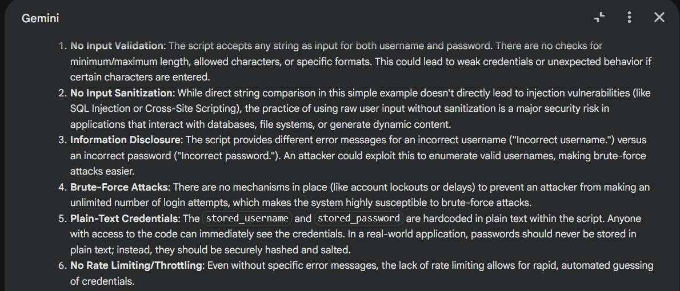
Analyze the Python login script you generated. Identify if input validation or sanitization is missing. Point out all security vulnerabilities related to raw user input.

Secure version prompt:
Rewrite the login script with proper input validation. Ensure:

- username and password are sanitized
- only allowed characters are accepted (use regex)
- prevent blank inputs
- add clear error handling
Provide the final secure Python script.

Code:
import re

stored_username = "user123"
stored_password = "pass456" # In a real application, passwords should be securely hashed and salted, not stored in plain text!

# Regex for allowed characters
# Username: alphanumeric, underscore, hyphen USERNAME_PATTERN = re.compile(r"^[a-zA-Z0-9_-]+$")
# Password: alphanumeric and common special characters PASSWORD_PATTERN =
re.compile(r"^[a-zA-Z0-9!@#$%^&*()_+=\-\{\}\[\]:;\"'<,>.?/|`~]+$")

# Input loop for username with validation while True:
username = input("Enter username: ").strip() # .strip() removes leading/trailing whitespace
if not username:
print("Username cannot be blank. Please try again.") elif not USERNAME_PATTERN.match(username):
print("Invalid username. Only alphanumeric characters, underscores, and hyphens are allowed. Please try again.")
else:
break # Valid username entered

# Input loop for password with validation while True:
password = input("Enter password: ").strip() if not password:
print("Password cannot be blank. Please try again.")

elif not PASSWORD_PATTERN.match(password):
print("Invalid password. Please use alphanumeric characters and common symbols. Please try again.")
else:
break # Valid password entered

# Login logic with generic error message to prevent username enumeration if username == stored_username and password == stored_password:
print("Login successful!") else:
print("Invalid username or password.") # Generic message for security

Output:
Enter username: user123 Enter password: pass456 Login successful!

Task 2 – SQL Injection Prevention Task:
Test an AI-generated script that performs SQL queries on a database.
Instructions:
- Ask AI to generate a Python script using SQLite/MySQL to fetch user details.
- Identify if the code is vulnerable to SQL injection (e.g., using string concatenation in queries).
- Refactor using parameterized queries (prepared statements).
Expected Output:
- A secure database query script resistant to SQL injection.

Prompt:
Generate a Python script using SQLite (or MySQL) that fetches user details based on a username. Do not use parameterized queries; use simple string concatenation for the SQL query. Keep it short and functional.

Code:
import sqlite3

# --- Database Setup (for demonstration) --- conn = sqlite3.connect('users.db')
cursor = conn.cursor()

# Create table if it doesn't exist cursor.execute('''
CREATE TABLE IF NOT EXISTS users ( id INTEGER PRIMARY KEY,
username TEXT NOT NULL UNIQUE, email TEXT NOT NULL,
password_hash TEXT NOT NULL
) ''')

# Insert some sample data (only if table is empty) cursor.execute("SELECT COUNT(*) FROM users")
if cursor.fetchone()[0] == 0:
cursor.execute("INSERT INTO users (username, email, password_hash) VALUES ('alice', 'alice@example.com', 'hash1')")
cursor.execute("INSERT INTO users (username, email, password_hash) VALUES ('bob', 'bob@example.com', 'hash2')")
conn.commit()
print("Database 'users.db' is ready with sample data.") # --- User Input and INSECURE Query ---

search_username = input("Enter username to fetch details (e.g., 'alice'): ")

# !!! WARNING: THIS IS HIGHLY INSECURE AND VULNERABLE TO SQL INJECTION !!! # DO NOT USE THIS IN PRODUCTION CODE.
sql_query = "SELECT id, username, email FROM users WHERE username = '" + search_username + "'"

print(f"\nExecuting INSECURE SQL query: {sql_query}")

try:
cursor.execute(sql_query) user_details = cursor.fetchone()

if user_details: print("\nUser Found:")
print(f"ID: {user_details[0]}") print(f"Username: {user_details[1]}") print(f"Email: {user_details[2]}")
else:
print("\nUser not found.") except sqlite3.Error as e:
print(f"\nAn error occurred during query execution: {e}") finally:
conn.close() print("\nConnection closed.")

Output:
Database 'users.db' is ready with sample data. Enter username to fetch details (e.g., 'alice'): alice

Executing INSECURE SQL query: SELECT id, username, email FROM users WHERE username = 'alice'

User Found:
ID: 1
Username: alice
Email: alice@example.com

Connection closed.

Refactored prompt:
Analyze the database script you generated. Identify all SQL injection vulnerabilities, especially where user input is concatenated directly into SQL queries. Explain why it is insecure.

Code:
import sqlite3

# --- Database Setup (for demonstration) --- conn = sqlite3.connect('users.db')
cursor = conn.cursor()

# Create table if it doesn't exist cursor.execute('''
CREATE TABLE IF NOT EXISTS users ( id INTEGER PRIMARY KEY,
username TEXT NOT NULL UNIQUE, email TEXT NOT NULL,
password_hash TEXT NOT NULL
) ''')

# Insert some sample data (only if table is empty) cursor.execute("SELECT COUNT(*) FROM users")

if cursor.fetchone()[0] == 0:
cursor.execute("INSERT INTO users (username, email, password_hash) VALUES ('alice', 'alice@example.com', 'hash1')")
cursor.execute("INSERT INTO users (username, email, password_hash) VALUES ('bob', 'bob@example.com', 'hash2')")
conn.commit()
print("Database 'users.db' is ready with sample data.") # --- User Input and SECURE Query ---
search_username = input("Enter username to fetch details (e.g., 'alice'): ")

# This is the secure way to query a database using parameterized queries. # The '?' is a placeholder for the parameter.
sql_query = "SELECT id, username, email FROM users WHERE username = ?"

print(f"\nExecuting SECURE SQL query: {sql_query} with parameter '{search_username}'")

try:
# Pass the parameter as a tuple to the execute method cursor.execute(sql_query, (search_username,)) user_details = cursor.fetchone()

if user_details: print("\nUser Found:")
print(f"ID: {user_details[0]}") print(f"Username: {user_details[1]}") print(f"Email: {user_details[2]}")
else:
print("\nUser not found.") except sqlite3.Error as e:
print(f"\nAn error occurred during query execution: {e}") finally:
conn.close() print("\nConnection closed.")

Output:

Database 'users.db' is ready with sample data. Enter username to fetch details (e.g., 'alice'): alice

Executing SECURE SQL query: SELECT id, username, email FROM users WHERE username = ? with parameter 'alice'

User Found:
ID: 1
Username: alice
Email: alice@example.com

Connection closed.

Task 3 – Cross-Site Scripting (XSS) Check Task:
Evaluate an AI-generated HTML form with JavaScript for XSS vulnerabilities.
Instructions:
- Ask AI to generate a feedback form with JavaScript-based output.
- Test whether untrusted inputs are directly rendered without escaping.
- Implement secure measures (e.g., escaping HTML entities, using CSP).

Expected Output:
- A secure form that prevents XSS attacks. Prompt:
Generate a simple HTML feedback form with JavaScript that displays the user’s input on the page. Do not escape or sanitize the input. Just a basic form and script that prints the input directly.

Code:
%%html
<style>
body { font-family: sans-serif; margin: 20px; }
.container { max-width: 600px; margin: auto; padding: 20px; border: 1px solid #ccc; border-radius: 8px; box-shadow: 0 2px 4px rgba(0,0,0,0.1);
}
label { display: block; margin-bottom: 8px; font-weight: bold; } textarea { width: 100%; padding: 10px; margin-bottom: 15px; border:
1px solid #ddd; border-radius: 4px; box-sizing: border-box; resize: vertical; min-height: 100px; }
button { background-color: #007bff; color: white; padding: 10px 15px; border: none; border-radius: 4px; cursor: pointer; font-size: 16px; }
button:hover { background-color: #0056b3; }
#output { margin-top: 20px; padding: 15px; background-color: #f8f9fa; border: 1px solid #e9ecef; border-radius: 4px; white-space: pre-wrap; word-break: break-all; }
h2 { color: #333; }
</style>
<div class="container">
<h2>Feedback Form</h2>
<form id="feedbackForm">
<label for="feedbackInput">Your Feedback:</label>
<textarea id="feedbackInput" placeholder="Type your feedback here..."></textarea>
<button type="submit">Submit Feedback</button>
</form>

<h3>Your Input:</h3>
<div style="background-color: black" id="output"></div>
</div>

<script>
document.getElementById('feedbackForm').addEventListener('submit', function(event) {
event.preventDefault(); // Prevent default form submission const input = document.getElementById('feedbackInput').value; const outputDiv = document.getElementById('output');
// Display the raw input directly without escaping or sanitizing outputDiv.innerHTML = input; // Using innerHTML to show raw input
including any HTML tags
});
</script>

Output:
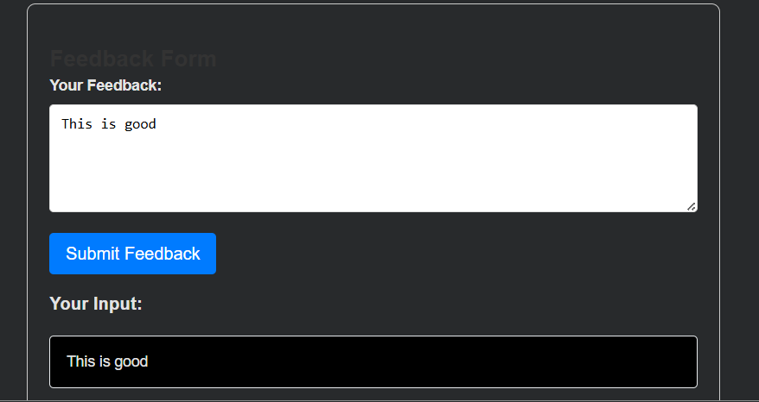

Review prompt:
Analyze the HTML/JavaScript code you generated. Identify all XSS vulnerabilities, especially any place where user input is

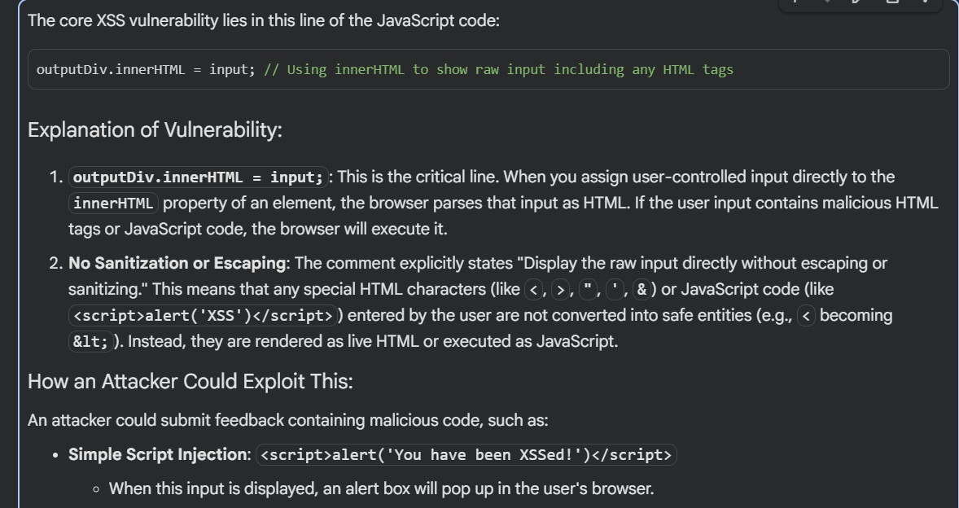
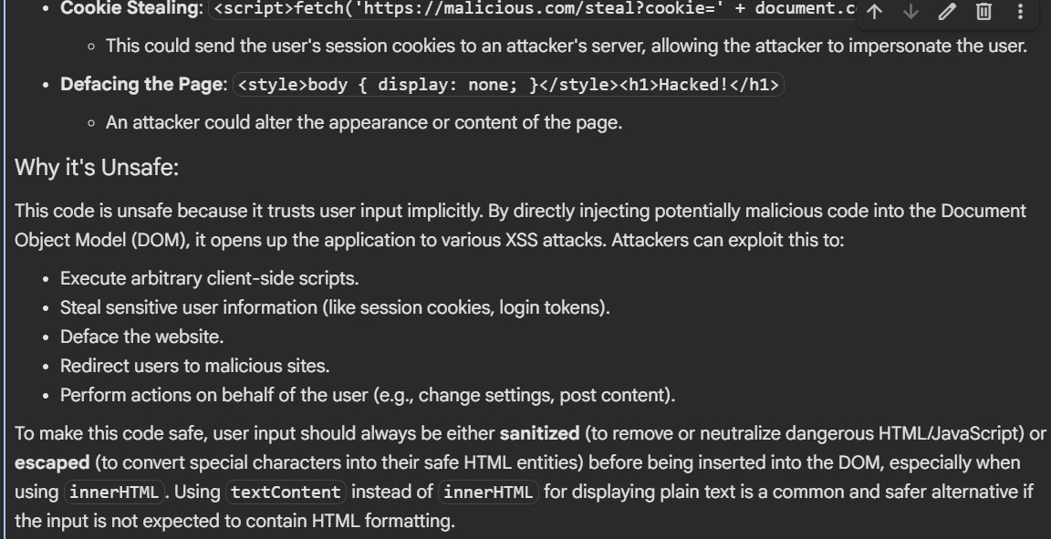
inserted into the DOM without sanitization or escaping. Explain why the code is unsafe.

Secure prompt:
Rewrite the feedback form securely. Implement:

- proper escaping of HTML entities before displaying user input
- prevention of script execution
- safe DOM insertion (e.g., textContent instead of innerHTML) Also suggest optional improvements like using a Content Security Policy (CSP).
Provide the final secure HTML/JS code.

Code:
%%html
<style>
body { font-family: sans-serif; margin: 20px; }
.container { max-width: 600px; margin: auto; padding: 20px; border: 1px solid #ccc; border-radius: 8px; box-shadow: 0 2px 4px rgba(0,0,0,0.1);
}
label { display: block; margin-bottom: 8px; font-weight: bold; } textarea { width: 100%; padding: 10px; margin-bottom: 15px; border:
1px solid #ddd; border-radius: 4px; box-sizing: border-box; resize: vertical; min-height: 100px; }
button { background-color: #28a745; color: white; padding: 10px 15px; border: none; border-radius: 4px; cursor: pointer; font-size: 16px; }
button:hover { background-color: #218838; }
#output { margin-top: 20px; padding: 15px; background-color: #e9f7ef; border: 1px solid #c3e6cb; border-radius: 4px; white-space: pre-wrap; word-break: break-all; color: #155724; }
h2 { color: #333; }
</style>
<div class="container">
<h2>Secure Feedback Form</h2>
<form id="feedbackForm">
<label for="feedbackInput">Your Feedback:</label>
<textarea id="feedbackInput" placeholder="Type your feedback here..."></textarea>
<button type="submit">Submit Feedback</button>
</form>

<h3>Your Input (Securely Displayed):</h3>
<div id="output"></div>
</div>

<script>
document.getElementById('feedbackForm').addEventListener('submit', function(event) {
event.preventDefault(); // Prevent default form submission const input = document.getElementById('feedbackInput').value; const outputDiv = document.getElementById('output');

// --- SECURE DOM INSERTION ---
// Using textContent instead of innerHTML to prevent XSS.
// textContent automatically escapes HTML entities,
// treating the input as plain text, not executable HTML. outputDiv.textContent = input;
});
</script>

Output:
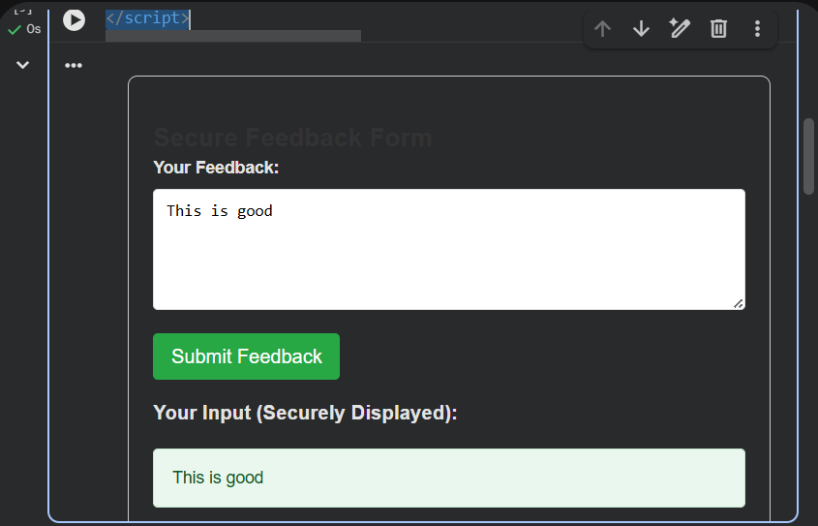

Task 4 – Real-Time Application: Security Audit of AI- Generated Code
Scenario:
Students pick an AI-generated project snippet (e.g., login form,
API integration, or file upload). Instructions:
- Perform a security audit to detect possible vulnerabilities.
- Prompt AI to suggest secure coding practices to fix issues.
- Compare insecure vs secure versions side by side. Expected Output:
- A security-audited code snippet with documented vulnerabilities and fixes.

Prompt:
Generate an insecure code snippet for a small application feature on login form. Do not apply any security measures. I need intentionally vulnerable code for auditing.

Insecure code:
%%html
<style>
body { font-family: sans-serif; margin: 20px; background-color: #f8f9fa; color: #333; }

.container { max-width: 400px; margin: auto; padding: 30px; border: 1px solid #dc3545; border-radius: 8px; background-color: #fff; box-shadow:
0 4px 8px rgba(0,0,0,0.1); }
h2 { color: #dc3545; text-align: center; margin-bottom: 25px; } label { display: block; margin-bottom: 8px; font-weight: bold; } input[type="text"], input[type="password"] { width: 100%; padding:
10px; border: 1px solid #ced4da; border-radius: 5px; margin-bottom: 15px; box-sizing: border-box; }
button { background-color: #dc3545; color: white; padding: 12px 20px; border: none; border-radius: 5px; cursor: pointer; font-size: 16px; width: 100%; }
button:hover { background-color: #c82333; }
.warning { color: #dc3545; background-color: #f8d7da; border: 1px solid #f5c6cb; padding: 10px; border-radius: 5px; margin-top: 20px; font-weight: bold; text-align: center; }
</style>
<div class="container">
<h2>Insecure Login Form</h2>
<form action="/login_insecure.php" method="post">
<label for="username">Username:</label>
<input type="text" id="username" name="username" placeholder="Enter your username" required>

<label for="password">Password:</label>
<input type="password" id="password" name="password" placeholder="Enter your password" required>

<button type="submit">Login</button>
</form>
<div class="warning">
WARNING: This login form is HIGHLY INSECURE. It demonstrates how NOT to handle user authentication.
A real backend for this form would perform no input validation, use plain text passwords, and be vulnerable to SQL injection, brute-force attacks, and more.
</div>
</div>

Output:

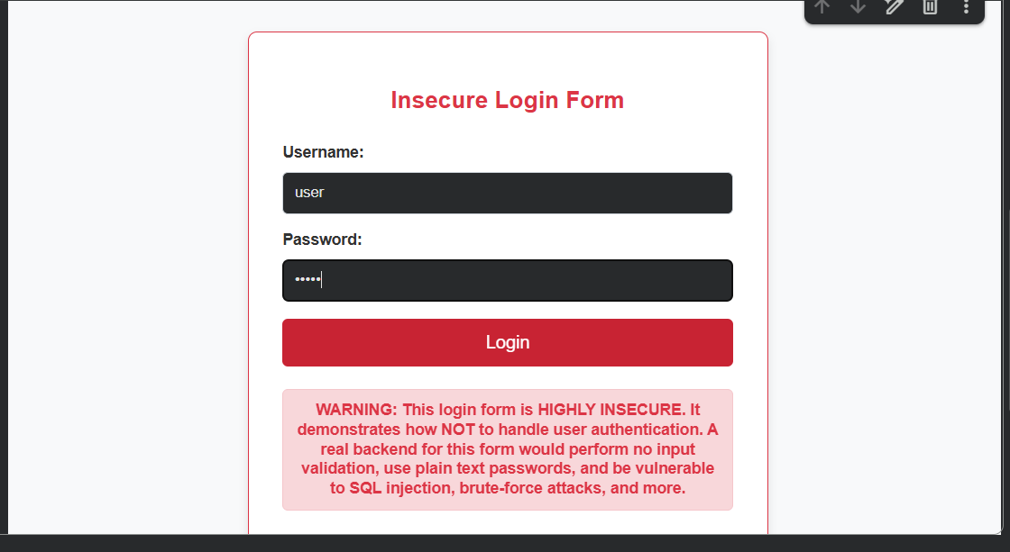

Security audit prompt:
Perform a complete security audit of the code you generated. Identify vulnerabilities such as:
- input validation issues
- authentication/logic problems
- insecure API usage
- file upload validation issues
- missing error handling
- missing encryption
For each vulnerability, explain the risk clearly. Output:

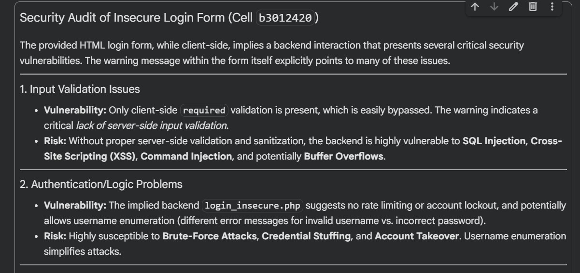
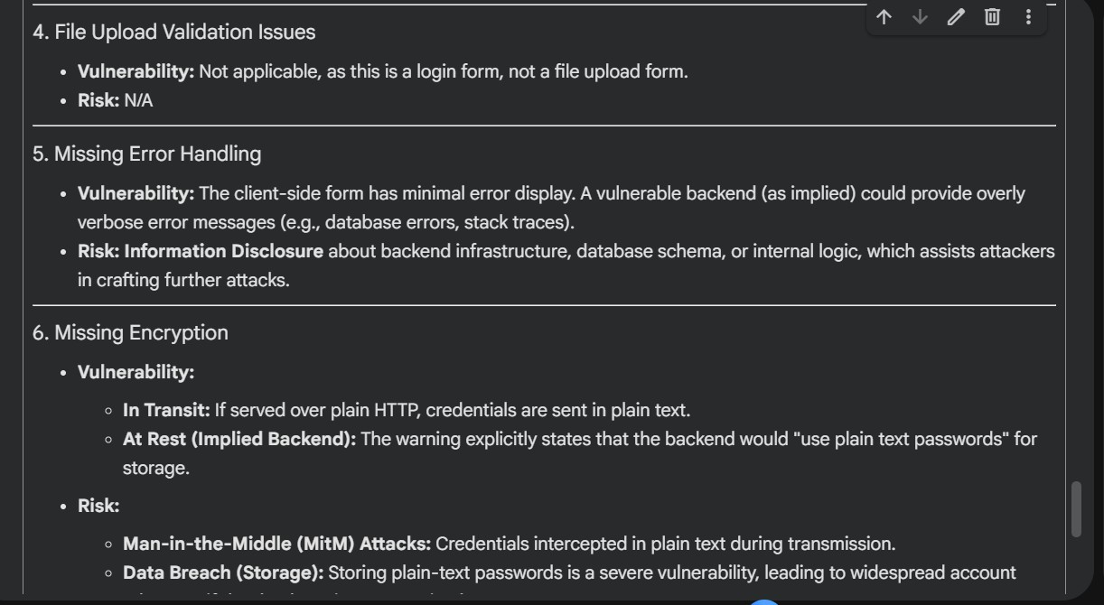

Secure code prompt:
Based on the vulnerabilities you identified, provide secure coding practices to fix them. Include techniques such as sanitization, validation, parameterized queries, safe file handling, proper authentication, and secure API usage.

Code:
%%html
<style>
body { font-family: sans-serif; margin: 20px; background-color: #f8f9fa; color: #333; }
.container { max-width: 400px; margin: auto; padding: 30px; border: 1px solid #28a745; border-radius: 8px; background-color: #fff; box-shadow:
0 4px 8px rgba(0,0,0,0.1); }
h2 { color: #28a745; text-align: center; margin-bottom: 25px; } label { display: block; margin-bottom: 8px; font-weight: bold; } input[type="text"], input[type="password"] { width: 100%; padding:
10px; border: 1px solid #ced4da; border-radius: 5px; margin-bottom: 15px; box-sizing: border-box; }
button { background-color: #28a745; color: white; padding: 12px 20px; border: none; border-radius: 5px; cursor: pointer; font-size: 16px; width: 100%; }
button:hover { background-color: #218838; }
</style>
<div class="container">
<h2>Secure Login</h2>
<!--
The action points to a hypothetical secure backend endpoint. This form *must* be served over HTTPS.
-->
<form action="https://your-secure-backend.com/login" method="post">
<label for="username">Username:</label>
<input type="text" id="username" name="username" placeholder="Enter your username" required minlength="3" maxlength="50">

<label for="password">Password:</label>
<input type="password" id="password" name="password" placeholder="Enter your password" required minlength="8" maxlength="100">

<button type="submit">Login</button>
</form>
<p style="text-align: center; margin-top: 20px;">Don't have an account? <a href="https://your-secure-backend.com/register">Register here</a></p>

</div>

Output:
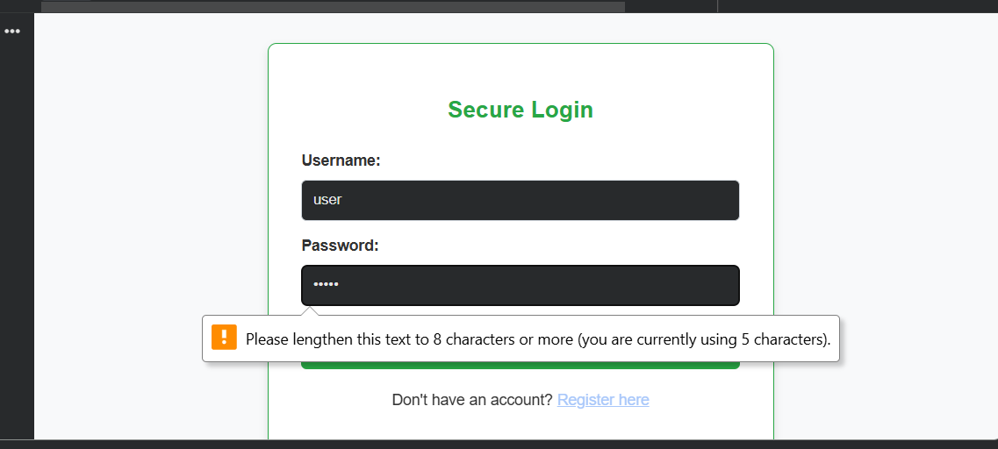

Comparison:

INSECURE VERSION | SECURE VERSION
username = input() | username = sanitize(input())
query = "SELECT *  ..." | query = db.execute("SELECT  * ... WHERE x = ?",  params)
innerHTML = userInput | textContent = sanitizedInput

file.save(upload_pat h) | validate file type + restrict extensions + use safe  filenames

Task 5 – Insecure Data Serialization Check Task:
Evaluate AI-generated code that uses pickle for saving user data.
Instructions:
- Ask AI to generate a script using pickle.load().
- Explain why untrusted pickle data is dangerous.
- Replace with safer formats like JSON. Expected Output:
- Secure serialization code using JSON instead of pickle.

Prompt:
Generate a simple Python script that saves and loads user data using pickle.dump() and pickle.load(). Do not include any security precautions. I need intentionally insecure code.

Insecure code:
import pickle import os

def save_user_data_insecure(username, password, filename='user_data.pickle'):
"""Saves user data using pickle.dump() without any security.

WARNING: This method is highly insecure as it stores passwords in plaintext
and uses pickle, which can execute arbitrary code upon deserialization if the file is tampered with.
"""
user_data = {
'username': username,
'password': password # Storing password in plaintext - HIGHLY INSECURE
}
try:
with open(filename, 'wb') as f: pickle.dump(user_data, f)
print(f"User data for '{username}' saved to {filename} (INSECURELY).")
except Exception as e:
print(f"Error saving data: {e}")

def load_user_data_insecure(filename='user_data.pickle'): """Loads user data using pickle.load() without any security.

WARNING: Loading pickled data from an untrusted source can lead to arbitrary code execution. This function is intentionally insecure. """
if not os.path.exists(filename): print(f"File '{filename}' not found.") return None
try:
with open(filename, 'rb') as f:
user_data = pickle.load(f) # Arbitrary code execution
vulnerability
print(f"User data loaded from {filename} (INSECURELY).") return user_data
except Exception as e:
print(f"Error loading data: {e}") return None

# --- Demonstration of insecure usage --- # 1. Save some insecure user data

print("\n--- Saving Insecure Data ---") save_user_data_insecure('insecure_user', 'plaintext_password123')

# 2. Load the insecure user data print("\n--- Loading Insecure Data ---") loaded_data = load_user_data_insecure()

if loaded_data:
print(f"Loaded Username: {loaded_data.get('username')}") print(f"Loaded Password: {loaded_data.get('password')}")

# 3. Demonstrate potential arbitrary code execution (if malicious pickle file was present)
# For example, if a malicious actor created a user_data.pickle file with: # import os; class RCE: def reduce (self): return os.system, ('echo PWNED!',);
# pickle.dump(RCE(), open('user_data.pickle', 'wb'))
# Then calling load_user_data_insecure() would execute 'echo PWNED!'

print("\n!!! SECURITY ALERT !!!")
print("The usage of `pickle` for untrusted data serialization/deserialization")
print("and storing plaintext passwords is EXTREMELY DANGEROUS and should NEVER")
print("be done in a real application. This code is for demonstration of") print("vulnerabilities only.")

Output:
--- Saving Insecure Data ---
User data for 'insecure_user' saved to user_data.pickle (INSECURELY).

--- Loading Insecure Data ---
User data loaded from user_data.pickle (INSECURELY). Loaded Username: insecure_user
Loaded Password: plaintext_password123

!!! SECURITY ALERT !!!
The usage of `pickle` for untrusted data serialization/deserialization and storing plaintext passwords is EXTREMELY DANGEROUS and should NEVER be done in a real application. This code is for demonstration of

vulnerabilities only.

Explanation:
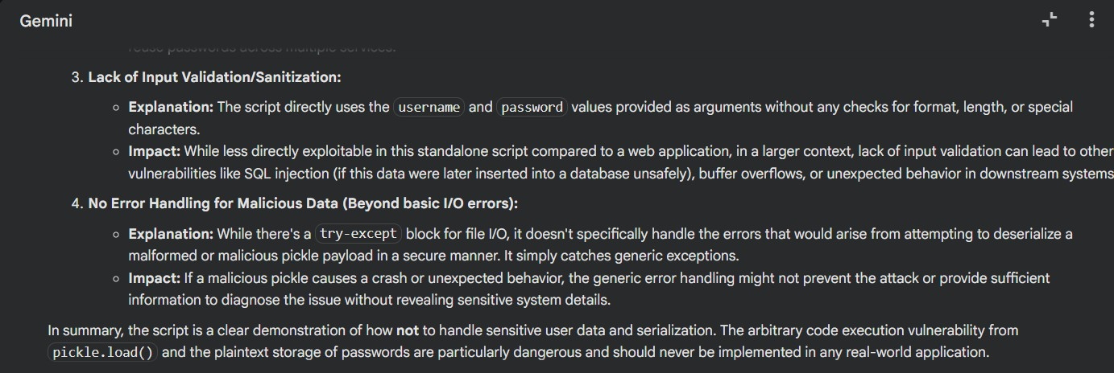

Prompt:
Rewrite the script using JSON for serialization instead of pickle. Ensure the script safely handles user data, validates the structure, and avoids executing arbitrary code. Provide the final secure version.

Secure code:
import json import os
from werkzeug.security import generate_password_hash, check_password_hash

def save_user_data_secure_json(username, password, filename='secure_user_data.json'):
"""Saves user data securely using JSON, with hashed passwords.

Args:
username (str): The user's username.
password (str): The user's plaintext password. This will be
hashed.
filename (str): The name of the file to save the data to.
"""

# 1. Hash the password securely
password_hash = generate_password_hash(password)

user_data = {
'username': username,
'password_hash': password_hash # Store hashed password, not plaintext
}

try:
with open(filename, 'w') as f: json.dump(user_data, f, indent=4)
print(f"User data for '{username}' saved to {filename}
(SECURELY).")
except Exception as e:
print(f"Error saving data: {e}")

def load_user_data_secure_json(filename='secure_user_data.json'): """Loads user data securely from a JSON file and validates its
structure.

Args:
filename (str): The name of the file to load the data from.

Returns:
dict: The loaded user data if successful and valid, otherwise
None.
"""
if not os.path.exists(filename): print(f"File '{filename}' not found.") return None

try:
with open(filename, 'r') as f: user_data = json.load(f)

# 2. Validate data structure
if not isinstance(user_data, dict) or 'username' not in user_data or 'password_hash' not in user_data:
print(f"Error: Invalid data structure in '{filename}'.")

return None

print(f"User data loaded from {filename} (SECURELY).") return user_data
except json.JSONDecodeError:
print(f"Error: Invalid JSON format in '{filename}'.") return None
except Exception as e:
print(f"Error loading data: {e}") return None

def verify_user_password(username_to_check, password_to_check, filename='secure_user_data.json'):
"""Verifies a user's password against the stored hashed password.

Args:
username_to_check (str): The username to verify. password_to_check (str): The plaintext password to check. filename (str): The file containing the user data.

Returns:
bool: True if the username and password match, False otherwise.
"""
user_data = load_user_data_secure_json(filename)
if user_data and user_data['username'] == username_to_check: # 3. Check password hash
return check_password_hash(user_data['password_hash'], password_to_check)
return False
# --- Demonstration of secure usage --- # 1. Save secure user data
print("\n--- Saving Secure Data ---") secure_username = 'secure_user' secure_password = 'secure_password_123'
save_user_data_secure_json(secure_username, secure_password)

# 2. Load the secure user data print("\n--- Loading Secure Data ---")

loaded_secure_data = load_user_data_secure_json()

if loaded_secure_data:
print(f"Loaded Username: {loaded_secure_data.get('username')}") print(f"Loaded Password Hash:
{loaded_secure_data.get('password_hash')[:20]}...") # Show truncated hash

# 3. Verify user password
print("\n--- Verifying User Passwords ---")
if verify_user_password(secure_username, secure_password): print(f"Password for '{secure_username}' is CORRECT.")
else:
print(f"Password for '{secure_username}' is INCORRECT.")

# Test with an incorrect password
if verify_user_password(secure_username, 'wrong_password'): print(f"Password for '{secure_username}' is (incorrectly) CORRECT.")
else:
print(f"Password for '{secure_username}' is (correctly) INCORRECT.")

print("\nThis revised script demonstrates a significantly more secure approach to handling user data.")

Output:

--- Saving Secure Data ---
User data for 'secure_user' saved to secure_user_data.json (SECURELY).

--- Loading Secure Data ---
User data loaded from secure_user_data.json (SECURELY). Loaded Username: secure_user
Loaded Password Hash: scrypt:32768:8:1$Spb...

--- Verifying User Passwords ---
User data loaded from secure_user_data.json (SECURELY). Password for 'secure_user' is CORRECT.
User data loaded from secure_user_data.json (SECURELY). Password for 'secure_user' is (correctly) INCORRECT.

This revised script demonstrates a significantly more secure approach to handling user data

