AI ASSISTED CODING ASS – 14.1
2303A51934
B-27

Task 1 – Portfolio Website Design
You are building a personal portfolio website to showcase your work.
Requirements:
Create sections for About Me, Projects, and Contact.
Use AI to:
- Suggest color palettes and typography.
- Create a responsive layout with Grid/Flexbox. • Add smooth scrolling navigation.

CODE:
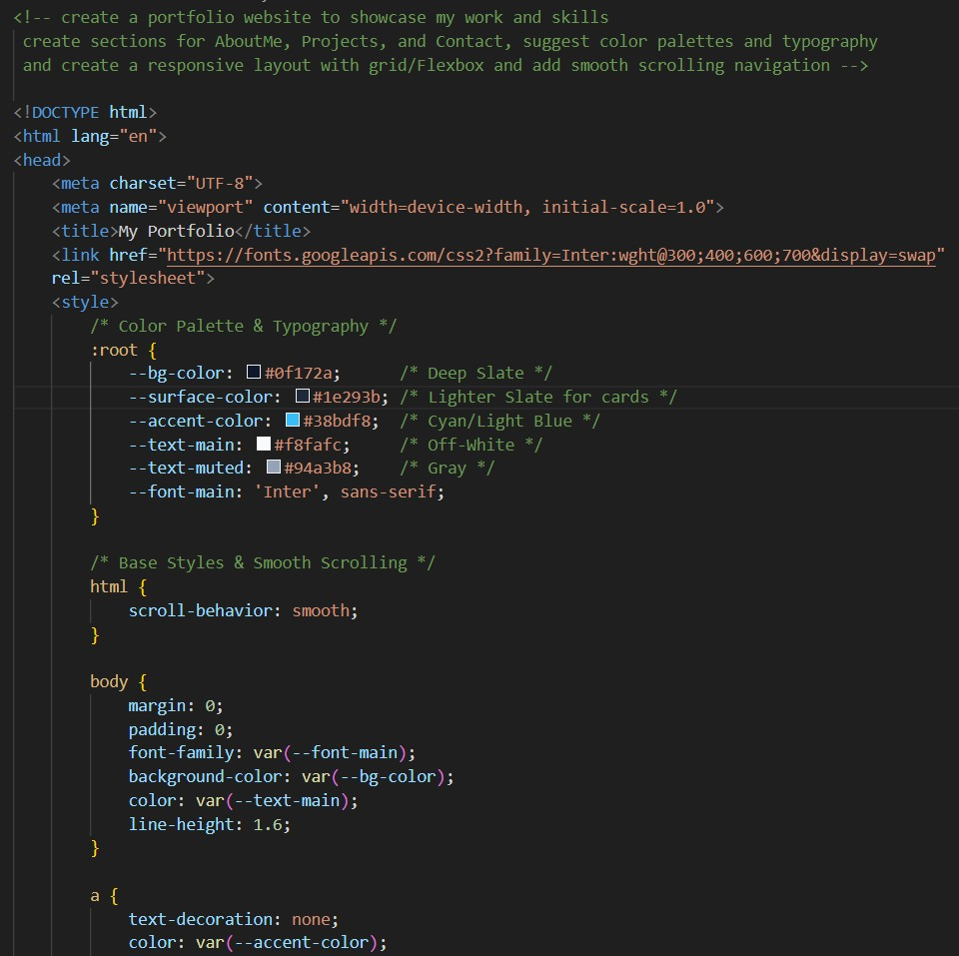
Output:
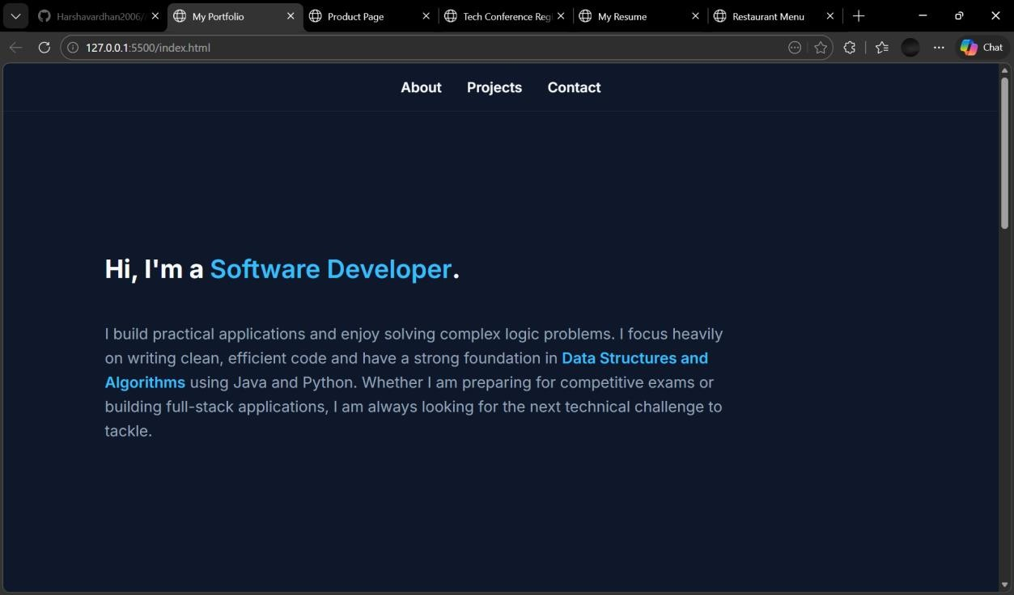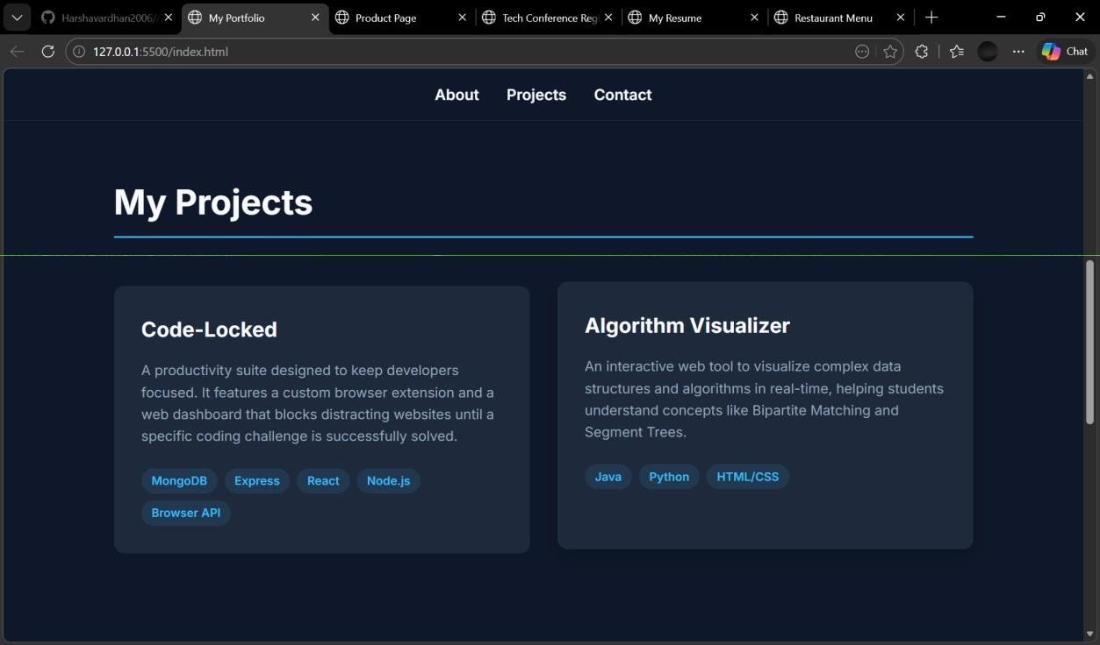

Task 2 – Online Store Product Page
Design a product display page for an online store.
Requirements:
Display product image, title, price, and "Add to Cart" button.
Use AI to:
- Style with BEM methodology.
- Make layout responsive.
- Add hover effects and "Add to Cart" alert.

CODE:
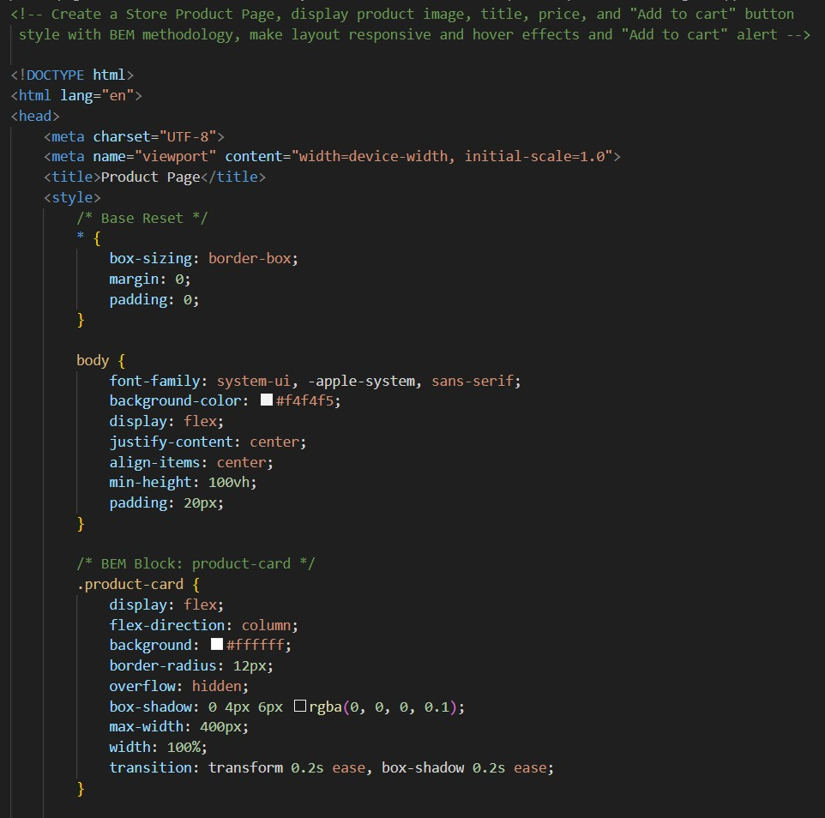
Output:
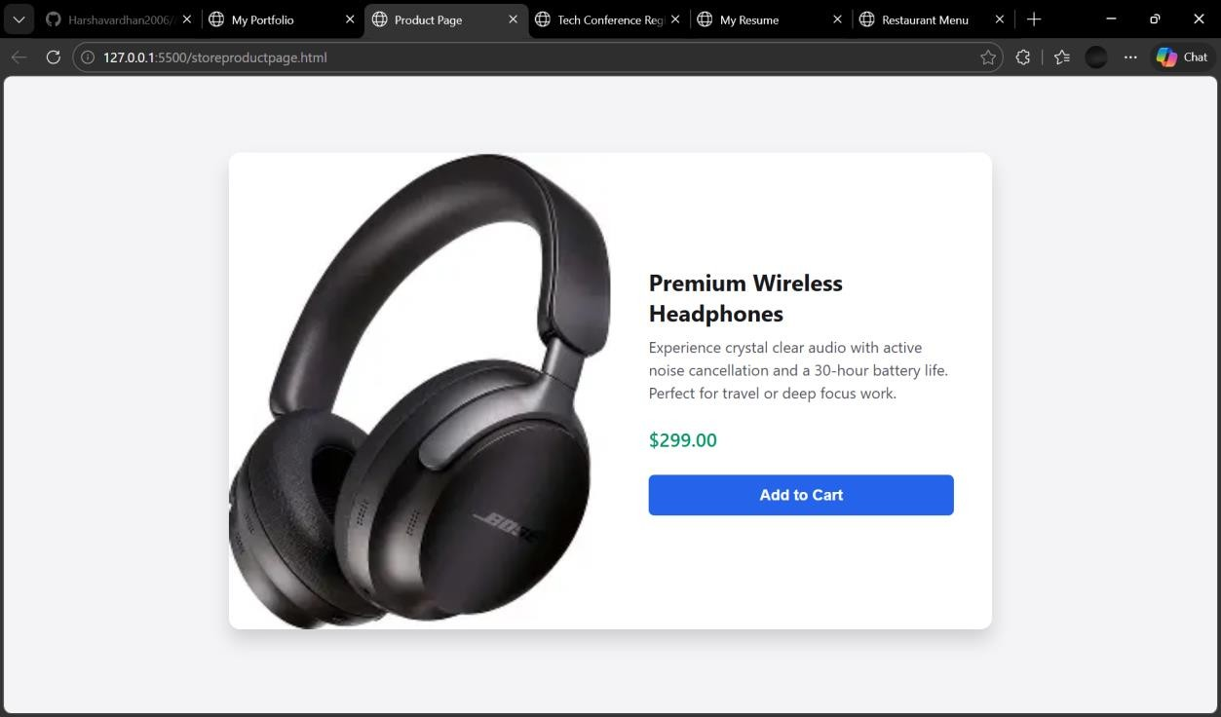

Task 3 – Event Registration Form
Build an event registration form for a conference.
Requirements:
Collect name, email, phone number, and session selection.
Use AI to:
- Add form validation with JavaScript.
- Make the form accessible with labels and ARIA. • Style with a professional look
CODE:
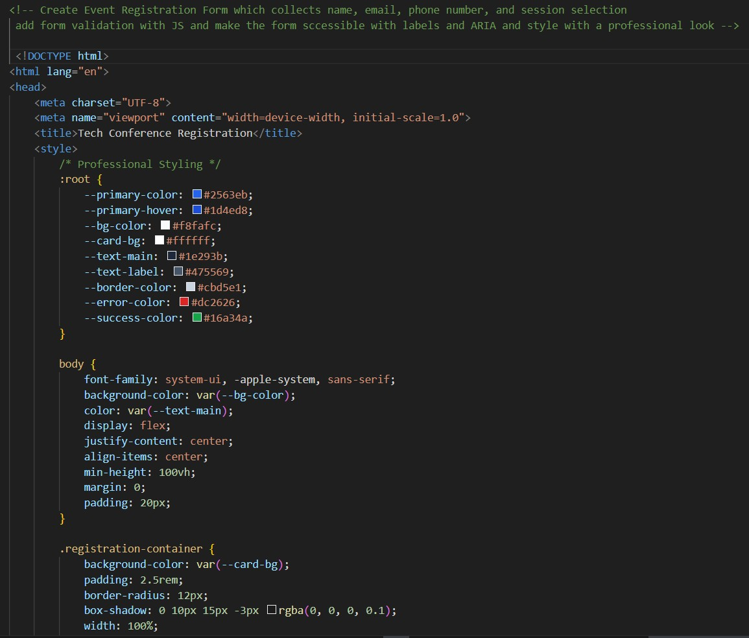

Output:
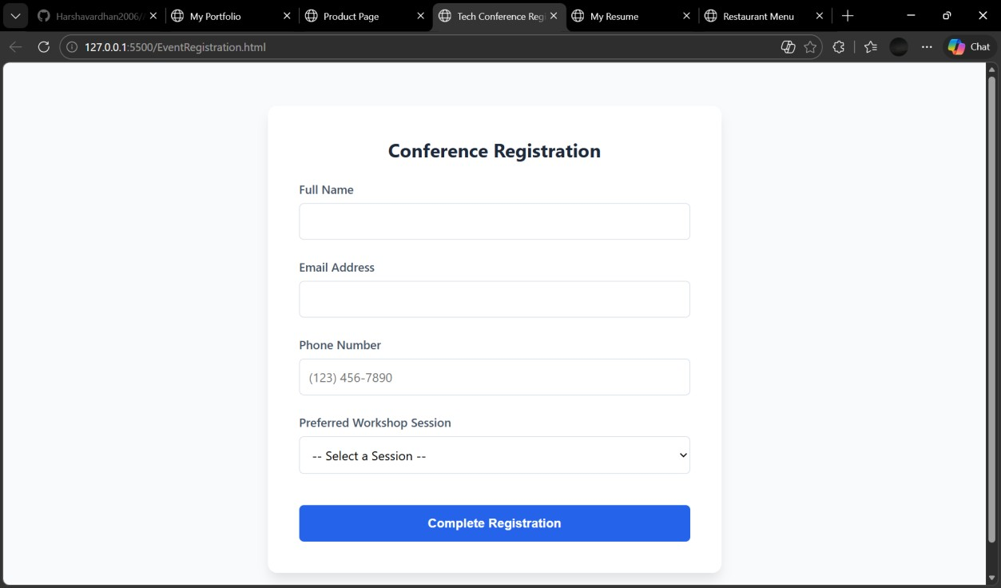
Task 4 – Resume Website
Build a one-page online resume.
Requirements:
Sections: Profile Summary, Skills, Education, Experience.
Use AI to:
- Propose professional typography styles.
- Align sections using CSS Grid.
- Add smooth scroll navigation between sections.

CODE:
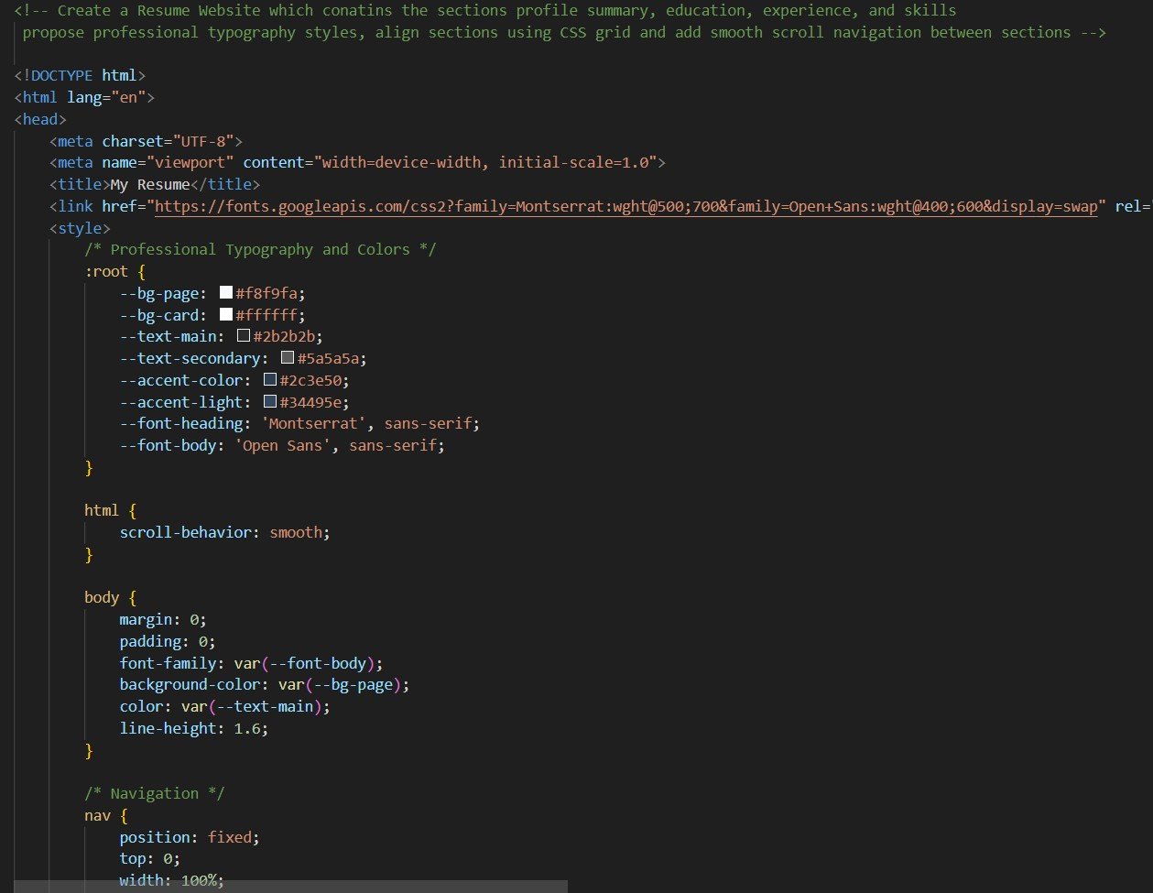

Output:
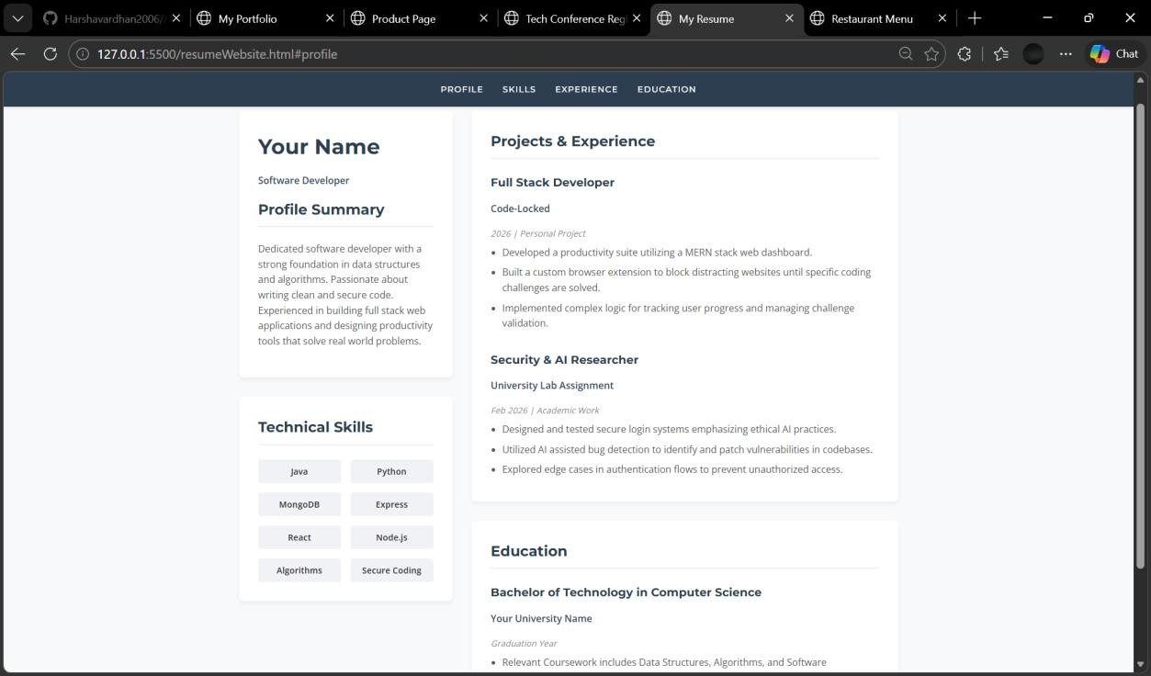

Task 5 – Restaurant Menu Page
Design a digital menu page for a restaurant.
Requirements:
Display menu items with name, description, and price.
Use AI to:
- Suggest a food-friendly color palette.
- Design a responsive card-based layout.
- Add hover effects on menu items.
CODE:
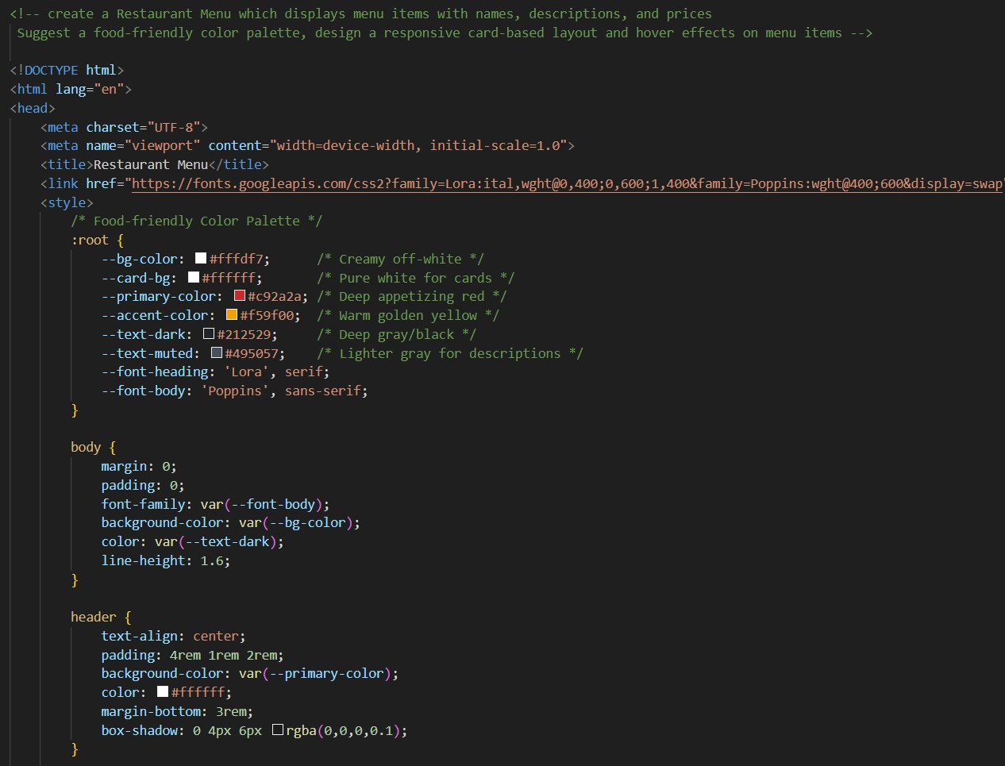
Output:
