JS:

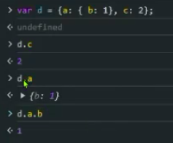

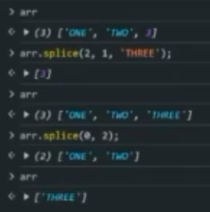
\

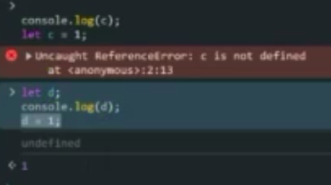

Temperory dead zone(TDZ).

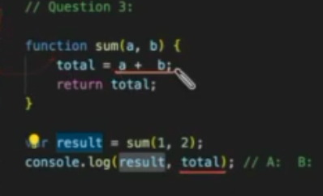
S

if variable is not declared its scope will be global.

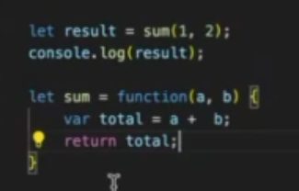
S

error because let will not be hosted.

Closures help to access the parent variables or functions for inner functions.

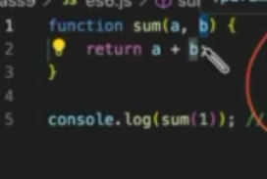
S

not a number

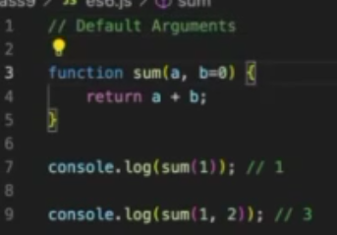
s

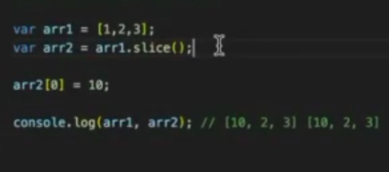
s

only arr2 will be changed because of slice. Ignore comment.
Remember pass by value and pass by reference when array is passed and changed inside function.

Pure function-> always same answer.

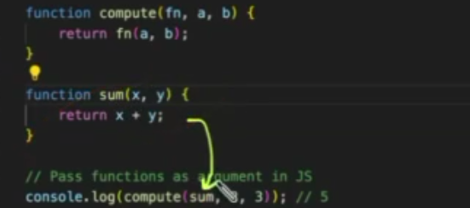
S

we can pass function as argument.

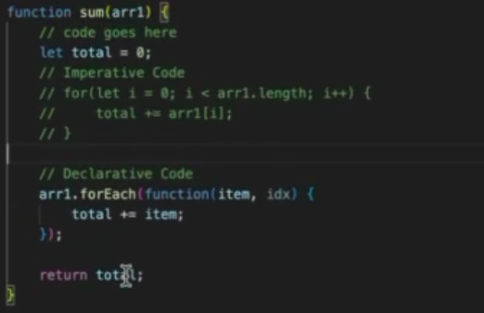
S

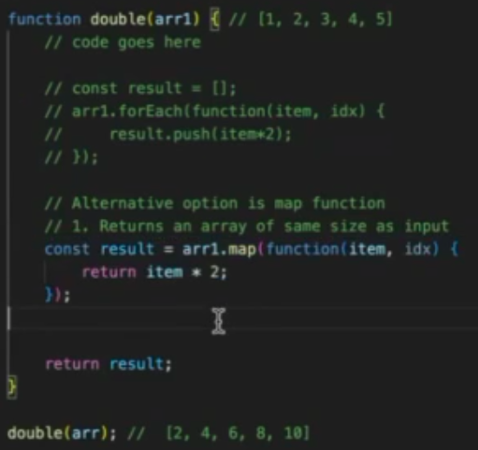
s

map creates same size array and returns as result.

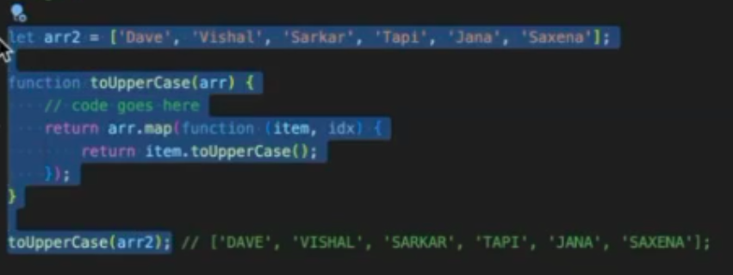
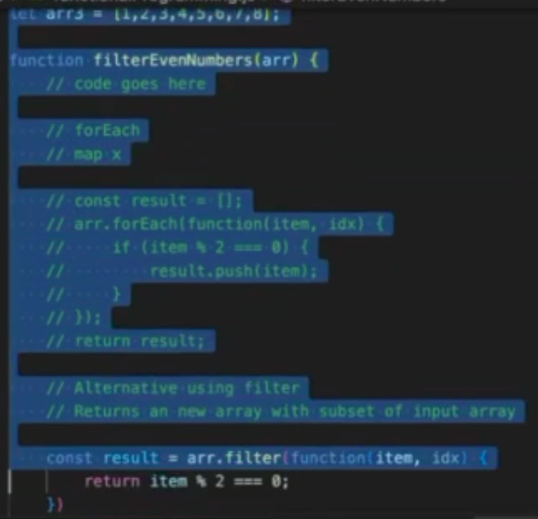

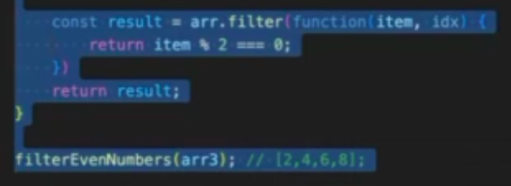
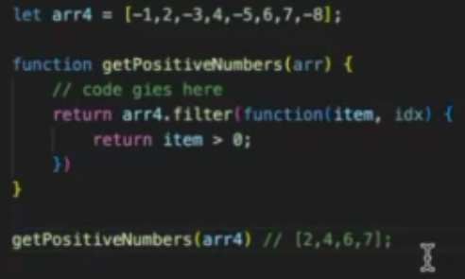
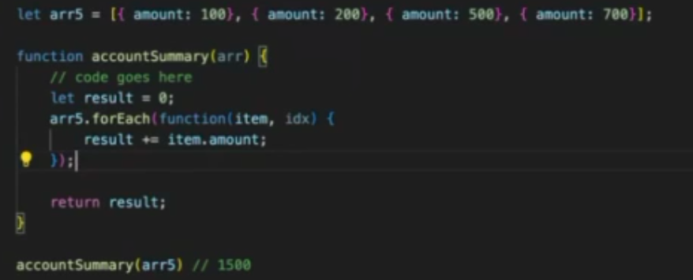

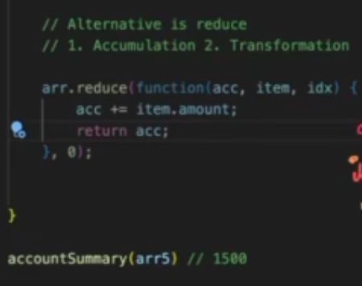
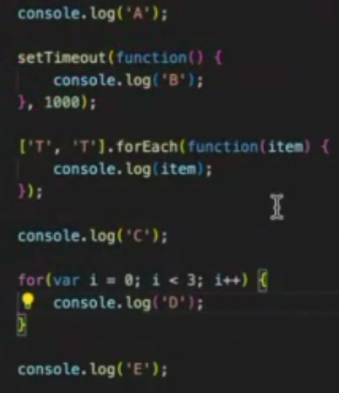
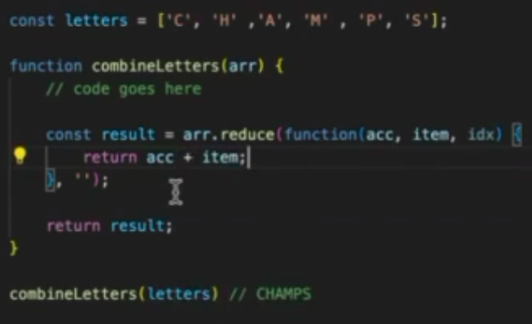
call back func: a func passed as parameter and expected to be called in future

set timeout-> async func
foreach-> sync func
by default js is sync func

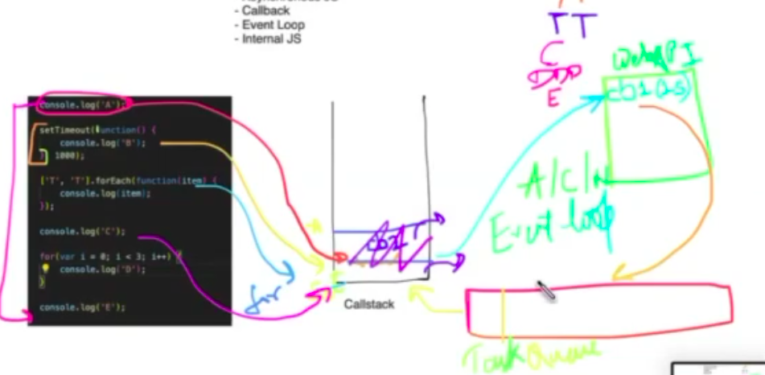
js starts executing the code line by line and places in call stach, when aync func comes it is sent to webapi and it waits. Whe sync func comes it will be executed in call stack, after particular time webapi places async into taskqueue and taskqueue checks call stack is empty or not. Once callstack is ready to execute it will execute async func. This whole process is managed by event loop.

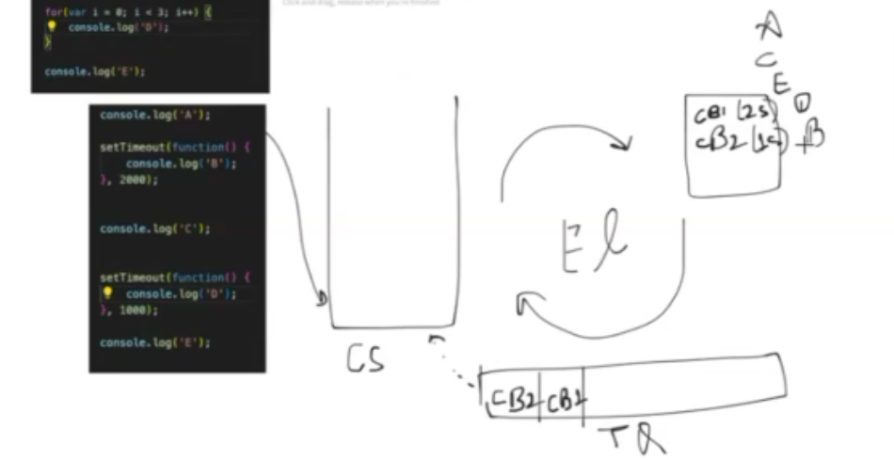
Dom:
document object mode.

Query selector is used for accessing selectors.
But the con is it may show only one. So we use query selctor all
every website consists of document which internally has object as a tree.
We can also get style color of this.

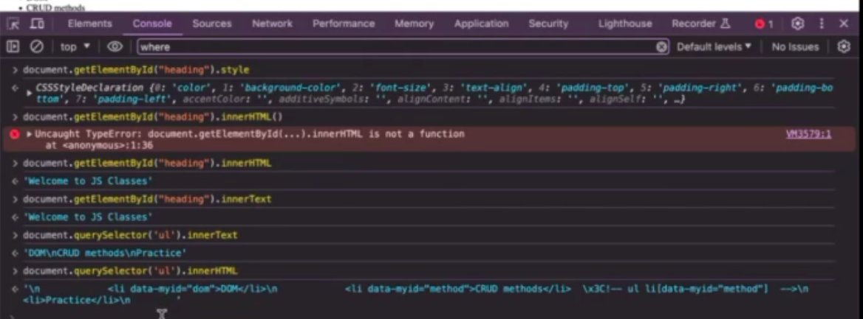
S

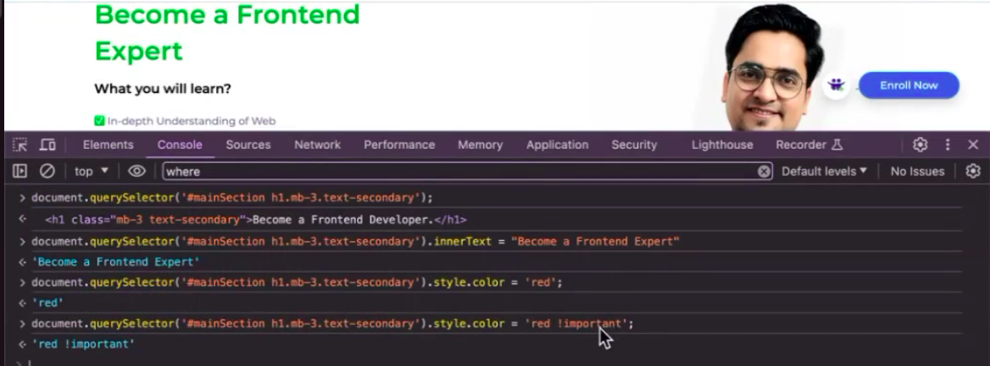
s

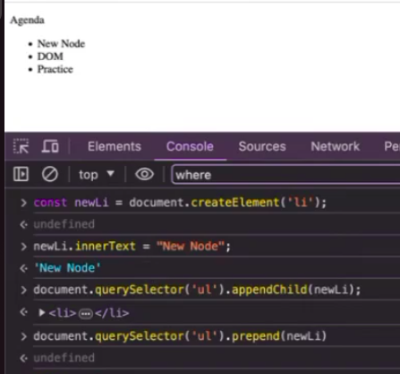

event:
e.target,shows where we clicked on
data-color->shows color of data only
dataset.color-> gives entire object data

by default form has submit. So we should stop default e.preventdefault and when credentials are given its shown in console.

