Artificial Intelligence – In Defense and Scientific Applications
A Detailed Report by Nikhil Prasad
Intern, Defense Research and Development Organization (DRDO)
Date: 5th Aug 2025

Table of Contents

1. Introduction to Artificial Intelligence
2. Types of Artificial Intelligence
3. Real-World Applications of AI
4. How AI Benefits Society and Industries
5. AI Industry in 2025 and Beyond
6. History and Evolution of AI
7. Major Achievements in AI
8. AI for Global Problems Yet to be Solved
9. Limitations and Challenges of AI
10. Sectors Needing AI Development
11. Hardware Requirements for AI
12. AI in Defense and Security
13. The Future of AI
14. Conclusion

1. Introduction to Artificial Intelligence
Artificial Intelligence (AI) is a branch of computer science that aims to create systems capable of performing tasks that typically require human intelligence. These tasks include learning, problem-solving, perception, language understanding, and decision-making.

AI can be embedded in machines, programs, or robots to make them intelligent. It ranges from rule-based systems to complex neural networks that learn from data. AI is used in everyday applications like voice assistants, recommendation systems, and autonomous vehicles.

According to “John McCarthy’s (Father of AI)” :
“Artificial Intelligence is the science and engineering of making intelligent machines, especially intelligent computer programs.”
Overall we can say that “Artificial Intelligence is the science of creating machines that can learn from experience, adapt to new inputs, and perform cognitive tasks with reasoning and autonomy- mimicking not just human actions, but also the way humans think and evolve.”
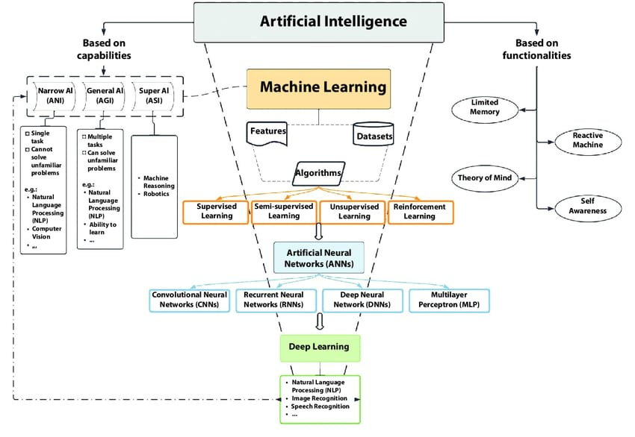

2. Types of Artificial Intelligence :

1. Based on Capabilities:
- Narrow AI: Also known as Weak AI, this type of AI is designed for a specific task (e.g., voice assistants, spam filters). It cannot perform tasks outside its predefined functions.
- General AI: Refers to machines that can perform any intellectual task a human can. This is still a theoretical concept under development.

- Super AI: Hypothetical AI that surpasses human intelligence. It could outperform humans in all cognitive tasks.

2. Based on Functionality:
- Reactive Machines: Respond to inputs without storing memory (e.g., Deep Blue chess computer).

- Limited Memory: Learn from historical data (e.g., self-driving cars).

- Theory of Mind: Understand emotions, beliefs, and interact socially (in research).

- Self-aware AI: Possess consciousness and self-awareness (not yet developed).
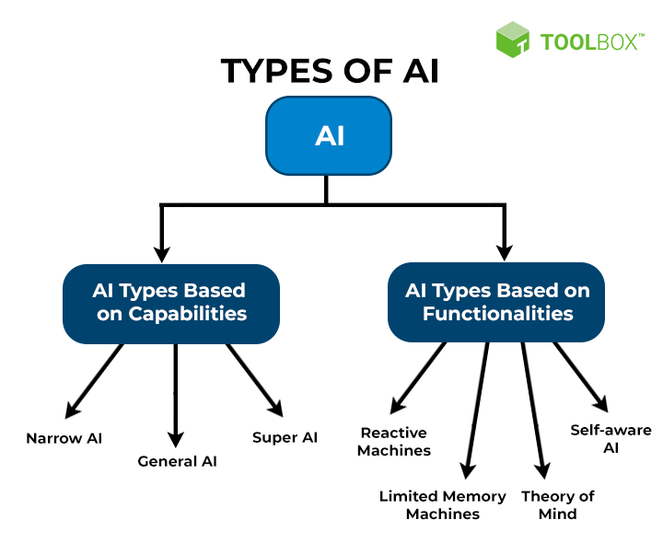
AI Applications in Real World: Focus on Defense, Space, and Science
Here's a detailed explanation of each AI application in the Defense Sector, focusing on how it works technically:
✅ 1. AI in Defense Sector :
🔹a. Autonomous Weapons Systems
• Unmanned Aerial Vehicles (UAVs)
Working:
- UAVs are equipped with onboard AI processors that handle real-time sensor data (cameras, LIDAR, radar).
- Computer vision is used to detect and classify targets (e.g., tanks, people). 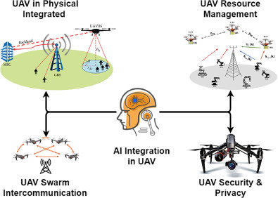
- AI algorithms (e.g., CNNs – Convolutional Neural Networks) guide flight path autonomously by avoiding obstacles and tracking objects.
- Target engagement is handled with decision-making models like reinforcement learning or rule-based expert systems, supervised by human operators.
• Loitering Munitions (Kamikaze Drones)
Working:
- Use pre-fed intelligence and real-time image recognition to identify high-value targets.
- These drones "loiter" in an area using GPS and inertial navigation while scanning for targets.
- Upon detection, AI confirms through multiple criteria (object size, thermal profile, movement) before executing a strike.
🔹 b. Tanks & Armored Vehicles
• AI-Based Navigation (in GPS-Denied Areas)
Working:
- AI fuses data from IMUs (Inertial Measurement Units), gyroscopes, cameras, and LIDAR for SLAM (Simultaneous Localization and Mapping).
- SLAM enables the vehicle to create a map of the environment and localize itself within it without GPS.
- Deep learning networks recognize terrain features to assist in route planning.
• Real-Time Threat Detection
Working:
- 360-degree visual and thermal cameras send feed to AI models that identify humans, mines, RPGs, or IEDs.
- Object detection algorithms (e.g., YOLO, Faster R-CNN) process images in milliseconds.
- Alerts are sent to crew and defensive systems are activated (e.g., active protection system auto-firing countermeasures).
• Predictive Maintenance
Working:
- Sensors monitor engine temperature, vibration, oil levels, etc.
- Data is sent to an AI model (often based on RNNs or anomaly detection) which predicts the likelihood of component failure.
- This ensures proactive repairs and reduces downtime.
🔹 c. Missile Systems
• AI-Based Target Tracking
Working:
- Real-time infrared or radar data is fed into AI algorithms that predict target trajectory using Kalman filters + neural networks.
- AI ensures precise mid-course correction by continuously updating flight paths.
• Swarm Intelligence
Working:
- Multiple missiles or drones communicate using decentralized AI agents.
- Inspired by nature (like bee swarms), they use consensus algorithms to assign tasks (who strikes, who jams, etc.).
- This coordination increases success and resilience to countermeasures.
🔹 d. Cybersecurity in Military Systems
• AI for Intrusion Detection
Working:
- AI monitors network traffic and system logs using unsupervised learning to detect anomalies.
- E.g., if an unusual access pattern is detected (like login from unknown location or time), it triggers a security alert.
• Adaptive Security
Working:
- AI continuously learns from new attack vectors and automatically updates firewall rules and access control policies.
- Uses Natural Language Processing (NLP) to parse threat reports and adapt defenses in near-real time.
🔹e. Intelligence, Surveillance & Reconnaissance (ISR)
• Image & Video Analysis
Working:
- Satellite and drone images are analyzed using computer vision + object detection to identify enemy bases, vehicles, or movement.
- AI filters out irrelevant data (clouds, birds, shadows) using segmentation algorithms.
• Signal Processing
Working:
- AI uses spectral analysis + ML classifiers to decode radio, radar, or encrypted enemy communications.
- NLP models transcribe and translate intercepted signals for intelligence use
🔹 f. Logistics & Supply Chain Optimization
• Route Optimization
Working:
- AI uses graph-based algorithms (like Dijkstra or A*) combined with real-time terrain/weather data to plan safest & fastest delivery routes.
- Dynamic replanning if route becomes unsafe (ambush, weather change).
• Predictive Demand Forecasting
Working:
- AI models forecast troop needs (ammunition, fuel, food) using time series data, past consumption rates, and mission type.
🔹 g. Soldier Augmentation Systems
• Wearable AI Health Monitors
Working:
- Biosensors measure vitals: heart rate, hydration, body temperature.
- AI detects patterns indicating fatigue, dehydration, or stress and alerts commanders in real-time.
• Neural Interface Exoskeletons
Working:
- Wearable robotic systems use EMG (Electromyography) signals or brain-machine interfaces.
- AI interprets neural signals and activates motors to assist in movement, reducing fatigue and increasing load-carrying ability.
🔹 h. Command and Control Systems
• AI for Decision Support
Working:
- Combines battlefield data, enemy movements, and logistics using multi-agent systems.
- AI suggests optimal troop deployments and strategy simulations using reinforcement learning and scenario generation models.
- Can operate under uncertainty and time pressure.
🔹 i. Border Surveillance
• AI-Enabled Surveillance Towers
Working:
- Thermal + IR cameras feed data to AI software to distinguish between humans, animals, or vehicles.
- Uses motion tracking and pattern recognition to detect suspicious behavior.
- Integrates with facial recognition, ground sensors, and autonomous drones for tracking intrusions.

2. AI in Space Sector
🔹 a. Autonomous Spacecraft Navigation
• Mars Rovers (e.g., Perseverance)
Working: 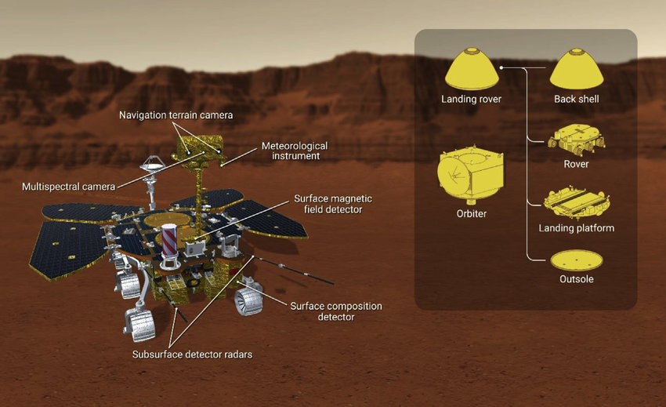
- Rovers use computer vision, LIDAR, and inertial sensors to perceive the terrain.
- AI algorithms (like deep neural networks) process visual data in real-time to detect obstacles (rocks, cliffs, craters).
- SLAM (Simultaneous Localization and Mapping) is used to map unknown environments and track the rover’s position without GPS.
- AI selects optimal paths using reinforcement learning and A pathfinding* to navigate efficiently.
🔹 b. Satellite Imagery Analysis
• Monitoring Land Use, Troop Movements, and Deforestation
Working:
- Satellites send high-resolution images to ground stations.
- AI models like Convolutional Neural Networks (CNNs) are trained to detect patterns such as:
  - Human-made structures (buildings, roads)
  - Vegetation cover changes (deforestation, crop failure)
  - Vehicle and troop movements (using heat, shadow, or movement analysis)
- AI distinguishes between natural and artificial changes and generates alerts for actionable intelligence.
🔹 c. Space Debris Tracking
• Collision Avoidance and Debris Mapping
Working:
- Radar and telescopic sensors detect and track objects in Low Earth Orbit (LEO).
- AI uses orbital mechanics simulations combined with real-time debris data to predict paths and potential collisions.
- Predictive models (e.g., Kalman filters + ML regressors) estimate when/where collision risks are high.
- AI triggers automatic course correction commands for satellites or spacecraft when threats are identified.
🔹 d. Astronaut Assistance
• Virtual Assistants (e.g., CIMON in the ISS)
Working:
- CIMON (developed by IBM and Airbus) uses Natural Language Processing (NLP) to understand astronaut commands.
- It's equipped with facial recognition, emotion detection, and contextual memory to provide personalized responses.
- Acts as a floating AI assistant, helping with:
  - Displaying procedures
  - Performing calculations
  - Logging data
  - Giving reminders and alerts
- Operates in microgravity with built-in thrusters and autonomous motion planning.
🔹 e. Rocket Launch and Mission Optimization
• Launch Sequence and Fault Detection
Working:
- During launches, AI monitors thousands of parameters like pressure, temperature, velocity, vibration, etc.
- AI systems detect anomalies using real-time sensor data + anomaly detection algorithms.
- Launch parameters are optimized via simulation-trained neural networks, minimizing fuel usage while maximizing payload efficiency.
- AI models are used in autonomous flight termination systems in case of launch failure.
🔹 f. Planetary Research
• Discovery of Life Signs and Planet Composition
Working:
- Space missions generate massive datasets from spectrometers, rovers, seismic detectors, etc.
- AI helps process this data using unsupervised learning, pattern recognition, and classification.
- For example:
  - In exoplanet research, AI analyzes light curves to detect planet transits.
  - On Mars, AI analyzes soil composition data to find organic compounds.
- AI accelerates hypothesis testing, reducing the need for manual data review.

3. AI in Scientific Research
🔹 a. Drug Discovery & Genomics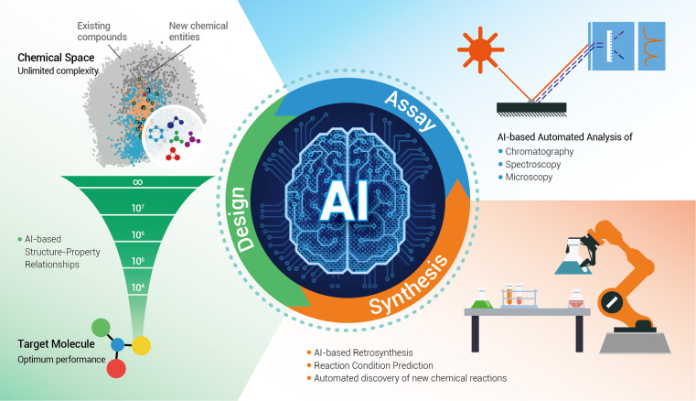
• AI in Molecular Simulations and Protein Folding
Working:
- AI models simulate the interaction between molecules, drastically speeding up drug discovery.
- Tools like AlphaFold (by DeepMind) predict 3D structures of proteins based on amino acid sequences using deep learning.
- AI scans billions of possible compound-target interactions using graph neural networks and bioinformatics data.
- Reduces years of lab work into weeks by simulating reactions and effectiveness virtually.
🔹 b. Particle Physics
• Large Hadron Collider (LHC) Data Analysis
Working:
- Particle collisions at CERN’s LHC generate petabytes of data per second.
- AI uses event classification and pattern recognition to identify rare phenomena like the Higgs boson.
- Machine learning filters background noise and isolates meaningful collisions.
- Algorithms like boosted decision trees and unsupervised clustering help in anomaly detection in quantum events.
🔹 c. Climate Science
• Weather Forecasting and Climate Modeling
Working:
- AI processes satellite and ground sensor data to predict extreme weather events (cyclones, heatwaves).
- Uses recurrent neural networks (RNNs) and spatiotemporal models to analyze temperature, pressure, and wind trends.
- In climate modeling, AI optimizes simulation models to assess long-term effects like glacier melt or sea-level rise.
- Emission tracking: AI estimates carbon footprints by analyzing energy consumption, transport data, and satellite imagery.
🔹 d. Material Science
• AI for New Material Discovery
Working:
- AI models analyze atomic and molecular properties using density functional theory (DFT) and machine learning regression.
- Can predict strength, thermal resistance, and conductivity before physical synthesis.
- Especially useful for defense R&D: discovering materials for ballistic armor, stealth coatings, and hypersonic vehicles.
- Accelerates development of superconductors, metamaterials, and thermally stable alloys.
🔹 e. Agricultural Science
• Precision Agriculture and Crop Monitoring
Working:
- AI uses satellite data + drone imagery to monitor crop health, detect diseases, and recommend irrigation or fertilization.
- Models analyze spectral data (NDVI – Normalized Difference Vegetation Index) to assess plant health.
- Uses predictive analytics for crop yield forecasting based on weather, soil, and historical data.
- AI-powered robots (agri-bots) can identify and remove weeds or harvest produce autonomously.
🔹 f. Robotics in Scientific Experiments
• AI-Powered Robotic Laboratories
Working:
- Labs now use AI-driven robots for conducting chemical or biological experiments.
- These robots operate 24/7, using reinforcement learning to optimize conditions like temperature, pH, or chemical ratio.
- AI can autonomously design experiments based on previous results — known as “self-driving labs”.
- Increases speed of research in pharmaceuticals, materials science, and energy storage.
✅ Other Real-World Applications of AI
Even outside critical sectors, AI is solving problems in daily life:
a. Healthcare
- AI diagnostic tools (like chest X-ray analysis).
- Virtual health assistants and robotic surgery.
b. Finance
- Fraud detection, algorithmic trading, risk profiling.
c. Transportation
- Self-driving vehicles, traffic optimization, predictive maintenance in public transport.
d. Education
- Adaptive learning platforms and automated assessment systems.
e. Retail
- Customer behavior prediction, smart inventory, chatbots.

4. How AI Benefits Society and Industries :
- Increased Efficiency:
AI automates repetitive, time-consuming tasks in industries like manufacturing, agriculture, logistics, and customer service.
- Better Accuracy:
AI systems reduce human error by using precise algorithms and large datasets.
In healthcare: AI tools detect diseases (like cancer or retinal diseases) with high accuracy, sometimes even better than doctors.
In finance: AI detects fraudulent transactions more accurately than traditional systems.
In agriculture: Drones and sensors powered by AI detect crop diseases with high precision.
- Cost Savings:
Once deployed, AI systems can handle large-scale tasks without needing constant human supervision, reducing labor costs.
AI reduces resource waste (e.g., using water, fertilizer, or energy more efficiently).
Examples:
- Banks use AI chatbots to handle customer queries, reducing the need for large customer service teams.
- Factories use AI for predictive maintenance, avoiding costly equipment failures.
- 24/7 Availability:
Chatbots, AI monitoring tools.
- Personalization:
AI learns user preferences and behaviors to deliver customized experiences.
In entertainment:
- Netflix recommends shows based on your watch history.
- Spotify curates playlists using AI that match your taste.
In e-commerce:
- Amazon suggests products based on browsing and purchase history.
5. AI Industry in 2025 and Beyond:
- Global Market: $305 billion by 2025 (Statista).
The global AI market is projected to reach $305 billion by 2025, driven by massive investments and integration across industries.
This includes AI software, hardware (like AI chips), services, and AI-powered platforms.
Growth is fueled by enterprise automation, healthcare AI, self-driving tech, smart cities, and personalized tech solutions.
Why it matters: It shows AI is no longer experimental—it's a mainstream economic driver.
- Key Players: Google, OpenAI, NVIDIA, Microsoft, Amazon.
- Growth Areas: Generative AI, AI chips, Robotics.
Generative AI: Tools like ChatGPT, DALL·E, and Midjourney generate text, code, images, and more — transforming content creation, software development, and education.
AI Chips: Specialized hardware (e.g., from NVIDIA, AMD, Intel) boosts AI processing speed and efficiency. Critical for autonomous vehicles, data centers, etc.
Robotics: AI-powered robots are advancing in manufacturing, logistics (like warehouse robots), healthcare (surgical bots), and even defense.
These areas are expected to dominate the next wave of innovation.
- Business Adoption: 70%+ companies investing in AI.
- AI Startups: 12,000+ globally; India is a fast-growing hub.
- Jobs: High demand for AI engineers, data scientists.
- 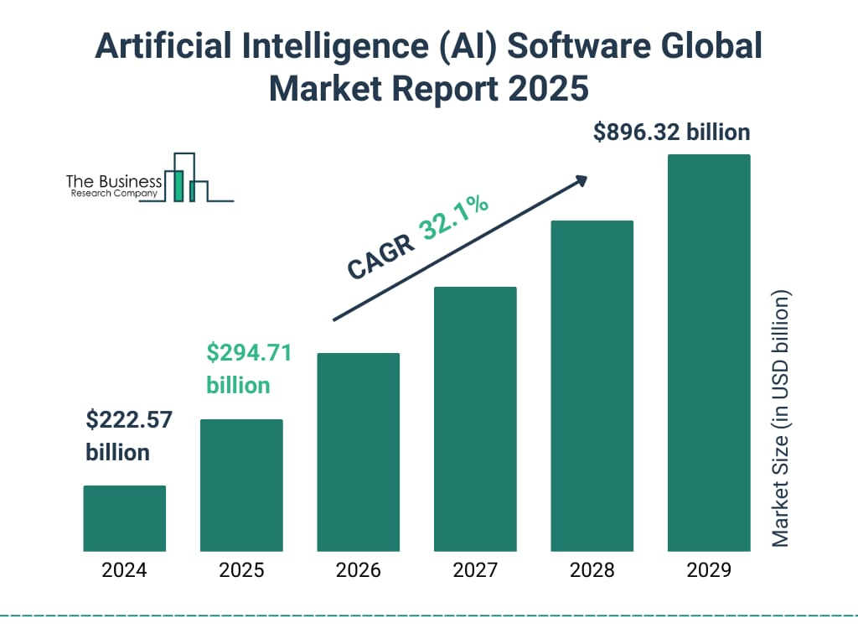
6. History and Evolution of AI :
- 1950: Alan Turing proposes the Turing Test.
• Alan Turing, a British mathematician and computer scientist, published a paper titled "Computing Machinery and Intelligence".
• He asked the famous question: “Can machines think?”
• He proposed the Turing Test to determine whether a machine can exhibit intelligent behavior indistinguishable from a human.
- 1956: 'AI' coined at Dartmouth Conference.
• The Dartmouth Summer Research Project on Artificial Intelligence, organized by John McCarthy, Marvin Minsky, Nathaniel Rochester, and Claude Shannon, is considered the birth of AI as a formal field.
• The term “Artificial Intelligence” was coined here.
• It proposed that “every aspect of learning or any other feature of intelligence can in principle be so precisely described that a machine can be made to simulate it.”

- 1980s: Rise of expert systems (e.g., XCON).
• The 1980s saw the growth of Expert Systems—AI programs that mimicked the decision-making abilities of a human expert.
• XCON, developed by Digital Equipment Corporation (DEC), was one of the most successful expert systems.
• It configured computer systems automatically based on customer requirements.
• Expert systems were used in medicine (MYCIN), business, and engineering, and marked the first commercial success of AI.

- 1997: IBM’s Deep Blue beats Kasparov.
• IBM’s Deep Blue, a supercomputer, defeated world chess champion Garry Kasparov in a 6-game match.
• This was the first time a computer beat a world champion under standard chess tournament rules.
• Deep Blue used brute-force computing and evaluated millions of positions per second.
• It was a symbolic victory for machine intelligence and gained worldwide media attention.

- 2011: IBM Watson wins Jeopardy!.
• IBM Watson, an AI system, competed on the quiz show Jeopardy! and beat two former champions.
• It could understand natural language questions, search massive databases, and answer with high accuracy.
• Watson’s success showcased the power of Natural Language Processing (NLP) and machine learning.

- 2016: AlphaGo defeats Go champion Lee Sedol.
• AlphaGo, developed by DeepMind (a Google company), defeated Lee Sedol, one of the world’s top Go players.
• Go is far more complex than chess, with more possible moves than atoms in the universe.
• AlphaGo used deep reinforcement learning and self-play to master the game.
• It shocked experts and proved that AI can master intuition-based tasks, not just rule-based ones.

- 2022-2025: Rise of Generative AI (ChatGPT, Sora, Gemini).
• This era is marked by the explosive growth of Generative AI—AI that can create content like text, images, videos, and code.
• ChatGPT (by OpenAI): A powerful language model capable of answering questions, writing essays, summarizing documents, coding, etc.
• Sora (OpenAI): AI that can generate realistic videos from text prompts.

7. Major Achievements in AI :
1. AlphaGo by DeepMind defeated world Go champion Lee Sedol in 2016, showcasing advanced strategic thinking.
2. GPT and ChatGPT by OpenAI demonstrated natural language understanding and generation, revolutionizing communication.
3. AI systems like IBM Watson and Google Health can diagnose diseases more accurately than human doctors in some cases.
4. Tesla, Waymo, and other companies have successfully developed autonomous vehicles that operate with minimal human intervention.
5. DeepMind’s AlphaFold solved the 50-year-old protein folding problem, accelerating drug discovery and biological research.


8. AI in Defense and Security:
AI is becoming a critical force multiplier in defense and national security worldwide, and India is actively exploring its use through organizations of Defense and Research and collaborations with startups.
Here’s a detailed explanation on how Artificial Intelligence can be used in Defense and Security:
🛡️ Artificial Intelligence in Defense and Security – Detailed Explanation
✅ 1. Surveillance and Reconnaissance
AI-powered systems can monitor borders, oceans, and airspace using data from:
- Drones (UAVs): Detect human movement, enemy camps, or illegal crossings.
- Satellite imagery analysis: AI can automatically detect missile launch sites, troop movements, or infrastructure changes using high-resolution images.
- Ground sensors and radars: AI filters out noise and detects suspicious activity in real time.
Benefits:
- Real-time monitoring
- Faster threat detection
- Reduced human fatigue in 24/7 surveillance
- 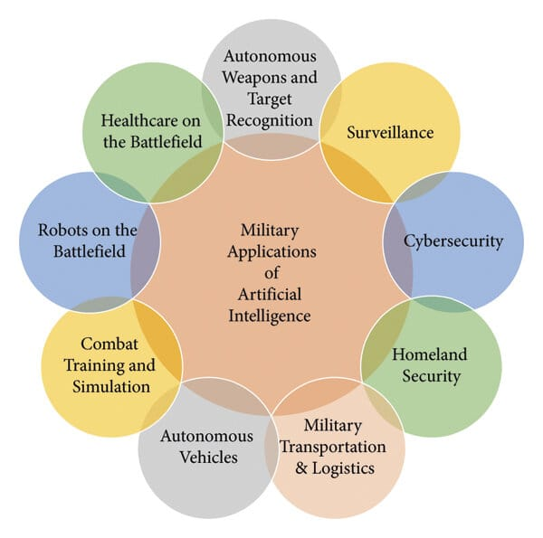
✅ 2. Autonomous Weapons Systems
AI is used to guide and operate autonomous or semi-autonomous weapon platforms:
- Missile guidance systems
- Unmanned ground vehicles (UGVs) and aerial vehicles (UAVs)
- Loitering munitions (aka "kamikaze drones")
- 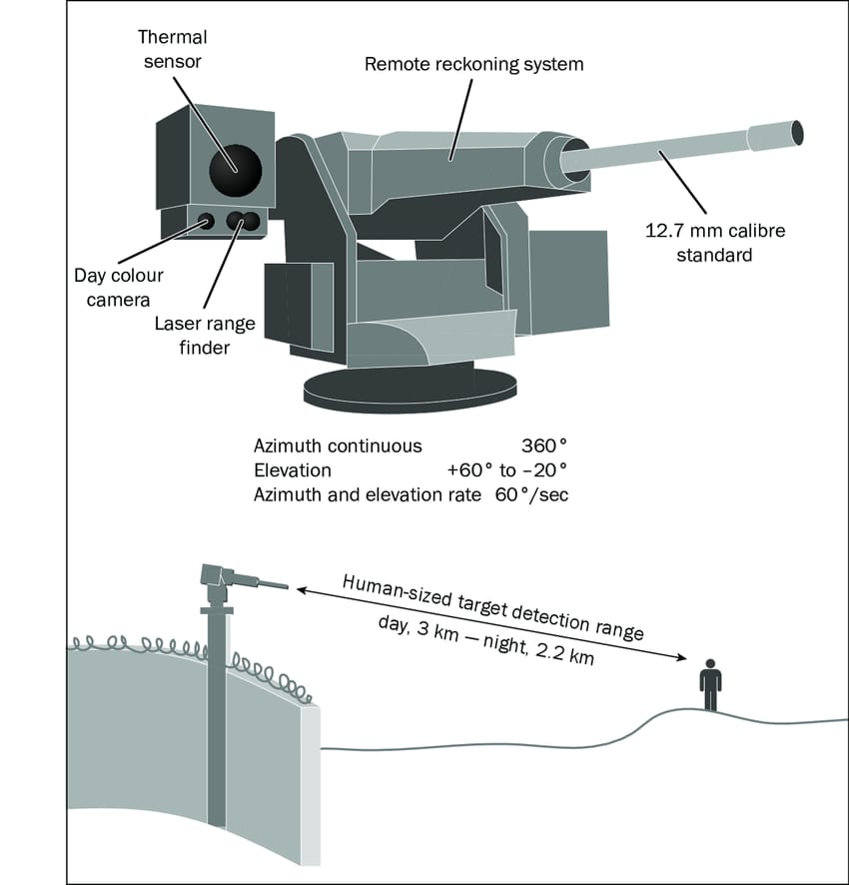

India's progress: DRDO is developing autonomous systems such as:
- RAJAK-XLR: Long-range surveillance system
- Tapas BH-201 (Rustom II): AI-assisted UAV for ISR (Intelligence, Surveillance, Reconnaissance)
✅ 3. Cybersecurity & Information Warfare
AI is a game-changer in cyber defense:
- Intrusion detection systems that monitor and block cyberattacks.
- AI models predict vulnerabilities in military networks and software.
- Fake news and misinformation detection using Natural Language Processing (NLP).
Use case: AI is used to defend against cyberespionage, malware, phishing, and to secure communication systems.
✅ 4. Combat Simulation & Training
AI enables virtual training environments for soldiers, pilots, and commanders:
- Simulates battlefield conditions, weather, terrain, and enemy tactics.
- Adaptive AI opponents help soldiers train against realistic, unpredictable scenarios.
Benefits:
- Safe and cost-effective training
- Personalized learning for each soldier
- Decision-making under pressure
✅ 5. Predictive Maintenance of Defense Equipment
AI predicts when aircrafts, tanks, submarines, or radars need servicing:
- Uses data from sensors and maintenance logs.
- Prevents breakdowns and ensures mission readiness.
Example: Predicting engine failure in fighter jets or faults in missile systems before deployment.
✅ 6. Border Security and Threat Detection
AI enhances security at LoC, LAC, and coastal regions through:
- Smart fencing and surveillance drones.
- Pattern recognition to detect infiltration or smuggling.
- Sensor fusion: Combining data from different sources (CCTV, seismic sensors, radar) to make better decisions.
✅ 7. Decision Support Systems (Command & Control)
AI assists commanders by:
- Analyzing battlefield data and recommending strategic options.
- Simulating the outcome of different decisions using war-gaming algorithms.
- Helping in logistics planning (troop movement, supply chain, ammunition).
AI tools used: Real-time dashboards, multi-source data fusion, and geo-intelligence systems.

✅ 8. Threat Identification through Facial & Voice Recognition
AI helps in:
- Identifying terrorists or suspects using facial recognition at borders or airports.
- Voiceprint analysis in intelligence gathering and communication monitoring.
Example: Flagging high-risk individuals from CCTV footage or intercepted communication.
✅ 9. Autonomous Naval and Air Defense:
- AI helps in monitoring and controlling unmanned underwater vehicles (UUVs) and AI-enabled air defense systems like SAMs (Surface-to-Air Missiles).
- Can detect enemy aircraft, missiles, or submarines and auto-respond with minimal delay.
✅ 10. Tactical AI for Soldiers (Smart Equipment):
- AI-powered helmets with real-time mapping, language translation, and object recognition.
- Smart vests that monitor soldier health (heartbeat, temperature, fatigue).
- AI-based communication tools for troops in remote, jammed or low-network zones.

8. Biggest Problems Yet to be Solved by AI :
Despite progress, major global issues remain unsolved. AI can offer solutions if developed and applied correctly:
1. Climate Change: AI can model climate patterns, optimize energy usage, and suggest policy actions.
2. Cancer Cure: AI is being used to analyze genetic data and design personalized treatments, but a universal cure remains elusive.
3. Food Insecurity: AI drones and sensors can optimize crop yields, detect disease early, and reduce waste.
4. Mental Health: AI-powered therapy bots are being developed, but lack emotional depth and cultural understanding.
The key challenge is integrating AI solutions with human systems and addressing ethical concerns.

9. Limitations and Challenges of AI :
1. Bias: AI systems can reflect and amplify societal biases if trained on biased data.
2. Privacy: Massive data collection for AI raises concerns about surveillance and misuse.
3. General Intelligence: Current AI lacks true understanding, context, and emotion.
4. Energy Use: Training large AI models consumes vast energy (e.g., GPT-4's training cost millions in energy).
5. Ethics: AI in military, facial recognition, or predictive policing raises significant moral questions.
Solving these requires global cooperation, better algorithms, and strict governance frameworks.
10. Sectors Needing AI Development :
1. Education: Personalized AI tutors can revolutionize learning in rural areas, but adoption is low.
2. Disaster Management: AI can predict natural disasters like earthquakes and tsunamis with early warnings.
3. Rural Healthcare: AI diagnostic tools can bridge doctor shortages in remote areas.
4. Waste Management: Smart sorting robots and AI recycling analysis are underutilized.
5. Legal System: AI can help process court backlogs and suggest legal precedents.
These areas remain underdeveloped, especially in low-income regions, due to lack of funding and awareness.

11. Hardware Requirements for AI :
AI hardware (for students/startups):
- Raspberry Pi with Coral USB Accelerator: Enables running light AI models locally.
- NVIDIA Jetson Nano: Ideal for robotics and real-time edge AI processing.
- Arduino + ML modules: For basic pattern recognition and control systems.
Large-scale AI hardware:
- NVIDIA A100 GPUs: High-performance GPUs for training and inference of massive AI models.
- Google TPUs (Tensor Processing Units): Custom hardware for deep learning.

- AI Supercomputers (e.g., IBM Watson, Fugaku): Used in climate science, genomics, and high-end simulations.
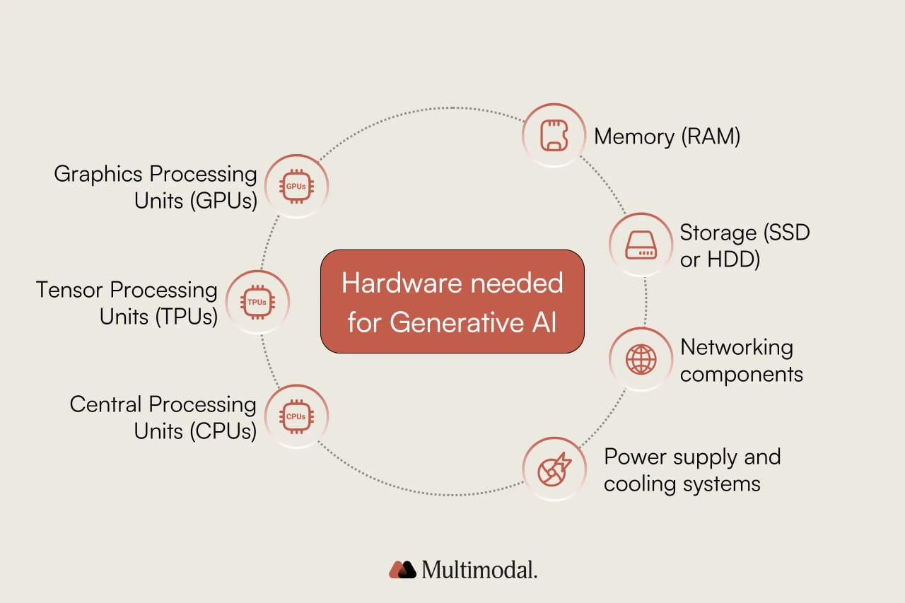

13. The Future of AI:
1. Human-AI Collaboration:
- In the future, AI will not replace humans but will work alongside them, amplifying human skills and decision-making. 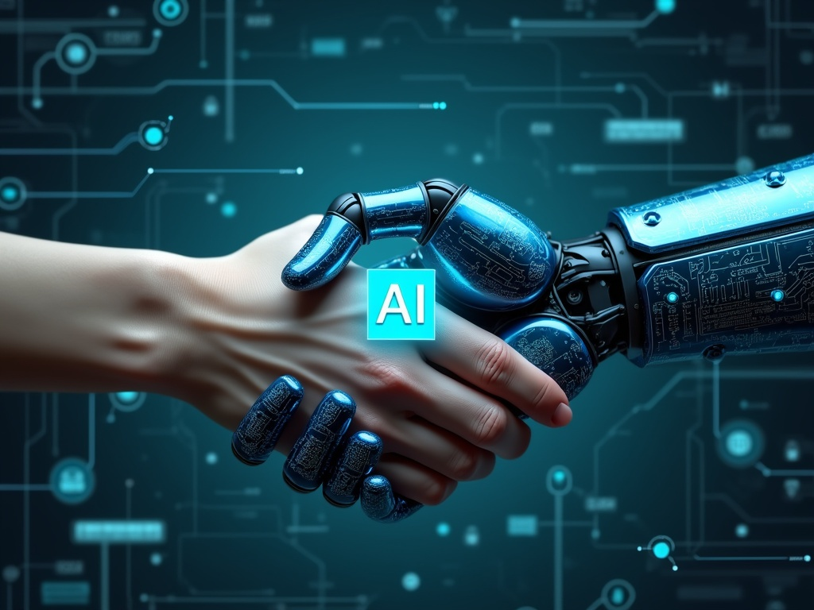

- Doctors will use AI for accurate diagnostics and treatment planning.
- Teachers will use AI to create personalized learning experiences and identify students who need help.
- Engineers will rely on AI for complex simulations, design optimization, and predictive maintenance.
- This collaboration will lead to better outcomes, faster innovation, and fewer errors.
Key Idea: AI as an assistant, not a replacement — a co-pilot in every profession.
2. Creative AI:
Explanation:
- AI is becoming increasingly creative, not just logical.
- Tools like:
  - DALL·E (by OpenAI): Generate realistic or artistic images from text prompts.
  - ChatGPT/GPT-4: Generate stories, essays, poems, scripts, and code.
  - Amper Music & AIVA: Compose original music with AI.
- Creative AI helps artists, writers, filmmakers, and musicians explore new ideas and generate content quickly.
- In education and advertising, it enables customized content creation at scale.
Key Impact: Enhances human creativity, making it more accessible, faster, and collaborative.
3. Explainable AI (XAI):
- Current AI models (like deep learning systems) often function as “black boxes”, meaning they give results without explaining how or why.
- Explainable AI (XAI) is the next step—AI that can justify its decisions in a way that humans can understand.
- This is especially important in critical fields like:
  - Healthcare (Why did AI suggest a particular diagnosis?)
  - Law (Why was someone flagged by an AI system?)
  - Finance (Why was a loan rejected?)
- XAI will help build trust between humans and machines and ensure accountability.
Goal: Make AI transparent, fair, and auditable.
4. Ethical AI:
As AI becomes more powerful, there’s a growing need for ethical rules and global standards to prevent misuse.
Key areas of concern:
- Bias and discrimination in AI decisions
- Data privacy
- AI in surveillance and warfare
- Job displacement
Organizations like the UNESCO, EU, OECD, and companies like Google and OpenAI are working on AI ethics frameworks.
The future of AI depends on how responsibly it is built and integrated into human society.
14. Conclusion:
Artificial Intelligence is already transforming our world—from healthcare to education, from business to space.
It has the potential to solve some of humanity's toughest challenges, but it also brings new risks. With responsible development, AI can be a powerful force for good.
Thank you for your attention. I’d be happy to answer any questions you have.


