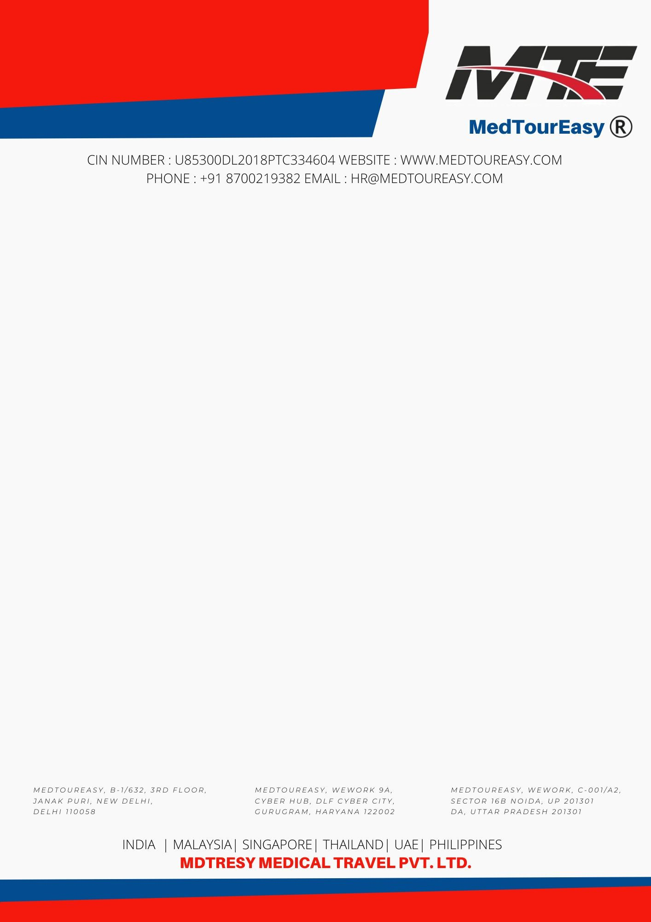

**DATE** : 02/01/2025

**Shashank GGSIPU University Subject - Internship**

Dear Shashank

With reference to your application, we would like to congratulate you for being selected as a Data Analytics Trainee for the Internship Program with MedTourEasy. Your training is scheduled to start from 06th January 2025 effective for a period of 16 weeks. All of us at MedTourEasy are excited that you will be joining our team!

As such your internship will include training/orientation and will be focused primarily on learning and developing new skills and gaining a deeper understanding of concepts through hands-on application of the knowledge you attain in class.

Upon completion of the program, you will be receiving a Certificate of Completion from the company. The best performer will also be offered a PPO by the company depending upon vacancies available. The project detail will be shared with you on or before commencement of training. Your appointment will be governed by the terms and conditions presented in the Annexure A.

You would be reporting online.

Congratulations again and we look forward to work with you.

Yours Sincerely

Human Resources Team

MedTourEasy



**Annexure A**

You shall be governed by the following terms and condition of service during your internship with MedTourEasy, and those may be amended from time to time.

1. You are being selected as a Data Analytics Intern. As a Data Analytics Trainee you would be responsible for completing the training modules on our partner platform and complete the live project thereafter as per the project requirement specified in the project proposal.
2. Your date of joining is 06th January 2025 and the duration of the internship would be 16 Weeks.
3. All the work that you will produce at or in relation to MedTourEasy will be the intellectual property of MedTourEasy. You are not allowed to store, copy, sell, share, and distribute it to a third party under any circumstances. Similarly you are expected to refrain from talking about your work in public domains (both online such as blogging, social networking site and oﬄine among your friends, college etc.)
4. You will be using your own computer throughout the program.
5. You will be required to submit the work on our Learning Management System.
6. You are expected to conduct yourself with utmost professionalism in dealing with your mentor, team members, colleagues, clients and customers and treat everyone with due respect. In case of misbehavior, the company reserves the right to terminate your training on disciplinary grounds.
7. We take data privacy and security very seriously and to maintain confidentiality of any students, customers, clients, and companies’ data and contact details that you may get access to during your internship will be your responsibility. MedTourEasy operates on zero tolerance principle with regard to any breach of data security guidelines. At the completion of the internship, you are expected to hand over all MedTourEasy work/data stored on your Personal Computer to the LMS and delete the same from your machine.