SIH 26130 — Backend Flow & Frontend Page Plan
What the backend does, step by step, and the pages needed to build against it

1. Purpose
This doc exists to answer one question for the build team: what pages do we actually need? It works backwards from the backend flow — each numbered step below is a real thing the system does, and every page in section 3 exists because some step needs a screen to trigger it or show its result. Section 4 maps the two together directly, so nothing gets built without a reason and nothing needed gets missed.

2. Backend Flow (end to end)
This is the same request lifecycle from the architecture doc, unpacked into eight concrete steps. Colors match the architecture layers: teal = applicant-triggered steps, purple = the intelligence layer, coral = department-side steps, amber = the decision point.
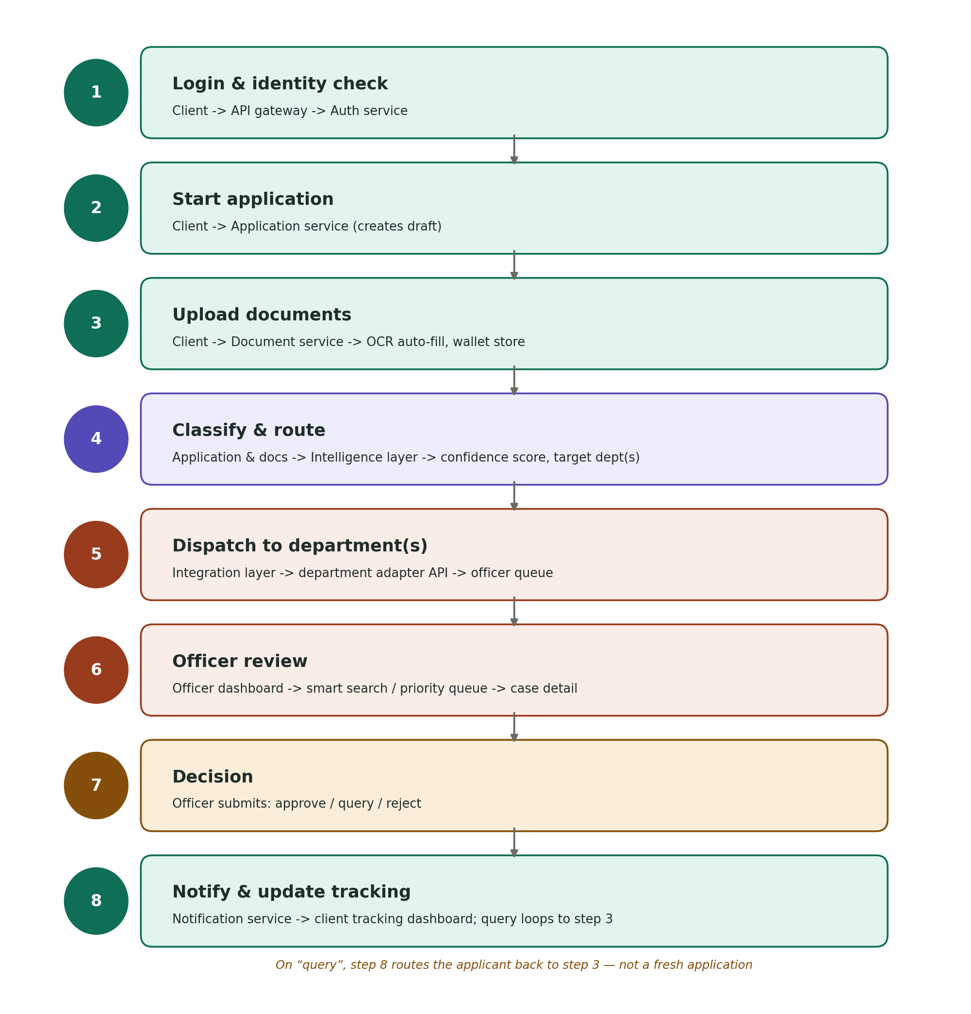

2.1 Notes on the flow
- Applicant side — Steps 1 to 3 are entirely applicant-driven and map to applicant-facing pages.
- No dedicated screen — Step 4 has no page of its own — it runs between document upload and department dispatch, and its only visible trace is the routing result shown on the tracking page.
- Officer side — Steps 5 to 7 happen on the officer side and never touch the applicant's screen directly.
- Query loop — A “query” decision at step 7 does not restart the application — it reopens the document upload step for just the flagged document, and the applicant sees this as a status change, not a new form.

3. Frontend Page Inventory
Pages are grouped by who uses them. “Backend calls” lists the services each page talks to, using the same service names as the architecture doc, so a developer can see the dependency at a glance.

3.1 Applicant-facing pages
Page | Purpose | Backend calls
Login / sign-in | Aadhaar or OAuth-based login, language toggle (English / Marathi). | Auth service
Registration & profile setup | One-time profile creation: business details, unit(s), contact info. | Application service
Applicant dashboard | Overview of all applications, quick actions, notifications. | Application service, Notification service
New application — approval type selector | Guided picker for which approval(s) the applicant needs. | Application service
Application form | The unified base form, auto-filled from uploaded documents. | Application service, OCR engine
Document upload & wallet | Upload documents; see auto-fill results, missing/duplicate flags, expiry dates on stored documents. | Document service, OCR engine, duplicate detector
Review & submit | Final check of the filled form and attached documents before submission. | Application service
Application tracking (detail view) | Live status, current department, predicted ETA, and bottleneck flag for one application. | Application service, predictive timeline estimator, Notification service
Grievance / raise a complaint | File a complaint against a stuck or mishandled application; shows the 30-day SLA countdown. | Grievance service
Notifications center | All alerts: document expiry, status changes, SLA warnings. | Notification service
Multi-unit enterprise dashboard | Consolidated view across a company's multiple factory units. | Application service
Remote/video verification scheduling | Book a video-call inspection slot for eligible low-risk approvals. | Application service, department adapter API
Profile & settings | Manage login details, language preference, notification preferences. | Auth service

3.2 Officer / department-facing pages
Page | Purpose | Backend calls
Officer login | Role-based sign-in for department staff. | Auth service
Officer queue dashboard | Auto-routed, pre-verified applications for this department, with priority flags. | Application service, department adapter API
Officer smart search | Search across applications by applicant, document type, or status. | Application service
Application review & decision | View a single application's documents and history; approve, query, or reject. | Application service, Document service, Grievance service
Department analytics | Turnaround times, SLA compliance, and volume for this department — source of the public leaderboard. | Application service, analytics store
Grievance management (officer side) | View and respond to complaints raised against this department. | Grievance service

3.3 Public / shared pages
Page | Purpose | Backend calls
Public leaderboard | Department turnaround times and applicant ratings — no login required. | Analytics store
Landing page | Entry point explaining the platform before login; language toggle. | None (static)

4. Flow-to-Page Mapping
This table reads the backend flow left to right and shows exactly which page triggers or displays each step, so a developer building step 4 or 5 knows there's no screen to build, and one building step 8 knows it touches two pages, not one.
Backend step | Triggering / displaying page(s)
1. Login & identity check | Login / sign-in, Officer login
2. Start application | New application — approval type selector, Application form
3. Upload documents | Document upload & wallet
4. Classify & route | No dedicated page — result surfaces on Application tracking
5. Dispatch to department(s) | Officer queue dashboard (receiving side)
6. Officer review | Officer smart search, Application review & decision
7. Decision | Application review & decision
8. Notify & update tracking | Notifications center, Application tracking (detail view)

5. Build order suggestion
- Phase 1 — core loop — Login/sign-in, Officer login, Application form, Document upload & wallet — nothing else works without these.
- Phase 2 — review loop — Officer queue dashboard, Application review & decision, Application tracking — closes the loop from submission to a visible decision.
- Phase 3 — supporting pages — Applicant dashboard, Notifications center, Grievance pages, Officer smart search, Department analytics.
- Phase 4 — polish and reach — Public leaderboard, Multi-unit dashboard, Remote verification scheduling, Landing page.

6. Closing note
Every page in section 3 traces back to a step in section 2 through the mapping in section 4 — there's no page here that exists just because it seemed nice to have, and no backend step that's invisible to the user without a reason.

