Book Recommendation System

Abhay Yadav
Dept. of Computer Science and Engineering
Galgotias University
Greater Noida, Uttar Pradesh, IN
abhay.21scse1010467@galgotiasuniversity.edu.in

Nikhil Kumar
Dept. of Computer Science and Engineering
Galgotias University
Greater Noida, Uttar Pradesh, IN
nikhil.21scse1010832@galgotiasuniversity.edu.in

Abstract—This paper provides an in-depth exploration of a Book Recommendation System designed to enrich the reader's experience, boost engagement, and support authors and publishers in connecting with their ideal audiences. In today's world of abundant literary options, readers often struggle to find books that match their tastes. To address this challenge, our system employs a hybrid recommendation model that combines both collaborative filtering and content-based filtering techniques.
By analyzing user behavior—such as reading habits, ratings, and demographic data—alongside book-specific information like genres, authors, and key themes, our system tailors personalized suggestions to meet individual preferences. Machine learning algorithms enable the system to continuously refine recommendations as users' interests evolve.
To assess the effectiveness of the system, we use performance metrics including precision, recall, and user satisfaction ratings. Additionally, user feedback and study results are incorporated to further improve the model's accuracy and relevance. The results demonstrate that the system not only enhances the likelihood of discovering new books but also encourages diverse reading patterns and contributes to overall user satisfaction.
Looking to the future, our work will focus on integrating more sophisticated machine learning techniques, deepening personalization, and adding community-driven features to create a more immersive and engaging reading environment. This study highlights the crucial role recommendation systems play in the literary world and their potential to inspire a lifelong passion for reading.
Keywords—machine learning, book recommendation

Introduction
In the age of digital content, discovering relevant and engaging literature has become a challenge for many readers. With an overwhelming abundance of books spanning countless genres, themes, and authors, the traditional methods of finding new reads—such as browsing through lists or relying on recommendations from friends—are no longer sufficient. This creates a significant need for more sophisticated tools that can guide users towards books that align with their individual preferences.
Book recommendation systems have emerged as a solution, leveraging data-driven algorithms to provide personalized suggestions. By tailoring recommendations based on a user’s reading history, preferences, and demographic information, these systems offer a more efficient and enjoyable way to explore literature. However, achieving both accuracy and adaptability in such systems is a complex task, requiring the integration of multiple recommendation techniques and the use of advanced machine learning models.
This paper presents a comprehensive study of a hybrid book recommendation system that combines collaborative filtering and content-based filtering to enhance the personalization of recommendations. The system not only helps readers discover new books but also supports authors and publishers by better connecting them to their target audiences. Through the analysis of user behavior and book metadata, the system evolves to reflect changing user preferences, offering increasingly relevant suggestions. In this research, we examine the effectiveness of this system using key performance metrics, user feedback, and real-world application scenarios, highlighting its potential to transform the way readers engage with literary content.

Problem Statement
With the vast and ever-expanding volume of books available in the digital age, readers face significant challenges in discovering literature that aligns with their interests. Traditional methods of book discovery, such as browsing through categories or relying on generic recommendations, often fall short in providing personalized suggestions. This not only leads to frustration for readers but also limits exposure to new and diverse content, creating a barrier to exploring a broader range of literary works.
Moreover, authors and publishers struggle to effectively connect with their target audiences in a saturated market, where the visibility of individual books can be easily overshadowed. There is a clear need for a system that can intelligently filter through massive amounts of data and provide users with accurate, personalized recommendations that reflect their evolving tastes, while also promoting a more dynamic interaction between readers and the literary world.
The problem lies in the development of an efficient, adaptive recommendation system that can offer relevant book suggestions, enhancing user satisfaction and engagement, while supporting authors and publishers in better reaching their audiences.

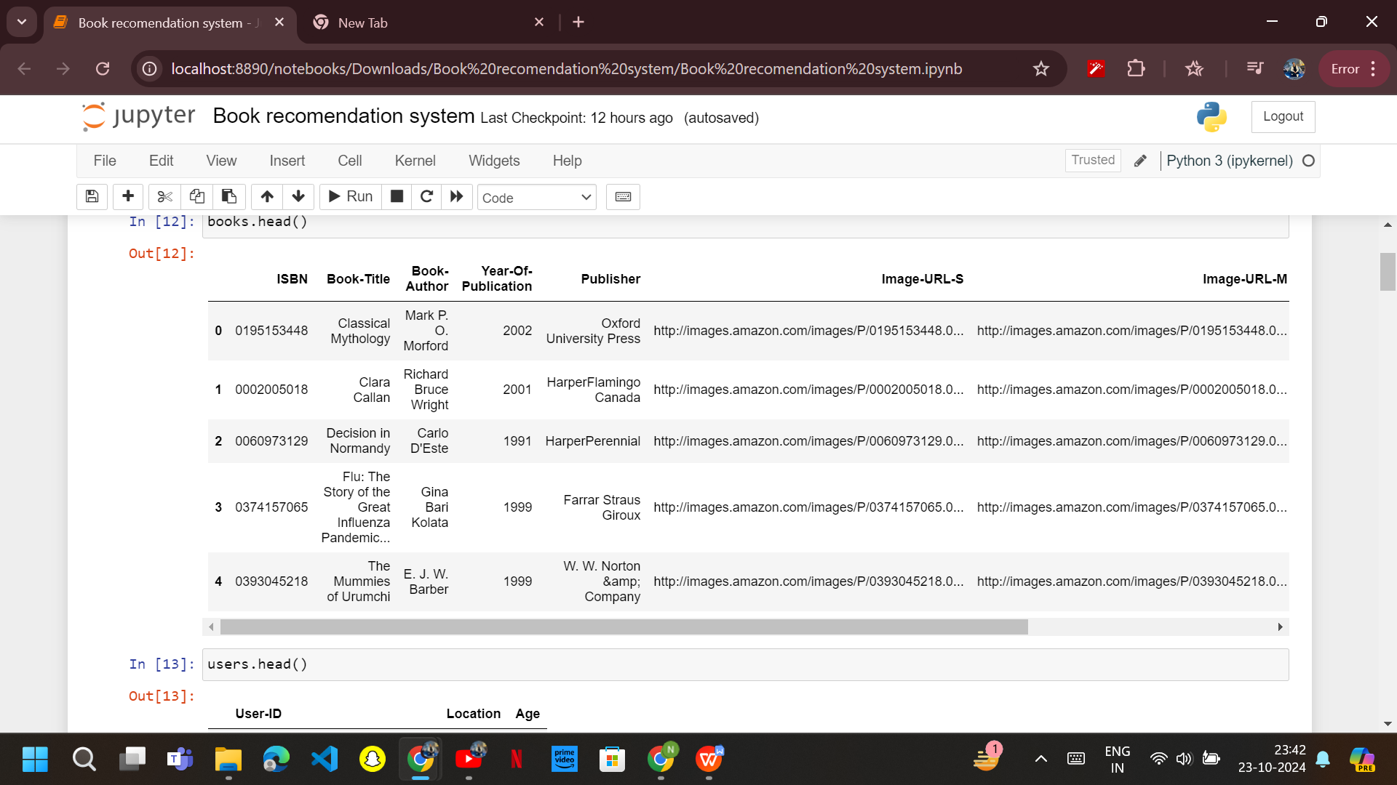
- Information about the input data.

Proposed Solution
The proposed solution is a hybrid book recommendation system that combines collaborative filtering and content-based filtering techniques. It aims to address the challenge of book discovery by providing personalized suggestions based on user behavior, such as reading history, ratings, and genre preferences, as well as book metadata like authors and keywords. This dual approach ensures that users receive highly relevant recommendations, balancing familiarity with new and diverse content, allowing them to discover books they are likely to enjoy while exploring new genres and authors.
A key aspect of the solution is its user-centric design, which emphasizes ease of use and engagement. The system will feature an intuitive interface with simple navigation, allowing users to filter recommendations based on different criteria. Additionally, engaging elements like book trailers, reviews, and feedback mechanisms will enhance the overall reading experience, encouraging users to interact with the platform and refine their preferences over time.
To boost user engagement and foster a sense of community, the system will incorporate features such as reading challenges, curated lists, and social sharing options. These features will motivate users to read more frequently, share their reading experiences with others, and participate in discussions. By creating a community-driven atmosphere, the system can promote active reading habits and increase user retention, helping readers explore a broader range of books.
Finally, the system will provide valuable insights to authors and publishers by analyzing user data to identify trends and target audiences. It will highlight emerging authors and lesser-known titles, helping publishers reach their audience more effectively. Machine learning algorithms will continuously adapt to user behavior and preferences, ensuring that the system remains relevant and dynamic, improving the overall book discovery process.
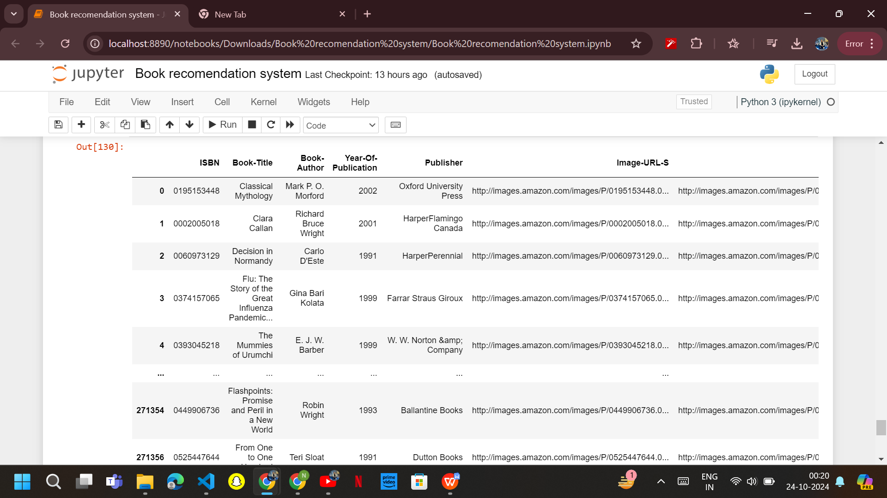
- Recommendation made on popularity basis.

Mehodology
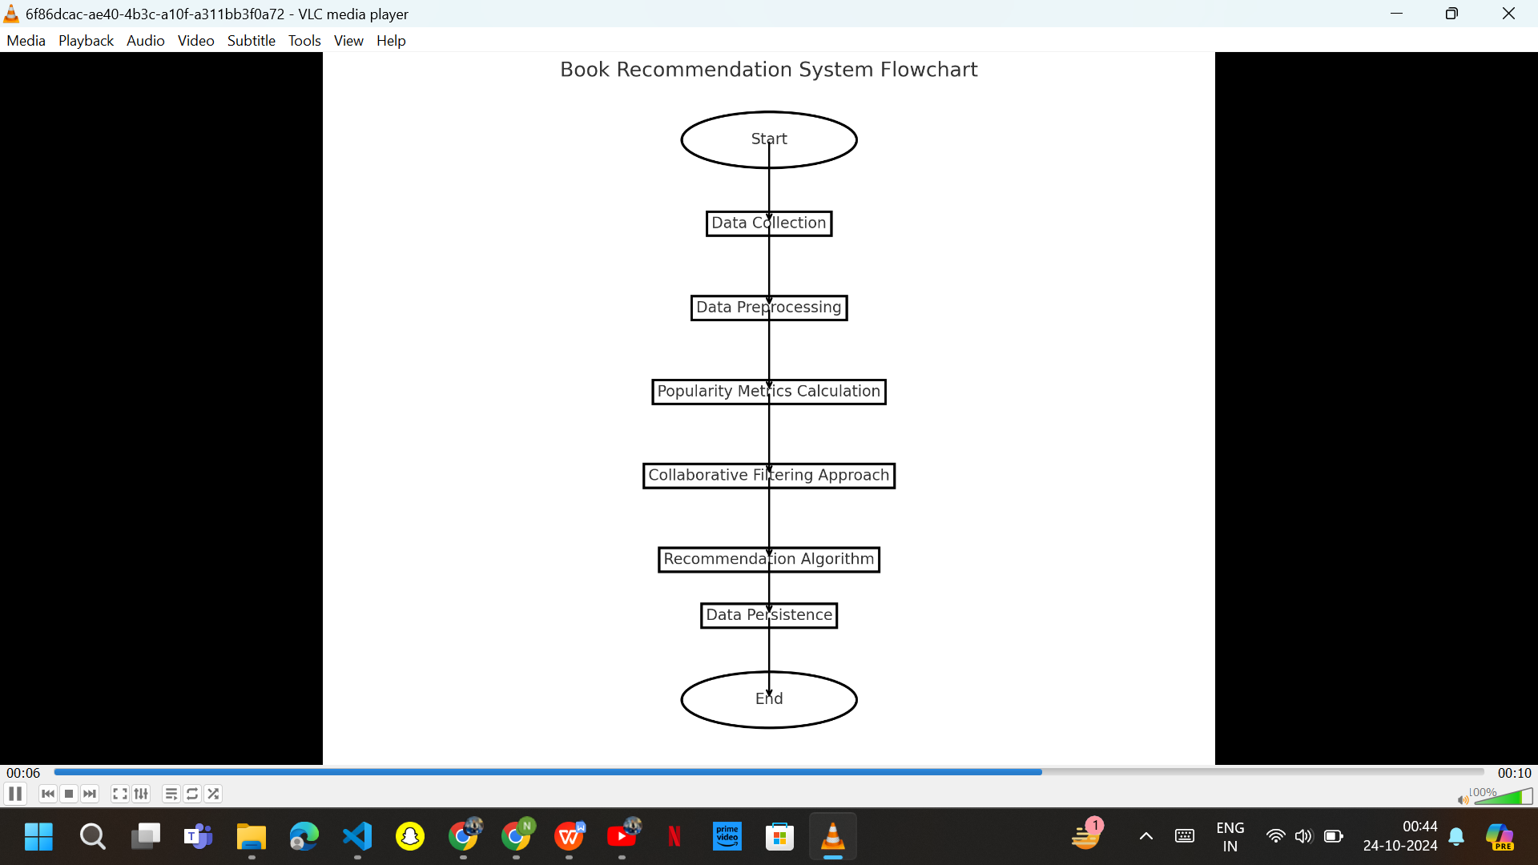
- System design.

Developing a book recommendation system using machine learning involves several steps and methodologies:

Data Collection: The datasets utilized for this study were sourced from publicly available repositories and consisted of three primary components:

Books Dataset: Contains metadata about books, including titles, authors, and ISBNs.

Users Dataset: Includes user profiles and demographic information.

Ratings Dataset: Contains user ratings for books, represented as numerical values.

The datasets were stored in CSV format, and to optimize storage and loading efficiency, they were compressed in a ZIP format.

Data Preprocessing: Upon loading the datasets using the pandas library, the following preprocessing steps were performed:

Data Integrity Checks: We checked for missing values and duplicates in all datasets. Rows with missing values or duplicates were identified and handled appropriately.

Data Merging: The ratings dataset was merged with the books dataset on the ISBN column to create a unified dataset (ratings_with_name) that includes book titles and their respective ratings.

Data Type Conversion: The Book-Rating column was converted to a numeric type to ensure accurate calculations of averages and counts.

Popularity Metrics Calculation: To identify popular books, the following steps were executed:

Count of Ratings: We grouped the ratings_with_name DataFrame by Book-Title to count the number of ratings each book received, resulting in the num_rating_df DataFrame.

Average Rating Calculation: The average rating for each book was computed and stored in the avg_rating_df DataFrame.

Merging Popularity Metrics: Both DataFrames were merged to create a comprehensive popular_df DataFrame, which included books with a minimum of 250 ratings, sorted by their average rating.

Collaborative Filtering Approach: A collaborative filtering approach was employed to recommend books based on user ratings:

User and Book Filtering: Users who had rated more than 200 books and books with at least 50 ratings were retained for analysis to enhance the reliability of recommendations.

Pivot Table Creation: A pivot table (pt) was constructed, with Book-Title as rows and User-ID as columns, filled with the respective ratings. Missing values were replaced with zeros.

Cosine Similarity Calculation: The cosine similarity between the items in the pivot table was computed using the cosine_similarity function from the sklearn library, resulting in a similarity score matrix.

Recommendation Algorithm: A recommendation function was developed to suggest similar books based on a user-provided book title:

The function takes the input book title, retrieves its index from the pivot table, and calculates similarity scores with other books.

The top N similar books (in this case, the top 4) are selected based on the highest similarity scores, along with their respective titles, authors, and image URLs for display.

Data Persistence: To facilitate future access and usage of the developed model and datasets, we employed the pickle library to serialize and save key components:

The popular books DataFrame, the pivot table, and the cosine similarity scores were saved as .pkl files.

Deployment: Once satisfied with the model's performance, deploy it to make real-time predictions.

Monitoring and Maintenance: Monitor the model's performance over time in performance, retrain and update it as needed. Consider retraining the model with new data periodically.

Dependencies

Numpy: For numerical operations.

Pandas: For data manipulation and analysis.

Pickle: This is included in Python's standard library serializing and deserializing Python objects.

Skikit-learn: For machine learning algorithms and metrics (used here for cosine similarity).

Objectives
Some of the primary objectives of this book recommendation model include:
- User Preference Analysis: Examine historical rating data to identify patterns in user book choices and preferences.
- Collaborative and Content-Based Filtering: Develop and implement collaborative filtering algorithms and explore content-based techniques to recommend books based on user/item similarity and book attributes.
- Hybrid Model Design: Create a hybrid recommendation model that combines collaborative and content-based methods to enhance accuracy and diversity in recommendations.
- Performance Evaluation: Establish evaluation metrics (such as precision, recall, and F1-score) to assess and compare the effectiveness of different recommendation algorithms.
- Scalability and Efficiency: Investigate the system’s ability to handle large datasets and maintain performance efficiency as user and book data increase.
- User Interface and Engagement: Design a user-friendly interface that enhances user engagement, incorporating features like personalized dashboards and interactive recommendations.
- Feedback and Improvement Mechanism: Implement a feedback system to gather user input and refine recommendation algorithms based on user preferences.
- Advanced Techniques Exploration: Explore advanced machine learning methods, such as deep learning and natural language processing, to improve recommendation performance.
- Future Trends and Adaptability: Discuss emerging trends in recommendation systems, including social media integration and real-time analytics, to enhance the recommendation process.

Impact and Contribution
The contribution of a book recommendation system is impactful across various domains. Some of them include:

Enhanced User Experience: The recommendation system significantly improves user satisfaction by providing personalized book suggestions, making it easier for users to discover new reads that align with their interests.

Increased Engagement and Retention: By tailoring recommendations to individual preferences, the system can increase user engagement and retention rates on platforms, leading to more frequent interactions and longer user sessions.

Improved Sales and Revenue: For bookstores and online retailers, effective recommendations can lead to higher sales conversion rates, as users are more likely to purchase books suggested to them based on their preferences.

Data-Driven Insights: The system provides valuable insights into user preferences and trends in book consumption, enabling publishers and authors to make informed decisions regarding marketing and inventory management.

Support for Diverse Readers: By incorporating various filtering techniques, the recommendation system can cater to diverse user backgrounds and reading tastes, promoting inclusivity and broadening the audience for different genres and authors.

Acknowledgments
We would like to thank everyone who helped us achieve this success. It was a great experience of working on this project of “Book Recommendation System Using Machine Learning”. It would not be possible without the consistent help of all our mentors, guide, friends, and family. We are immensely grateful to our university and our department, that is, Department of Computer Science and Engineering, Galgotias University, Greater Noida, and the members of the management including our dean, guide, and reviewer, for providing us this great opportunity where we could put our best knowledge together to give this outcome. A special thank you to all who gave us their precious time and knowledge, which really helped us to think better and produce the best of what we could achieve with this project.

References
Ricci, F., Rokach, L., & Shapira, B. (2011). Recommender Systems Handbook. Springer.
This book provides an extensive overview of recommendation systems, covering various algorithms and their applications.
Journal Articles
Adomavicius, G., & Tuzhilin, A. (2005). Toward the Next Generation of Recommender Systems: A Survey of the State-of-the-Art and Future Research Directions. IEEE Transactions on Knowledge and Data Engineering, 17(6), 734-749.
This article discusses existing recommendation techniques and suggests directions for future research.
Conference Papers
Ziegler, J., & Draxler, J. (2005). Improving Recommendations with User Models. In Proceedings of the International Conference on Adaptive Hypermedia and Adaptive Web-Based Systems (pp. 77-86).
This paper explores the role of user modeling in enhancing recommendation accuracy.

