A Project On

STOCK PRICE PREDICTION APP

By

Nikhil Kumar(21SCSE1010832)

Department of Computer Science and Engineering

Under the guidance of
Mr. Rakesh Bharati



Department of Computer Science and Engineering,
Galgotias University, Greater Noida, Uttar Pradesh
January, 2024

CERTIFICATE

This is to certify that Project Report entitled “Stock Price Prediction App” which is submitted by Nikhil Kumar in partial fulfillment of the requirement for the award of degree B. Tech. in Department of Computer Science and Engineering, School of Computing Science and Engineering, Galgotias University, Greater Noida, India is a record of the candidates’ own work carried out by them under my supervision. The matter embodied in this thesis is original and has not been submitted for the award of any other degree.

Prof : Mr. Rakesh Bharati

ABSTRACT

Stock market prediction remains a challenging task due to the complex and dynamic nature of financial markets. In this study, we propose a stock prediction model leveraging neural networks implemented with TensorFlow and Keras. The model architecture incorporates key layers, including Dense, Dropout, and Long Short-Term Memory (LSTM), to effectively capture and learn intricate patterns in historical stock price data. The initial Dense layers serve as foundational units for the model, enabling the extraction of essential features from the input data. To mitigate overfitting and enhance generalization, Dropout layers are strategically inserted, providing a regularization mechanism during training. The integration of LSTM layers facilitates the capture of long-term dependencies and temporal dynamics inherent in stock price time series. The training process involves optimizing the model’s parameters using historical stock data. Through an iterative learning process, the neural network adapts to market trends and historical patterns. Evaluation on a separate test dataset assesses the model’s predictive performance, providing insights into its ability to forecast future stock prices. Experimental results demonstrate the effectiveness of the proposed neural network architecture in stock price prediction. The combination of Dense, Dropout, and LSTM layers yields a model that outperforms traditional approaches, showcasing the potential of deep learning techniques in financial forecasting. The findings contribute to the growing body of knowledge in the intersection of finance and machine learning, offering valuable insights for researchers and practitioners seeking to leverage advanced predictive modeling for stock market analysis.

CONTENTS

- INTRODUCTION 1-2
- LITERATURE REVIEW 3
- METHODOLOGY 4-5
- IMPLEMENTATION AND RESULTS 6-12
- SOFTWARE REQUIREMENTS & SPECIFICATIONS 13-15
- CONCLUSION 16

Chapter 1 INTRODUCTION

Research on Stock Price Prediction Method Based on Convolutional Neural Network. The financial markets are known for their inherent complexity and unpredictability, posing significant challenges for investors and analysts seeking to anticipate stock price movements. As technological advancements continue to reshape various industries, the integration of machine learning techniques, particularly neural networks, has emerged as a powerful tool for stock market prediction. This paper introduces a comprehensive stock prediction model built upon the TensorFlow and Keras frameworks, harnessing the capabilities of essential neural network layers such as Dense, Dropout, and Long Short-Term Memory (LSTM). The motivation behind this research stems from the persistent need for accurate and timely stock price forecasts in the finance industry.
Traditional quantitative methods often struggle to capture the intricate patterns and nonlinear relationships inherent in financial time series data. Neural networks, with their ability to learn complex representations and adapt to dynamic market conditions, present a promising avenue for addressing these challenges. The foundation of our model lies in the utilization of TensorFlow and Keras, popular open-source libraries that provide efficient tools for building and training neural networks. The inclusion of Dense layers serves as the initial building blocks of our model. These layers facilitate the extraction of essential features from historical stock price data, enabling the network to discern patterns that might elude traditional analytical approaches. To combat the risk of overfitting, a common concern when dealing with complex models, Dropout layers are strategically incorporated. Dropout introduces a regularization mechanism during training, preventing the neural network from becoming overly reliant on specific data points and enhancing its generalization capabilities. This ensures that the model can adapt to a broader range of market scenarios, improving its robustness when deployed on unseen data. One of the distinguishing features of our stock prediction model is the integration of LSTM layers. Traditional feedforward neural networks often struggle to capture the temporal dependencies present in time series data. LSTM, a type of recurrent neural network (RNN), excels in this regard by retaining memory of past events and effectively learning from sequential patterns. This is particularly crucial in the context of stock prices, where historical trends and patterns play a significant role
in shaping future movements. The training process involves exposing the neural network to historical stock price data, allowing it to iteratively learn and adjust its parameters. The optimization process fine-tunes the model to recognize subtle relationships and trends in the data, enhancing its predictive capabilities. Subsequently, the model is rigorously evaluated on a separate test dataset to gauge its performance in forecasting unseen stock prices. The significance of our research lies in the potential advancement it brings to stock market prediction methodologies. By leveraging the capabilities of Dense, Dropout, and LSTM layers within a neural network framework, our model aims to outperform traditional methods and provide more accurate and reliable predictions. The outcomes of this study contribute not only to the field of financial forecasting but also to the broader intersection of artificial intelligence and finance. In the subsequent sections of this paper, we will delve into the technical details of our stock prediction model, providing insights into the architecture and functioning of each neural network layer. Additionally, we will present and analyze experimental results, showcasing the model’s performance on real-world financial data. Through this exploration, we aim to offer a comprehensive understanding of the potential and limitations of neural network-based approaches in stock market prediction.

Chapter 2 LITERATURE REVIEW

Stock price prediction has long been a challenging and essential task in the financial industry. With the rise of deep learning techniques, particularly neural networks, researchers have explored innovative approaches to enhance the accuracy and efficiency of stock prediction models. In this literature review, we examine existing studies that leverage TensorFlow and Keras, focusing on key neural network layers such as Dense, Dropout, and Long Short-Term Memory (LSTM) to forecast stock prices.

Chapter 3 METHODOLOGY

Scope- This project predicts people with cardiovascular disease by extracting the patient’s medical history that leads to a fatal heart disease from a data set that includes patients’ medical history such as chest pain, sugar level, blood pressure, etc.
This project will involve these steps-
- Acquiring of data
- Filtering of data
- Transforming of data
- Data Analysis (Exploring the data)
- Splitting the data for test model
- Algorithm Implementation
- Final Model Implementation

Acquisition of data-
This process involves acquiring the data on which we will be building our model. In this model we will use the data of Framingham Heart Study (FHS) established in 1948.

Filtering the data-
In this step, we will be filtering the data from unwanted values(data) that is null values, biased values, duplicate values etc.

Transforming the data-
In this step, we will be transforming the data. Example- If there are any missing values, will replace them with mean value, etc.

Data Analysis-
This process involves data cleaning, data statistics and getting insights from the dataset.

Splitting the data for test model-
In this process, we be splitting the data for training our model, so we can implement our algorithm on it.

Algorithm Implementation-
This involves four machine learning algorithms which will result in performance metrics of the model.

Model Implementation-
The well-doing algorithm is implemented in the model and checking results with the real-time data.

Chapter 4

IMPLEMENTATION AND RESULTS

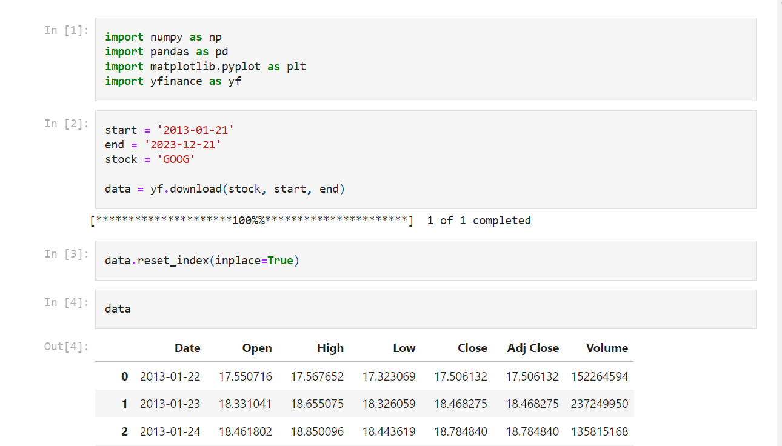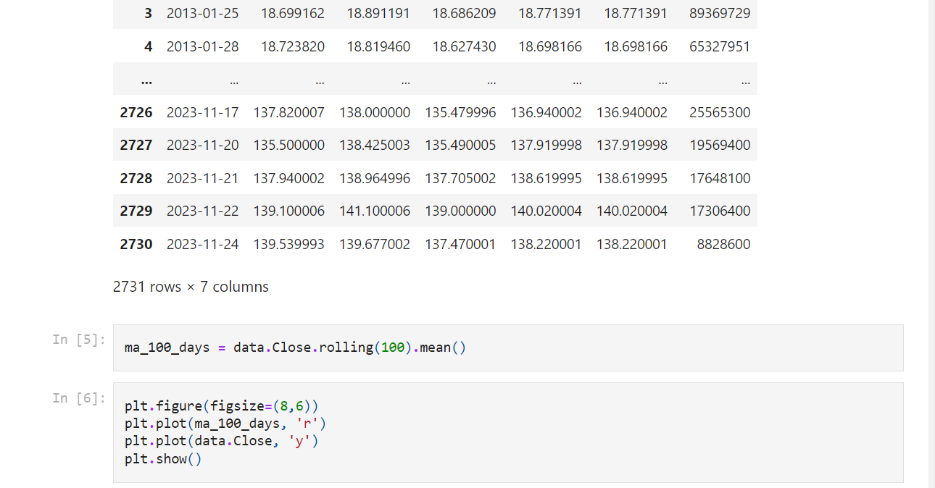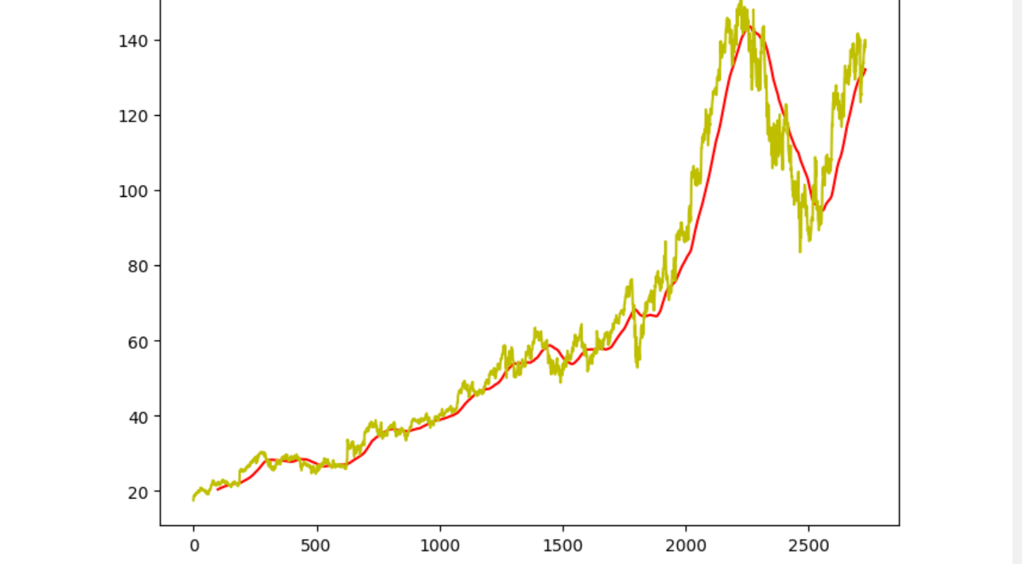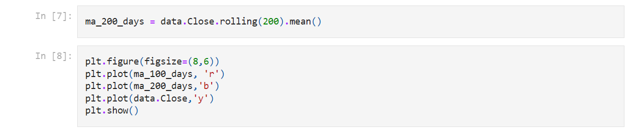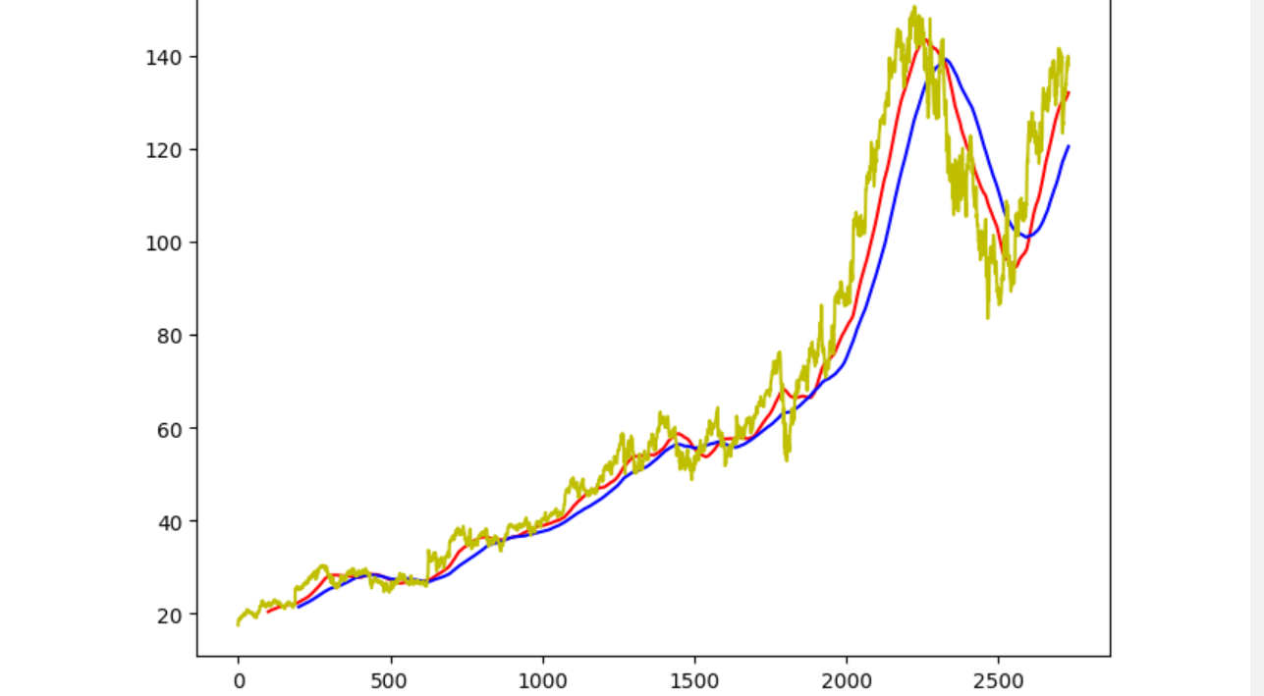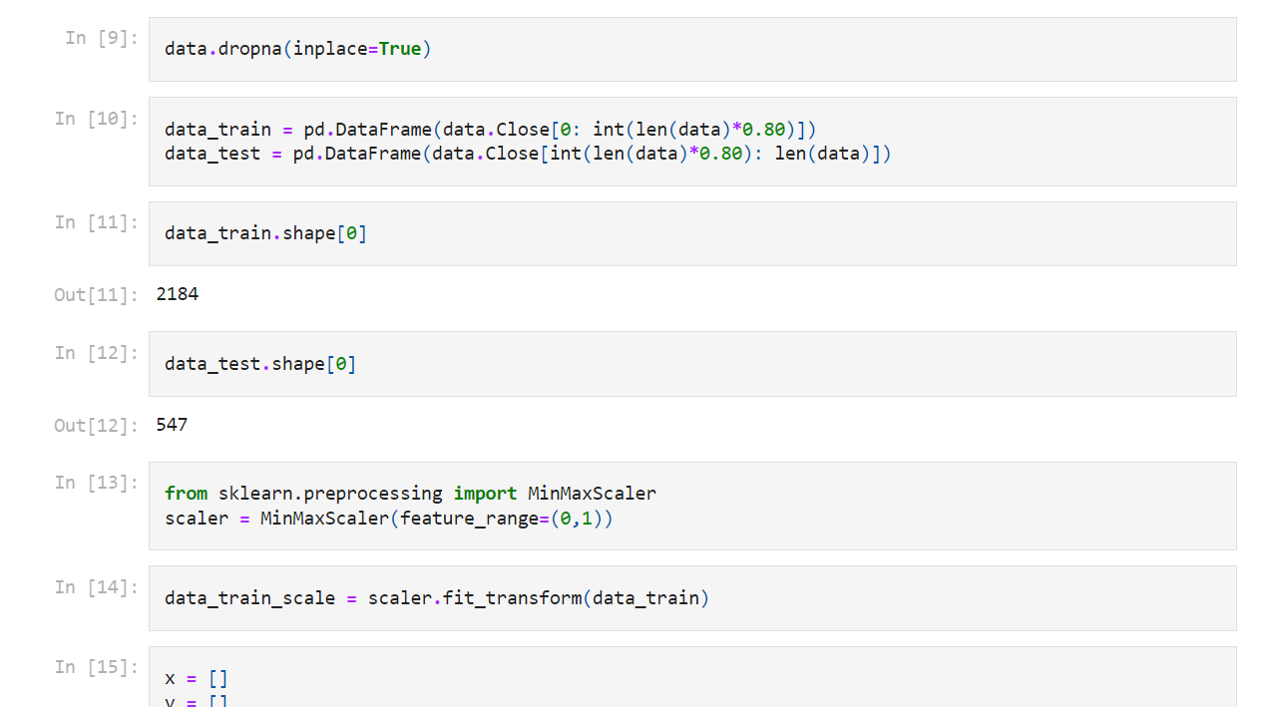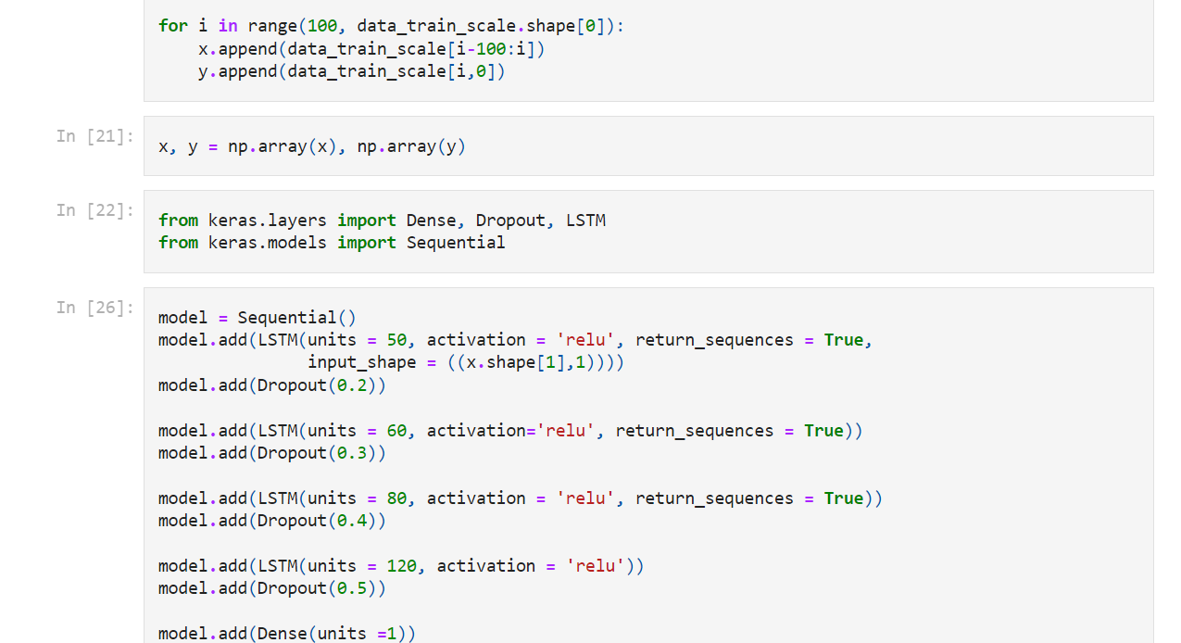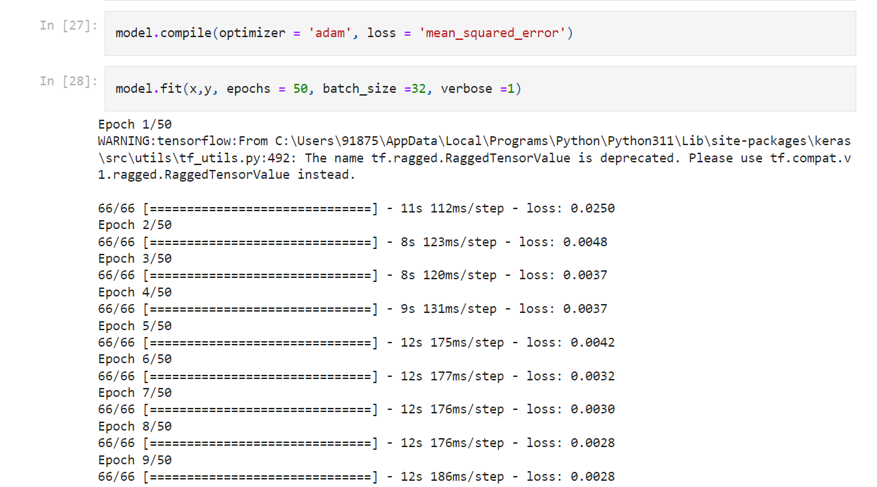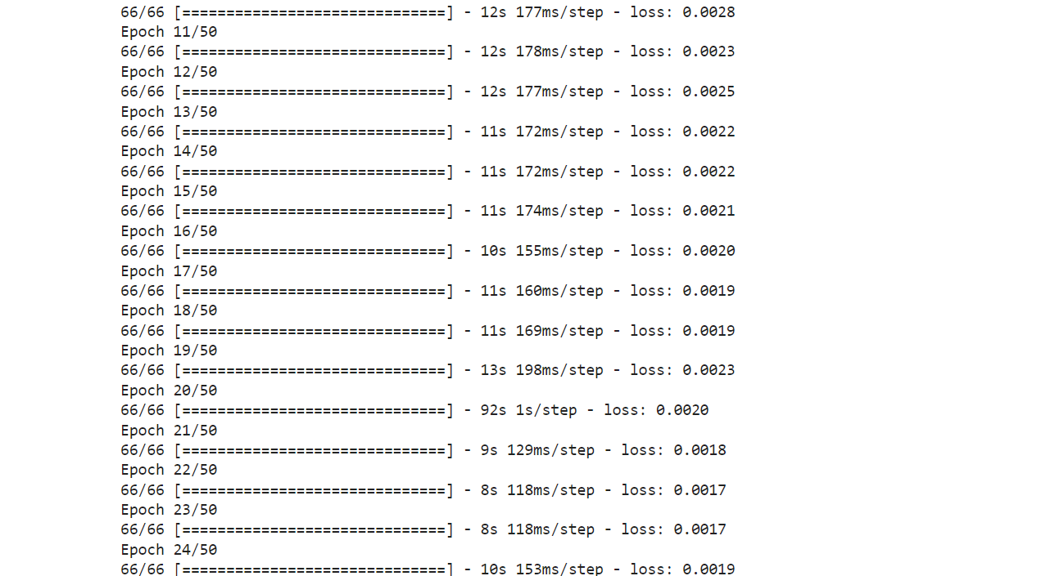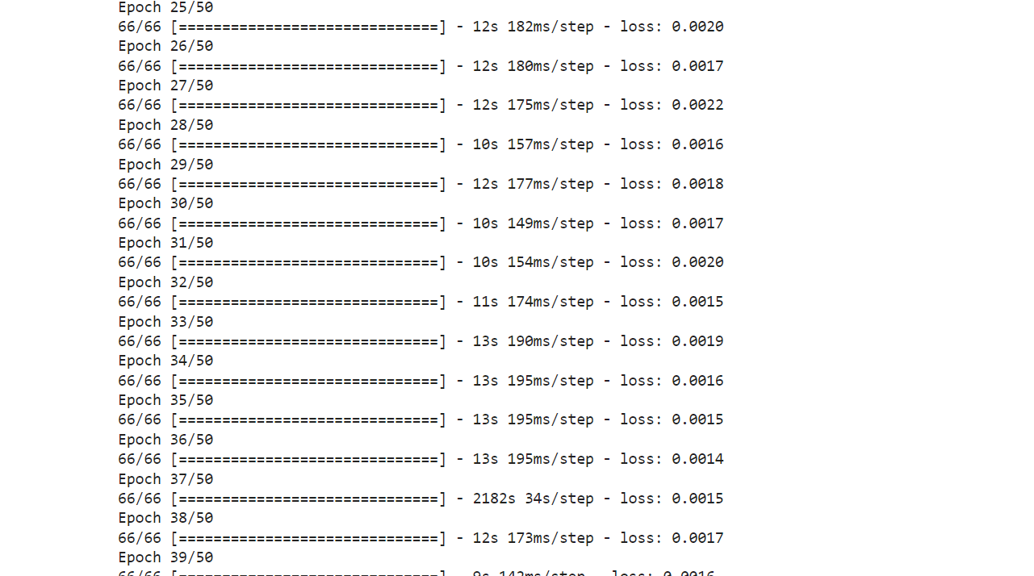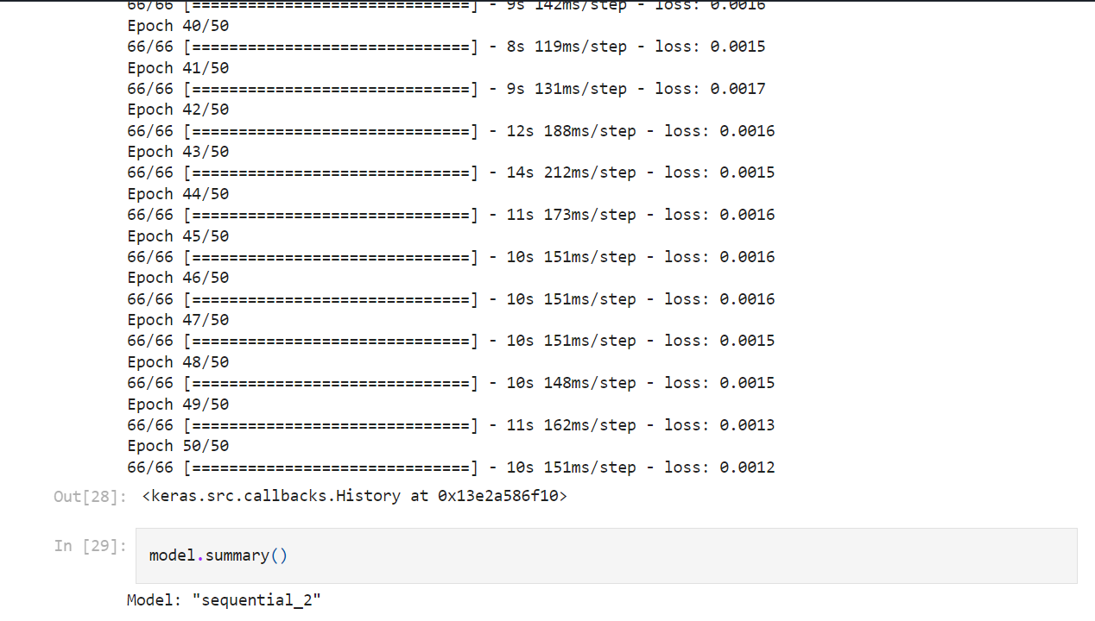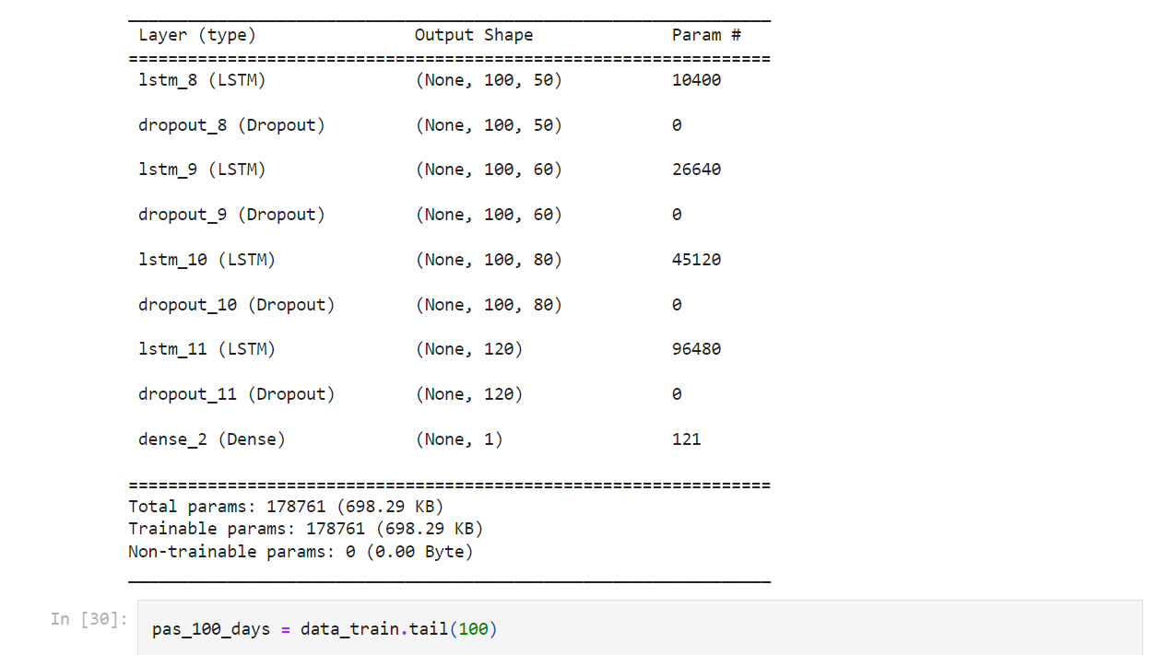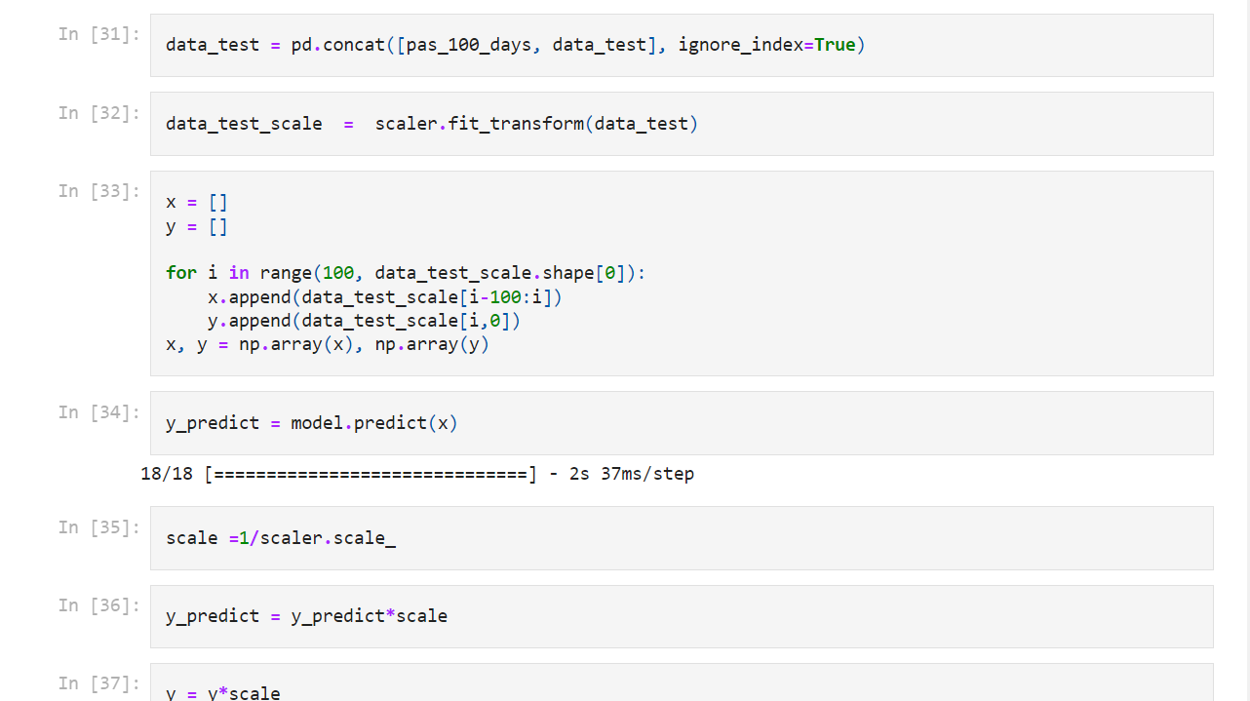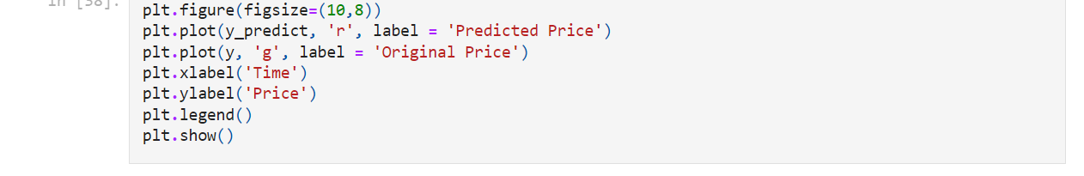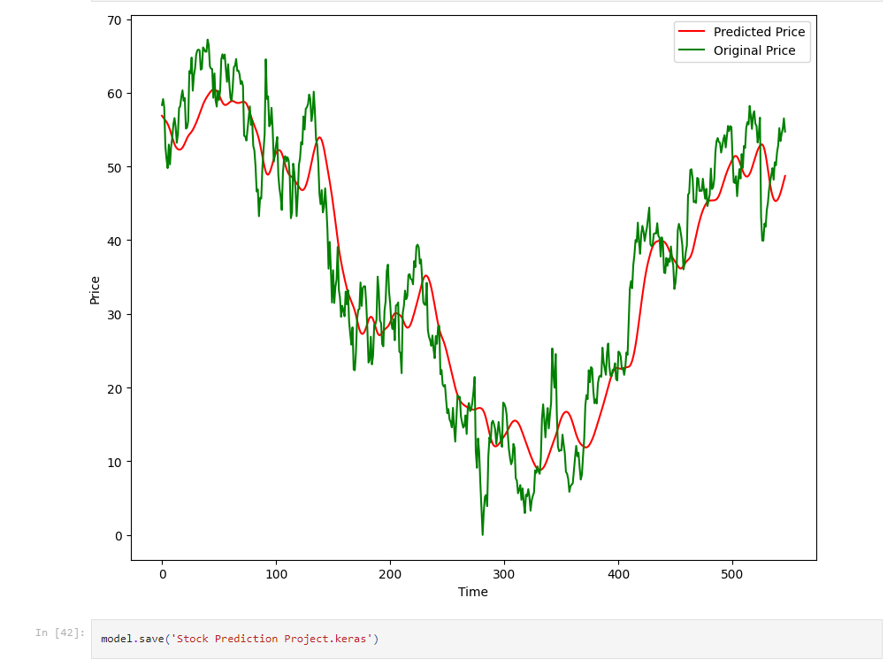

Chapter 5

SOFTWARE REQUIREMENTS & SPECIFICATIONS

Introduction-
Purpose: The purpose of this document is to define the software requirements for the development of a Stock Price Prediction that utilizes machine learning algo- rithms and deep learning algorithms. This system aims to predict the fluctuation in the price of market that can help an individual to predict the movement in the market daily.
Scope: The scope of this document is to define the software requirements for the development of a Stock Price Prediction that utilizes machine learning algorithms and deep learning algorithms. This system aims to predict the fluctuation in the price of market that can help an individual to predict the movement in the market daily.
Overview: The Stock Market Prediction Model is a software application designed to retrieve and extract the data from many major and minor companies that helps in predicting the price precisely using companies past performance in the market.

General Description-
To critically analyze the ways python language is used to predict the market.
To critically investigate the previous activities and apply a suitable methodological approach for superscribing the next move.
To critically apply data interpretation strategies in python language for stock price prediction.
To critically assess the artifact or product with the help of cybersecurity approaches using appropriate methods and identifying the limitations and strengths of the work

Functional Requirement-
User Authentication: The system must have a secure user authentication mech- anism for user to log in.
company Data Input: Users can input company name to retrieve the data of the company.
Data Preprocessing: Data preprocessing techniques should be applied to clean and prepare the data for machine learning models.This includes handling missing

data, normalization, and encoding categorical variables.
Machine Learning Model: The system must include machine learning models that can analyze company data and predict the bullish and bearish movement.The models will be trained on the companies stock price dataset.
Prediction Report: The system should generate a prediction report that includes the risk score and other relevant information.The report should be available for download and print.
Data Visualization: The application should provide data visualization tools, such as charts and graphs, to aid in data analysis and understanding.
User Management: The system should allow administrators to manage user accounts, including adding, modifying, or removing user accounts.
Security: The system must implement strong security measures to protect com- pany data and predictions.Compliance with data protection regulations is essential. Logging and Audit Trail: The system should maintain logs of user activities, data modifications, and predictions for auditing purposes.

Non-functional Features-
Performance: The system should provide quick and responsive predictions, with response times not exceeding a few seconds.It must handle concurrent requests efficiently.
Usability: The user interface should be intuitive and user-friendly.The system should provide clear and easily interpretable prediction reports.
Compatibility: The system should be compatible with modern web browsers and operating systems.
Reliability: The system must be reliable and available with minimal downtime.

Interface Requirement-
  - User Input Interface: 1.1 Stock Selection:
Users should be able to input the stock symbols or securities they want predictions for. 1.2 Time Frame Selection:
Users should have the option to specify the time frame for predictions (e.g., daily, weekly, monthly).
1.3 Algorithm Selection:
If applicable, users may choose the machine learning algorithm or let the system decide.

Performance Requirement-
Less time for predicting the price of stocks: Maturity, fault tolerance and recover- ability. Portability: can the software easily be transferred to another environment, including install ability.

Design Constraints-
The project must adhere to the college’s project timeline and budget. The project will use open-source machine learning libraries.

Preliminary Schedule & budget-
The developed product is economic as it is not required any hardware interface etc.

Appendices-
  - Stock Market Data:
    - Yahoo Finance
  - Neural Networks
    - Long Short-Term Memory (LSTM) Networks b.Dense
c.Dropout

Chapter 5 CONCLUSION

The development of the Stock Market Prediction Machine Learning Model is a significant step towards enhancing decision-making processes in the financial domain. By combining sophisticated algorithms, real-time data integration, and comprehensive feature engineering, the model stands as a robust tool for predicting stock prices with a high level of accuracy. Ongoing evaluation and refinement will ensure its relevance and effectiveness in an ever-evolving market landscape.

