1) Register User (Valid credentials)

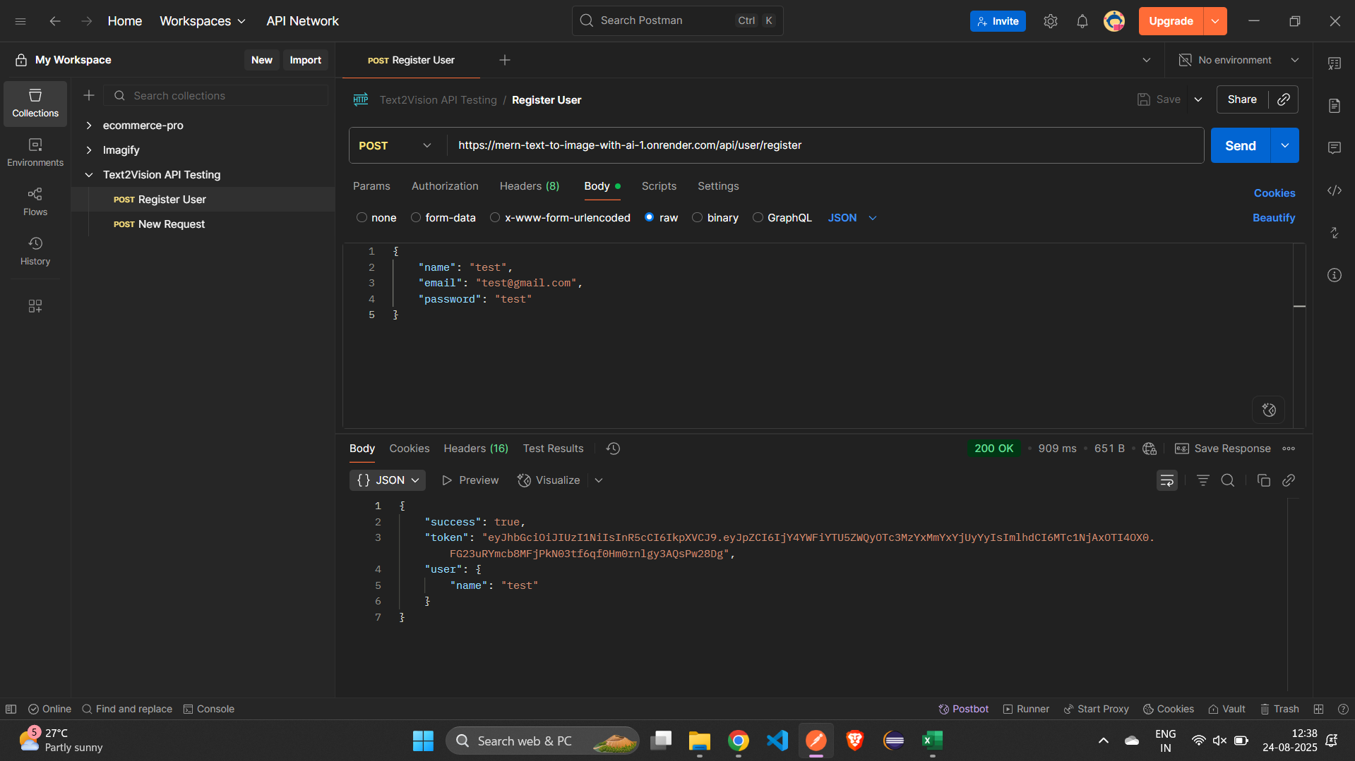

2) Register User (Neg) (Existing email)

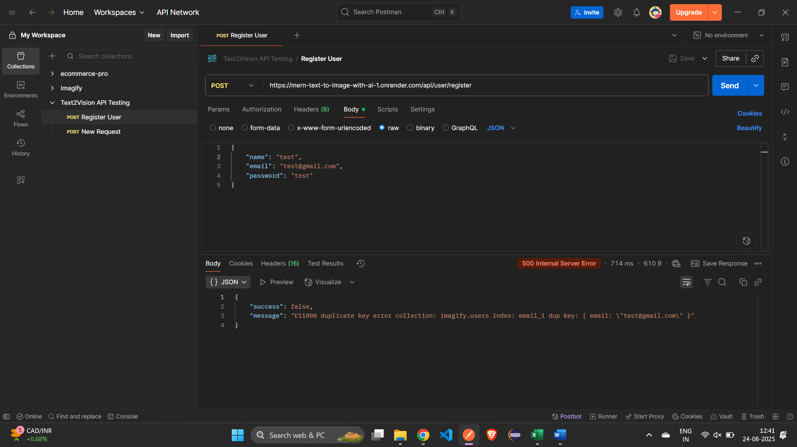

3) Login User(Valid credentials)

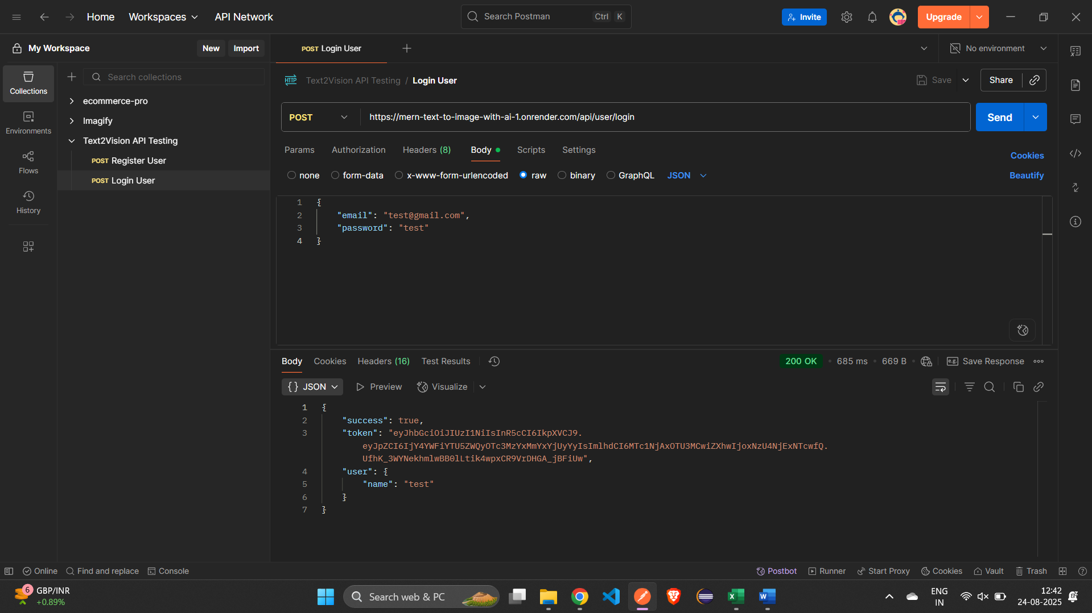

4) Login User (Neg) (Wrong password)

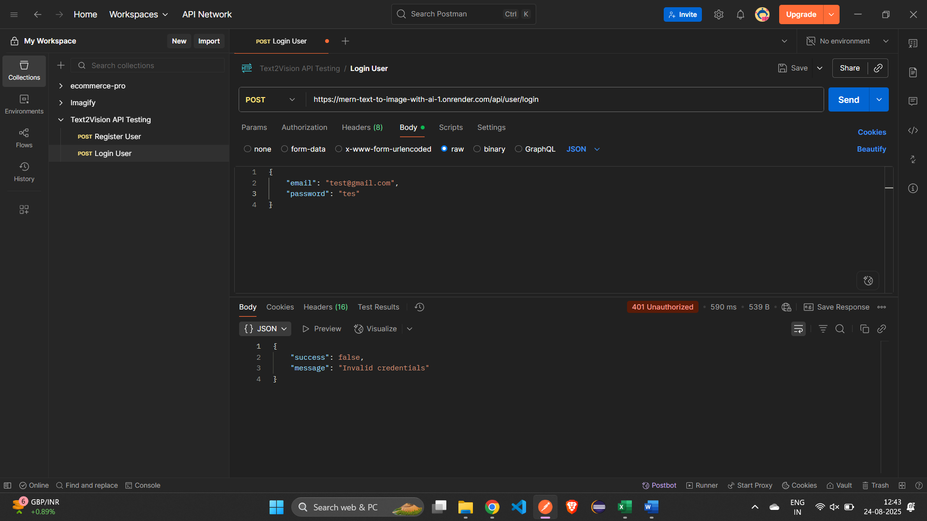

5) Get Credits(Valid token)

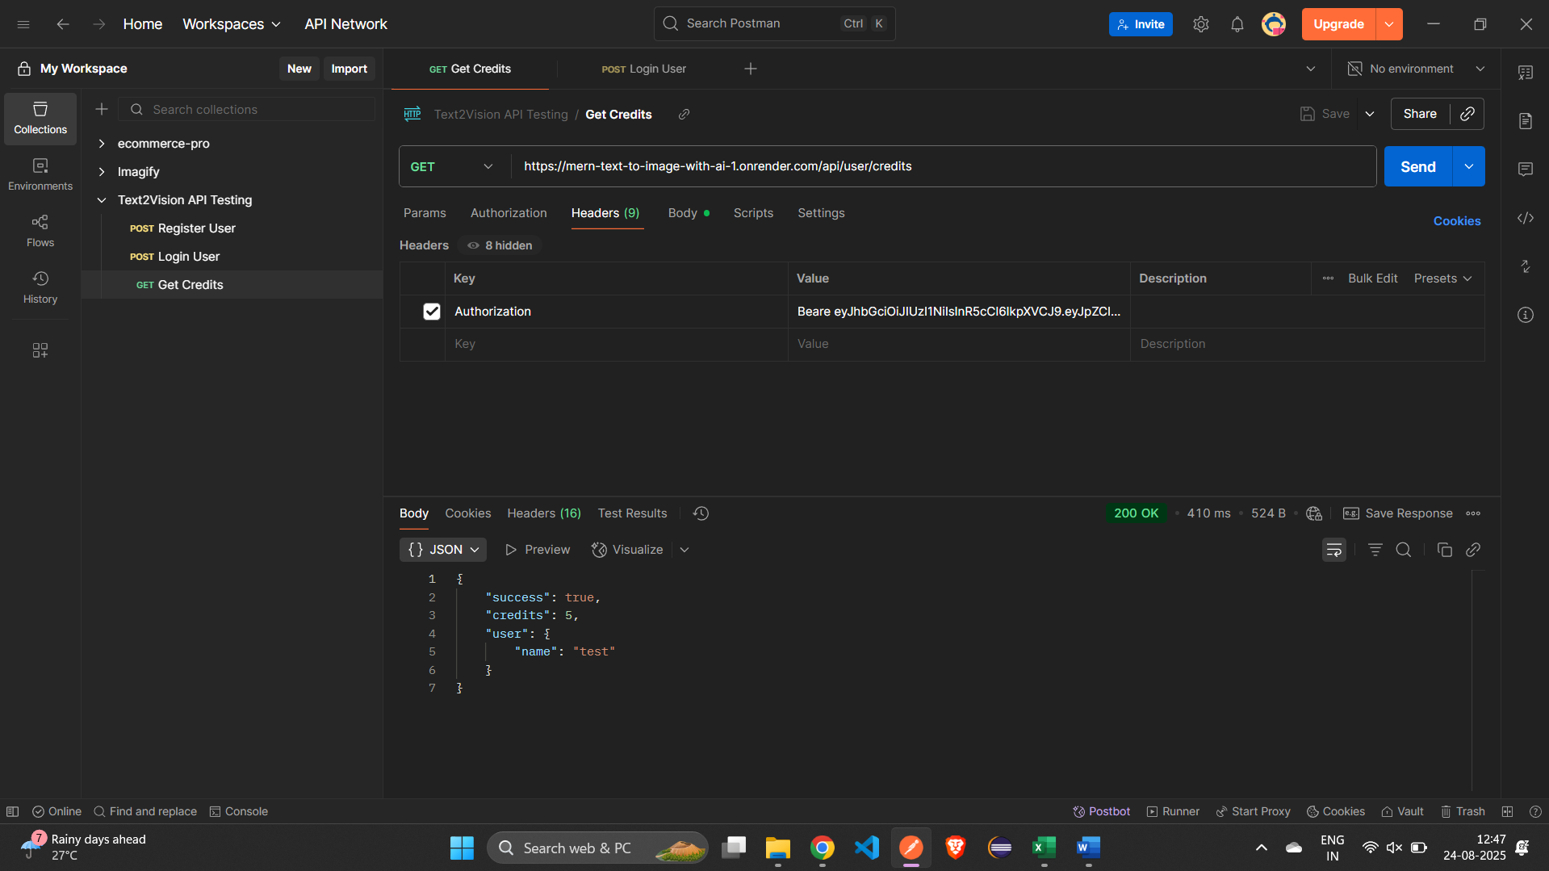

6) Get Credits (Neg) (Invalid/missing token)

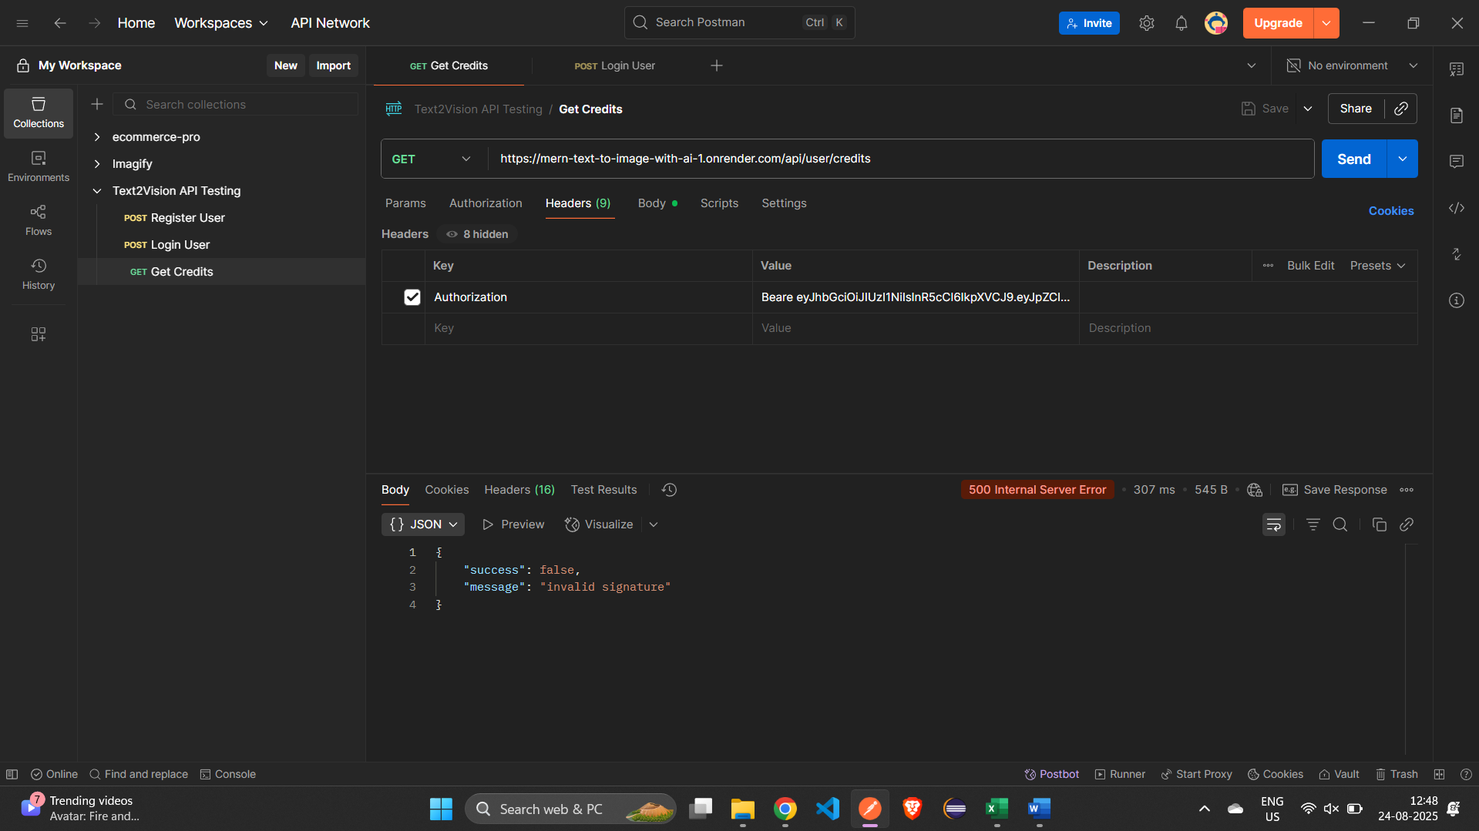

7) Generate Image (Valid prompt + token)

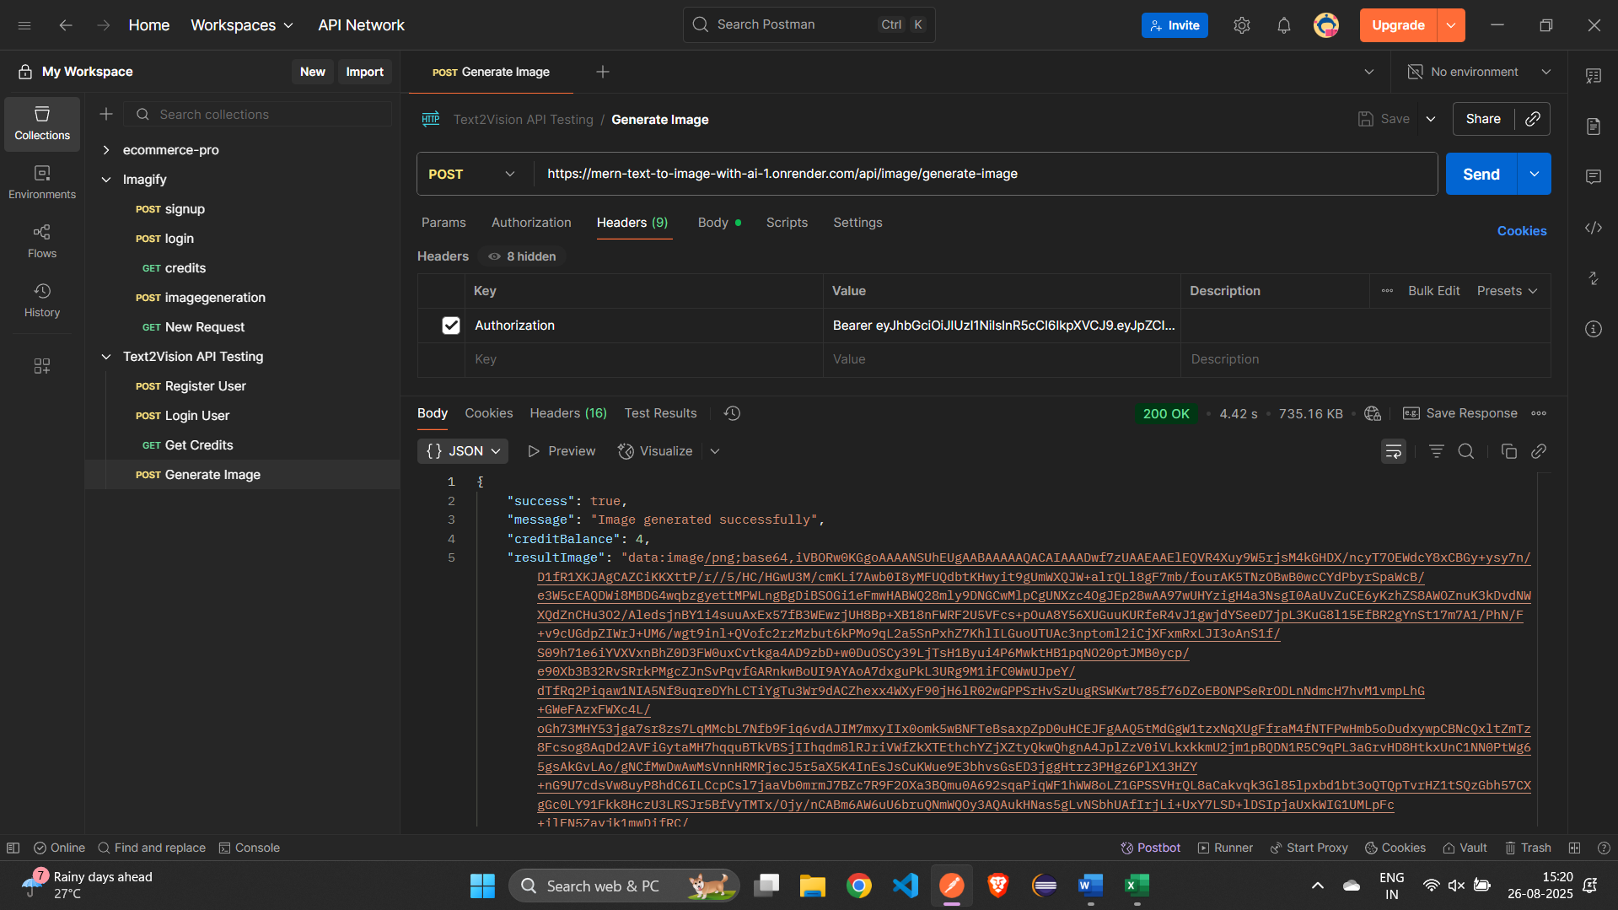

8) Generate Image (Neg) (Empty prompt + token)

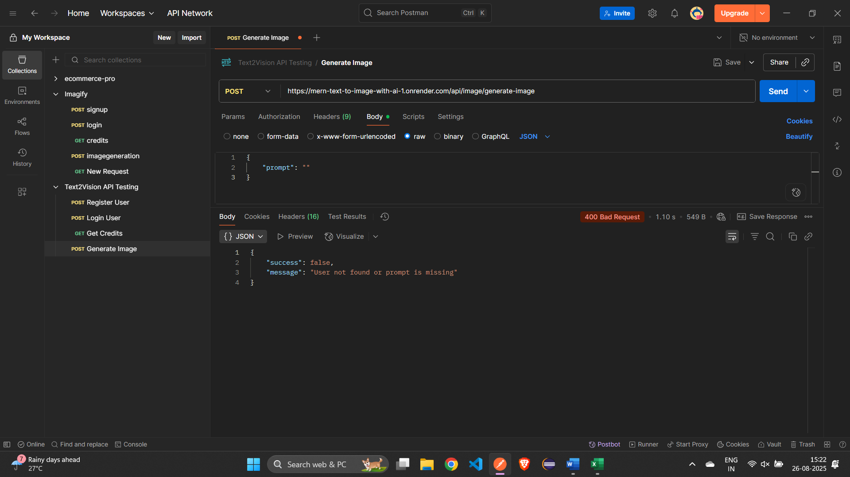

9) Get Image History (Valid token)

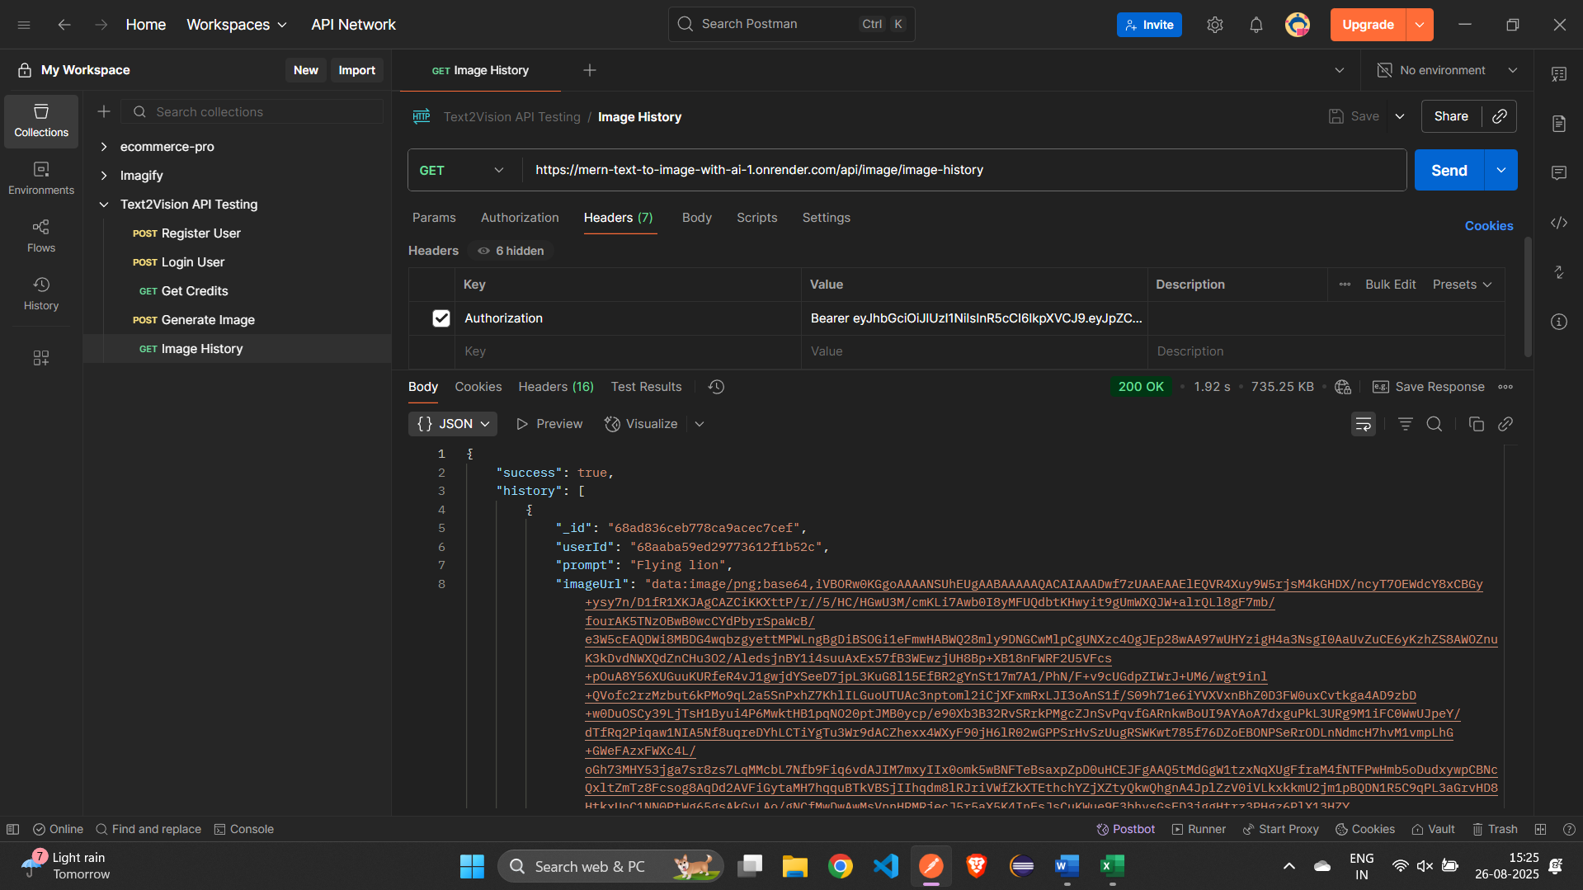

10) Get Image History (Neg) (Invalid/missing token)

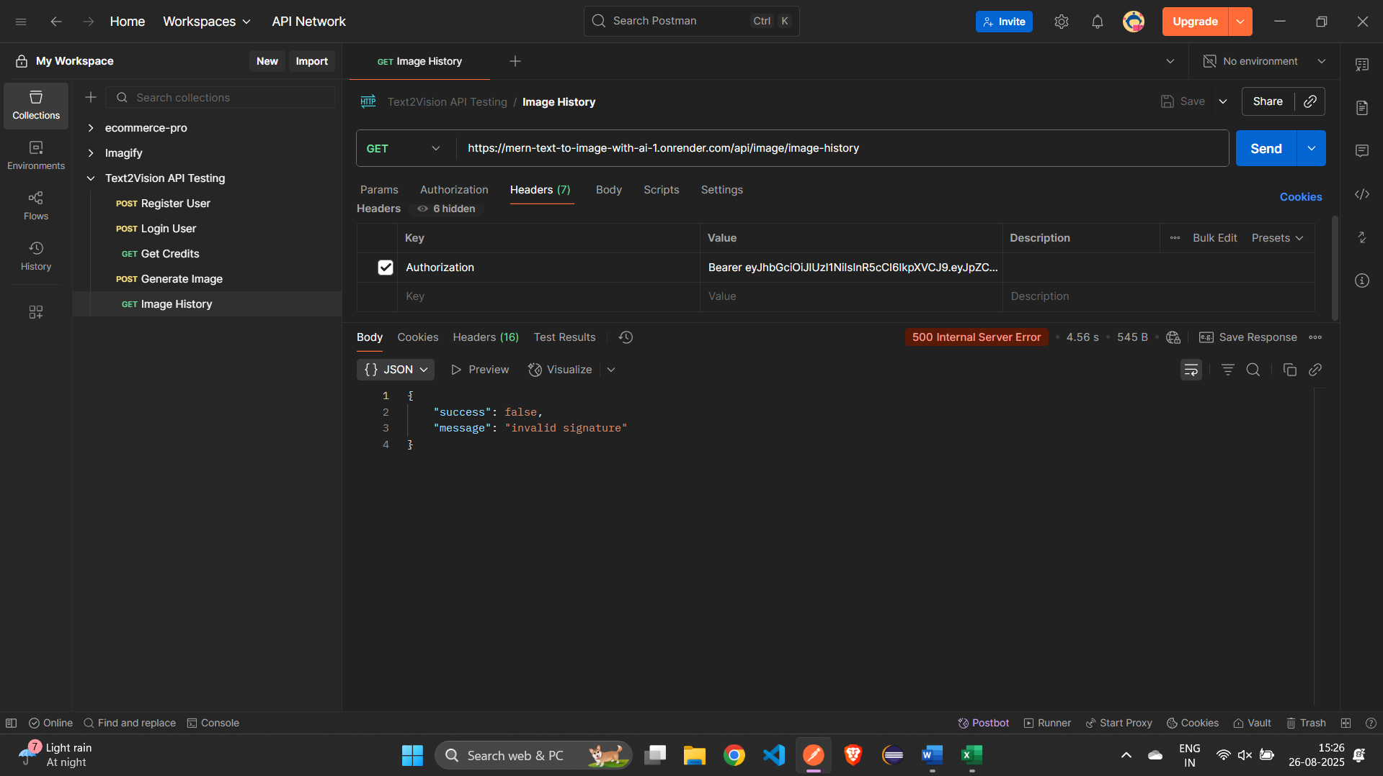

11) Delete Image (Valid image ID + token)

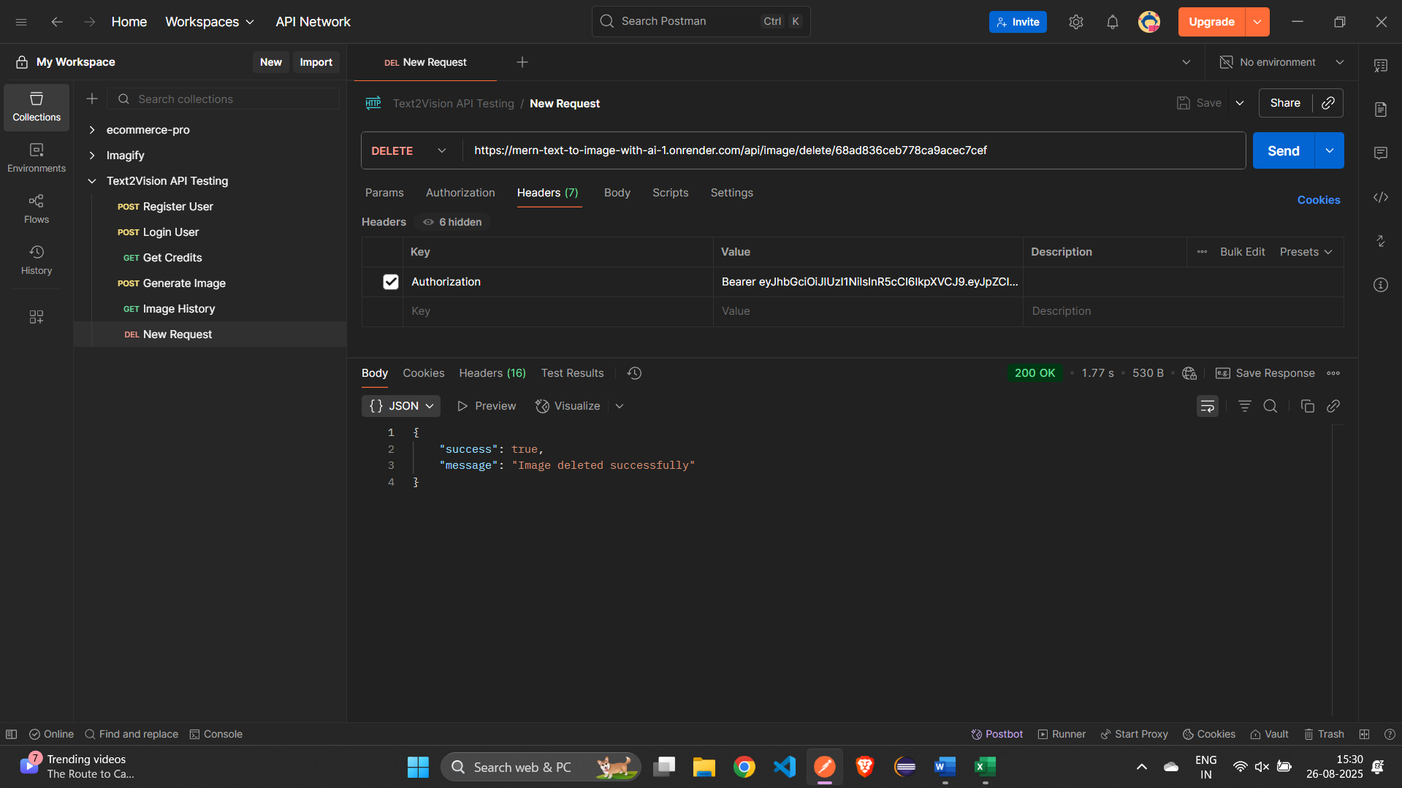

12) Delete Image (Neg) (Invalid ID or token)

