**PROJECT REPORT**

EXTENDING THE FAMA FRENCH THREE AND MOMENTUM FACTOR RETURNS

**Student Name & Affiliation: Supervising Professor:**

Nikhil Garg Prof. Ellapulli Vasudevan

Mathematics & Computing, Finance & Accounting,

IIT (BHU), Varanasi IIM Ahmedabad

**Introduction**

The Fama French Model is an asset pricing model developed in 1992 that expands on the capital asset pricing model (CAPM) by adding size risk and value risk factors to the market risk factor in CAPM. The two additional size and value factors are called “**SMB**” (Small minus Big) and “**HML**” (High minus Low). This model considers the fact that value and small-cap stocks outperform markets regularly. **Eugene Fama** and his colleague **Kenneth French**developedthis model in the 1990s. **Carhart** introduced the fourth factor, Momentum, by the name “WML” (Winner minus Loser) in his research paper “**On Persistence in Mutual Fund Performance.**” which can be cited in [Carhart, Mark M. “On Persistence in Mutual Fund Performance.” The Journal of Finance 52, no. 1 (1997): 57–82. https://doi.org/10.2307/2329556.](https://onlinelibrary.wiley.com/doi/full/10.1111/j.1540-6261.1997.tb03808.x)

This work has been replicated for the Indian Equities Market by **Prof. Jayanth R Varma**, **Prof.** **Sobhesh K. Agarwalla**, and **Prof. Joshy Jacob**(faculty members in Finance and Accounting Area at IIM Ahmedabad) in their research paper titled “**Four Factor Model in Indian Equities Market.**” The same can be accessed at: [Four_Factor_Model_Indian_Equities_Market](https://faculty.iima.ac.in/~iffm/Indian-Fama-French-Momentum/four-factors-India-90s-onwards-IIM-WP-Version.pdf)

Industry practitioners use this model as a benchmark for evaluating fund performance since it adjusts for the riskiness of investing in value and small-cap stocks, thus providing a better-adjusted benchmark for Expected Returns. The research community also uses these factors in their work. The Legacy (CMIE Prowess) stopped updating these factors in March 2019. The need for this project arises due to providing updated factors calculated by the latest available market data. The faculty members of the Finance and Accounting Area at IIM Ahmedabad have taken the initiative to provide this data on a regular monthly basis on the institute data library.

I have computed the Fama-French and Momentum Factor Returns replicating the same methodology for the Indian equity market for the October 1993 - December 2020 period using data from Prowess dx as it is the most widely used data source for academic research in India and covers significantly more number of firms.

During the period from January 1994 to December 2020, **the average annual return of the momentum factor (WML) was 14.114%, the average annual return on the Value factor (HML) was 1.941%, that of the size factor (SMB) was 2.648%, and the average annual excess return on the Market factor (Rm-Rf) was 4.137%.**

**Project Output Expectations**

The tasks assigned to me in the project were as follows:

1. Learning Prowess databases and fetching relevant project data from the database.
2. Optimizing the existing R code for faster execution and less memory requirement over a large amount of data.
3. Calculating the updated Fama French Four factors over Jan 1994- Dec 2020.
4. Preparing a project report consisting of the Appendices and submitting the analysis output files.

**Work Chart during the Internship Period**

|  |  |
| --- | --- |
| Week | Tasks Finished |
| Week 1 (26 May-1 June) | Getting the corresponding research paper, reading and understanding about the Fama French Model |
| Week 2 & 3 ( 2 June – 15 June) | Getting the corresponding R code file, understanding the functioning of various code sections |
| Week 4 (16 June – 22 June) | Learning working of Prowess databases comprising both Prowess IQ and Prowess dx, fetching relevant data for Factor calculation |
| Week 5 (23 June – 29 June) | Learning working of relevant R packages for code optimization including “**dplyr**”, “**data.table**”,“**magrittr**”, “**tidyverse**”, “**purrr**”,etc. |
| Week 6 (30 June – 06 July) | Making changes in code structure until Section-5 |
| Week 7 & 8 (07 July – 20 July) | Creating SMB (Size Risk factor) Portfolios and WML (Momentum) Portfolios |
| Week 9 & 10 (21 July – 03 August) | Calculating Daily, Monthly and Yearly Four factor returns & checking the validity of outputs |

**Survivorship Bias: Adjustment for Vanishing Firms**

In my dataset, I have found that there were 3,912 firms that stopped trading during the period covered. Out of these, I could confirm that 563 firms had stopped trading due to mergers. Taking zero returns for all the remaining firms could have upwardly biased our return estimates as some of these firms could have disappeared (vanished) as an outcome of financial distress, leading to complete capital loss.

I have computed an alternative version of the factor portfolios assuming 100% capital loss for the firms vanishing due to distress. Firms were identified as distressed if its last traded market price was below 50% of its face value. The year-wise distribution of these firms is given in Table 3.

**Output of Project**

The complete set of all output files consisting of Portfolios formed for each year-month, daily, monthly & yearly returns, etc. along with the code file can be accessed at: [FamaFrench&MomentumFactorOutputs](https://drive.google.com/file/d/1LidMTqgtQyVKTSdMyqtwFzaPQXhHC-C-/view?usp=sharing)

The output files consist of the following tables for both Survivorship and Without Survivorship Bias adjusted case:

* Four Factor Cumulative Returns Curve over entire period
* Market Cap Break Point Analysis
* Descriptive Statistics of Market Capitalization, firms disappearing from trading and liquidity
* Four Factor Tables and R Workspace
* Four Factor Daily, Monthly and Yearly data
* R Code File
* Momentum Break Points for Size-Momentum Portfolio
* Size Break Points for Size-Momentum Portfolio
* Size Break Points for Size-Value Portfolio
* Value Break Point for Size Value Portfolio
* Size Momentum Portfolio Returns Daily, Monthly and Yearly
* Size Value Portfolio Returns Daily, Monthly and Yearly

In the Appendices section below, four tables have also been attached which are as follows:

* Descriptive Statistics of Market Capitalization of firms
* Descriptive Statistics of Liquidity (Number of Trading days per year)
* Number of firms that stopped trading over the years
* Market and four-factor return files with and without survivorship bias adjustment

The cumulative four factor returns graph for both with and without survivorship bias adjusted case have also been attached.

**Appendices**

**Descriptive Statistics of Market Capitalization of firms**

Market Capitalization – percentile (₹ billion)

|  |  |  |  |  |  |  |  |  |
| --- | --- | --- | --- | --- | --- | --- | --- | --- |
| **Cycle**  **Year** | **Number of firms** | **10%** | **30%** | **50%** | **70%** | **90%** | **Total Market cap.**  **(₹ billion)** | **Avg. Market cap.**  **(₹ billion)** |
| 1992 | 2092 | 0.031 | 0.070 | 0.147 | 0.341 | 1.646 | 1.003 | 2098.735 |
| 1993 | 3052 | 0.035 | 0.079 | 0.153 | 0.390 | 1.972 | 1.317 | 4019.802 |
| 1994 | 4446 | 0.036 | 0.070 | 0.131 | 0.309 | 1.478 | 1.236 | 5493.475 |
| 1995 | 5271 | 0.021 | 0.039 | 0.068 | 0.154 | 0.878 | 0.898 | 4730.930 |
| 1996 | 5019 | 0.009 | 0.019 | 0.041 | 0.102 | 0.678 | 0.948 | 4758.873 |
| 1997 | 4147 | 0.007 | 0.015 | 0.036 | 0.102 | 0.726 | 1.091 | 4524.281 |
| 1998 | 3783 | 0.007 | 0.017 | 0.039 | 0.119 | 1.000 | 1.299 | 4915.898 |
| 1999 | 4044 | 0.012 | 0.026 | 0.058 | 0.176 | 1.434 | 2.043 | 8261.033 |
| 2000 | 3491 | 0.008 | 0.021 | 0.051 | 0.157 | 1.216 | 1.723 | 6015.556 |
| 2001 | 3082 | 0.010 | 0.025 | 0.058 | 0.190 | 1.535 | 1.886 | 5811.113 |
| 2002 | 2896 | 0.010 | 0.025 | 0.066 | 0.244 | 1.930 | 2.353 | 6814.301 |
| 2003 | 2837 | 0.011 | 0.030 | 0.089 | 0.405 | 3.693 | 4.263 | 12094.040 |
| 2004 | 2974 | 0.023 | 0.075 | 0.231 | 0.854 | 6.957 | 6.009 | 17871.380 |
| 2005 | 2939 | 0.026 | 0.096 | 0.344 | 1.433 | 11.860 | 9.538 | 28033.245 |
| 2006 | 3087 | 0.029 | 0.117 | 0.442 | 1.733 | 15.609 | 13.257 | 40925.631 |
| 2007 | 3207 | 0.040 | 0.148 | 0.521 | 2.034 | 19.475 | 17.584 | 56392.360 |
| 2008 | 3221 | 0.030 | 0.096 | 0.290 | 1.087 | 10.997 | 12.330 | 39713.520 |
| 2009 | 3412 | 0.040 | 0.149 | 0.495 | 1.944 | 19.299 | 18.366 | 62664.793 |
| 2010 | 3512 | 0.043 | 0.161 | 0.510 | 2.032 | 20.421 | 19.370 | 68028.908 |
| 2011 | 3698 | 0.033 | 0.115 | 0.345 | 1.406 | 14.853 | 16.323 | 60361.221 |
| 2012 | 3749 | 0.031 | 0.106 | 0.329 | 1.396 | 15.242 | 17.592 | 65952.781 |
| 2013 | 3837 | 0.030 | 0.104 | 0.358 | 1.588 | 17.621 | 20.327 | 77995.797 |
| 2014 | 4004 | 0.031 | 0.117 | 0.414 | 2.041 | 24.140 | 25.143 | 100672.962 |
| 2015 | 3989 | 0.030 | 0.113 | 0.430 | 2.258 | 26.800 | 25.288 | 100872.451 |
| 2016 | 4021 | 0.031 | 0.134 | 0.549 | 2.970 | 35.903 | 30.482 | 122567.366 |
| 2017 | 4042 | 0.033 | 0.149 | 0.600 | 3.571 | 43.112 | 37.095 | 149938.337 |
| 2018 | 4089 | 0.027 | 0.115 | 0.414 | 2.387 | 34.993 | 35.564 | 145420.724 |
| 2019 | 4042 | 0.022 | 0.087 | 0.305 | 1.763 | 31.694 | 36.001 | 145514.238 |
| 2020 | 4042 | 0.031 | 0.122 | 0.514 | 3.316 | 54.254 | 52.267 | 211261.253 |
| 2021 | 3930 | 0.043 | 0.182 | 0.869 | 5.497 | 76.880 | 67.821 | 266537.789 |

**Table 1**

This table shows the cross-sectional percentiles, total and average market capitalization for various years for all listed firms. The market capitalization of a firm is taken as its average market capitalization over the trading days of the firm during the period of 1-October to 30-September. The year 2021 covers only a 3-month period from 1 October,2021 to 31 December,2021.

We can observe that the Total Market Capitalization has increased substantially high to **2,66,537 billion Rs. in 2021 from just 2098 billion Rs. in 1992.**

**Descriptive Statistics of Liquidity (Number of Trading Days per Year)**

Number of trading days – percentile

|  |  |  |  |  |  |  |  |  |  |  |
| --- | --- | --- | --- | --- | --- | --- | --- | --- | --- | --- |
| **Cycle Year** | **Number of firms** | **10%** | **20%** | **30%** | **40%** | **50%** | **60%** | **70%** | **80%** | **90%** |
| 1992 | 2092 | 19 | 57 | 106 | 142 | 172 | 191 | 203 | 209 | 213 |
| 1993 | 3052 | 11 | 36 | 71 | 110 | 152 | 189 | 207 | 215 | 219 |
| 1994 | 4446 | 28 | 64 | 98 | 135 | 170 | 194 | 210 | 220 | 225 |
| 1995 | 5271 | 24 | 68 | 114 | 150 | 179 | 199 | 214 | 226 | 233 |
| 1996 | 5019 | 6 | 19 | 37 | 59 | 88 | 120 | 156 | 189 | 222 |
| 1997 | 4147 | 3 | 6 | 14 | 29 | 51 | 87 | 128 | 173 | 224 |
| 1998 | 3783 | 3 | 7 | 19 | 42 | 77 | 122 | 167 | 210 | 240 |
| 1999 | 4044 | 6 | 21 | 47 | 81 | 117 | 152 | 188 | 220 | 245 |
| 2000 | 3491 | 3 | 6 | 16 | 34 | 65 | 108 | 160 | 214 | 248 |
| 2001 | 3082 | 4 | 16 | 39 | 76 | 125 | 170 | 213 | 240 | 250 |
| 2002 | 2896 | 9 | 41 | 82 | 130 | 176 | 211 | 234 | 247 | 250 |
| 2003 | 2837 | 16 | 73 | 136 | 191 | 226 | 246 | 254 | 256 | 256 |
| 2004 | 2974 | 54 | 169 | 225 | 245 | 251 | 252 | 252 | 252 | 252 |
| 2005 | 2939 | 95 | 190 | 233 | 245 | 249 | 250 | 250 | 250 | 250 |
| 2006 | 3087 | 94 | 191 | 232 | 245 | 248 | 248 | 248 | 248 | 248 |
| 2007 | 3207 | 97 | 192 | 232 | 245 | 249 | 250 | 250 | 250 | 250 |
| 2008 | 3221 | 76 | 151 | 201 | 225 | 236 | 240 | 240 | 241 | 241 |
| 2009 | 3412 | 96 | 197 | 236 | 247 | 249 | 249 | 249 | 249 | 249 |
| 2010 | 3512 | 91 | 180 | 227 | 244 | 250 | 251 | 251 | 251 | 251 |
| 2011 | 3698 | 54 | 127 | 187 | 227 | 241 | 248 | 249 | 250 | 250 |
| 2012 | 3749 | 44 | 94 | 142 | 185 | 218 | 241 | 248 | 249 | 249 |
| 2013 | 3837 | 45 | 103 | 159 | 199 | 226 | 242 | 248 | 248 | 248 |
| 2014 | 4004 | 37 | 82 | 141 | 194 | 229 | 243 | 245 | 245 | 245 |
| 2015 | 3989 | 24 | 64 | 121 | 188 | 230 | 244 | 246 | 246 | 246 |
| 2016 | 4021 | 28 | 71 | 128 | 188 | 236 | 247 | 248 | 248 | 248 |
| 2017 | 4042 | 21 | 59 | 113 | 184 | 234 | 246 | 247 | 247 | 247 |
| 2018 | 4089 | 14 | 42 | 86 | 150 | 211 | 236 | 244 | 245 | 245 |
| 2019 | 4042 | 17 | 46 | 93 | 157 | 211 | 241 | 249 | 250 | 250 |
| 2020 | 4042 | 40 | 109 | 172 | 221 | 244 | 248 | 248 | 248 | 248 |
| 2021 | 3930 | 18 | 47 | 62 | 63 | 63 | 63 | 63 | 63 | 63 |

**Table 2**

The table shows the cross-sectional percentiles (calculated using data of all listed firms) of trading days in Bombay Stock Exchange during 1 October to 30 September of various years. **The year 2021 covers only a 3-month period from 01 October, 2021 to 31 December, 2021.**

**Number of firms that stopped trading over the years**

|  |  |  |  |  |  |  |
| --- | --- | --- | --- | --- | --- | --- |
|  |  |  | **Had P/FV < 50% (considered for 100% capital loss)** | | **Had P/FV >= 50%** | |
| Calendar Year of last trading day | Number of firms that stopped trading | Stopped trading due to mergers | Number of Merged firms | Number of Non-Merged firms | Number of Merged firms | Number of Non-Merged firms |
| 1992 | 7 | 1 | 0 | 0 | 1 | 6 |
| 1993 | 43 | 9 | 0 | 5 | 9 | 29 |
| 1994 | 43 | 10 | 0 | 8 | 10 | 25 |
| 1995 | 113 | 33 | 4 | 18 | 29 | 62 |
| 1996 | 256 | 28 | 7 | 101 | 21 | 127 |
| 1997 | 487 | 29 | 8 | 353 | 21 | 105 |
| 1998 | 234 | 26 | 9 | 154 | 17 | 54 |
| 1999 | 238 | 34 | 20 | 152 | 14 | 52 |
| 2000 | 380 | 34 | 12 | 267 | 22 | 79 |
| 2001 | 298 | 36 | 18 | 207 | 18 | 55 |
| 2002 | 123 | 24 | 6 | 73 | 18 | 26 |
| 2003 | 128 | 24 | 2 | 69 | 22 | 35 |
| 2004 | 107 | 16 | 1 | 69 | 15 | 22 |
| 2005 | 90 | 24 | 3 | 33 | 21 | 33 |
| 2006 | 73 | 37 | 0 | 23 | 37 | 13 |
| 2007 | 60 | 20 | 0 | 19 | 20 | 21 |
| 2008 | 45 | 19 | 2 | 5 | 17 | 21 |
| 2009 | 55 | 12 | 1 | 21 | 11 | 22 |
| 2010 | 50 | 22 | 1 | 10 | 21 | 18 |
| 2011 | 56 | 14 | 1 | 15 | 13 | 27 |
| 2012 | 61 | 15 | 3 | 32 | 12 | 14 |
| 2013 | 80 | 10 | 0 | 47 | 10 | 23 |
| 2014 | 49 | 5 | 0 | 12 | 5 | 32 |
| 2015 | 218 | 19 | 0 | 93 | 19 | 106 |
| 2016 | 94 | 5 | 0 | 41 | 5 | 48 |
| 2017 | 141 | 20 | 0 | 86 | 20 | 35 |
| 2018 | 110 | 9 | 0 | 60 | 9 | 41 |
| 2019 | 151 | 12 | 0 | 83 | 12 | 56 |
| 2020 | 122 | 16 | 5 | 61 | 11 | 45 |

**Table 3**

The table shows the number of firms that stopped trading over the years. Column 3 shows the number of firms that stopped trading due to mergers. Column 4-5 categorizes the firms that had P/FV < 50% on their last trading day into merged and non-merged. Column 6-7 categorizes the same for firms that had P/FV >= 50% on last trading day.

**Market and four-factor** **returns with and without survivorship bias adjustment**

|  |  |  |  |  |  |  |  |  |  |  |
| --- | --- | --- | --- | --- | --- | --- | --- | --- | --- | --- |
|  | **Four-factors with adjustment** | | | | | **Four-factors without adjustment** | | | | |
| Calendar Year | SMB | HML | WML | Rm | Rm-Rf | SMB | HML | WML | Rm | Rm-Rf |
| 1994 | 32.9 | 11.3 | -17.2 | 21.7 | 13.7 | 32.9 | 11.3 | -17.2 | 21.7 | 13.7 |
| 1995 | -20 | -17 | -2.3 | -40.4 | -51.8 | -20 | -17 | -2.3 | -40.4 | -51.8 |
| 1996 | -41.1 | -25 | 29.2 | -12.7 | -23.1 | -40.9 | -24.9 | 28.5 | -12.7 | -23.1 |
| 1997 | -35.5 | -24.9 | 6.7 | 13.1 | 6.3 | -34.4 | -23.7 | 1.5 | 13.1 | 6.3 |
| 1998 | 13 | -4.9 | -17.3 | -9.3 | -17 | 13.4 | -4.4 | -17.7 | -9.3 | -17 |
| 1999 | 39 | 6.7 | 62 | 67.2 | 58.5 | 39.1 | 6.8 | 62.4 | 67.2 | 58.5 |
| 2000 | -16.1 | 7.8 | -28.9 | -30.8 | -39.4 | -15.9 | 8 | -28 | -30.8 | -39.4 |
| 2001 | 5.1 | -4.7 | 57.4 | -23.2 | -30.4 | -0.8 | 6.5 | 53.3 | -23.2 | -30.4 |
| 2002 | -20 | 50.3 | 21.2 | 20 | 14.2 | -20 | 50.3 | 21.8 | 20 | 14.2 |
| 2003 | 4.7 | 39.1 | 21.4 | 72.3 | 67.5 | 4.8 | 39.3 | 20.9 | 72.3 | 67.5 |
| 2004 | 19.1 | 36.3 | 23.2 | 19.3 | 14.8 | 19.2 | 36.6 | 23 | 19.3 | 14.8 |
| 2005 | 30.3 | 17 | 23.3 | 34.6 | 29.4 | 30.3 | 17 | 23 | 34.6 | 29.4 |
| 2006 | 4.9 | -0.3 | 16.9 | 31.8 | 25.6 | 5 | -0.3 | 16.8 | 31.8 | 25.6 |
| 2007 | 19.1 | 49.7 | 40.3 | 56 | 49.1 | 19.2 | 49.8 | 40.3 | 56 | 49.1 |
| 2008 | -32.2 | -18.4 | -11 | -84.4 | -92 | -32.2 | -18.4 | -11.2 | -84.4 | -92 |
| 2009 | 15.3 | 12.2 | -36.5 | 65.2 | 61.7 | 15.3 | 12.2 | -36.5 | 65.2 | 61.7 |
| 2010 | 7.9 | -0.5 | 14.1 | 12.1 | 6.8 | 7.9 | -0.5 | 14 | 12.1 | 6.8 |
| 2011 | 7.5 | -24.7 | 41.9 | -31.6 | -39.2 | 7.6 | -24.7 | 41.8 | -31.6 | -39.2 |
| 2012 | 0.8 | 7.8 | -11.1 | 24.4 | 16.3 | 0.8 | 7.9 | -6.8 | 24.4 | 16.3 |
| 2013 | -16.9 | 7.5 | 26.1 | 2.3 | -6.1 | -16.9 | 7.6 | 27.1 | 2.3 | -6.1 |
| 2014 | 30.2 | 4 | 12.3 | 33 | 24.8 | 30.2 | 4 | 12.3 | 33 | 24.8 |
| 2015 | 31.5 | -16.8 | 32.3 | 1.7 | -5.8 | 31.6 | -16.6 | 32 | 1.7 | -5.8 |
| 2016 | -1.1 | -2.9 | 0.1 | 5.7 | -0.8 | -1.1 | -2.9 | -0.1 | 5.7 | -0.8 |
| 2017 | 12.5 | 16.7 | 21.4 | 32.1 | 26.2 | 12.4 | 16.5 | 21.2 | 32.1 | 26.2 |
| 2018 | -20.7 | -32.6 | 18.7 | -5.3 | -11.7 | -20.5 | -32.2 | 18.1 | -5.3 | -11.7 |
| 2019 | -25.5 | -30.3 | 33.1 | 5.6 | -0.1 | -25.5 | -30.3 | 32.5 | 5.6 | -0.1 |
| 2020 | 26.8 | -11 | 3.8 | 17.9 | 14.2 | 26.8 | -11 | 4.1 | 17.9 | 14.2 |
|  |  |  |  |  |  |  |  |  |  |  |
| Cumulative | 55.2 | 53.1 | 404.0 | 324.7 | 129.3 | 52.0 | 67.6 | 397.7 | 324.7 | 129.3 |
| Mean | 2.0 | 1.9 | 14.4 | 11.6 | 4.6 | 1.9 | 2.4 | 14.2 | 11.6 | 4.6 |
| Max | -41.1 | -32.6 | -36.5 | -84.4 | -92.0 | -40.9 | -32.2 | -36.5 | -84.4 | -92.0 |
| Min | 39.0 | 50.3 | 62.0 | 72.3 | 67.5 | 39.1 | 50.3 | 62.4 | 72.3 | 67.5 |
| SD | 22.9 | 22.6 | 23.9 | 34.7 | 35.5 | 22.9 | 22.5 | 23.5 | 34.7 | 35.5 |
| Skewness | -0.2 | 0.6 | -0.2 | -0.5 | -0.5 | -0.2 | 0.5 | -0.2 | -0.5 | -0.5 |
|  |  |  |  |  |  |  |  |  |  |  |

**Table 4**

The table shows the annualized logarithmic market and four-factors returns (in percentage). The data covers the period from January 1994 to December 2020.

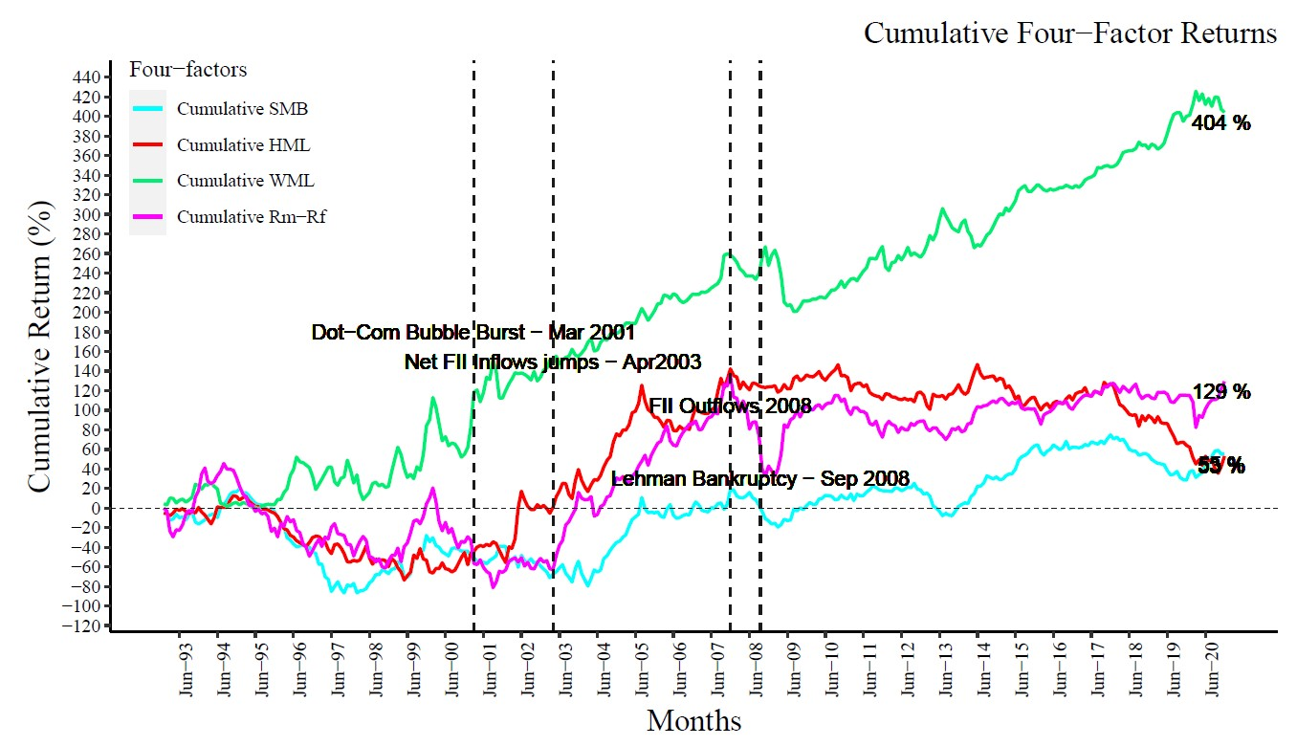

**Cumulative Four Factors Returns with survivorship bias adjusted case**

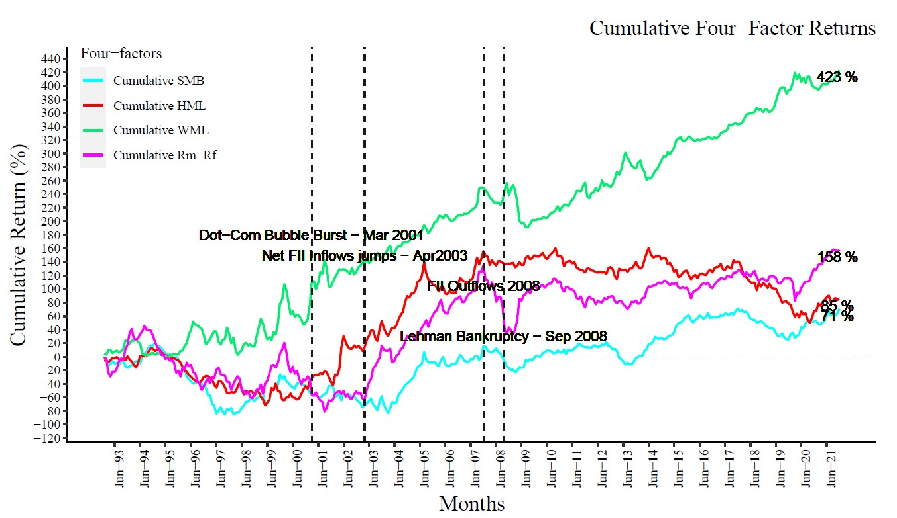

**Cumulative Four Factors Returns without survivorship bias adjusted case**

**Learning Outcomes**

* Learned about CMIE Prowess databases (Prowess IQ and Prowess dx) for financial markets data collection.
* Learned about how to write faster and memory-efficient code in R programming.
* Learned various relevant packages including "**dplyr**", **“data.table”**, "**magrittr**", "**tidyverse**", "**purrr**" in R.
* Learned about extensive data handling and applying statistical analysis techniques to it.
* Learned about Fama-French return factors and the motivation behind their formation.

**Future Extension**

This study covers only the companies listed on the Bombay Stock Exchange (BSE), but over the past decade, the number of firms trading on the NSE has increased substantially. Moreover, the trading volume on NSE is significantly greater than on BSE. We can also include these exclusively NSE-listed firms in the study for more accurate results based on the investment universe. Market Returns (Rm) shall also take both NIFTY 50 and SENSEX returns simultaneously in consideration.

**References**

Bahl, B. (2006), ‘Testing the fama and french three-factor model and its variants for the indian stock returns’, Available at SSRN 950899 **.**

Carhart, M. M. (1997), ‘On persistence in mutual fund performance’, The Journal of Finance 52(1), 57–82.

Connor, G. and Sehgal, S. (2001), ‘Tests of the fama and french model in india’ .

Fama, E. F. and French, K. R. (1993), ‘Common risk factors in the returns on stocks and bonds’, Journal of financial economics 33(1), 3–56 .

Fama, E. F. and French, K. R. (2012), ‘Size, value, and momentum in international stock returns’, Journal of Financial Economics 105(3), 457–472.

French, K. R. (n.d.), ‘Data library’, <https://mba.tuck.dartmouth.edu/pages/faculty/ken.french/data_library.html>.