Lab 5- Joint and conditional Probability

A survey was carried out with 500 strangers in London’s West End to determine people’s favorite sports. The options were Football, Rugby and the rest was grouped together in Other; The results of the test are displayed below

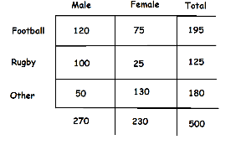

After probability distribution

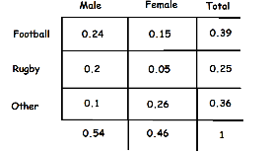

II. Calculate Joint probability of two events occurring together at the same time.

III. Calculate Conditional Probability that a person would like Rugby given that they are a female