# **Tasks**

**Learners have to develop a dashboard to support the answers to the following questions and suggestions for places for newer restaurants.**

**Objective Questions**:

1. **What is the total no. of tables present in the data?**

ANS 2, as ‘Raw Data’ & ‘country description’ both contains one table each.

1. **What is the total no. of attributes present in the data?**

ANS 20

1. **How many categorical columns are there in the data? [Search about categorical and continuous data, and try to answer this question]**

ANS 16

* Restaurant ID
* Restaurant Name
* Country Code
* City
* Address
* Locality
* Locality verbose
* Longitude
* Latitude
* Cuisines
* Currency
* Has Table booking
* Has online booking
* Is Delivering now
* Switch to order menu
* Date key Opening

Categorical columns typically represent qualitative data, such as categories or groups, while continuous columns represent quantitative data, such as numerical values that can be measured.

1. **The data consists of some inconsistent and missing values so ensure that the data used for further analysis is cleaned**.

ANS Cuisines has 9 missing values I have enter the most matched cuisines in it Also there is an inconsistency in average cost of two people column i.e., it’s never be zero I will delete the entire row who has 0 value then there will be 9534 rows available.

1. **Using the Lookup functions, fill up the countries in the original data using the country code.**

Ans – Country column (D)

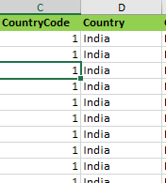

In Raw data sheet in excel we can see In column **C** & **D**

1. **Create a table to represent the number of restaurants opened in each country.**

ANS –Tabel 1 (country description)

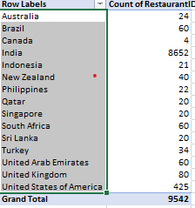

Here in country description sheet in excel we can see at **table 1**

1. **Also, the management wants to look at the number of restaurants opened each year, so provide them with something here.**

ANS – Tabel 2 (country description)

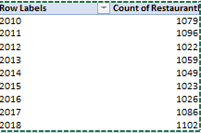

Here in country description sheet in excel we can see at **table 2**

1. **What is the total number of restaurants in India in the price range of 4?**

ANS – **388**

Formula used: **=COUNTIFS(D:D,"India",Q:Q,4)**

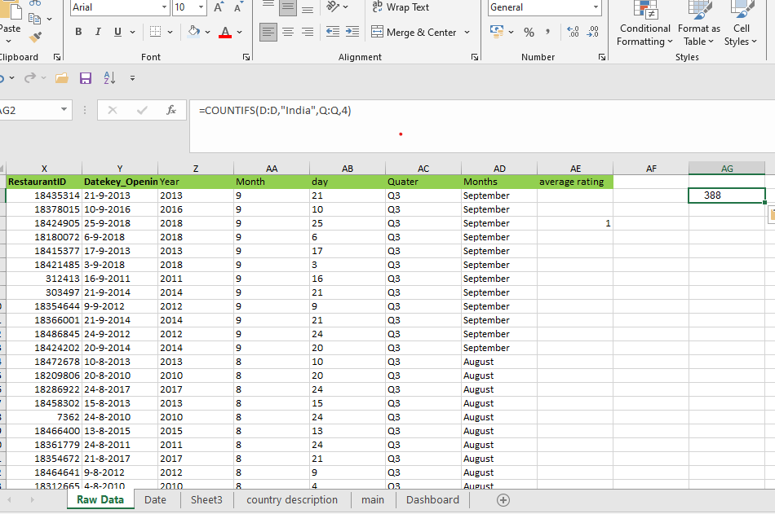

1. **What is the average number of voters for the restaurants in each country according to the data?**

ANS -

|  |  |
| --- | --- |
| **Row Labels** | **Average of Votes** |
| Australia | 111.4 |
| Brazil | 19.6 |
| Canada | 103.0 |
| India | 137.2 |
| Indonesia | 772.1 |
| New Zealand | 243.0 |
| Philippines | 407.4 |
| Qatar | 163.8 |
| Singapore | 31.9 |
| South Africa | 315.2 |
| Sri Lanka | 146.5 |
| Turkey | 431.5 |
| United Arab Emirates | 493.5 |
| United Kingdom | 205.5 |
| United States of America | 430.9 |
| **Grand Total** | **156.8** |

Analysis: Average number of voters in country can be tabulated in a pivot table by putting country in the row column and Votes in the values column summarised as average

* + The average number of voters in each country are given in the chart above. For example, Australia has 111.4 number of voters, while Brazil has only 19.6.

1. **Calculate the average rating for all the restaurants that have price_range < 4 and provide online delivery. Use only the “IF” function, Logical Operators, and Aggregation functions to solve this problem. [Note: Don’t use Conditional aggregation in this question.]**

**ANS – 3.27**

**Formula used: =IF(AND(Q9542<4,N9542="yes"),V9542," ")**

**=AVERAGE(AE4:AE9154)**

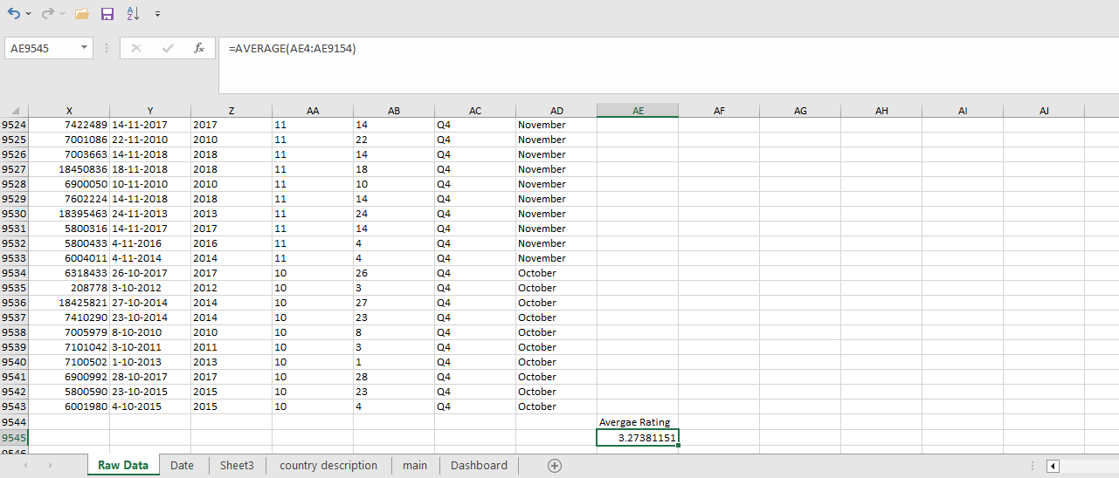

1. **Using Conditional formatting highlight the rows of restaurants that are located in the countries or cities that you’ve suggested to the management for opening new restaurants.**

Ans To highlight any rows using conditional formatting, we go to Format > Conditional Formatting > Select a Format Rule > Done

I have highlighted all the **RestaurantID** that I suggest to open new resturant

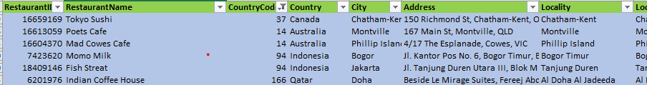

1. **Create a new customized price column that consists of the abbreviation/symbol of the currency along with the Average_cost_for_two value. [Use string operations to do this task]**

ANS – Customize price present in Raw Data in excel sheet.

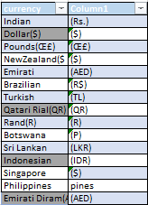 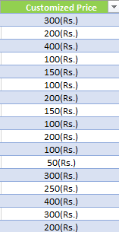

1. **How can you create an array formula in Excel or Google Sheets to count the number of restaurants listed that do not offer online delivery, are in the lowest price range, and have an average cost for two people less than or equal to 250 Indian Rupees?**

ANS - { =SUM(N2:N9543="No")*(Q2:Q9543=1)*(T2:T9543<=250)}

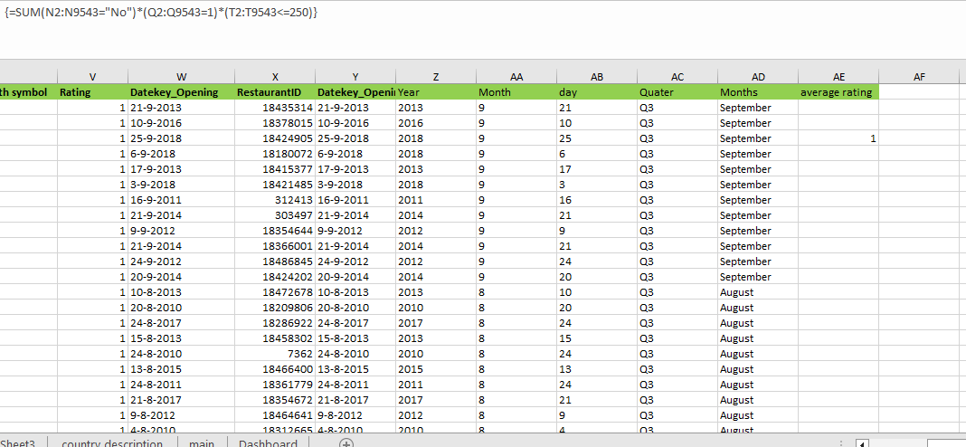

Here we can see that formula used in (AI) column

**Subjective Question:**

1. **Suggest a few countries where the team can open newer restaurants with lesser competition. Which visualization/technique will you use here to justify the suggestions?**

ANS – Here in this question my approach was like I selected the highest number of voters with lower Ratings. The reason behind is like we can got to know by the number of voters that they are all love to eat at restaurants that will help us to know about environment and we will open restaurants where ratings are low as ratings are low that mean the food quality is not that much good so we can improve that in our restaurants.

* So, for analysing this I made a pivot table where I can compare all these things like the number of customer and no of ratings.
* And with help of table I selected these four countries where we can open our new restaurants.

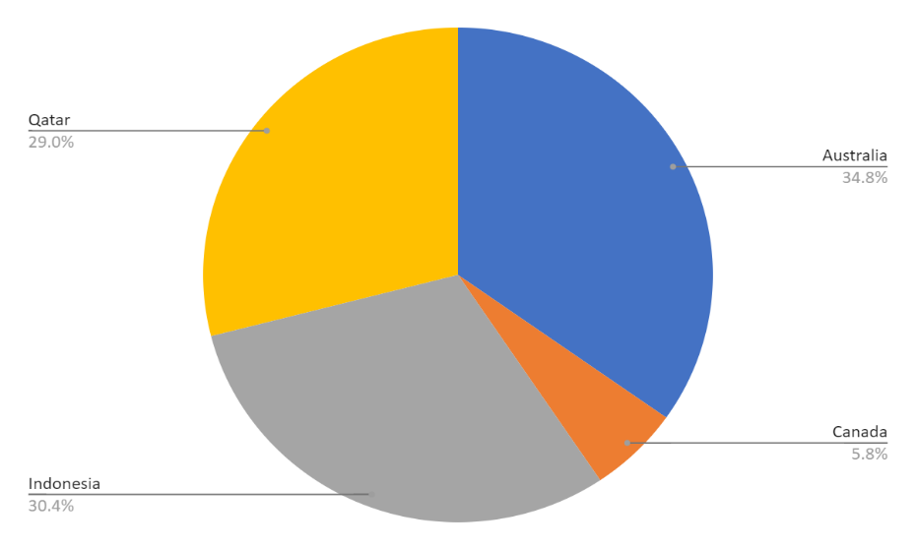

Canada

Australia

Qatar

Indonesia

1. **Come up with the names of States and cities in the suggested countries suitable for opening restaurants.**

ANS - Here in this question my approach was same as question 1 like I selected the highest number of voters with lower Ratings .The reason behind is like we can got to know by the number of voters that they are all love to eat at restaurants that will help us to know about environment and we will open restaurants where ratings are low as ratings are low that mean the food quality is not that much good so we can improve that in our restaurants.

* For this Question also I made a pivot table with same analysis as done for country and with help of table we have selected these states and cities.

**Australia** **Montville**

167 Main St, Montville, QLD

Phillip Island,

4/17 The Esplanade, Cowes, VIC

**Canada** **Chatham-Kent**

150 Richmond St, Chatham-Kent, ON N7M2V2

**Qatar** **Doha**

Beside Le Mirage Suites, Fereej Abdul Aziz Street, Al Doha Al Jadeeda, Doha

**Indonesia** **Jakarta**

Beside Le Mirage Suites, Fereej Abdul Aziz Street, Al Doha Al Jadeeda, Doha

**BogorJl**.

Kantor Pos No. 6, Bogor Timur, Bogor

1. **According to the countries you suggested, what is the current quality regarding ratings for restaurants that are open there?**

ANS -

|  |  |
| --- | --- |
| **Row Labels** | **Average of Rating** |
| Australia | 4 |
| Canada | 4 |
| Indonesia | 4 |
| Qatar | 4 |
| **Grand Total** | **4** |

The average rating of the countries that I suggested for opening new restaurants is **4**

For solving this question I use pivot table

1. **Also, what is the current expenditure on food in the suggested countries, so we can keep our financial expenditure in control?**

ANS -

* Here I have converted all currency in dollar that will help us to calculate the average amount .
* So here you can se in the below table .
* Here in Indonesia there is lowest price after that Australia and Canada then

Qatar.

* We can go with the average price of **13.62**

|  |  |  |  |  |
| --- | --- | --- | --- | --- |
| country | Currency | Dollar | Average of Average_Cost_for_two | Average amount |
| Australia | Dollar($) | 1 | 24 | 24 |
| Qatar | Qatari Rial(QR) | 0.27 | 224 | 60.48 |
| Indonesia | Indonesian Rupiah(IDR) | 0.000064 | 281190 | 17.99619048 |
| Canada | Dollar($) | 1 | 36 | 36 |
|  |  |  |  | 13.62095238 |

1. **Come up with the names of restaurants from the recommended states that are our biggest competitors and also those that are rated in the lower brackets, i.e. 1-2 or 2-3.**

Ans- **Biggest competion**

Poets Cafe

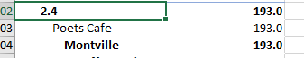

Tokyo Sushi

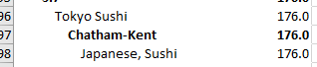

Talaga Sampireun



Mainland China Restaurant



These are our Biggest competitor because they have good rating with number of voters

**Rated in the lower brackets**

Poets Cafe



Fish Streat



7st by Mumbai Spices

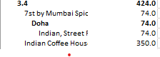

These are the restaurants where rating is low because of this reason we

We can open new restaurants.

1. **Which cuisines should we focus on in the newer restaurants to get better feedback? Does the choice of cuisines affect the restaurant ratings?**

**ANS -**

* Here with the help of pivot table that was taken from raw data we can easily get to know which Cuisines are more like by the customer as the total number of voters are there are more
* And they also good rating.
* By this analysis we can easily got to know about that.
* Chinese
* Indian
* Sunda
* Indonesian
* Sushi
* Japanese
* Italian
* Mediterranean
* Pizza
* Bar Food



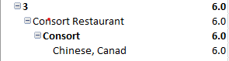 



1. **According to our current data, should we go for online delivery and table booking? Does that affect the customer’s ratings?**

**ANS** -Yes, we can go with online delivery and table booking. As we got to know by the data that these things are increasing

Day by day. Online booking is rapidly increasing and these things are directly related with the rating. As we give good

Service they will give us good rating.

* From our dashboard we can got to know about that online delivery and table booking we really help to improve rating and gather more information but some time it will reduce your rating If you service is not good then they will give you bad ratings also.
* Some factor that will affect the ratings are –
* For online delivery timing should matter if there is delay in delivery timing, they may give you bad ratings
* For table booking we should take for the decoration and proper hygiene should be there because it going affect ratings.

1. **Should the team keep the rate of cuisines higher? Will that affect the feedback? According to our data are the rates of cuisines and ratings, correlated?**

ANS -

It’s totally depended on the locations and services provided by the restaurant. If the restaurant is those which I

Suggested I think we can increase the rate as I selected the cuisines that are more liked by the customers according

To their ratings and vote. These things play and important role in feedback also as we are increasing the price and quality are not good then it will directly affect because now days everyone needs quality, they are paying money for the quality and taste.

Rates of cuisines and ratings are both corelated as I explained above everyone needs quality and taste.

* Here we can also see by our dashboard that how the cost are changing by years,cities,and cuisines .
* According to me we can go with raise in price if we have good restaurants ratings and number of customer are increasing day by day .
* And at last I also agree with that point that cuisines and ratings, correlated that we can se in our dashboard as cuisines are good the are getting good ratings If the cuisines are average they are getting average ratings.

1. **What is the distribution of the number of restaurants of different price ranges in all the countries?**

|  |  |  |  |
| --- | --- | --- | --- |
| **Row Labels** | **Sum of Price_range** | **Count of RestaurantID** | **Percentage Distribution** |
| Australia | 51 | 24 | 2.125 |
| Brazil | 204 | 60 | 3.4 |
| Canada | 10 | 4 | 2.5 |
| India | 14896 | 8652 | 1.721682848 |
| Indonesia | 62 | 21 | 2.952380952 |
| New Zealand | 126 | 40 | 3.15 |
| Philippines | 74 | 22 | 3.363636364 |
| Qatar | 73 | 20 | 3.65 |
| Singapore | 73 | 20 | 3.65 |
| South Africa | 215 | 60 | 3.583333333 |
| Sri Lanka | 57 | 20 | 2.85 |
| Turkey | 96 | 34 | 2.823529412 |
| United Arab Emirates | 193 | 60 | 3.216666667 |
| United Kingdom | 220 | 80 | 2.75 |
| United States of America | 873 | 425 | 2.054117647 |

**Formula used for percentage Distribution**= (24 / 9542) * 100

**Lower price range countries**

* Australia
* Canada
* India
* Indonesia
* Sri Lanka
* Turkey
* United Kingdom
* United States

**Upper Price Range Countries:**

* Brazil
* New Zealand
* Philippines
* Qatar
* Singapore
* South Africa
* United Arab Emirates

10.**Explain your approach in brief for suggesting countries/cities in order to open new restaurants, if the objective and subjective questions would have not been given to assist you. [you have to give bullet pointers in order to answer this question]**

**ANS -**

* I will first go with research on global or regional food trends, consumer preferences, and dining habits.
* I also consider the geographical location as the different country has different Population, currency, Income level, Age diversity in various country and cities
* Considering economic indicators such as GDP per capita, unemployment rates, and consumer spending patterns. Strong economies with growing middle-class populations generally offer better prospects for restaurant businesses.
* We will consider quality ingredients, transportation networks, and availability of skilled labor. A robust infrastructure can streamline operations and minimize costs.
* Identify markets with potential for future growth and expansion opportunities. This could involve analyzing population growth projections, urban development plans, and emerging tourism trends.
* We will also consider risk management as like geopolitical instability, currency fluctuations, and natural disasters. Mitigation strategies should be developed to address these risks.

**Thankyou**