# Security Overview Document

Author: Nikhil Kumar Yadav

## 1. Introduction

This document provides a security overview of the Secure File Sharing System. The system is designed to allow users to upload files, encrypt them securely, and download encrypted files. It also supports decryption when authorized, ensuring data confidentiality during storage and transmission.

## 2. Encryption Approach

The system uses AES (Advanced Encryption Standard) for encrypting and decrypting files. AES is a symmetric encryption algorithm widely used for its security and efficiency. Each file is encrypted with a secure key, ensuring confidentiality and integrity.

## 3. Key Handling

Encryption keys are generated and managed within the application. Keys are not exposed to unauthorized users. For additional security, keys should be rotated periodically and stored in a secure key vault.

## 4. Security Considerations

- Ensure strong key management practices.  
- Use HTTPS for secure file transfer.  
- Restrict unauthorized access to encrypted files.  
- Regularly audit and monitor encryption processes.  
- Apply principle of least privilege to access control.

## 5. System Screenshots

The following screenshots demonstrate the working of the Secure File Sharing System.

Screenshot: Screenshot 2025-08-31 102520.png

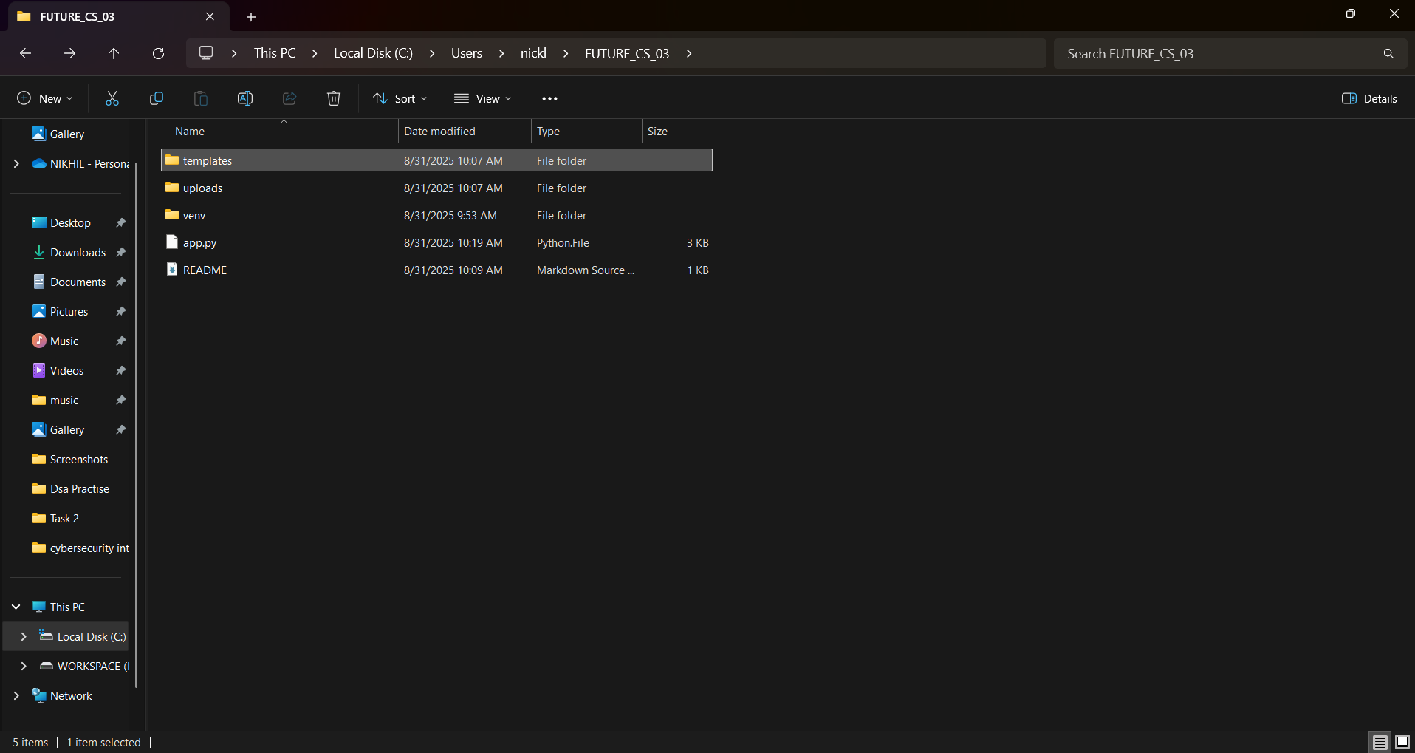

Screenshot: Screenshot 2025-08-31 102549.png

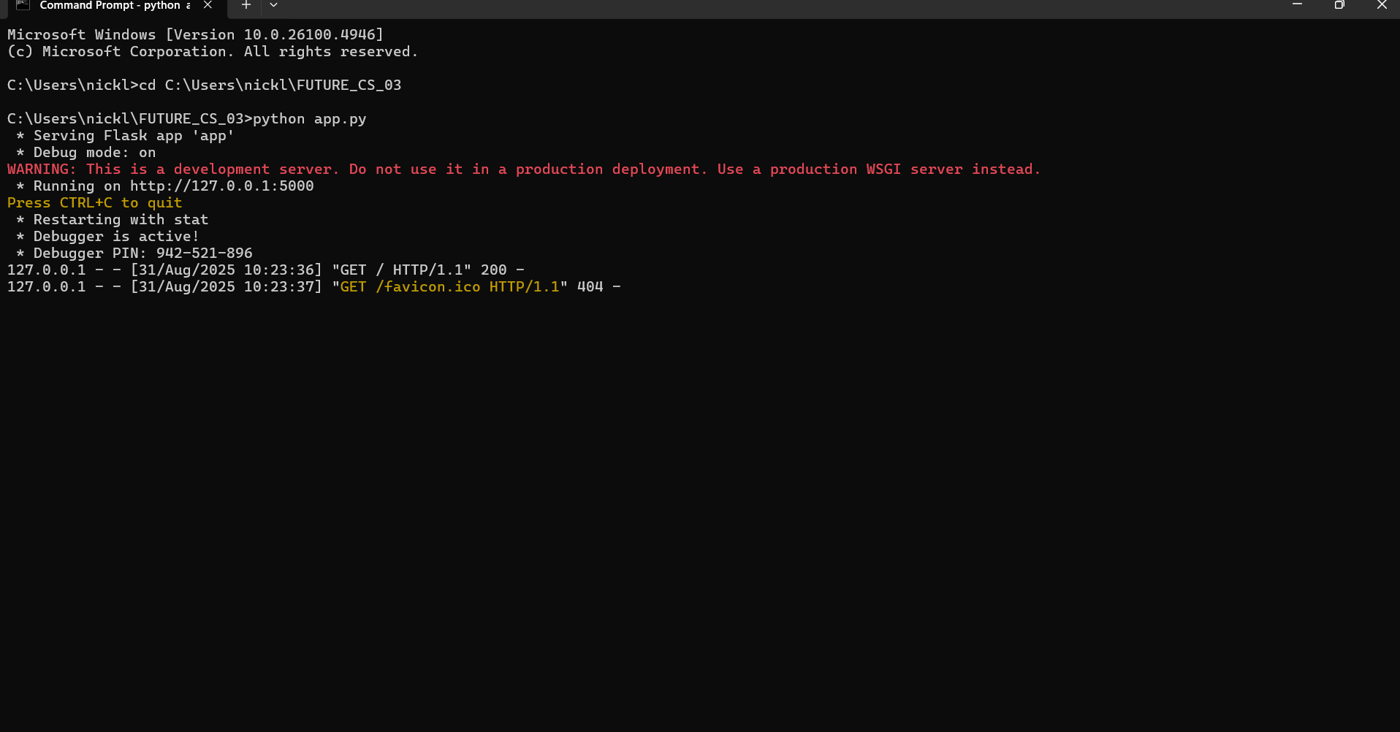

Screenshot: Screenshot 2025-08-31 105110.png

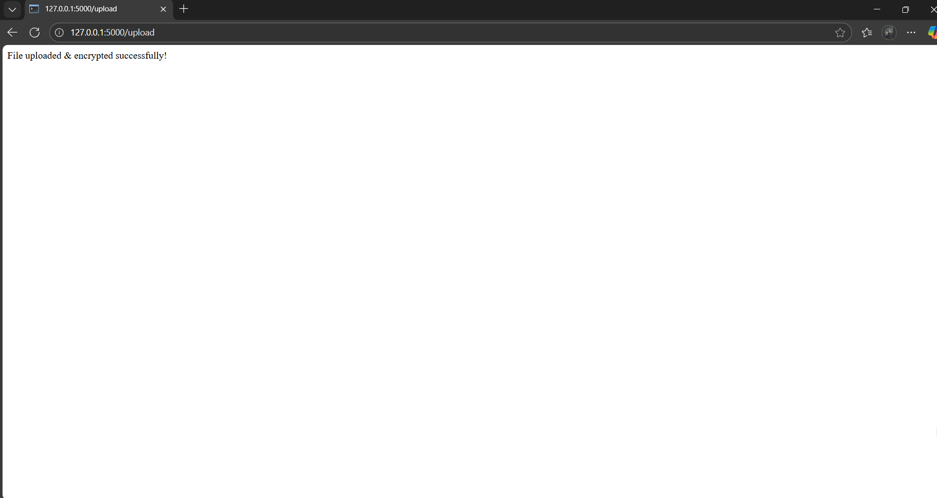

Screenshot: Screenshot 2025-08-31 105215.png

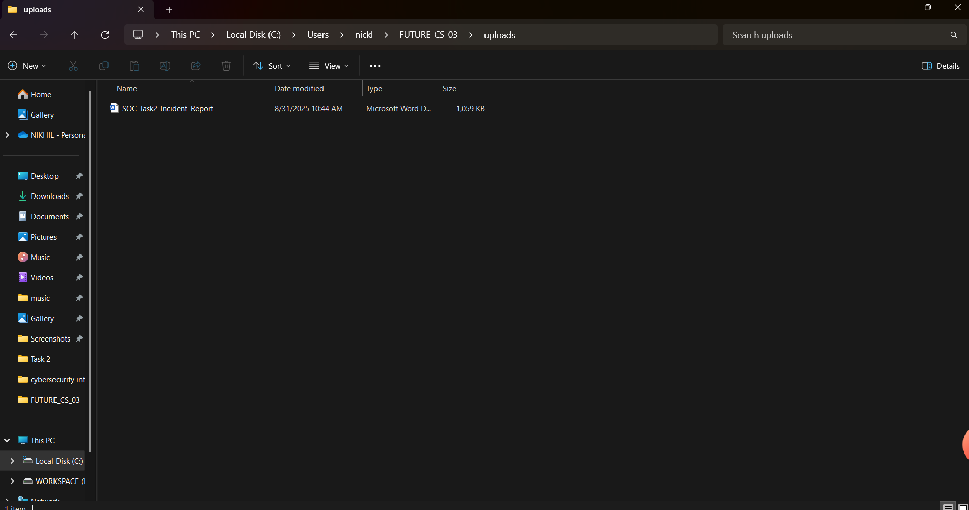

Screenshot: Screenshot 2025-08-31 105622.png

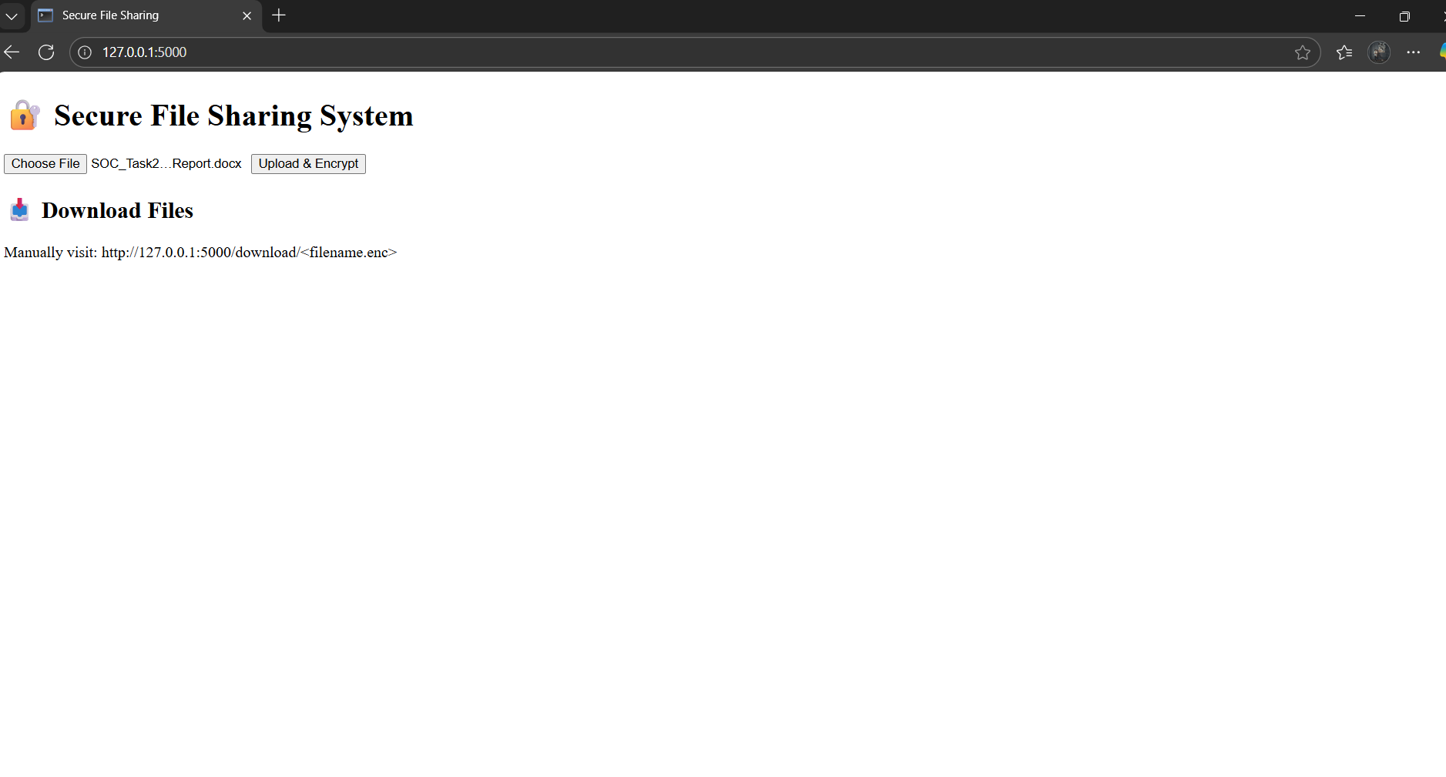

Screenshot: Screenshot 2025-08-31 110549.png

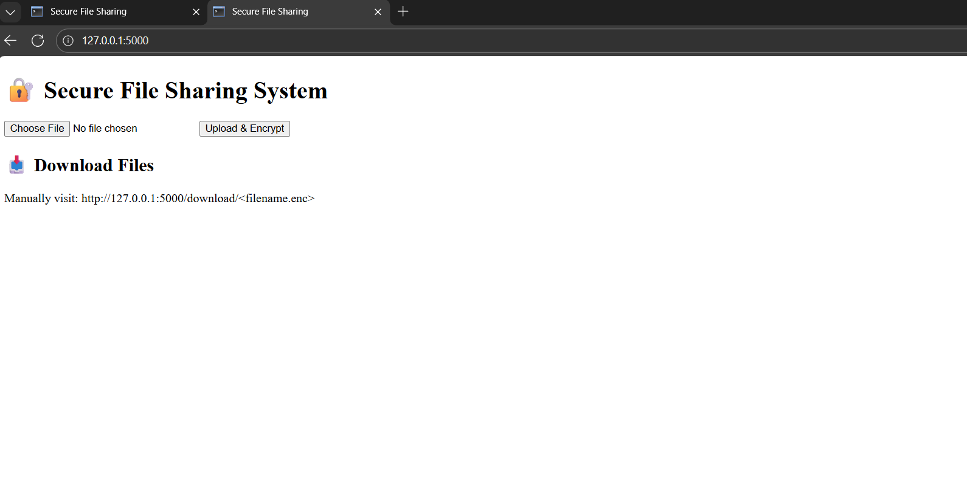

Screenshot: Screenshot 2025-08-31 111350.png

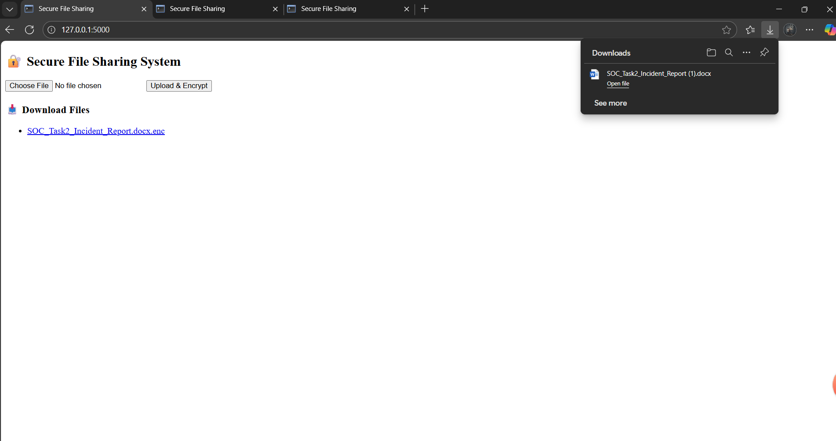

Screenshot: Screenshot 2025-08-31 111423.png

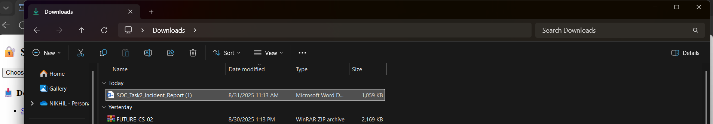

Screenshot: Screenshot 2025-08-31 141114.png

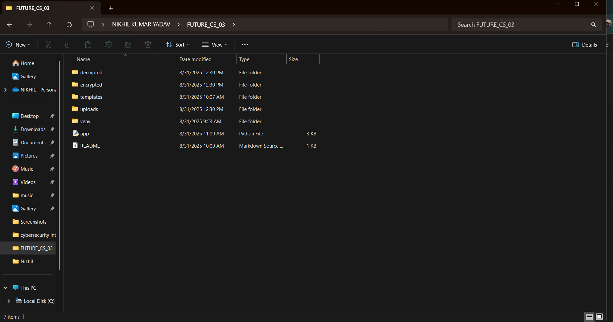

## 6. Conclusion

This Secure File Sharing System provides a safe way to exchange files using AES encryption. With proper key handling and secure practices, it ensures confidentiality and integrity of shared data.