MEMO

Why profit fell in Central and South in 2019

(Superstore data, 2016 to 2019, in US dollars)
Central and South profit fell sharply in 2019 even though their sales did not collapse. Discounts above 20% are the likely link.
Finding | Central and South lost half or more of their profit in 2019, while East and West grew. The company as a whole still grew, so the problem is local. Discounts above 20% are the strongest lead: their losses grew most in exactly these two regions.
Number | Central: profit fell from $19,899 to $7,551 (down 62%) while sales were flat (down 0.2%). Margin fell from 13.5% to 5.1%.  South: profit fell from $17,703 to $8,849 (down 50%) even though sales rose 31%. Margin fell from 18.9% to 7.2%.  Discounts: in the same year, losses on discounts above 20% in these two regions grew from $12,687 to $31,078. That is $18,391 more, about 87% of their combined $21,202 profit drop.
Ruled out | Falling sales: Central sales did not fall (down 0.2%), yet profit fell 62%.  Seasonality: sales drop from March to April every year (2016 down 49.2%, 2017 down 11.7%, 2018 down 25.1%, 2019 down 38.0%). A pattern that repeats yearly cannot explain a one-year regional drop.
Recommendation | Review and cap discounts above 20% in Central and South, starting with the products that carry them. Re-check their margins after one quarter. Separately, plan stock and promotions for April, which is weak every year.
Risk | Only four years of data. Discounts are linked to the losses, but the data does not prove they caused the 2019 drop. Costs, shipping and returns were not checked, and regional totals do not show which products are responsible.
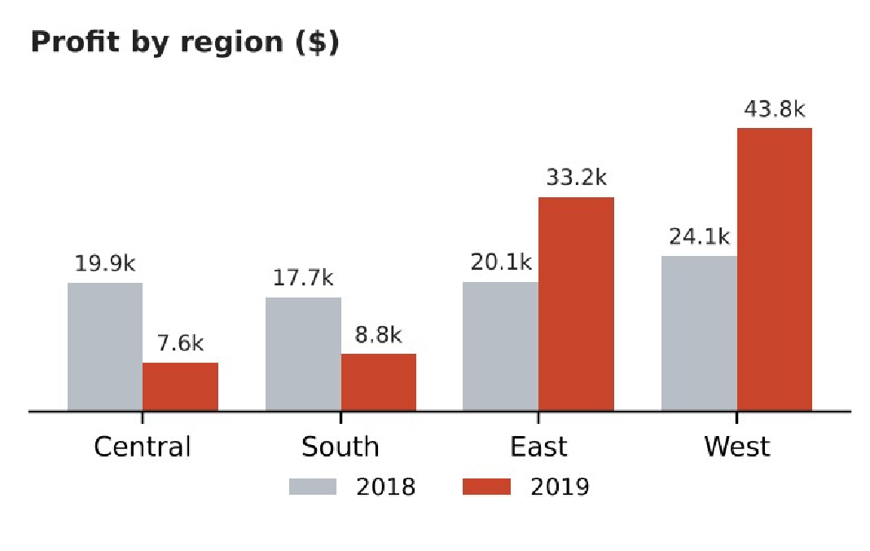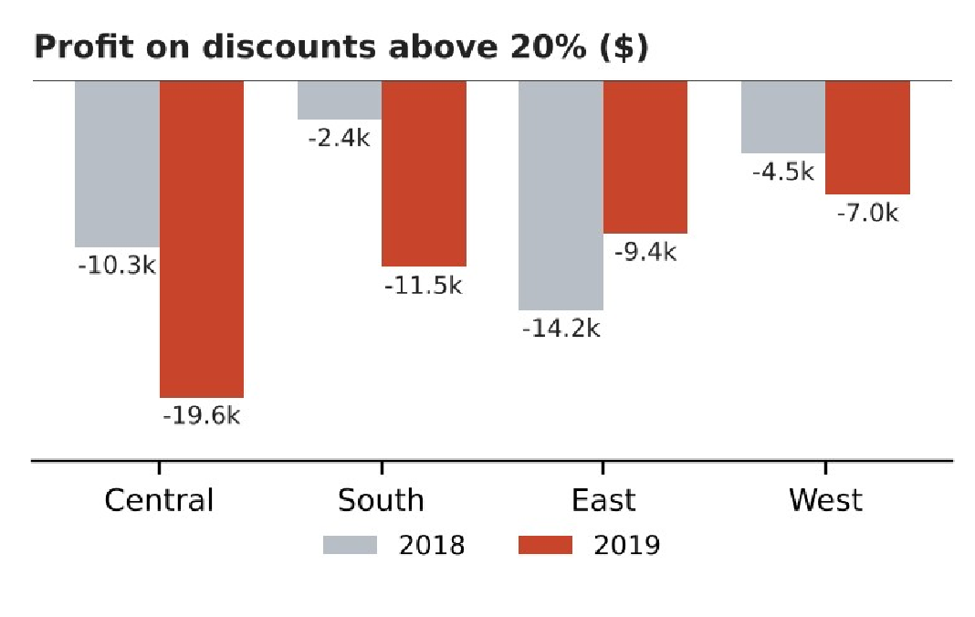
Left: Central and South profit dropped in 2019. Right: losses on discounts above 20% grew in the same two regions. Over all four years, discounts above 20% lost $135,376, while low discounts (20% or less) earned $100,785 and no discount earned $320,988.
Region | Profit 2018 |  | Profit 2019 |  | Change |  | Margin 2018 to 2019 |  | Loss on discounts above 20%,  2018 to 2019
Central | $19,899 |  | $7,551 |  | -62% |  | 13.5% to 5.1% |  | -$10,269 to -$19,552
South | $17,703 |  | $8,849 |  | -50% |  | 18.9% to 7.2% |  | -$2,418 to -$11,526
East |  | $20,142 |  | $33,231 |  | +65% |  | 11.1% to 15.6% |  | -$14,168 to -$9,447
West |  | $24,052 |  | $43,809 |  | +82% |  | 12.8% to 17.5% |  | -$4,503 to -$7,045
Company |  | $81,795 |  | $93,439 |  | +14% |  | 13.4% to 12.7% |  | -$31,357 to -$47,570
From Nikhil kumar – Data analyst

