Most of the fraudulent cases are 1%, so data is unbalanced and since supervised learning is very sensitive to unbalanced data. We can use unsupervised learning:

* We use PCA for reducing the features and preserving the most important features

Challenges of fraud detection

* Incorrect flagging: Avoid harassing real customers

Dealing with Unbalanced Data

* Classifier tend to favor majority class (= real/ legitimate )
* Large classification error over the fraud cases
* Classifiers learn better from a balanced distribution
* We will balance the training set
  + 1st technique is random over sampling: We copy the lesser observations (here fraudulent class) until we reach a threshold value. Problem is there will be lots of observations what we get after copying and there will be variance which can’t be explained by the data
  + Random under sampling: We remove the dominant cases (legitimate cases). Problem is we will throw lots of useful information that is not preferred in general
  + We can do both over-sampling and under-sampling
  + SMOTE (synthetic minority over sampling technique): In this technique, we over-sample the fraud cases (minority class) by creating synthetic fraud cases.

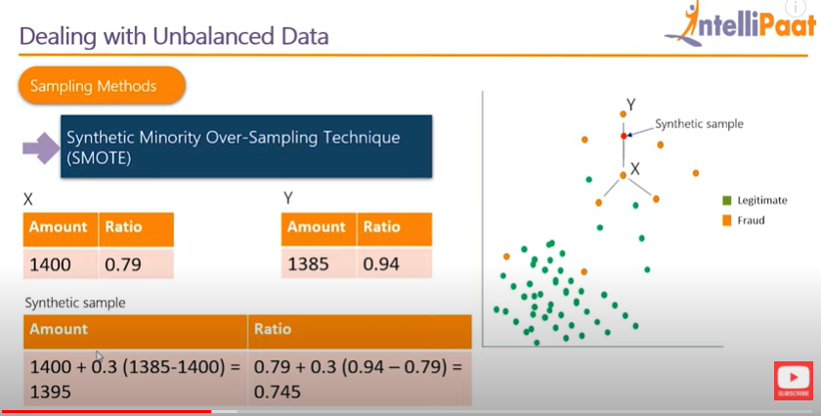

* Find k nearest neighbour of fraud case (suppose k=3), randomly choose one neighbour say Y, now we have to choose any point on line between x and y.
* We will do this repeatedly to get different synthetic fraudulent case points