##### NETWORK PROGRAMMING

**CSX-354**

**LAB PRACTICALS RECORD**

**COMPUTER SCIENCE AND ENGINEERING**



**DEPARTMENT OF COMPUTER SCIENCE AND ENGINEERING**

**Dr. B R AMBEDKAR NATIONAL INSTITUTE OF TECHNOLOGY**

**JALANDHAR – 144011, PUNJAB (INDIA)**

###### **Submitted To: Submitted By:**

Mr. MANOJ KUMAR Nikhil Bansal

Asst. Professor 13103011

Department of CSE 6th Semester

|  |  |  |  |  |
| --- | --- | --- | --- | --- |
| **S. No** | **Objective** | **Page No.** | **Date** | **Signature** |
| 01. | Client Server Communication using TCP | 2 | 11/01/2016 |  |
| 02. | TCP iterative client and server application to reverse given input | 6 | 18/01/2016 |  |
| 03. | TCP Sockets Date and Time Server | 11 | 25/01/2016 |  |
| 04. | TCP client and server application to transfer a file | 15 | 08/02/2016 |  |
| 05. | UDP client and server application to transfer a file | 20 | 15/02/2016 |  |
| 06. | Creation of one way pipe in single process | 24 | 29/02/2016 |  |
| 07. | To make a Server client for receiving and sending messages using FIFO | 26 | 21/03/2016 |  |
| 08. | Program to implement message queue (to transfer a file or any) | 29 | 28/03/2016 |  |
| 09. | To perform Semaphore Operations | 32 | 11/04/2016 |  |
| 10. | DNS Server to resolve a given host name | 34 | 18/04/2016 |  |

**INDEX**

**PROGRAM-1**

**Simple TCP Communication**

This Program illustrates communication between client and server using TCP Protocol.

**Server Program:**

#include<sys/types.h>

#include<sys/socket.h>

#include<string.h>

#include<stdio.h>

#include<netinet/in.h>

#include<unistd.h>

#include<stdlib.h>

int main()

{

struct sockaddr_in servaddr;

char output[20];

int n, temp, i, j, mysockfd, clientfd;

struct sockaddr_in client;

int clilen=sizeof(client);

// create socket at server

mysockfd = socket(AF_INET, SOCK_STREAM, 0);

if(mysockfd<0)

{

perror("Socket failed");

return -1;

}

// create the server address

memset(&servaddr, 0, sizeof(servaddr));

servaddr.sin_family = AF_INET;

servaddr.sin_port = htons(5000);

// bind the server address to the socket

temp = bind(mysockfd, (struct sockaddr *)&servaddr, sizeof(servaddr));

if(temp<0)

{

perror("Bind failed");

return -1;

}

else

{

printf("Bind successful\n");

}

// listen to the requests with at max 2 requests

temp = listen(mysockfd, 2);

if(temp<0)

{

perror("Listen failed");

return -1;

}

else

{

printf("Listen successful\n");

}

// accept the clients request

clientfd = accept(mysockfd, (struct sockaddr *)&client, (unsigned int *)&clilen);

if(clientfd<0)

{

perror("Accept failed");

return -1;

}

else

{

printf("Accept successful\n");

}

// communicate with client

while(1)

{

if((n=read(clientfd,output,20-1))==0)

break;

if(n>0)

{

output[n]='\0';

printf("%s\n",output);

}

}

printf("Client Disconnected\n");

return 0;

}

**Client Program:**

#include<sys/types.h>

#include<sys/socket.h>

#include<string.h>

#include<stdio.h>

#include<netinet/in.h>

#include<unistd.h>

#include<stdlib.h>

#define MAXLINE 20

int main()

{

struct sockaddr_in servaddr;

char sendline[MAXLINE];

int n, temp, mysockfd;

// make socket

mysockfd = socket(AF_INET, SOCK_STREAM, 0);

if(mysockfd<0)

{

perror("Socket failed");

return -1;

}

// get the server address

memset(&servaddr, 0, sizeof(servaddr));

servaddr.sin_family = AF_INET;

servaddr.sin_port = htons(5000);

// connect with the server

temp = connect(mysockfd, (struct sockaddr *)&servaddr, sizeof(servaddr));

if(temp<0)

{

perror("Connection failed");

return -1;

}

else

{

printf("Connection Successful\n");

}

// input data to send to server

printf("Enter the data to be send: \n");

while(fgets(sendline,MAXLINE,stdin)!=NULL)

{

write(mysockfd,sendline,strlen(sendline));

printf("Line send\n");

printf("Enter the data to be send: \n");

}

exit(0);

return 0;

}

**Output:**

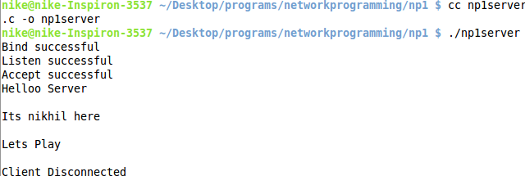

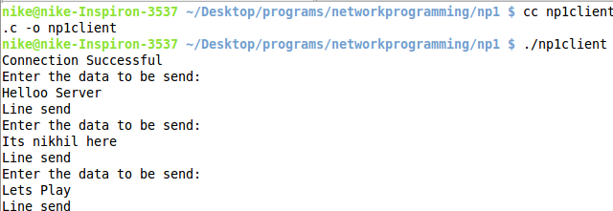

**PROGRAM 2**

**Reverse String using TCP**

Design TCP iterative client and server application to reverse a given input string.

**Server Program:**

#include<bits/stdc++.h>

using namespace std;

#include<sys/types.h>

#include<sys/socket.h>

#include<netinet/in.h>

#include<unistd.h>

#include<time.h>

#define MAXLEN 200

void reverseString(char input[], char output[]){

int i=0, len=strlen(input);

while(len--){

output[i]=input[len];

i++;

}

output[i]='\0';

}

int main()

{

struct sockaddr_in servaddr, client;

char sendData[MAXLEN], rcvData[MAXLEN];

int n, temp, mysockfd, clientfd;

int clilen=sizeof(client);

// create socket at server

mysockfd = socket(AF_INET, SOCK_STREAM, 0);

if(mysockfd<0){

perror("Socket failed");

return -1;

}

// create the server address

memset(&servaddr, 0, sizeof(servaddr));

servaddr.sin_family = AF_INET;

servaddr.sin_port = htons(5001);

// bind the server address to the socket

if(bind(mysockfd, (struct sockaddr *)&servaddr, sizeof(servaddr)) < 0){

perror("Bind failed");

return -1;

}

else{

printf("Bind successful\n");

}

// listen to the requests with at max 2 requests

if(listen(mysockfd, 2) < 0){

perror("Listen failed");

return -1;

}

else{

printf("Listen successful\n");

}

while(1){

// accept the clients request

clientfd = accept(mysockfd, (struct sockaddr *)&client, (unsigned int *)&clilen);

if(clientfd<0){

perror("Accept failed");

return -1;

}

else{

printf("Accept successful\n");

}

// get string from client

n=read(clientfd, rcvData, MAXLEN-1);

if(n<0){

perror("Read error in server");

return -1;

}

rcvData[n]='\0';

// reverse the string

reverseString(rcvData, sendData);

// send reversed string to client

write(clientfd, sendData, strlen(sendData));

printf("Reversed String => %s sent to client.\n", sendData);

printf("Client Disconnected\n");

close(clientfd);

}

return 0;

}

**Client Program:**

#include<bits/stdc++.h>

using namespace std;

#include<sys/types.h>

#include<sys/socket.h>

#include<netinet/in.h>

#include<unistd.h>

#include<stdlib.h>

#define MAXLINE 200

int main(){

struct sockaddr_in servaddr;

char rcvline[MAXLINE], sendline[MAXLINE];

int n, mysockfd;

// make socket

mysockfd = socket(AF_INET, SOCK_STREAM, 0);

if(mysockfd<0){

perror("Socket failed");

return -1;

}

// get the server address

memset(&servaddr, 0, sizeof(servaddr));

servaddr.sin_family = AF_INET;

servaddr.sin_port = htons(5001);

// connect with the server

if(connect(mysockfd, (struct sockaddr *)&servaddr, sizeof(servaddr)) < 0){

perror("Connection failed");

return -1;

}

else{

printf("Connection Successful\n");

}

// input the string to be reversed

printf("Enter the string to be reversed: ");

scanf("%s", sendline);

// send the string to the server

write(mysockfd, sendline, strlen(sendline));

// get the reverse of string from server

n=read(mysockfd, rcvline, MAXLINE-1);

if(n<0){

perror("Read data from server failed");

}

else{

rcvline[n]='\0';

printf("Reversed String: %s\n", rcvline);

}

printf("Disconnecting from client\n");

return 0;

}

**Output:**

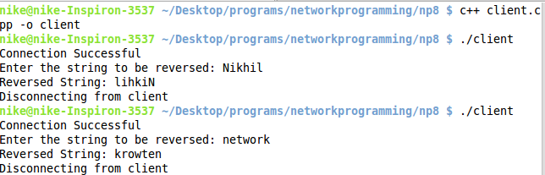

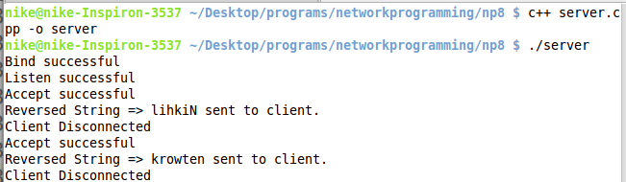

**PROGRAM 3**

**Date/Time using TCP**

Program for date and time server using TCP sockets

**Server Program:**

#include<bits/stdc++.h>

using namespace std;

#include<sys/types.h>

#include<sys/socket.h>

#include<netinet/in.h>

#include<unistd.h>

#include<stdlib.h>

#include<time.h>

#define MAXLEN 200

int main()

{

struct sockaddr_in servaddr, client;

char sendData[MAXLEN];

int n, temp, mysockfd, clientfd;

int clilen=sizeof(client);

// create socket at server

mysockfd = socket(AF_INET, SOCK_STREAM, 0);

if(mysockfd<0){

perror("Socket failed");

return -1;

}

// create the server address

memset(&servaddr, 0, sizeof(servaddr));

servaddr.sin_family = AF_INET;

servaddr.sin_port = htons(5001);

// bind the server address to the socket

if(bind(mysockfd, (struct sockaddr *)&servaddr, sizeof(servaddr)) < 0){

perror("Bind failed");

return -1;

}

else{

printf("Bind successful\n");

}

// listen to the requests with at max 2 requests

if(listen(mysockfd, 2) < 0){

perror("Listen failed");

return -1;

}

else{

printf("Listen successful\n");

}

// accept the clients request

clientfd = accept(mysockfd, (struct sockaddr *)&client, (unsigned int *)&clilen);

if(clientfd<0){

perror("Accept failed");

return -1;

}

else{

printf("Accept successful\n");

}

// get current time

time_t ct;

ct = time(NULL);

sprintf(sendData, "%s", ctime(&ct));

// send time to client

write(clientfd, sendData, strlen(sendData));

printf("Current date & time => %s Sent\n",sendData);

printf("Client Disconnected\n");

close(clientfd);

return 0;

}

**Client Program:**

#include<bits/stdc++.h>

using namespace std;

#include<sys/types.h>

#include<sys/socket.h>

#include<netinet/in.h>

#include<unistd.h>

#include<stdlib.h>

#define MAXLINE 200

int main(){

struct sockaddr_in servaddr;

char rcvline[MAXLINE];

int n, mysockfd;

// make socket

mysockfd = socket(AF_INET, SOCK_STREAM, 0);

if(mysockfd<0){

perror("Socket failed");

return -1;

}

// get the server address

memset(&servaddr, 0, sizeof(servaddr));

servaddr.sin_family = AF_INET;

servaddr.sin_port = htons(5001);

// connect with the server

if(connect(mysockfd, (struct sockaddr *)&servaddr, sizeof(servaddr)) < 0){

perror("Connection failed");

return -1;

}

else{

printf("Connection Successful\n");

}

// get date/time to server

printf("Current Date & Time: ");

while((n=read(mysockfd, rcvline, MAXLINE-1)) > 0){

rcvline[n]='\0';

printf("%s",rcvline);

}

printf("\n");

printf("Disconnecting from client\n");

return 0;

}

**Output:**

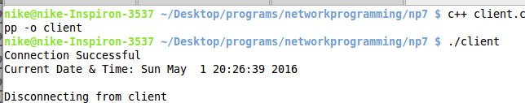

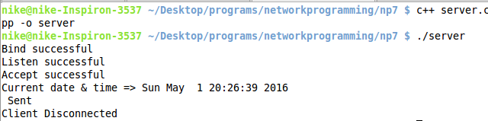

**PROGRAM 4**

**Transfer File Using TCP**

Design TCP client and server application to transfer a file.

**Server Program:**

#include<bits/stdc++.h>

using namespace std;

#include<sys/types.h>

#include<sys/socket.h>

#include<string.h>

#include<stdio.h>

#include<netinet/in.h>

#include<unistd.h>

#include<stdlib.h>

#define MAXLINE 200

int main(){

int mysockfd, clientSize, clientfd;

struct sockaddr_in serverAddress, clientAddress;

char sendData[MAXLINE], fileName[MAXLINE];

// socket file descriptor at server

mysockfd=socket(AF_INET, SOCK_STREAM, 0);

if(mysockfd==-1){

perror("Socket Socket call failed\n");

exit(EXIT_FAILURE);

}

// create server address

serverAddress.sin_family=AF_INET;

serverAddress.sin_port=htons(5000);

// bind the server address with the server file descriptor

if(bind(mysockfd, (struct sockaddr *)&serverAddress, (socklen_t)sizeof(serverAddress)) < 0){

perror("Bind failed");

return -1;

}

// listen to the client requests

if(listen(mysockfd, 3)<0){

perror("Listen Failed");

return -1;

}

while(1){

// accept a client connection

if((clientfd=accept(mysockfd, (struct sockaddr *)&clientAddress, (socklen_t *)&clientSize)) < 0){

perror("Accept Failed");

return -1;

}

printf("New Client Connected\n");

// receive the name of file

if(recv(clientfd, fileName, MAXLINE, 0) < 0){

perror("Receive failed");

}

printf("File requested by client: %s\n", fileName);

// open the file and send it to client

FILE *input = fopen(fileName, "r");

if(input==NULL){

printf("Requested file not available on server\n");

strcpy(sendData, "File not available\n");

send(clientfd, sendData, strlen(sendData)+1, 0);

return -1;

}

else{

while(fgets(sendData, MAXLINE, input)){

write(clientfd, sendData, strlen(sendData));

}

printf("Requested File %s sent to client.\n",fileName);

}

// close the files and connection

fclose(input);

close(clientfd);

printf("Client Disconnected\n\n");

}

return 0;

}

**Client Program:**

#include<bits/stdc++.h>

using namespace std;

#include<sys/types.h>

#include<sys/socket.h>

#include<string.h>

#include<stdio.h>

#include<netinet/in.h>

#include<unistd.h>

#include<stdlib.h>

#define MAXLINE 200

int main(){

int mysockfd, len;

unsigned int serverSize;

char sendData[MAXLINE],recvData[MAXLINE],fileName[MAXLINE];

struct sockaddr_in serverAddress;

// socket at client

mysockfd=socket(AF_INET, SOCK_STREAM, 0);

if(mysockfd==-1){

perror("Socket client failed");

exit(-1);

}

// server address

memset(&serverAddress, 0, sizeof(serverAddress));

serverAddress.sin_family = AF_INET;

serverAddress.sin_port = htons(5000);

// connect to the server

if(connect(mysockfd, (struct sockaddr *)&serverAddress, sizeof(serverAddress)) < 0){

perror("Connect failed");

return -1;

}

// get the filename to be downloaded

printf("Enter the file name to download: ");

scanf("%s",fileName);

// send the file name to the server

if(send(mysockfd, fileName, strlen(fileName), 0) < 0){

perror("Sending failed");

return -1;

}

// download the file

FILE *download = fopen(fileName, "w");

if(download==NULL){

printf("File opening failed\n");

return -1;

}

else{

while((len=read(mysockfd, recvData, MAXLINE-1)) > 0){

recvData[len]='\0';

fputs(recvData, download);

}

}

fclose(download);

printf("File has been downloaded: %s\n",fileName);

return 0;

}

**Output:**

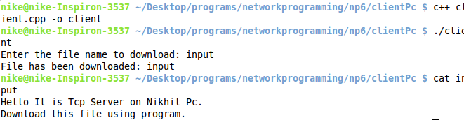

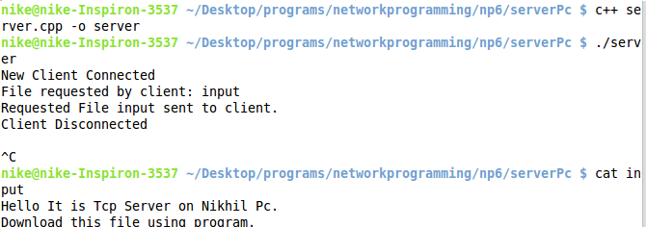

**PROGRAM 5**

**Transfer File using UDP**

UDP client and server application to transfer a file

**Server Program:**

#include<bits/stdc++.h>

using namespace std;

#include<sys/types.h>

#include<sys/socket.h>

#include<string.h>

#include<stdio.h>

#include<netinet/in.h>

#include<unistd.h>

#include<stdlib.h>

#define MAXLINE 200

int main(){

int mysockfd, clientSize;

struct sockaddr_in serverAddress, clientAddress;

char sendData[MAXLINE], fileName[MAXLINE];

// socket file descriptor at server

mysockfd=socket(AF_INET, SOCK_DGRAM, 0);

if(mysockfd==-1){

perror("Socket Socket call failed\n");

exit(EXIT_FAILURE);

}

// create server address

serverAddress.sin_family=AF_INET;

serverAddress.sin_port=htons(5000);

// bind the server address with the server file descriptor

if(bind(mysockfd, (struct sockaddr *)&serverAddress, (socklen_t)sizeof(serverAddress)) < 0){

perror("Bind failed");

return -1;

}

// receive the name of file

if(recvfrom(mysockfd, fileName, MAXLINE, 0, (struct sockaddr *)&clientAddress, (socklen_t *)&clientSize) < 0){

perror("Receive failed");

}

printf("File requested by client: %s\n", fileName);

// open the file and send it to client

FILE *input = fopen(fileName, "r");

if(input==NULL){

printf("Requested file not available on server\n");

strcpy(sendData, "File not available\n");

sendto(mysockfd, sendData, strlen(sendData)+1, 0, (struct sockaddr *)&clientAddress, (socklen_t)clientSize);

return -1;

}

else{

while(fgets(sendData, MAXLINE, input)){

sendto(mysockfd, sendData, MAXLINE, 0, (struct sockaddr *)&clientAddress, (socklen_t)clientSize);

}

printf("Requested File %s sent to client.\n",fileName);

}

fclose(input);

return 0;

}

**Client Program:**

#include<bits/stdc++.h>

using namespace std;

#include<sys/types.h>

#include<sys/socket.h>

#include<string.h>

#include<stdio.h>

#include<netinet/in.h>

#include<unistd.h>

#include<stdlib.h>

#define MAXLINE 200

int main(){

int mysockfd, len;

unsigned int serverSize;

char sendData[MAXLINE],recvData[MAXLINE],fileName[MAXLINE];

struct sockaddr_in serverAddress;

// socket at client

mysockfd=socket(AF_INET, SOCK_DGRAM, 0);

if(mysockfd==-1){

perror("Socket client failed");

exit(-1);

}

// server address

memset(&serverAddress, 0, sizeof(serverAddress));

serverAddress.sin_family = AF_INET;

serverAddress.sin_port = htons(5000);

// get the filename to be downloaded

printf("Enter the file name to download: ");

scanf("%s",fileName);

// send the file name to the server

serverSize=sizeof(serverAddress);

if(sendto(mysockfd, fileName, strlen(fileName), 0, (struct sockaddr*)&serverAddress, (socklen_t)serverSize) < 0){

perror("Sending failed");

return -1;

}

// download the file

FILE *download = fopen(fileName, "w");

if(download==NULL){

printf("File opening failed\n");

return -1;

}

else{

while(recvfrom(mysockfd, recvData, MAXLINE, 0, (struct sockaddr *)&serverAddress, (socklen_t *)&serverSize) > 0){

fputs(recvData, download);

// here break should not be done but in udp it recvfrom cannot stop as it cannot find EOF

// break is done assuming file is less than MAXLINE size

break;

}

}

fclose(download);

printf("File has been downloaded: %s\n",fileName);

return 0;

}

**Output:**

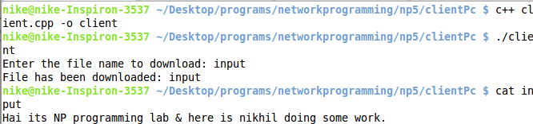

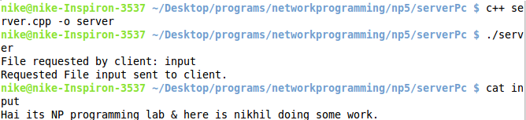

**PROGRAM 6**

**PIPE**

Creation of a one way pipe in a single process

**Program:**

#include<sys/wait.h>

#include<unistd.h>

#include<stdio.h>

#include<stdlib.h>

#include<string.h>

int main(int argc, char *argv[]){

// 1 argument i.e. message to be sent to child

if(argc!=2){

printf("1 argument is required.\n");

exit(EXIT_FAILURE);

}

int pipefd[2];

pid_t cpid;

char buf;

if(pipe(pipefd)!=-1){

// pipe successful

cpid=fork();

if(cpid==-1){

// fork failed

printf("fork failed\n");

exit(EXIT_FAILURE);

}

if(cpid==0){

// child process

// close the write descriptor in the child process

close(pipefd[1]);

printf("Message received from parent: ");

while(read(pipefd[0], &buf, 1)){

printf("%c",buf);

}

printf("\n");

printf("Child exiting\n");

return 0;

}

else{

// parent process

// close the read descriptor in the parent process

close(pipefd[0]);

printf("Message sent to child: %s\n", argv[1]);

write(pipefd[1], argv[1], strlen(argv[1]));

close(pipefd[1]);

wait(NULL);

printf("Parent exiting\n");

return 0;

}

}

else{

// pipe failure

printf("Pipe failed\n");

exit(EXIT_FAILURE);

}

return 0;

}

**Output:**

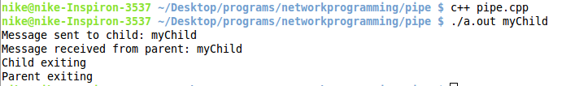

**PROGRAM 7**

**FIFO**

To make a Server client for receiving and sending messages using FIFO

**Creating FIFO:**

#include <sys/types.h>

#include <sys/stat.h>

#include <stdio.h>

#include <unistd.h>

#include <stdlib.h>

int main(int argc, char *argv[]){

if(argc!=2){

printf("Enter the name of the fifo to be made as an argument\n");

exit(EXIT_FAILURE);

}

// make fifo

if(mkfifo(argv[1], 0777)==-1){

printf("unable to make fifo\n");

exit(EXIT_FAILURE);

}

printf("Fifo %s made.\n", argv[1]);

return 0;

}

**FIFO Write Program:**

#include <sys/types.h>

#include <sys/stat.h>

#include <stdio.h>

#include <stdlib.h>

int main(int argc, char *argv[]){

if(argc!=2){

printf("Enter the name of the fifo to write data\n");

exit(EXIT_FAILURE);

}

char buffer[100];

// open the fifo file to write data

FILE *myfile=fopen(argv[1], "w");

if(myfile==NULL){

printf("unable to open fifo file\n");

exit(EXIT_FAILURE);

}

printf("Enter the data to be sent: \n");

fgets(buffer, 100, stdin);

fputs(buffer, myfile);

printf("Data sent.\n");

fclose(myfile);

return 0;

}

**FIFO Read Program:**

#include <sys/types.h>

#include <sys/stat.h>

#include <stdio.h>

#include <unistd.h>

#include <stdlib.h>

int main(int argc, char *argv[]){

if(argc!=2){

printf("Enter the name of the fifo to read data\n");

exit(EXIT_FAILURE);

}

char buffer[100];

// open the fifo file to read data

FILE *myfile=fopen(argv[1], "r");

if(myfile==NULL){

printf("unable to open fifo file\n");

exit(EXIT_FAILURE);

}

fgets(buffer, 100, myfile);

printf("Data received: %s\n",buffer);

fclose(myfile);

return 0;

}

**Output:**

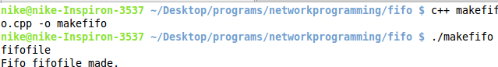

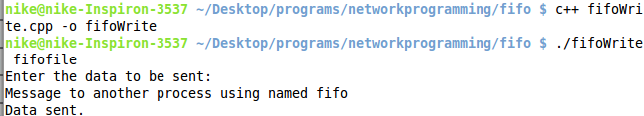

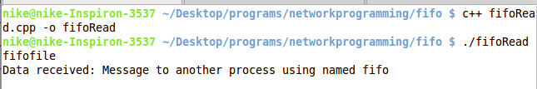

**PROGRAM 8**

**Message Queue**

Program to implement Message Queue where a message is sent from 1 process to another. Also display information about the message queue.

**Message Send Program:**

#include<bits/stdc++.h>

using namespace std;

#include <sys/types.h>

#include <sys/ipc.h>

#include <sys/msg.h>

#define MSG_KEY 34

#define MAX_LEN 100

typedef struct mymsgbuf{

long mtype;

char mtext[MAX_LEN];

}msg;

int main(int argc, char const *argv[])

{

int msqQue, temp;

msg sendMsg;

// create the msg queue

msqQue = msgget(MSG_KEY, IPC_CREAT | 0666);

if(msqQue==-1){

perror("Msq Queue failed");

return -1;

}

// get the msg from user

printf("Enter the message to send:\n");

scanf("%[^\n]",sendMsg.mtext);

// send the message

if(msgsnd(msqQue, &sendMsg, strlen(sendMsg.mtext)+1, 0) < 0){

perror("Message Sending failed");

return -1;

}

printf("Message has been sent\n");

return 0;

}

**Message Receive Program:**

#include<bits/stdc++.h>

using namespace std;

#include <sys/types.h>

#include <sys/ipc.h>

#include <sys/msg.h>

#define MSG_KEY 34

#define MAX_LEN 100

typedef struct mymsgbuf{

long mtype;

char mtext[MAX_LEN];

}msg;

int main(int argc, char const *argv[])

{

int msgQue, temp;

msg rcvMsg;

struct msqid_ds myqueue;

// create the msg queue

msgQue = msgget(MSG_KEY, IPC_CREAT | 0666);

if(msgQue==-1){

perror("Msq Queue failed");

return -1;

}

// receive the message

if(msgrcv(msgQue, &rcvMsg, MAX_LEN, 0, 0) < 0){

perror("Message Receiving failed");

return -1;

}

// print the message

printf("Message Received: %s\n", rcvMsg.mtext);

// print data about queue

msgctl(msgQue, IPC_STAT, &myqueue);

printf("PID of Last Sent Message: %d\n", myqueue.msg_lspid);

printf("PID of Last Received Message: %d\n", myqueue.msg_lrpid);

printf("Current No of messages in queue: %lu\n", myqueue.msg_qnum);

printf("Time of last change: %ld\n", myqueue.msg_ctime);

return 0;

}

**Output:**

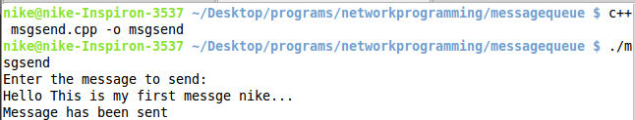

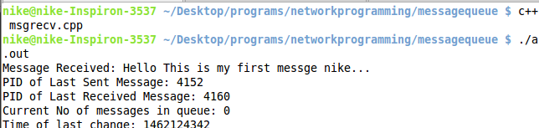

**PROGRAM 9**

**Semaphore**

To perform Semaphore Operations

**Semaphore Process1 Program:**

#include<bits/stdc++.h>

using namespace std;

#include<fcntl.h>

#include<sys/stat.h>

#include<semaphore.h>

#include<unistd.h>

int main(){

sem_t *semAddress;

int i;

// A semaphore is created with name as "hai" and initial value of resources as 1

semAddress=sem_open("hai", O_CREAT, 0777, 1);

if(semAddress==NULL){

perror("Error while opening semaphore");

return -1;

}

sleep(1);

// write to the file when semaphore is free

for(i=0;i<2;i++){

sem_wait(semAddress);

FILE *input = fopen("input", "a");

fprintf(input, "Process 1 writing %d\n",i);

sem_post(semAddress);

}

return 0;

}

**Semaphore Process2 Program:**

#include<bits/stdc++.h>

using namespace std;

#include<fcntl.h>

#include<sys/stat.h>

#include<semaphore.h>

int main(){

sem_t *semAddress;

int i;

semAddress=sem_open("hai", O_EXCL);

if(semAddress==NULL){

printf("Error while opening semaphore %d\n",errno);

return -1;

}

// write to file when semaphore is free

for(i=0;i<2;i++){

sem_wait(semAddress);

FILE *input = fopen("input", "a");

fprintf(input, "Process 2 writing %d\n",i);

sem_post(semAddress);

}

return 0;

}

**Output:**

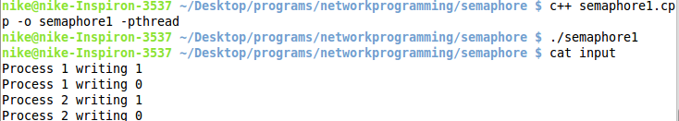

**PROGRAM 10**

**DNS Server**

DNS Server to resolve a given host name

**Program:**

#include<stdio.h>

#include<netdb.h>

#include<arpa/inet.h>

#include<netinet/in.h>

int main(int argc, char* argv[])

{

struct hostent* host;

struct in_addr h_addr;

if(argc!=2){

printf("Requires 1 argument\n");

}

// get the host

if((host=gethostbyname(argv[1]))==NULL){

printf("Nslookup Failed for %s\n",argv[1]);

}

// convert ip address from network byte order to dotted decimal notation

h_addr.s_addr = *((unsigned long*)host->h_addr_list[0]);

printf("Ip Address: %s\n", inet_ntoa(h_addr));

// print the details

printf("Host Name: %s\n",host->h_name);

printf("Address Length: %d\n",host->h_length);

printf("Address Type: %d\n",host->h_addrtype);

printf("List of Address: %s\n",inet_ntoa(h_addr_list[0]));

return 0;

}

**Output:**

