House Price Correlation Analysis Report

1. Introduction
This report presents a correlation analysis of the house price dataset. The objective of this analysis is to identify the most influential factors affecting house prices and derive meaningful business insights for price estimation.

2. Dataset Description
The dataset contains the following variables:
id, date, price, bedrooms, bathrooms, sqft_living, sqft_lot, floors, waterfront, view, condition, grade, sqft_above, sqft_basement, yr_built, yr_renovated, zipcode, lat, long, sqft_living15, sqft_lot15
Target Variable: price

3. Data Preprocessing
• Removed irrelevant columns: id, date
• Checked for missing values
• Generated correlation matrix using Pandas
• Created heatmap visualization using Seaborn
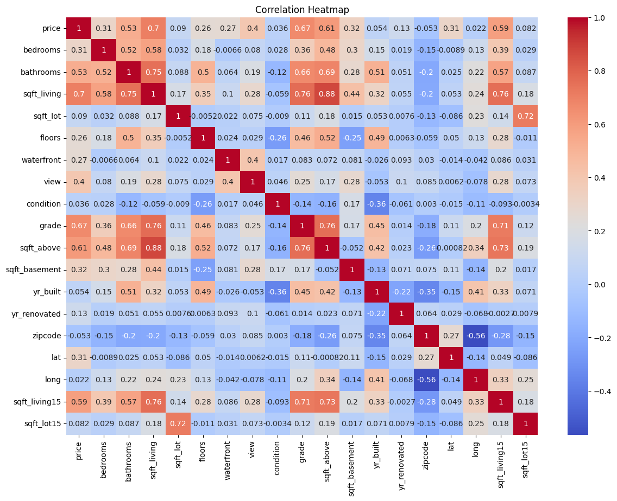

4. Correlation Analysis Results

Strong Positive Correlations with Price
• sqft_living – Strongest predictor of price.
• grade – Construction quality significantly impacts price.
• sqft_above – Above-ground living space affects value.
• bathrooms – More bathrooms increase property value.
• sqft_living15 – Neighborhood living area impacts price.
• view – Better view increases desirability.
• waterfront – Waterfront properties command higher prices.

Weak Correlations with Price
• sqft_lot – Large land size has minimal impact on price.
• bedrooms – Bedroom count alone does not significantly increase price.
• condition – Weak influence compared to grade.
• yr_built – Property age has limited direct impact.

5. Key Business Insights
1. Living space (sqft_living) is the strongest driver of house price.
2. Construction quality (grade) significantly influences valuation.
3. Buyers prioritize interior usable space over lot size.
4. Location-based features such as waterfront and view add premium value.
5. Bedroom count is less important compared to total living area.

6. Recommended Variables for Price Estimation
Strong Predictors:
sqft_living, grade, sqft_above, bathrooms, sqft_living15, view, waterfront
Moderate Predictors:
floors, yr_built, lat, condition
Not Recommended:
id, date, sqft_lot, sqft_lot15

7. Conclusion
The analysis concludes that house prices are primarily driven by living area, construction quality, and interior features rather than lot size or number of bedrooms. These findings are crucial for building accurate predictive models and improving real estate valuation strategies.

