**Java Assignment – 1**

1. Write a java program. Create class Item having itemid, itemname, price. It also have parameterized constructor to set initial values of Items. Create class methods display() to display details. Create order() which takes number of unit as a parameter and return price . Create two objects of items. And display details of those item which have a maximum price.

class Item {

    int itemid;

    String itemname;

    double price;

    Item(int itemid, String itemname, double price) {

        this.itemid = itemid;

        this.itemname = itemname;

        this.price = price;

    }

    void display() {

        System.out.println("Item id :- " + itemid);

        System.out.println("Item Name :- " + itemname);

        System.out.println("Item price :- " + price);

    }

    double order(int units) {

        return price * units;

    }

}

public class Q1 {

    public static void main(String[] args) {

        Item i1 = new Item(1, "Laptop", 9999.89);

        Item i2 = new Item(2, "Iphone", 10999.99);

        if (i1.price > i2.price) {

            i1.display();

        } else {

            i2.display();

        }

    }

}

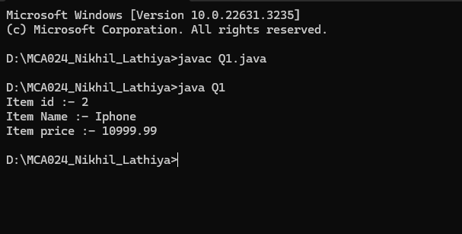

2. Write java program Which perform the addition of two matrix and store in third matrix. Size of matrix should be taken form user. If both the matrix size is same then perform the addition of matrix o.w display message “Addition is not possible”.

import java.util.Scanner;

public class Q2 {

  public static void main(String[] args) {

    Scanner scanner = new Scanner(System.in);

    System.out.println("Enter the Rows and Columns :- ");

    int rows = scanner.nextInt();

    int cols = scanner.nextInt();

    int[][] matrix1 = new int[rows][cols];

    int[][] matrix2 = new int[rows][cols];

    int[][] sum = new int[rows][cols];

    System.out.println("Enter First Matrix Element :- ");

    inputMatrix(matrix1, scanner);

    System.out.println("Enter Second Matrix Element :- ");

    inputMatrix(matrix2, scanner);

    if (rows != cols) {

      System.out.println("Addition is not possible");

    } else {

      addMatrices(matrix1, matrix2, sum);

      System.out.println("The Sum of the matrices is:");

      displayMatrix(sum);

    }

scanner.close();

  }

  static void inputMatrix(int[][] matrix, Scanner scanner) {

    for (int i = 0; i < matrix.length; i++) {

      for (int j = 0; j < matrix[0].length; j++) {

        matrix[i][j] = scanner.nextInt();

      }

    }

  }

  static void addMatrices(int[][] matrix1, int[][] matrix2, int[][] result) {

    for (int i = 0; i < matrix1.length; i++) {

      for (int j = 0; j < matrix1[0].length; j++) {

        result[i][j] = matrix1[i][j] + matrix2[i][j];

      }

    }

  }

  static void displayMatrix(int[][] matrix) {

    for (int[] row : matrix) {

      for (int num : row) {

        System.out.print(num + " ");

      }

      System.out.println();

    }

  }

}

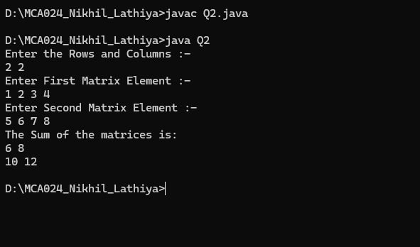

3. Write java program to achieve following Create class Person having property name, age, hobbies (having maximum 5 hobbies). Hobbies is an array of string. Create constructor which set the name and age. Create method setHobbies(int[] a) which will set the hobbies property. Create display() method to display all details of a person. Create a three objects of person class and display details.

class Person

{

    String name;

    int age;

    String[] hobbies;

    Person(String name, int age)

    {

        this.name = name;

        this.age = age;

        this.hobbies = new String[5];

    }

    void setHobbies(String[] hobbies)

    {

        if (hobbies.length <= 5)

        {

            this.hobbies = hobbies;

        }

        else

        {

            System.out.println("Maximum hobbies allowed is 5.");

        }

    }

    void display()

    {

        System.out.println("Name: " + name);

        System.out.println("Age: " + age);

        System.out.println("Hobbies:");

        for (String hobby : hobbies) {

            if (hobby != null) {

                System.out.println("- " + hobby);

            }

        }

    }

}

public class Q3

{

    public static void main(String[] args)

    {

        Person p1 = new Person("Vatsal", 22);

        String[] hobbies1 = { "Reading", "Cooking", "Hiking" };

        p1.setHobbies(hobbies1);

        Person p2 = new Person("Aditya", 24);

        String[] hobbies2 = { "Photography", "Painting", "Traveling"};

        p2.setHobbies(hobbies2);

        Person p3 = new Person("Ananth", 26);

        String[] hobbies3 = { "Singing", "Dancing" };

        p3.setHobbies(hobbies3);

        System.out.println("Details of Person 1:");

        p1.display();

        System.out.println();

        System.out.println("Details of Person 2:");

        p2.display();

        System.out.println();

        System.out.println("Details of Person 3:");

        p3.display();

    }

}

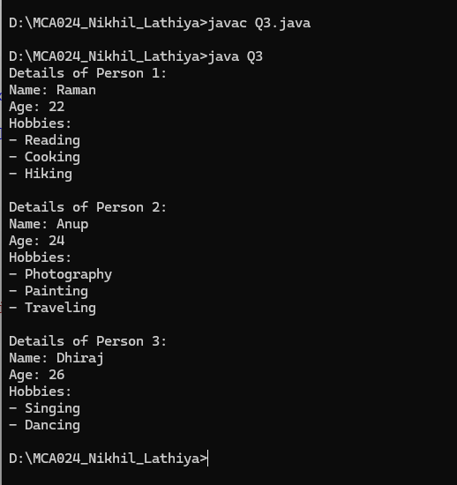

4. Write a java program havine Person with Property name,age.

Class Person

Property : name ,age

Methods : constructor, display() method

Class Employee inherits person

Property salary,experience

Method : employee(name,age,salary,exp) , display(), float calbonus() -> if salary grather than 10000 bounus is 20% if it is between 10001 to 20,000 then bonus 23% if salary greater than 20000 then bonus 25%. If salary less than 10,000 bonus is 15%.

(Hint use the super key word)

Create 3 employee object and display detail. Calculate bonus and display it.

class Person

{

    String name;

    int age;

    Person(String name, int age)

    {

        this.name = name;

        this.age = age;

    }

    void display()

    {

        System.out.println("Name: " + name);

        System.out.println("Age: " + age);

    }

}

class Employee extends Person

{

    double salary;

    int experience;

    Employee(String name, int age, double salary, int experience)

    {

        super(name, age);

        this.salary = salary;

        this.experience = experience;

    }

    void display()

    {

        super.display();

        System.out.println("Salary :- " + salary);

        System.out.println("Experience :- " + experience + " years");

    }

    float calBonus()

    {

        float bonusPercentage;

        if (salary < 10000)

        {

            bonusPercentage = 0.15f;

        }

        else if (salary <= 20000)

        {

            bonusPercentage = 0.23f;

        }

        else

        {

            bonusPercentage = 0.25f;

        }

        return (float) (salary * bonusPercentage);

    }

}

public class Q4

{

    public static void main(String[] args)

    {

        Employee e1 = new Employee("Vatsal", 30, 12000, 5);

        Employee e2 = new Employee("ADitya", 35, 18000, 8);

        Employee e3 = new Employee("Ananth", 25, 25000, 3);

        System.out.println("Details of Employee 1:");

        e1.display();

        System.out.println("Bonus :- " + e1.calBonus());

        System.out.println();

        System.out.println("Details of Employee 2:");

        e2.display();

        System.out.println("Bonus :-" + e2.calBonus());

        System.out.println();

        System.out.println("Details of Employee 3:");

        e3.display();

        System.out.println("Bonus :- " + e3.calBonus());

    }

}

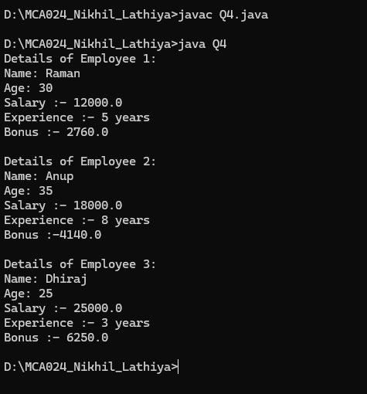

5. Create class category

property: category name

Method: constructor, display() method

Item inherits Category

Property: itemname,price

Constructor : item(name, price,category) , display()

Order inherits items

Property : order, totalamount

Method : constructor, cal_total(item i , int noofitem) _> totalamout= calculate price * noof item, Display()

Create 2 object of order and display the total amount of each order

class Category {

    String categoryname;

    Category(String categoryname) {

        this.categoryname = categoryname;

    }

    void display() {

        System.out.println("Category Name is :- " + categoryname);

    }

}

class Items extends Category {

    String itemname;

    double price;

    Items(String itemname, double price, String categoryname) {

        super(categoryname);

        this.price = price;

        this.itemname = itemname;

    }

    void display() {

        System.out.println("Item Name :- " + itemname);

        System.out.println("Item Price :- " + price);

    }

    double cal_total(int noOfItem) {

        return price * noOfItem;

    }

}

class Order extends Items {

    int order;

    Order(String itemName, double price, String categoryName, int order) {

        super(itemName, price, categoryName);

        this.order = order;

    }

    void display() {

        super.display();

        System.out.println("Order :- " + order);

        System.out.println("Total Amount :- " + cal_total(order));

    }

}

public class Q5 {

    public static void main(String[] args) {

        Order order1 = new Order("Iphone", 200000, "Electronics", 3);

        Order order2 = new Order("Laptop", 800000, "Electronics", 2);

        System.out.println("Details of Order 1:");

        order1.display();

        System.out.println();

        System.out.println("Details of Order 2:");

        order2.display();

    }

}

