Smart Loan Recovery System

A machine learning-powered system for predicting loan recovery probability

# Table of Contents

*Right-click here and select "Update Field" to update the table of contents.*

Table of Contents will be generated here. Right-click and select "Update Field" after opening the document.

# 1. Introduction

The Smart Loan Recovery System is a machine learning-powered application designed to help financial institutions predict the likelihood of recovering loans. By analyzing various customer and loan attributes, the system provides insights that can help prioritize collection efforts and optimize recovery strategies.

This document provides a comprehensive overview of the system, including its architecture, components, installation instructions, and usage guidelines.

# 2. System Overview

The Smart Loan Recovery System uses a Random Forest machine learning model to predict loan recovery probability. The system provides a user-friendly web interface built with Streamlit, allowing users to input loan details individually or upload batch data for processing.

## 2.1 System Workflow

The system follows a streamlined workflow from data input to results visualization:

* Data Input: Users can enter individual loan details or upload CSV files for batch processing
* Data Processing: The system preprocesses the data, performs feature engineering and normalization
* Random Forest Model: The prediction engine analyzes the data using the Random Forest algorithm
* Results Visualization: Interactive charts display recovery probability and risk assessment

The following diagram illustrates the complete workflow of the system:

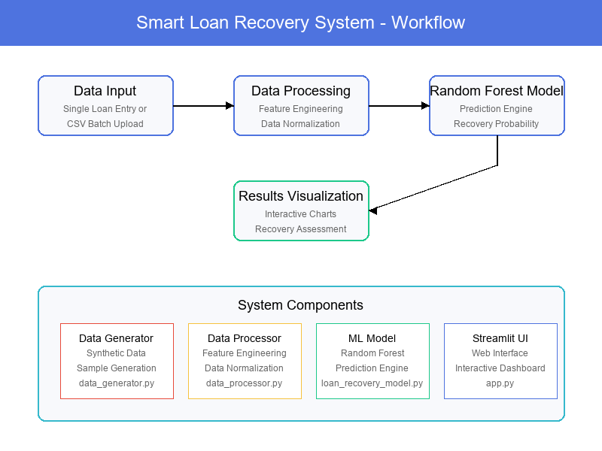

Figure 1: Smart Loan Recovery System Workflow

## 2.2 Key Features

* Predictive Analytics: Uses machine learning to predict loan recovery probability
* Individual Loan Assessment: Analyze individual loans for recovery potential
* Batch Processing: Process multiple loans at once for efficient analysis
* Data Visualization: Interactive charts and graphs for better understanding
* Risk Factor Identification: Highlights key factors affecting recovery

# 3. System Architecture

The Smart Loan Recovery System is built with a modular architecture that separates concerns and promotes maintainability. The system consists of the following components:

## 3.1 Components

### 3.1.1 Data Generator

File: data_generator.py

Generates synthetic loan data for testing and demonstration purposes. Creates realistic loan records with various attributes and calculates recovery status based on predefined rules.

### 3.1.2 Data Processor

File: data_processor.py

Handles data preprocessing, including feature engineering, normalization, and transformation. Prepares raw data for input to the machine learning model.

### 3.1.3 Loan Recovery Model

File: loan_recovery_model.py

Implements the Random Forest machine learning model for predicting loan recovery probability. Includes methods for training, evaluation, and prediction.

### 3.1.4 Streamlit Web Interface

File: app.py

Provides a user-friendly web interface for interacting with the system. Allows users to input loan details, view predictions, and visualize results.

## 3.2 Project Structure

The project follows a structured organization of files and directories:

smart-loan-recovery-system/  
├── app.py # Main Streamlit application  
├── data/ # Data directory  
│ └── loan_data.csv # Sample loan data  
├── models/ # Trained models  
├── src/ # Source code  
│ ├── models/ # ML model implementations  
│ │ └── loan_recovery_model.py  
│ ├── preprocessing/ # Data preprocessing  
│ │ └── data_processor.py  
│ ├── utils/ # Utility functions  
│ │ └── data_generator.py  
│ └── train_model.py # Script to train models  
├── screenshots/ # Screenshots and diagrams  
│ └── system_workflow.png # System workflow diagram  
├── README.md # Project documentation  
└── requirements.txt # Project dependencies

# 4. Machine Learning Model

The Smart Loan Recovery System uses a Random Forest model for loan recovery prediction. Random Forest is an ensemble learning method that operates by constructing multiple decision trees during training and outputting the class that is the mode of the classes of the individual trees.

## 4.1 Model Selection

Random Forest was chosen for this application due to its following advantages:

* High accuracy and robustness to outliers and non-linear data
* Ability to handle a large number of features without feature selection
* Provides feature importance measures, helping identify key factors affecting loan recovery
* Reduces overfitting by averaging multiple decision trees
* Works well with both categorical and numerical features

## 4.2 Feature Engineering

The system processes various loan and customer attributes to predict recovery probability. Key features used in the model include:

* Customer demographics (age, gender)
* Employment status and annual income
* Credit score
* Loan details (amount, interest rate, term)
* Payment history
* Days past due
* Previous defaults
* Calculated metrics (debt-to-income ratio, monthly payment)

# 5. Web Interface

The Streamlit web interface provides a clean and intuitive way for users to interact with the loan recovery prediction system. The interface focuses solely on loan recovery prediction, without showing model selection or data sections.

## 5.1 Interface Features

* Single Loan Prediction: Input form for entering individual loan details
* Batch Prediction: Upload CSV files with multiple loans for batch processing
* Visual Results: Interactive charts showing recovery probability
* Risk Assessment: Visual indicators of recovery likelihood
* Sample Data: Option to download sample CSV templates for batch processing

# 6. Installation and Setup

This section provides instructions for installing and setting up the Smart Loan Recovery System.

## 6.1 Prerequisites

Before installing the system, ensure you have the following prerequisites:

* Python 3.9 or higher
* Git (for cloning the repository)
* Pip (Python package manager)

## 6.2 Installation Steps

### Step 1: Clone the Repository

Clone the repository to your local machine:

git clone https://github.com/yourusername/smart-loan-recovery-system.git

cd smart-loan-recovery-system

### Step 2: Create a Virtual Environment

Create and activate a virtual environment:

# On Windows

python -m venv venv

venv\Scripts\activate

# On macOS/Linux

python -m venv venv

source venv/bin/activate

### Step 3: Install Dependencies

Install the required dependencies:

pip install -r requirements.txt

## 6.3 Dependencies

The system requires the following main dependencies:

* pandas>=2.0.0
* numpy>=1.20.0
* scikit-learn>=1.0.0
* streamlit>=1.20.0
* matplotlib>=3.5.0
* seaborn>=0.12.0
* joblib>=1.1.0

# 7. Usage Guide

This section provides instructions for using the Smart Loan Recovery System.

## 7.1 Starting the Application

To start the application, follow these steps:

### Step 1: Train the Model (Optional)

If you want to train the model with your own data or retrain it, run the training script:

python src/train_model.py

Note: This step is optional. The application will automatically train the model if it doesn't find a pre-trained model when it starts.

### Step 2: Launch the Streamlit Application

Run the Streamlit application:

streamlit run app.py

### Step 3: Access the Web Interface

Open your web browser and navigate to the URL displayed in the terminal (usually http://localhost:8501).

## 7.2 Using the Web Interface

### 7.2.1 Single Loan Prediction

To predict recovery probability for a single loan:

1. Select "Single Loan" from the prediction type options
2. Fill in the loan details in the form (age, gender, employment status, etc.)
3. Click the "Predict Recovery Probability" button
4. View the prediction results, including the recovery probability gauge and assessment

### 7.2.2 Batch Prediction

To predict recovery probability for multiple loans:

1. Select "Batch Prediction" from the prediction type options
2. Download the sample CSV template by clicking "Download Sample CSV"
3. Prepare your CSV file with loan data following the template format
4. Upload your CSV file using the file uploader
5. Click the "Run Batch Prediction" button
6. View the prediction results table with recovery probabilities for all loans

# 8. Extending the System

The Smart Loan Recovery System is designed to be modular and extensible. This section provides guidance on how to extend or customize the system for your specific needs.

## 8.1 Adding New Features

To add new features to the model, modify the following files:

* src/utils/data_generator.py: Update the data generation logic to include new features
* src/preprocessing/data_processor.py: Add the new features to the appropriate feature lists (numerical_features or categorical_features)
* app.py: Update the input form to include fields for the new features

## 8.2 Customizing the Interface

The Streamlit interface can be customized by modifying the app.py file. You can:

* Change the layout, colors, and styling
* Add new visualization types
* Modify the input form fields
* Add additional pages or sections

# 9. Conclusion

The Smart Loan Recovery System provides financial institutions with a powerful tool for predicting loan recovery probability. By leveraging machine learning and a user-friendly interface, the system helps optimize collection efforts and improve recovery rates.

This documentation provides a comprehensive overview of the system, including its architecture, components, installation instructions, and usage guidelines. For further assistance or to report issues, please contact the system administrator or refer to the project repository.

# 10. References

* [Scikit-learn Documentation](https://scikit-learn.org/stable/documentation.html)
* [Streamlit Documentation](https://docs.streamlit.io/)
* [Random Forest Algorithm](https://en.wikipedia.org/wiki/Random_forest)
* [Pandas Documentation](https://pandas.pydata.org/docs/)
* [Matplotlib Documentation](https://matplotlib.org/stable/contents.html)